# ISSUES: FIGURE SET A graphing activity to investigate functional responses of lionfish

Suann Yang

Department of Biology, State University of New York Geneseo, Geneseo, NY 14454

Corresponding author: Suann Yang ([yang@geneseo.edu](mailto:yang@geneseo.edu))

*Pterois volitans* (lionfish) (Photo by [Wolfgang Hasselmann](https://unsplash.com/@wolfgang_hasselmann?utm_source=unsplash&utm_medium=referral&utm_content=creditCopyText) on [Unsplash](https://unsplash.com/photos/xralViB5pUI?utm_source=unsplash&utm_medium=referral&utm_content=creditCopyText))

**THE ISSUE:**

Non-indigenous invasive species are considered one of the major threats to biodiversity. Generalist invasive predators have a direct effect on their ecological communities by consuming a wide variety of prey species. We can apply the concept of predator-prey interactions to understand the negative effects of generalist invasive predators. Impacts can include not only the reduction of a prey species' population size, but also the loss of biodiversity when the invasive predator population grows large enough to drive prey species locally extinct. Studying the impacts of invasive predator species can help to inform how conservation managers protect or respond to invasion in different habitats. In this figure set, students will generate graphs of data from an experiment to quantify predator functional responses and interpret these graphs.

**FOUR DIMENSIONAL ECOLOGY EDUCATION (4DEE) FRAMEWORK**

* **Core Ecological Concepts**
  + Organisms
    - Resources and regulators
  + Communities
    - Predation
* **Ecology Practices**
  + Quantitative reasoning and computational thinking
    - Data analysis and interpretation
  + Designing and critiquing investigations
    - Evaluating claims
    - Argument from evidence
  + Working collaboratively
* **Human-Environment Interactions**
  + How humans shape and manage resources/ecosystems/the environment
    - Natural resource management (biological control agents, ecological risk assessments)
* **Cross-cutting Themes**
  + Systems
  + Biogeography
    - alien/invasive species

**STUDENT-ACTIVE APPROACHES:**

Think-pair-share, graphing data, drawing diagrams

**STUDENT ASSESSMENTS:**

Answering questions on a worksheet, sharing responses with the class

**CLASS TIME:**

50 minutes

**COURSE CONTEXT:**

This figure set is designed for a majors’ introductory ecology course, within a unit on predator-prey interactions and after students have been introduced to Type I, II, and III functional responses. This Figure Set could be used in conjunction with Jean et al. (2023), which introduces Type I and Type II functional responses (<https://tiee.esa.org/vol/v19/issues/figure_sets/jean/abstract.html>).

**ACKNOWLEDGEMENTS:**

This figure set would not have been possible without the support and inspiration from the leaders and participants of ESA’s 2023 Transforming Ecology Education Faculty Mentoring Network, funded by the National Science Foundation (DBI 2120678). Special thanks to Linda Auker, Jeremy Hsu, and Rosny Jean for the conversation that shaped this figure set and feedback to improve it. Thanks also to Christopher Beck and an anonymous reviewer for their constructive comments.

**OVERVIEW**

**WHAT IS THE ECOLOGICAL ISSUE?**

Non-indigenous invasive species are considered one of the major threats to biodiversity. Generalist invasive predators have a direct effect on their ecological communities by their direct and indirect impacts on food webs (David et al. 2017), and these impacts are compounded by other threats to biodiversity (Doherty et al. 2015). Examples include Burmese pythons in the Florida Everglades, feral and domestic cats, the harlequin lady beetle (*Harmonia axyridis*) in North America, and lionfishes in the Western Atlantic Ocean (focus of this figure set).

This figure set relates the concepts of predator-prey interactions to understand the context-dependence of interactions with generalist invasive predators, specifically consumer functional responses (Holling 1965). There is broad evidence for the context-dependence of functional responses, even within a single predator-prey species pairing (reviewed in Hossie and Murray 2023). Environmental temperature, habitat complexity, presence of intra- and interspecific competitors, relative abundance of prey, and other factors can change predator foraging behavior, and through this behavioral change, alter the functional response. Students will have an opportunity to discover how relative abundance of prey affects foraging behavior in this figure set.

This ecological issue of generalist invasive predators also brings the intersection of ecology and society, i.e., Human-Environment Interactions (4DEE Framework) to the classroom. Intentional and unintentional introduction of non-indigenous species by humans is one way in which globalization of human society has shaped biogeography and biodiversity. Studying the impacts of invasive predator species can help to inform how conservation managers protect or respond to invasion in different habitats.

**FIGURE SETS TABLE**

|  |  |  |
| --- | --- | --- |
| **Figure Set** | **Student-active Approach** | **Cognitive Skill** |
| Graphing functional responses | Think-pair-share, graphing data and drawing diagrams | comprehension, interpretation, application |

**Learning Objectives:**

Students will be able to

* + Determine predictor (independent) and response (dependent) variables from a description of an experiment.
  + Graph and interpret data from an ecological experiment.
  + Identify the type of functional response that is depicted in a graph.
  + Explain why different types of functional responses could arise for the same predator in different habitats.
  + Make a recommendation about the conservation of ecological resources using knowledge of ecological concepts.

**FIGURE SET BACKGROUND**

For this figure set, students will be visualizing data collected by McCard et al. (2021), using a freely available, web-based graphing application. The comma separated values data files for this figure set are reformatted from the Excel data file included in the supplementary information of McCard et al. (2021).

McCard et al. (2021) investigated the functional response and prey switching behavior of the lionfish *Pterois volitans*, with an overall goal of improving how we evaluate and predict the impacts of predatory invasive species on the population stability of native species. As with many other studies on functional responses, their investigation used simplified and controlled environments rather than *in situ* observations. The three different prey species used were *Artemia salina*, *Palaemonetes varians* and *Gammarus oceanicus*.

The Student Instructions contain background information on lionfish and a more detailed description of the experimental design of McCard et al. (2021).

**FIGURES**

The original figures from McCard et al. (2021) are below, along with new figure captions to provide to students if an instructor decides to use these figures instead of assigning students to construct graphs.

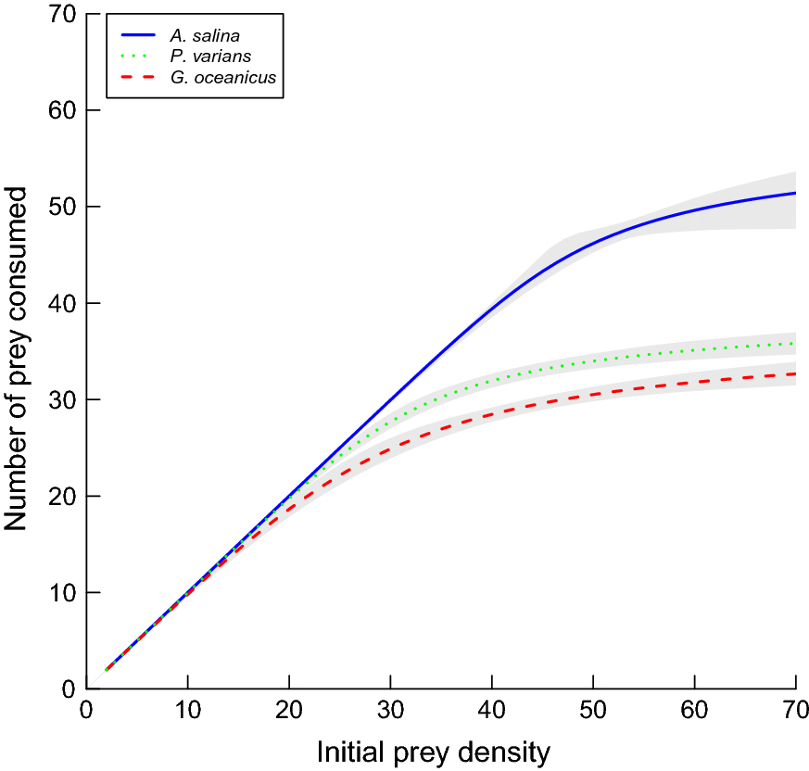

**Figure 1.** The number of prey consumed during three hours by an individual lionfish in a 45 L aquarium tank containing only one prey species. The three different prey species used were *Artemia salina* (blue, solid line), *Palaemonetes varians* (green, dotted line) and *Gammarus oceanicus* (red, dashed line). Shaded areas are 95% confidence intervals. This graph is Figure 2 from McCard et al. (2021), which is licensed under [CC-BY-4.0.](http://creativecommons.org/licenses/by/4.0/)

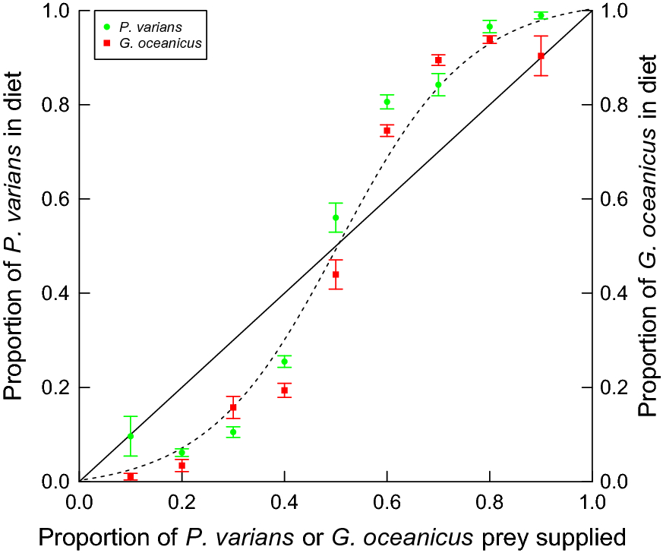

**Figure 2.** Consumption patterns for lionfish in trials with a mixture of prey species. The proportion of a prey species consumed over an hour by an individual lionfish in a 45 L aquarium tank is shown across a range of initial supply proportions: *Palaemonetes varians* (green, circle) or *Gammarus oceanicus* (red, square). Each symbol is the mean proportion across seven replicates, and the error bars show the standard error (SE). The solid line shows the expected relationship if lionfish consume prey at random (without preference). The dashed line shows a hypothetical relationship if lionfish are consuming more common prey preferentially. This graph is Figure 2 from McCard et al. (2021), which is licensed under [CC-BY-4.0.](http://creativecommons.org/licenses/by/4.0/)

**STUDENT INSTRUCTIONS**

B

In this activity, we will apply our knowledge of predator-prey interactions, specifically functional responses, toward a very real problem: invasive lionfish in the western Atlantic Ocean. You may want to review Type I, II, and III functional responses before diving in.

**Background information on the red lionfish**

*Pterois volitans*, or the red lionfish, is a coral reef fish from the Indian Ocean and western Pacific Ocean, and has rapidly established in the Gulf of Mexico, the Caribbean region, and in the Atlantic Ocean along the southeast US coast (Hare and Whitfield 2003). A popular tropical fish in the aquarium trade (though now banned in Florida), it is thought to have been intentionally or accidentally released off the coast of southeast Florida, rather than catching a ride in ballast water like other marine invasive species (Hare and Whitfield 2003).

A few characteristics of lionfish facilitate its rapid expansion in its new range. As a venomous species, lionfish have very few natural enemies in their new habitat. Lionfish eat mostly other fish, but also invertebrates such as crabs and shrimps. They are voracious in their appetites. A study conducted in the northern Gulf of Mexico documented at least 77 coral reef taxa from the contents of lionfish stomachs (Dahl and Patterson 2014). Altogether, the invasion of the western Atlantic by lionfish is a major threat to marine biodiversity.

Eradication of lionfish from the western Atlantic is likely impossible. A more practical goal is to try to reduce the negative impact of lionfish. Many management approaches have been and continue to be implemented, e.g., lionfish spearfishing tournaments encourage a concentrated effort at reducing the population size of lionfish (Ulman et al. 2022). We can apply our knowledge of the predator-prey interaction to help figure out the best approaches for reducing the negative impact of lionfish.

**Functional responses in lionfish: an experiment**

Dr. Monica McCard and her colleagues conducted an experiment to examine how lionfish responded to the density of prey (McCard et al. 2021). The researchers measured predation rates in trials with only one prey species at a time. They also conducted trials where two prey species were mixed together in different proportions. The prey species studied were brine shrimp (*Artemia salina*), dwarf white shrimp (*Palaemonetes varians*) and a marine gammarid (*Gammarus oceanicus*). They gathered 14 lionfish juveniles (pre-reproductive individuals) of similar size for their trials. All trials took place in 45 L aquarium tanks.

For the single-species trials, the researchers set up a tank with one of 16 density levels: 2, 4, 6, 8, 12, 16, 20, 25, 30, 35, 40, 45, 50, 55, 60, and 70 prey individuals per tank. For each of these single-species trials, the scientists released one lionfish into the tank to hunt and capture prey for three hours, then counted the number of remaining prey individuals to calculate the number of prey eaten during the trial. Each density level was repeated seven times, with different lionfish each time.

For the mixed-species trials, Dr. McCard and her colleagues chose to focus on *P. varians* (PV) and *G. oceanicus* (GO). In these trials, the researchers set up nine different prey ratios: 45 PV:5 GO, 40 PV:10 GO, 35 PV:15 GO, 30 PV:20 GO, 25 PV:25 GO, 20 PV:30 GO, 15 PV:35 GO, 10 PV:40 GO, and 5 PV:45 GO. Like the single-species trials, each ratio was repeated seven times, with different lionfish each time. For each of these trials, one lionfish was released into the tank to hunt and capture prey for one hour. During the one-hour trial, the researchers tallied which prey species were eaten, and added back prey individuals to maintain the prey ratios throughout the trial.

Next, we will illustrate the experimental setup, make graphs of the data that Dr. McCard collected with her colleagues, interpret our graphs, and discuss conclusions.

**Your turn**

*Illustrate the experimental setup and prepare to graph data*

1. From the single-species trials, choose any low density (e.g., 2, 4, 6, 8) and high density (e.g., 50, 55, 60, 70) level, and one of the prey species. Draw a diagram (i.e., a cartoon or schematic) of the aquarium tank with prey and lionfish to show how a low-density and a high-density trial was set up for that species. Be sure to differentiate among the lionfish and prey species. You can use symbols and/or colors (or draw little shrimp/gammarids and fish).
2. From the mixed-species trials, choose one prey ratio, and draw a diagram to show how a trial was set up. Be sure to differentiate among the lionfish and the two prey species. You can use symbols and/or colors (or draw little shrimp/gammarids and fish). You may want to consult with your neighbors and draw different prey ratios, so you all have different diagrams to refer to later.
3. Fill out the table below to identify the response and predictor variables in the experiment. The response variable, also called the dependent variable, of an experiment is what was measured. The predictor variable, also called the independent variable, is what we think causes the response variable to change in value. There can be more than one response and predictor variable in an experiment. The first row is filled out as an example.

|  |  |  |  |
| --- | --- | --- | --- |
| **Trial** | **Variable name** | **Type of variable** | **Which graph axis is this type of variable usually plotted on? (x or y)** |
| Single-species | Prey density | predictor | x-axis |
| Single-species | Prey species |  |  |
| Single-species | Number of prey eaten |  |  |
| Mixed-species | Prey ratio |  |  |
| Mixed-species | Prey species |  |  |
| Mixed-species | Number of prey eaten |  |  |

1. What functional responses do you expect to see for the single-species and the mixed-species trials?

*Graph and interpret the results*

* Step 1. On a computer, navigate to our course website and download these two data files from today’s assignment:
  + [lionfish_consumption_single_prey.csv](https://tiee.esa.org/vol/v19/issues/figure_sets/yang/resources/lionfish_consumption_single_prey.csv)
  + [lionfish_consumption_mixed_prey.csv](https://tiee.esa.org/vol/v19/issues/figure_sets/yang/resources/lionfish_consumption_mixed_prey.csv)
* Step 2. Navigate to <https://codap.concord.org> and scroll down to Try CODAP. Click on Try CODAP.
* Step 3. On the center pop-up message, click on Create New Document.
* Step 4. Click on the menu icon at the top left corner and choose Import…

* Step 5. Make sure Local File is selected. Drop the single-species prey data file into the dotted box or click to select the file from your computer.

* Step 6. Repeat Step 4 and 5 to import the mixed-species prey data file, then inspect both data tables.
  + For both data tables, each row contains the data from a single trial. The number of prey that the lionfish ate is under “Number of prey eaten,” and the species of prey is under “Prey species.” The column of “Number of prey supplied” is the number of individuals of a prey species that was set up in the trial.
  + Talk to your neighbors about the relationship between “Number of prey supplied” and the variables of “Prey density” and “Prey ratio” from the table in Question 3. You may want to review the description of the experiment as well.
* Step 7. Click on the Graph icon to initiate an empty graph.

* Step 8. Use your completed table from Question 3 to help you make your graphs. Make one graph for the single-species trials, and a second graph for the mixed-species prey trials.
  + Plot “Number of prey supplied,” “Number of prey eaten,” and “Prey species.” For example, prey density is a predictor variable for the single-species trials. Drag “Number of prey supplied” from the single-species data table’s column names to the x-axis of your empty graph.
  + You’ll also want to drag “Prey species” into the plotting area (not an axis) to color the points by the prey species.
* Step 9. Make sure your symbols and colors match up across graphs. By default, the first color chosen is orange, and the second is purple. This means that the colors for *P. varians* are not initially the same, which is confusing. Click on the paintbrush icon next to an active graph to make symbol/color adjustments.
* Step 10. Click on the ruler icon next to an active graph and select Plotted Function. In the gray f() box, type **x**. This will draw a line of y = x.

* Step 11. Download your nice graphs by clicking on the camera icon for a graph and select Export PNG Image… Save to your computer with “Local File.” Replace “Untitled Document” with a logical name for the graph and click DOWNLOAD. Repeat for the other graph.

1. Now it’s time to interpret the graphs you made. What type of functional response do you think occurred in the single-species trials? Explain your choice.
2. The red line we added to the graph for **the single-species trials** (y = x) marks the expected values of lionfish eating the entire supply of prey.
   1. Describe where the data points do and do not match up perfectly to the line.
   2. What is happening in the predator-prey interaction to cause this pattern? Hint: Refer to the diagram you drew in Question 1 to imagine what the lionfish is experiencing.
3. In contrast to the single-species graph, the red line we added to the graph for **the mixed-species trials** (y = x) marks the expected values of lionfish capturing and eating prey at random, or exactly in the proportion the prey was present during the trials.
   1. Describe where the data points do and do not match up perfectly to the line.
   2. Relate the diagram you and your neighbors drew in Question 2 to specific data points and explain how lionfish foraging behavior is creating the mismatch between expectation and reality.
4. What type of functional response do you think occurred in the mixed-species prey trials? Explain your choice.

*Apply and extend what we have learned from this experiment*

1. We previously learned about how the types of functional responses are characteristic of different kinds of predators (e.g., Type I and filter-feeders). Today, we learned that the same predator could exhibit different functional responses. In a few sentences, summarize why different types of functional responses could arise for the same predator in different habitats.
2. Dr. McCard and her research team published a paper on their lionfish experiment. In this paper, they claim that the functional response of lionfish in real communities of multiple prey species has relevance for biodiversity: lionfish would have a smaller negative impact on the populations of prey species that are rare. Do the findings we examined in this activity today support their claim? Why or why not?
3. This experiment on lionfish studied functional responses in a relatively simple system of one lionfish individual plus one or two prey species. Real coral reef communities that have been invaded by lionfish have much higher densities of this invasive species. How might the shape of lionfish functional responses differ in coral reef communities with few lionfish compared to many? Explain your reasoning.
4. As mentioned in the background reading on lionfish, there are many ongoing conservation efforts to reduce the population sizes of lionfish where it is invasive. Organizing people to remove lionfish is no small task, so it is important to figure out how to prioritize where the removal efforts should take place. Putting together everything you’ve learned so far about predator-prey interactions and functional responses, what research do you think would need to be done to figure out the characteristics of coral reefs to prioritize?

**NOTES TO FACULTY**

This figure set is designed for an introductory ecology course, within a unit on predator-prey interactions and after students have been introduced to Type I, II, and III functional responses. The questions could be placed in a worksheet to be graded, and/or used to guide a discussion in small groups, followed by debriefing at the whole class level.

Questions 1-4, in which students illustrate the experimental setup and prepare to graph data, provide an opportunity to visualize the controlled experiments that have traditionally been used to quantify functional responses. The diagrams that students produce serve later purposes as well: concrete connections to what is represented on the x-axis of functional response graphs, especially for Type III functional responses caused by prey switching. Questions 1 and 2 allow for individual choice in depicting the experimental setups, following Universal Design of Learning (UDL) guidelines for optimizing individual choice and autonomy to recruit interest (CAST 2018). Figure 3 offers an example of diagrams illustrating single-species and mixed-species trials.



**Figure 3.** Example diagrams that could be drawn. A) Low density (prey density = 4). B) High density (prey density = 50). C) Mixed-species trial with a ratio of 40 PV to 10 GO.

Question 3 asks students to identify the response and predictor variables of the experiment, setting up for the actual graphing steps. Prey density and prey ratio may be the most obvious predictor variables for students, and gentle nudging may be needed to guide them to realize that prey species is also a predictor variable. Providing a table for their answers to Question 3 is one way to show students how to manage and organize information, freeing students’ working memory for the graph construction and interpretation questions (see UDL guidelines to support executive function; CAST 2018). Question 4 prepares students to construct graphs by asking them to make predictions of the results.

Questions 5-8 ask students to interpret the graphs. The graph from the single-species trials displays a Type II functional response (Question 5), while the mixed-species trials follow a Type III functional response (Question 8). Question 6 checks that students are able to relate foraging behavior to the Type II functional response, perhaps using the vocabulary terms of search and handling time if students have already been introduced to those terms. Rather than immediately asking students to identify the type of functional response in the mixed-species graph, Question 7 intentionally asks students to recognize that prey-switching behavior (or density-dependent preference) causes the shape of the curve before identifying the type of functional response in Question 8. Instructors may wish to guide or wrap-up these questions by showing Figure 2 (perhaps with annotations) to point out parts of the graph that lead to the conclusion about the type of functional response. For example, instructors could point out that when prey species were equally abundant they were consumed equally, whereas when each prey species was more abundant it was consumed more than expected.

Students apply and extend what they have learned from interpreting the figures in Questions 9-12. These questions offer opportunities to relate new ideas and information with those that are more familiar, along with generalizing knowledge to new situations (see UDL guidelines to provide options for comprehension; CAST 2018). If instructors plan to use this activity for a grade, consider allowing for a range of acceptable answers for this section, so long as explanations are sound. Question 8 prompts students to consider the context-dependence of functional responses. Follow-up discussion of this question could be an opportunity to highlight other context-dependent outcomes of interactions between species. For Question 9, students consider the broader implications of the experiment and practice with identifying salient evidence to support a claim. If needed, guide students in focusing on the possible population-level impacts based on lionfish consumption rates at low prey densities or ratios (i.e., what is meant by “rare”). Uncertainty about this claim is definitely also reasonable, such as recognizing the limitations of a simplified experimental system. Students may return to add this idea of limitations after answering Question 11. Question 11 not only reminds students that real communities are much more complex, but also prompts them to think about frequency-dependent regulation of populations. Finally, Question 12 closes the activity by encouraging students to think creatively about specific research questions that are needed to help inform conservation of coral reefs that have been invaded by lionfish. I would expect students to identify factors investigated by McCard et al. (2021), namely richness of prey species, relative abundance of prey species, and density of prey species. Based on the prompt to Question 11, students may also identify lionfish density or lionfish population size as data to gather. Any other factors that they could identify from prior knowledge or personal experience would also be great, demonstrating an ability to integrate experiences outside of class with this activity.

I estimate that this full figure set would take a 50-minute class period. The activities could be divided up into pre-class homework and in-class collaborative work to reduce the amount of class time needed. The background reading, questions on experimental design (Questions 1-4), and graphing activity (Steps 1-11) could be assigned as homework (completed individually), followed by answering Questions 5-12 as a collaborative activity in class. The wording in Question 2 would need to be revised to remove the reference to consulting with neighbors. Alternatively, the activity could be shortened by eliminating the learning objective *Graph and interpret data from an ecological experiment*. Instructors would need to provide the graphs or the original figures from McCard et al. (2021). If using the latter, I’d suggest asking students to perform calculations to convert a few of the prey ratios into proportions, so that the relationship between the experimental design and the published figures are clearer. Furthermore, the y-axis in Figure 1 plots the number of prey consumed, but Figure 2’s y-axes show the proportion of each prey species in the lionfish’s diet. Instructors may want to point out this difference or ask students to notice this difference. As the data are freely available, another option would be redrawing the figures to reduce the cognitive load of the mixed-species graph – label the x-axis ticks with the ratios listed in the experiment’s description (e.g., 45 PV:5 GO) and plot the number of prey consumed rather than the proportion.

A potential warm-up activity could be to asking students to think about what factors could facilitate the rapid expansion observed in invasive lionfish, distinguishing between life history traits and properties of the invaded ecosystem.

A final modification could be to add a post-class assignment for students to learn more about Dr. Monica McCard or fishing tournaments to remove lionfish (see Additional Resources). Dr. McCard’s counterstereotypical career path makes her a relatable role model. Assignments asking students to reflect on counterstereotypical scientists can support the development of science identity in introductory ecology students (Schinske et al. 2016).

Note that this figure set could be used in conjunction with the TIEE resource “[Figure Set update: An inquiry-based module aligned with the 4DEE framework for teaching about functional responses and biological control](https://tiee.esa.org/vol/v19/issues/figure_sets/jean/abstract.html).”

**ADDITIONAL** **RESOURCES**

More about Dr. Monica McCard

* <https://www.ljmu.ac.uk/about-us/staff-profiles/faculty-of-science/school-of-biological-and-environmental-sciences/monica-mccard>
* Bell, S. She left school at 16 with one GCSE, now this Lisburn mum is a marine biologist studying for a PhD. Belfast Telegraph. February 19, 2019. <https://www.belfasttelegraph.co.uk/life/features/she-left-school-at-16-with-one-gcse-now-this-lisburn-mum-is-a-marine-biologist-studying-for-a-phd/37827936.html>
* Find her on X, formerly known as Twitter, @monica_mccard

Examples of tournaments to control lionfish population densities

* <https://emeraldcoastopen.com/>
* <https://www.reef.org/lionfish-derbies>

**LITERATURE CITED**

CAST. 2018. Universal Design for Learning Guidelines version 2.2. <https://udlguidelines.cast.org>.

Dahl, K. A. and W. F.Patterson III. 2014. Habitat-specific density and diet of rapidly expanding invasive red lionfish, *Pterois volitans*, populations in the northern Gulf of Mexico. PloS One 9:e105852.

David, P., E. Thebault, O. Anneville, P. F. Duyck, E. Chapuis, and N. Loeuille. 2017. Impacts of invasive species on food webs: a review of empirical data. Advances in Ecological Research 56:1-60.

Doherty, T. S., C. R. Dickman, D. G.Nimmo, and E. G. Ritchie. 2015. Multiple threats, or multiplying the threats? Interactions between invasive predators and other ecological disturbances. Biological Conservation 190:60-68.

Hare, J. A. and P. E.Whitfield. 2003. An integrated assessment of the introduction of lionfish (*Pterois volitans/miles* complex) to the western Atlantic Ocean. <https://repository.library.noaa.gov/view/noaa/17793>

Holling, C. S. 1965. The functional response of predators to prey density and its role in mimicry and population regulation. Entomological Society of Canada 97:5-60.

Hossie, T. J. and D. Murray. 2023. New perspectives and emerging directions in predator-prey functional response research: Homage to CS Holling (1930-2019). Frontiers in Ecology and Evolution 11:1238953.

McCard, M., J. South, R.N. Cuthbert, J.W. Dickey, N. McCard, and J.T. Dick. 2021. Pushing the switch: functional responses and prey switching by invasive lionfish may mediate their ecological impact. Biological Invasions 23: 2019-2032.

Schinske, J. N., H. Perkins, A. Snyder, and M. Wyer. 2016. Scientist spotlight homework assignments shift students’ stereotypes of scientists and enhance science identity in a diverse introductory science class. CBE—Life Sciences Education 15:ar47.

Ulman, A., F. Z. Ali, H. E. Harris, M. Adel, S. A. Al Mabruk, M. Bariche, A. C. Candelmo, J. K. Chapman, B. A. Çiçek, K. R. Clements, and A. Q. Fogg. 2022. Lessons from the Western Atlantic lionfish invasion to inform management in the Mediterranean. Frontiers in Marine Science 9:865162.