ISSUES: FIGURE SET
Using RGB high-resolution color imagery for object-based image classification and assessing urban canopy cover
Rosny Jean
School of Environment–Sustainability Institute, Florida Agricultural and Mechanical University, Tallahassee, FL 32307
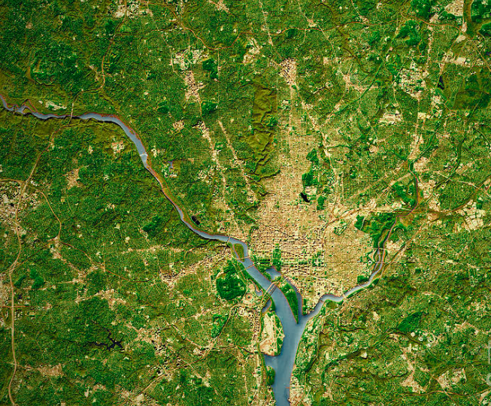
Corresponding author: Rosny Jean (rosny.jean@famu.edu)

Washington, D.C. City Topographic Map (Photograph by Frank Ramspott)
THE ISSUE:
Urban trees and urban forests provide a variety of different benefits for a city including decreased energy expenditure, removal of pollutants, and increased property values. Mapping the spatial distribution of the urban trees in a city holds a significant value for maintenance and also for future planning regarding the need of additional trees and green spaces. However, the unequal distribution of urban trees poses environmental justice challenges. Identifying regions with limited tree cover is particularly important due to their vulnerability to the urban heat island effect. Such areas experience elevated temperatures, impacting residents' health and well-being. Recognizing these disparities becomes a pivotal step for city councils to prioritize interventions effectively, ensuring that environmental benefits are equitably distributed across communities. This figure set will provide students with visual insights into the distribution patterns of urban trees, enabling students to interpret and understand geographical variations.
FOUR DIMENSIONAL ECOLOGY EDUCATION (4DEE) FRAMEWORK
- Core Ecological Concepts:
  - Ecosystems
- Ecology Practices:
  - Quantitative reasoning and computational thinking
    - Data analysis and interpretation
  - Working collaboratively
- Human-Environment Interactions:
  - Ethics
    - Environmental ethics
  - How humans shape and manage resources/ecosystems/the environment
    - Urban ecosystems, urban ecology, urban-rural gradient
- Cross-cutting Themes:
  - Spatial & Temporal

STUDENT-ACTIVE APPROACHES:
Think-pair-share, hands-on image analysis, drawing predicted results, designing experiments, and understanding various software tools commonly used for object-based classification and image analysis (e.g., ArcGIS, QGIS, ENVI).

STUDENT ASSESSMENTS:
Answering questions on a worksheet, sharing responses with the class, image interpretation, classification interpretation, and completing post-class homework that assesses understanding of key concepts.

CLASS TIME:
This Figure Set is designed to span one 75-minute class or split over two 50-minute class sessions.

COURSE CONTEXT:
This Figure Set is recommended as a part of advanced science courses, such as environmental science, geography, or remote sensing at undergraduate and graduate levels.

ACKNOWLEDGEMENTS:
This Figure Set was developed as a part of the Teaching with Figures in Ecology Faculty Mentoring Network, which was supported by ESA's Transforming Ecology Education to 4D (TEE) Project with funding from the National Science Foundation (DBI-2120678).
OVERVIEW
WHAT IS THE ECOLOGICAL ISSUE?
The environmental quality of natural ecosystems is being decimated by an extremely rapid rate of urbanization. By 2050, the projected percentage of the world population living in cities will be seventy-five percent (Roy et al. 2012). Continuous development of cities and road networks during recent decades has resulted in an increase in water proofing of the ground and the creation of impervious surfaces. Therefore, it is highly important for municipalities to measure canopy cover so they make decisions about city finances, need for new trees, and the cost-benefit analysis for the urban trees and forests in their city (Roy et al. 2012). Urban forests and trees provide many benefits, including reducing waterbody pollution caused by stormwater runoff, mitigating air pollution, and sequestering atmospheric carbon dioxide (Richardson and Moskal 2014). An urban tree is a perennial plant that reaches a considerable height (greater than 6 meters) and typically has one woody stem and multiple horizontal limbs. An urban forest is not only the total collection of all urban trees in a specific geographic area, but also includes the summation of shrubs, bushes, and grasses of the area (Roy et al. 2012).
Urban forests provide a range of social and ecological services, but due to the nature of these canopies their spatial extent is difficult to quantify and monitor. Traditional per-pixel classification methods have been used to map urban canopies; however, such techniques are not generally appropriate for assessing these highly variable landscapes. Landsat imagery has historically been used for per-pixel driven land use/land cover (LULC) classifications, but the spatial resolution limits our ability to map small urban features. In such cases, hyperspatial resolution imagery such as aerial or satellite imagery with a resolution of 1 meter or below is preferred. Classic image classification techniques include manual human interpretation, normalized difference vegetation index, pixel-based classification (both supervised and unsupervised), and object-based classification (OBC). Object-based image analysis (OBIA) allows for use of additional variables such as texture, shape, context, and other cognitive information provided by the image analyst to segment and classify image features, and thus, improve classifications. Some municipalities do not have access to LiDAR data or even Near-Infrared (NIR) bands for a variety of reasons. Therefore, freely available, public domain imagery and ancillary datasets are suggested for municipalities for classifying land use and land cover in a heterogeneous urban landscape that allows suitable detail for monitoring and planning at the parcel level.
Object based image classification technique is a highly relevant form of feature extraction, which allows the use of additional variables such as shape, texture, and contextual relationships to classify image features. This can both improve accuracy results and allows us to map very small urban features, such as mature individual trees or small clusters of shrubs.
Students will explore this Figure Set by thinking critically about ways for urban environmental monitoring, urban forest resources, and national forest city assessment.

FIGURE SET TABLE

Figure Set | Student-active Approach | Cognitive Skill
Application of object-based classification of RGB high-resolution color imagery and assessing urban canopy cover | Discussion and reflection on Image pre-processing, object segmentation, and feature extraction | Know, comprehend, interpret, analyze, synthesize

Learning Objectives:
Students will be able to:
- Explain the concept of RGB high-resolution color imagery and its relevance in remote sensing.
- Describe the principles of object-based image classification and apply these principles to analyze urban areas.
- Identify the factors that influence urban canopy cover and explain the importance of assessing urban canopy cover.
- Illustrate the steps involved in object-based classification, including segmentation, feature extraction, and classification, using visual representations from the figure set by understanding the steps being used in software (ENVI and i-Tree Canopy).

Student Assessment:
Students will complete written reflections that can be carried out through think-pair-share, through discussion groups in the classroom, or in an online setting. Students will be given a worksheet with questions related OBC data required, segmentation, feature extraction, and classification.

FIGURE SET BACKGROUND
Huntsville, Alabama, served as the study area for this project. With a population growth rate of 10.8% from 2010 to 2019, Huntsville is growing at a rate double that of the national average (City of Huntsville Urban Development, Long-Range Planning Division, 2020). The University of Alabama’s Center for Business and Economic Research (CBER 2020) predicts a population increase of 26.5% between 2010 and 2030. Rapid urban growth negatively impacts the environment by decreasing tree canopy cover and increasing impervious surface cover, which can intensify the urban heat island effect. Alabama recognizes the importance of an urban forest and the value of urban tree canopy. Evidence exists that, to be healthy and sustainable, a community must integrate the natural environment into urban development design. Trees and vegetation provide critical environmental services, which in turn affect the quality of life of residents, visitors, daytime workers, and neighboring communities.
Students will explore the high-resolution color imagery and current boundary data that was provided by the City of Huntsville GIS Department. The dataset can be accessed on the website: https://maps.huntsvilleal.gov/datadepot/
The imagery for the current study was taken during the fall 2014 while trees were leaf on, leaf off, and mid color change with a spatial resolution of 0.12 x 0.15 meters. Different software programs including EDRDAS Imagine produced by Intergraph, ArcGIS produced by ESRI, and ENVI produced by Exelis were used to process the dataset. i-Tree Canopy was also used to calculate the total percent canopy cover, as well as other pervious surfaces, and impervious surfaces.

Figure 1: Location map of Huntsville, Alabama with subset image showing city boundaries (outlined in purple)
STUDENT INSTRUCTIONS
B
OVERVIEW
WHAT IS THE ECOLOGICAL ISSUE?
The environmental quality of natural ecosystems is being decimated by an extremely rapid rate of urbanization. By 2050, the projected percentage of the world population living in cities will be seventy-five percent (Roy et al. 2012). Continuous development of cities and road networks during recent decades has resulted in an increase in water proofing of the ground and the creation of impervious surfaces. Therefore, it is highly important for municipalities to measure canopy cover so they make decisions about city finances, need for new trees, and the cost-benefit analysis for the urban trees and forests in their city (Roy et al. 2012). Urban forests and trees provide many benefits, including reducing waterbody pollution caused by stormwater runoff, mitigating air pollution, and sequestering atmospheric carbon dioxide (Richardson and Moskal 2014). An urban tree is a perennial plant that reaches a considerable height (greater than 6 meters) and typically has one woody stem and multiple horizontal limbs. An urban forest is not only the total collection of all urban trees in a specific geographic area, but also includes the summation of shrubs, bushes, and grasses of the area (Roy et al. 2012).
Urban forests provide a range of social and ecological services, but due to the nature of these canopies their spatial extent is difficult to quantify and monitor. Traditional per-pixel classification methods have been used to map urban canopies; however, such techniques are not generally appropriate for assessing these highly variable landscapes. Landsat imagery has historically been used for per-pixel driven land use/land cover (LULC) classifications, but the spatial resolution limits our ability to map small urban features. In such cases, hyperspatial resolution imagery such as aerial or satellite imagery with a resolution of 1 meter or below is preferred. Classic image classification techniques include manual human interpretation, normalized difference vegetation index, pixel-based classification (both supervised and unsupervised), and object-based classification (OBC). Object-based image analysis (OBIA) allows for use of additional variables such as texture, shape, context, and other cognitive information provided by the image analyst to segment and classify image features, and thus, improve classifications. Some municipalities do not have access to LiDAR data or even Near-Infrared (NIR) bands for a variety of reasons. Therefore, freely available, public domain imagery and ancillary datasets are suggested for municipalities for classifying land use and land cover in a heterogeneous urban landscape that allows suitable detail for monitoring and planning at the parcel level.
Object based image classification technique is a highly relevant form of feature extraction, which allows the use of additional variables such as shape, texture, and contextual relationships to classify image features. This can both improve accuracy results and allows us to map very small urban features, such as mature individual trees or small clusters of shrubs.
Background
Land use/land cover (LULC) classifications are often created to visually assess the composition of urban landscapes and quantify different aspects of the environment. “Land cover” describes natural and built objects covering the land surface, while “land use” documents human uses of the landscape (Anderson et al. 1976). Remote sensing imagery effectively captures characteristics of the Earth’s surface, but it takes an interpreter’s knowledge about shape, texture, patterns, and site context to derive information about land use activities from information about land cover (Blaschke 2010). Land use/land cover needs to be classified at a very fine scale to be effective for city planning and urban land management (Blaschke 2010, Cleve et al. 2008, Zhou et al. 2008).
A relatively new classification method, object-based image analysis, sometimes referred to as feature extraction, feature analysis, or object-based remote sensing, appears to work best on hyperspatial satellite and aerial imagery as well as LiDAR. This form of feature extraction allows for use of additional variables such as shape, texture, and contextual relationships to classify image features. This can both improve accuracy results and allows us to map very small urban features, such as mature individual trees or small clusters of shrubs (Platt and Rapoza 2008). Furthermore, others have shown that per-pixel classification approaches, although appropriate on Landsat imagery, are outperformed by OB approaches on hyperspatial imagery in urban, suburban, and agricultural landscapes and in the urban-wildland interface, especially in instances where the tree cover is complex and heterogeneous. The significant strength of OB classification is that it can also be used on free, publicly available, hyperspatial, NAIP imagery, which is limited in the number of spectral bands available.
In class, you will be learning more about object-based classification and will be learning the steps to process satellite images. First, however, it is important to understand the broad range of image classification tools and available datasets. For your pre-class assignment, find a recent (from the past year) research or web article that features object-based classification and is not the same example as the one mentioned in this figure set. Read this article, bring in a copy for class, and be prepared to share your article with your peers. We will use your articles to illustrate the diversity of features classified. A link to a suggested article has been provided in the section “Additional Resources”.

During class:
We have explored a range of classification tools and will now focus on a specific example. Object-based or object-oriented classification uses both spectral and spatial information for classification. The process involves categorization of pixels based on their spectral characteristics, shape, texture, and spatial relationship with the surrounding pixels. Object-based classification methods were developed relatively recently compared to traditional pixel-based classification techniques. While pixel-based classification is based solely on the spectral information in each pixel, object-based classification is based on information from a set of similar pixels called objects or image objects. Image objects or features are groups of pixels that are similar to one another based on the spectral properties (i.e., color, size, shape, and texture), as well as context from a neighborhood surrounding the pixels. The two-step process of object-based classification starts with segmentation, where the image is divided into discrete objects or features based on predefined criteria. These criteria include spectral similarity, size, shape, and texture. Subsequently, each segmented object undergoes classification based on its unique set of features. This type of classification attempts to mimic the type of analysis done by humans during visual interpretation. In this figure set, you will investigate the process of identifying image objects (segmentation) and labelling them (Classification).

Software used: ENVI, iTree
ENVI requires a license. iTree tools are freely available (https://www.itreetools.org/i-tree-tools-download).

Part 1
Objective: Explore the RGB imagery of test area of Huntsville, Alabama to deepen understanding of core ecological concepts, practice critical thinking through active learning, and analyze human-environment interactions.
Skills developed: Visual interpretation, critical thinking skills by analyzing and interpreting the observed patterns, and spatial awareness by identifying and delineating features.

Exploring RGB imagery is a creative process, involving both visual interpretation and computational analysis to extract meaningful insights from the images. Explore this RGB image (Figure 2) on computer screens or printed on physical media. Understand the color composition of the image. RGB images typically have three bands (Red, Green, and Blue). Identify different patterns including urban areas, vegetation, water bodies, roads, and other relevant elements. Pay attention to patterns, shapes, and colors.
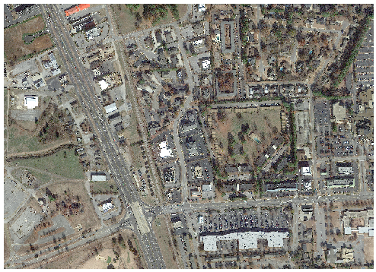

Figure 2: Zoomed in section of RGB imagery of test area for visual comparison of classified images.
Description of Figure 2 for non-visual students or students with different color visions
Figure 2 is a RGB image of Huntsville, Alabama that captures various features using the three-color channels: Red, Green, and Blue. Each channel represents spectral reflectance in these three channels, and when combined, they create a natural color composite image. Vegetation, including trees, grass, and shrubs, appear as different textures and patterns of green across the landscape. Roofs and buildings are depicted using a combination of colors, including shades of gray, brown, or other earthy tones, depending on the construction materials. Bodies of water, such as lakes, or ponds, are represented by shades of blue. The intensity of blue may vary based on the depth and nature of the water. Built up areas are visible clusters of structures with distinct shapes. Roads and paved surfaces appear as gray or lighter tones, providing a network of pathways throughout the image. Landmarks are represented by various colors and shapes within the image.
After carrying out the detailed analysis of RGB image, students will answer the following questions:
- What are the different land cover features visible in this true color RGB image?
- How do the colors in the image correspond to different objects or materials on the ground?
- Are there any distinct patterns or structures that can be observed in the image?
- Can we identify specific land cover classes such as vegetation, water bodies, or built-up areas based on their visual appearance?
- Are there any anomalies or abnormalities in the form of discoloration or irregular patterns in the image that require further investigation?

Part II
Objective: Understand the Feature Extraction tool in ENVI and classification of a pre-classified image into distinct classes by exploring their ecological relationships and patterns
Skills developed: Interpretation of images based on intensities and contrasts.

In this specific example, the process begins with feature extraction, aiming to extract relevant information or features from the image that can differentiate between different classes or groups of objects. Once the objects are segmented, they are classified (similar objects put into groups). Feature extraction tool in ENVI is used to classify imagery, where an object (also called segment) is a group of pixels with similar spectral, spatial, and/or texture attributes.

The workflow involves the following steps:
- Divide an image into segments
- Compute various attributes for the segments
- Create several new classes
- Interactively assign segments (called training samples) to each class
- Classify the entire image with a K Nearest Neighbor (KNN) supervised classification method, based on the training samples.
- Export the classes to a shapefile or classification image.

The first part of the process will be segmentation in which pixels in an image will be grouped into segments, objects, or features, that have similar spectral and spatial characteristics. In this example, a subset of approximately 12.95 square kilometers of the city will be used to run different classification tests with different parameters. The subset area was chosen because it contained a wide variety of land cover classes including different types of tree cover, residential areas, industrial or business areas, large parks and open spaces of grass, major roadways, and a large pond.

In this specific example, four total object-based classifications with different attributes and algorithm options were run in ENVI.

Set the parameters as follows:
- Object Based Classification Test 1 (Figure 3)
  - Object Creation Panel
    - Segment: Intensity (1)
      - Select Segment bands: Band 2 and 3
    - Merge algorithm: Full Lambda Schedule (97)
    - Example Selection (number of segments being selected)
      - Tree Canopy (305)
      - Road (70)
      - Grass (27)
      - Roof (51)
      - Water (28)
    - Attribute Selection (All attributes being selected)
    - Algorithm Selection
      - K Nearest Neighbor (KNN) with threshold of 15 and Neighbors at 3
      - Unclassified areas allow

- Object Based Classification Test 2 (Figure 3)
  - Object Creation Panel
    - Segment: Intensity (1)
      - Select Segment bands: Band 2 and 3
    - Merge algorithm: Full Lambda Schedule (97)
    - Example Selection (number of segments being selected)
      - Tree Canopy (305)
      - Road (70)
      - Grass (27)
      - Roof (51)
      - Water (28)
    - Attribute Selection (all except spectral attributes)
    - Algorithm Selection
      - K Nearest Neighbor (KNN) with threshold of 20 and Neighbors at 9
      - Unclassified areas allow

- Object Based Classification Test 3 (Figure 3)
  - Object Creation Panel
    - Segment: Intensity (1)
      - Select Segment bands: Band 2 and 3
    - Merge algorithm: Full Lambda Schedule (97)
    - Example Selection (number of segments being selected)
      - Tree Canopy (305)
      - Road (70)
      - Grass (27)
      - Roof (51)
      - Water (28)
    - Attribute Selection (all except spectral attributes)
    - Algorithm Selection
      - K Nearest Neighbor (KNN) with threshold of 15 and Neighbors at 3
      - Unclassified areas not allow
- Object Based Classification Test 4 (Figure 3)
  - Object Creation Panel
    - Segment: Edge (64)
      - Select Segment bands: Band 1, 2, and 3
    - Merge algorithm: Full Lambda Schedule (55)
    - Example Selection (number of segments being selected)
      - Tree Canopy (790)
    - Attribute Selection (all attributes)
    - Algorithm Selection
      - Texture Kernel (19)
      - Unclassified areas allow

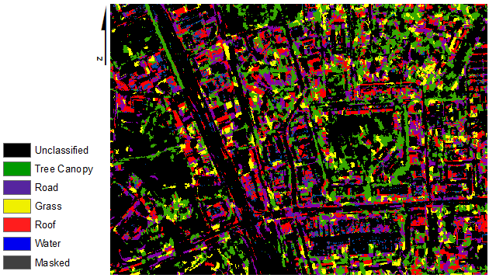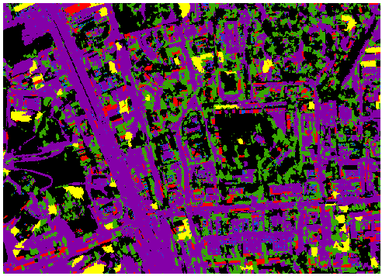
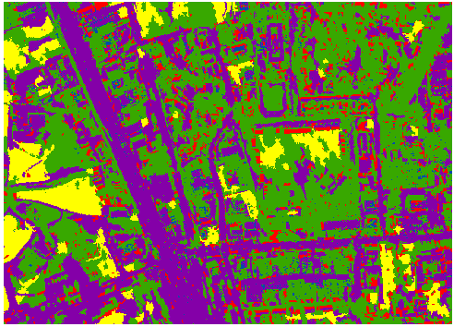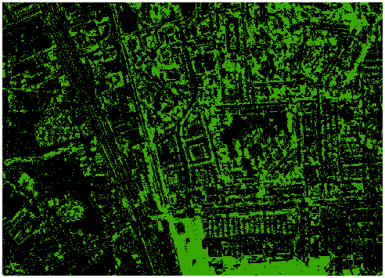

Figure 3: Object based classification or example-based feature extraction in ENVI. From top left bottom right is Test 1, Test 2, Test 3, and Test 4 respectively.
Description of Figure 3 for non-visual students or students with different color visions
In Figure 3, Test 1, the image undergoes segmentation based on intensity, specifically considering bands 2 and 3. The segmentation process is guided by the Full Lambda Schedule merge algorithm with a parameter value of 97. Following segmentation, examples or representative segments are chosen for different classes, including Tree Canopy (305 segments), Road (70 segments), Grass (27 segments), Roof (51 segments), and Water (28 segments). All available attributes, including spectral attributes, are selected for classification. The K Nearest Neighbor (KNN) algorithm was employed with a threshold of 15 and 3 neighbors. Unclassified areas are permitted in the final classification output.
In the second test, a similar segmentation approach was applied based on intensity (bands 2 and 3) with the Full Lambda Schedule merge algorithm (97). The selection of examples for different classes remained the same as in Test 1. However, this time, spectral attributes were excluded from the attribute selection. The classification employed the K Nearest Neighbor (KNN) algorithm with a higher threshold of 20 and 9 neighbors. Unclassified areas were allowed in the output.
Test 3 shares similarities with the previous tests in terms of segmentation and merge algorithm. The examples for different classes and the attribute selection process mirror those of Test 1. However, in this case, unclassified areas were not allowed in the final classification output. The K Nearest Neighbor (KNN) algorithm with a threshold of 15 and 3 neighbors is again utilized.
In the fourth test, a different segmentation approach was taken using the Edge segment method with bands 1, 2, and 3. The Full Lambda Schedule merge algorithm was applied with a parameter value of 55. For this test, only the Tree Canopy class was considered, and 790 segments were selected as examples. All available attributes were chosen for the classification process, and the Texture Kernel algorithm with a parameter value of 19 was employed. Unclassified areas were allowed in the final output. Therefore, the picture in the test 4 shows only green (treen canopy) and black (unclassified) color.
After understanding and exploring the images related to object-based classification, students will answer the following questions:

- Why were different attributes and algorithm options used?
- Why were Bands 2 and 3 selected for segmenting in the object-based classification?
- Can you explain the significance of creating several new classes in the object-based classification process?
- How are the different parameter settings for each object-based classification test (Test 1, Test 2, Test 3, and Test 4) chosen?
- What is the role of the K Nearest Neighbor (KNN) supervised classification method in classifying the entire image?
- What is the purpose of using different merge algorithms (Full Lambda Schedule) in the object-based classifications?
- What does the threshold parameter indicate in the KNN algorithm, and how does it affect the classification results?
- Why are unclassified areas included or excluded in different object-based classification tests?

Part III
Objective: Identify and explore the group pixels or segments in an image into 6 distinct classes or clusters performed through unsupervised classification in ENVI based on their spectral characteristics to promote active learning and critical thinking.
Skills developed: Enhanced pattern recognition and understanding of the underlying structure and inherent similarities in image data

Unsupervised classification is a technique used in image analysis and pattern recognition to automatically classify or group pixels or segments in an image based on their inherent similarities or patterns, without the need for predefined training samples or prior knowledge. Unsupervised classification aims to discover the underlying structure or natural groupings in the data on its own.
In the ENVI software, only six categories will be allowed for the computer to automatically assign spectral signatures. In Figure 4, you can see that the unsupervised classification confused Road and Grass and classified many pixels as Water.

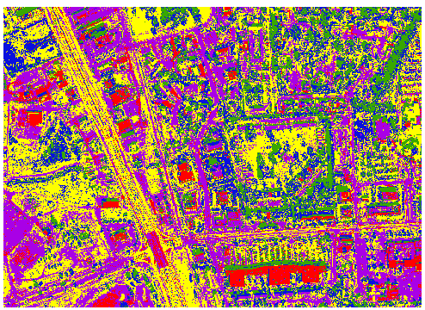
Figure 4: An unsupervised classification with 6 classes. Note the confusion between the Road and Grass and Grass and Water land cover classes.
For non-visual learners, the image can be described as a combination of intensities and contrasts. The red channel represents features with higher reflectance in the red part of the spectrum, such as built-up areas or rooftops. The green channel highlights vegetation, showcasing parks or wooded areas. Meanwhile, the blue channel emphasizes water bodies or paved surfaces. To cater to students with different color visions, consider incorporating patterns or symbols alongside color, aiding in the differentiation of land cover types. Describing the image in terms of its spatial arrangement and distinctive features, such as urban areas, vegetation, and water bodies, enables a comprehensive understanding beyond color perception.
Description of Figure 4 for non-visual students or students with different color visions
Figure 4 is an unsupervised classification of RGB image of Huntsville, Alabama with 6 classes (tree, road, grass, water, masked, water). The "tree canopy" class represents areas where vegetation, such as trees and other greenery, is present. This class is typically depicted in shades of green on the classification map. The "road" class corresponds to areas covered by roads or paved surfaces. This class is depicted in shades of purple that distinguishes it from other classes. The "grass" class represents open areas covered by grass or low vegetation and has shown in yellow color. The "water" class identifies bodies of water, such as lakes, or ponds and is depicted in shades of blue on the classification map. The "masked" class typically indicates areas that were masked or excluded from the classification process and has been shown in black color.
After carrying out the unsupervised classification, students will answer the following questions:
- What are the advantages of unsupervised classification compared to supervised classification methods?
- How can we evaluate the quality or accuracy of unsupervised classification results without ground truth data?
- Can unsupervised classification be used effectively for any type of image or data, or are there specific scenarios where it performs better?

Part IV
Objective: Understand the use of the i-Tree Canopy software to calculate the percentage of tree crown cover for the entire city of Huntsville to gain deep understanding of urban ecology.
Skills developed: Enhanced understanding of the urban ecology, acquire skills in conducting comparative analyses by comparing the percentage of tree canopy cover estimated by i-Tree Canopy for each unsupervised class, and gain expertise in understanding the benefits associated with tree cover.

The i-Tree Canopy is a software tool developed by the USDA Forest Service that allows users to access and analyze the distribution of tree canopy cover in a specified area. The software is part of the larger i-Tree suite, which provides tools and resources for assessing and managing urban and community forests. The i-Tree Canopy focuses specifically on quantifying the extent of tree canopy cover, offering valuable insights into the benefits and ecological contributions of urban trees. The i-Tree Canopy software utilizes specific formulas to calculate the standard error and confidence intervals for the interpreted points. (Walton and Binkley 2011). The boundaries of the study area can be specified within i-Tree Canopy, which can be done by either manually drawing a polygon or importing a shapefile delineating the area. For this example, the technical recommendations indicate that between 500 and 1000 randomly placed interpretation points should be used. Since Huntsville has an area of approximately >500 km² (“City of Huntsville,” 2015), 1000 points were used for the random sample interpretation, as 1000 points were used in Seattle, Washington (Richardson and Moskal 2014). Analysts or interpreters have visually inspected each of the 1000 points on the aerial imagery to determine the predominant land cover type at each point based on visual cues such as color, texture, and shape.

Table 1. Percent cover of four separate land cover classes for Huntsville, Alabama. Graph and Table include percent out of 100 and standard error (SE) based on aerial image interpretation of 1000 randomly selected points.

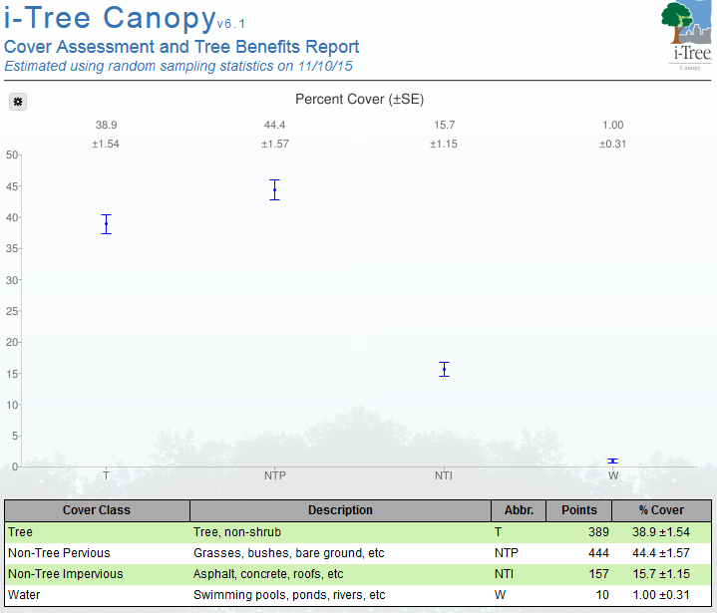
Cover Class | Description | Abbr. | Points | % Cover
Tree | Tree, non-shrub | T | 389 | 38.9±1.54
Non-Tree Pervious | Grasses, bushes, bare ground, etc. | NTP | 444 | 44.4±1.57
Non-Tree Impervious | Asphalt, concrete, roofs, etc. | NTI | 157 | 15.7±1.15
Water | Swimming pools, ponds, rivers etc. | W | 10 | 1.00±0.31

Table 2. Tree benefits calculated by i-Tree Canopy based on percent cover of 38.9% for Huntsville, Alabama.

Abbr. | Benefit Description | Value | ±SE | Amount | ±SE
CO | Carbon Monoxide removed annually | $51,645.90 | ±2,046.83 | 38.87T | ±1.54
NO2 | Nitrogen Dioxide removed annually | $26,093.28 | ±1,034.13 | 105.86T | ±4.20
O3 | Oxone removed annually | $2,317,799.43 | ±91,858.99 | 1,301.96T | ±51.60
PM2.5 | Particulate Matter less than 2.5 microns removed annually | $5,533,178.86 | ±219,290.85 | 81.38T | ±3.23
SO2 | Sulfur Dioxide removed annually | $8,177.94 | ±324.11 | 85.34T | ±3.38
PM10 | Particulate Matter greater than 2.5 microns and less than 10 microns removed annually | $3,142,527.39 | ±124,544.60 | 503.10T | ±19.94
CO2seq | Carbon dioxide sequestered annually in tress | $10,900,528.39 | ±432,009.56 | 301,268.16T | ±11,939.85
CO2stor | Carbon dioxide stored in trees (Note: This benefit is not an annual rate) | $244,417,221.04 | ±9,686,739.18 | 6,754,379.65T | ±267,689.46

The integration of results from unsupervised classification and i-Tree Canopy classifications allows for a comprehensive understanding of the urban landscape. Discrepancies or consistencies between classifications can highlight areas of interest, guiding further investigation. To have a comparison of results obtained from both classification tools, analyze the percentage of tree canopy cover estimated by i-Tree Canopy for each unsupervised class. Identify if certain classes exhibit higher or lower tree canopy cover percentages.

- How can the results obtained from i-Tree Canopy analysis help assess the accuracy of object-based classification by comparing the tree canopy percentage and its relevant classes?

NOTES TO FACULTY
Part I
This part explores the visual information present in the high-resolution RGB imagery of the test area. Faculty should make sure students have a strong understanding of the visual information captured by the sensor including the fine details in the image, objects for identification and classification, spatial context, and vegetation. To evaluate students at this level, look for skills such as keen observation, precise object recognition, spatial awareness, and a nuanced understanding of vegetation patterns in the context of remote sensing imagery.

Suggested answers to the questions posed in this part are below:

- What are the different land cover features visible in this true color RGB image?
The true color RGB image reveals various land cover features such as vegetation (trees, grass), built-up areas (urban infrastructure, buildings), and roads.
- How do the colors in the image correspond to different objects or materials on the ground?
In a true color RGB image, the colors are typically assigned to specific spectral bands (red, green, and blue) captured by the sensor. Green vegetation appears as bright green or shades of green, water bodies can appear as shades of blue, urban areas may appear as gray or lighter tones, and roads can be visible as dark gray or black.
- Are there any distinct patterns or structures that can be observed in the image?
Patterns and structures such as road networks, vegetation patches, water bodies, building footprints, or geometric shapes might indicate human-made structures or natural features like forests or fields.
- Can we identify specific land cover classes such as vegetation, water bodies, or built-up areas based on their visual appearance?
Yes, based on their visual appearance, students can attempt to identify specific land cover classes. For instance, vegetation may appear as green patches, water bodies as blue areas, and built-up areas as a combination of gray or lighter tones.
- Are there any anomalies or abnormalities in the image that require further investigation?
These could include areas of discoloration, irregular patterns, or the presence of objects or structures that deviate from the expected land cover types.

Part II
This part describes four different object-based classification tests that were conducted using ENVI software. Object-based classification is a technique used in remote sensing and image analysis to classify image pixels into meaningful objects or regions based on their spectral, spatial, and contextual characteristics.
Each test has different parameters and settings, including the segment type, bands used for segmentation, merge algorithm, example selection, attribute selection, and algorithm selection.

Suggested answers to the questions posed in this part are below:

- Why different attributes and algorithm options were used?
By running multiple object-based classifications with different attributes and algorithm options, you can compare and assess the impact of these variations on the classification results. This process allows for experimentation and optimization of the classification workflow to achieve the desired accuracy and classification performance.
- Why were Bands 2 and 3 selected for segmenting in the object-based classification?
Bands 2 and 3 were likely selected for segmenting in the object-based classification in ENVI due to their spectral properties and their ability to differentiate between land cover classes. These bands provide good spectral discrimination, particularly for vegetation-related features. By leveraging the sensitivity of these bands to chlorophyll content and vegetation health, they can effectively differentiate vegetation classes like tree canopy, grass, and crops from other land cover types. Additionally, the red-green contrast offered by Bands 2 and 3 aids in the separation of vegetation from non-vegetated surfaces.
- Can you explain the significance of creating several new classes in the object-based classification process?
Creating several new classes allows for the classification of objects or regions based on their distinct characteristics. By assigning segments to different classes, the classification algorithm can differentiate between different land cover types, features, or objects of interest in the image.
- How are the different parameter settings for each object-based classification test (Test 1, Test 2, Test 3, and Test 4) chosen?
The parameter settings for each object-based classification test are chosen based on the desired objectives, the characteristics of the image, and previous knowledge or experience. The parameters may be adjusted to optimize classification accuracy, improve discrimination between classes, or address specific challenges encountered in the image.
- What is the role of the K Nearest Neighbor (KNN) supervised classification method in classifying the entire image?
The K Nearest Neighbor (KNN) supervised classification method uses the training samples assigned to each class to classify the entire image. It compares the features of unclassified segments to the features of the training samples and assigns the unclassified segments to the class that has the closest resemblance in feature space.
- What is the purpose of using different merge algorithms (Full Lambda Schedule) in the object-based classifications?
Merge algorithms, such as Full Lambda Schedule, determine how segments are merged during the object creation process. The choice of merge algorithm affects the size, shape, and overall quality of the segments. Different merge algorithms may be used to obtain optimal segmentation results for different types of images or classes.
- What does the threshold parameter indicate in the KNN algorithm, and how does it affect the classification results?
The threshold parameter in the KNN algorithm specifies the maximum distance allowed between a segment and its nearest neighbor for classification. If a segment's nearest neighbor exceeds the threshold, it is left unclassified. Adjusting the threshold affects the sensitivity of the classification: a smaller threshold leads to a more stringent classification, while a larger threshold allows for more flexibility.
- Why are unclassified areas allowed or disallowed in different object-based classification tests?
Allowing unclassified areas means that segments that do not meet the classification criteria will remain unassigned to any specific class. Allowing unclassified areas provides flexibility but may result in less accurate classification results. Disallowing unclassified areas forces all segments to be assigned to a class, which can improve classification accuracy but may also introduce misclassifications.

Part III

This part deals with the unsupervised classification in ENVI to group pixels or segments in an image into distinct classes or clusters based on their spectral characteristics. This technique does not require predefined training samples and aims to uncover underlying patterns in the data.

Suggested answers to the questions posed in this part are below:

- What are the advantages of unsupervised classification compared to supervised classification methods?
Unsupervised classification has the advantage of not requiring prior knowledge or training samples, making it suitable for exploratory data analysis or scenarios where labeled training data is unavailable. It can reveal unknown patterns or structures within the data and can be used as a preprocessing step for supervised classification.
- How can we evaluate the quality or accuracy of unsupervised classification results without ground truth data?
Without ground truth data, evaluating the accuracy of unsupervised classification becomes more challenging. However, some approaches can be used, such as visual inspection to assess the coherence and consistency of the identified clusters or comparing the results with existing maps or knowledge to identify potential errors or inconsistencies.
- Can unsupervised classification be used effectively for any type of image or data, or are there specific scenarios where it performs better?
Unsupervised classification can be used with various types of image or data, such as multispectral or hyperspectral imagery. However, its effectiveness depends on the inherent patterns or structures present in the data. It may perform better in scenarios where clear clusters or classes exist, such as in land cover classification or identifying geological formations.

Part IV

Part IV involves understanding the use of the i-Tree Canopy software by exploring the already generated results and analysis that can help carry out the accuracy assessment of object-based classification.

Suggested answers to the questions posed in this part are below:

- How can the results obtained from i-Tree Canopy analysis help with object-based classification?
The results from i-Tree Canopy analysis can assist in object-based classification in the following ways:
Ground Truth Data: The results obtained from i-Tree Canopy analysis can serve as ground truth data for object-based classification. They provide information on the presence and extent of tree canopy cover, which can be used as reference or training data.
Class Definition: The i-Tree Canopy results help in defining specific classes related to tree canopy cover. They provide distinct information that can differentiate tree canopy areas from other land cover types during object-based classification.
Feature Extraction: The results provide valuable attributes related to tree canopy cover that can be extracted and used as input for object-based classification. These attributes contribute to the feature set used for classifying objects in the image.
Training Samples: The i-Tree Canopy results can be used to generate training samples for the object-based classification. Random points or areas corresponding to tree canopy cover can serve as training samples, improving the accuracy of tree-related object classification.
Accuracy Assessment: The i-Tree Canopy results act as a reference for validating the accuracy of object-based classification. By comparing the classified tree-related objects with the tree canopy cover identified by i-Tree Canopy, the classification accuracy can be assessed, and the results refined if needed.

ADDITIONAL RESOURCES
Amalisana, B. and R. Hernina, R. 2017. Land cover analysis by using pixel-based and object-based image classification method in Bogor. IOP Conference Series: Earth and Environmental Science 98:012005. https://doi.org/10.1088/1755-1315/98/1/012005

LITERATURE CITED
Anderson, J.R., E.E. Hardy, J.T. Roach, and R.E. Witmer. 1976. A Land Use and Land Cover Classification System for Use with Remote Sensor Data. Geological Survey Professional Paper964. US Geological Survey: Washington, DC, USA.
Blaschke, T. 2020. Object based image analysis for remote sensing. ISPRS J. Photo gramm. 65:2-16.
Center for Business and Economic Research. 2020. Alabama Economic Outlook. The University of Alabama. https://hsvchamber.org/wp-content/uploads/2020/01/2020-Economic-Outlook-Huntsville-Metro-Area.pdf
Cleve, C., M. Kelly, F. R. Kearns, and M. Moritz. 2008. Classification of the wildland–urban interface: A comparison of pixel- and object-based classifications using high-resolution aerial photography. Comput. Environ. Urban Syst. 32:317-326.
Platt, R.V. and L. Rapoza. 2008. An evaluation of an object-oriented paradigm for land use/land coverclassification. The Professional Geogr. 60:87-100
Richardson, J. and L. Moskal. 2014. Uncertainty in urban forest canopy assessment: Lessons from Seattle, WA, USA. Urban Forestry & Urban Greening 13:152-157.
Roy, S., J. Byrne, and C. Pickering. 2012. A systematic quantitative review of urban tree benefits, costs, and assessment methods across cities in different climatic zones. Urban Forestry & Urban Greening 11:351-363.
Zhou, W. and A. Troy. 2008. An object-oriented approach for analysing and characterizing urban landscape at the parcel level. Int. J. Remote Sens. 29:3119-3135.

