Marine Fisheries and Conflicts of Interest
The primary learning objectives of this module are for students to be able to:
- Examine how forecasts fit within broader socioeconomic systems, and the associated ethical responsibilities that arise for forecasters.
- Anticipate the direct and indirect effects of forecast development on diverse forecast users including industries, government offices, small and medium-size businesses, Indigenous communities, or other scientists.
- Develop and analyze best practices for the ethical development of marine forecasts.

Assigned reading
Before class, please read through Table 1 from Hobday et al. (2019), as well as the following Case Study.

Reading all of Hobday et al. (2019) is optional, but would provide additional context for this module (link here).

Case Study
Throughout human history, fishing has been a vital pillar of coastal communities. However, overfishing can also have substantial consequences for marine ecosystems. Today, over one third of shark and ray species are threatened by overfishing, and three species are possibly extinct (have not been observed in over 80 years) as a result of overfishing (Dulvy et al. 2021). Overfishing not only risks the livelihoods of fishing communities but also has strong ecosystem-level impacts, as effects of fishing on large, predatory species such as tuna, cod, and pike, can affect smaller fish populations and other non-target species (Casey et al. 2017, Eriksson et al. 2009, Heithaus et al. 2008).
Forecasts of economically important species have become increasingly available due to better monitoring technology, open worldwide databases, and more accurate marine temperature and circulation data (Hobday et al. 2016, Payne et al. 2017). Yet, ethical issues arise because many end users are involved in each fishery; at any one location, government regulators, industrial fishing operations, academic and NGO organizations, and small-scale fishing communities and/or Indigenous communities may all have important connections to the fishing economy. Each of these groups may have different incentives and objectives, and their perspectives are not always considered by the forecast providers (Hobday et al. 2019). To examine these issues, a review by Hobday et al. (2019) provides insight into the different ethical considerations that must be made regarding marine forecasts for economically important species such as salmon, tuna, lobster and sturgeon among others.

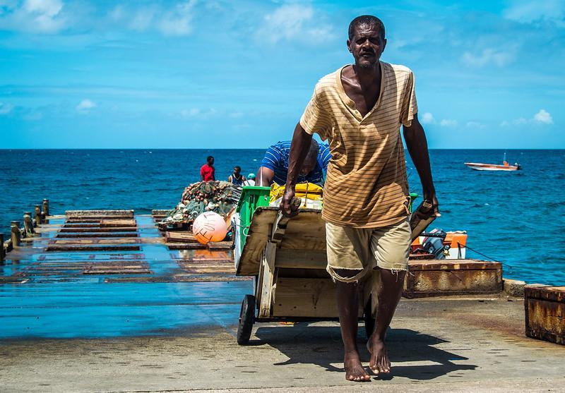
Figure 2: Small-scale fishermen bring in their harvest at the Old Road Fisheries in Saint Kitts and Nevis. Photo by St Kitts & Nevis Government on flickr, licensed under CC BY 2.0.

Think, Pair, Share: Context-dependent forecasting
Coordinate with a partner sitting near you and pick different forecasting examples from Table 1 in Hobday et al. (2019), then respond to the following questions.

On your own, write down brief answers to the following questions:
- What potential conflicts of interest could you see arising in this example?
- At what point in forecast development could these issues arise?
- How would you try to remediate these conflicts after an issue arises? What could you do earlier in the forecast development process to preempt these issues?

Discuss with your partner:
- Share a brief summary of your forecasting example and what potential conflicts you identified
- What similarities did you find between your examples?
  - If there were similarities, did you come up with similar solutions?

Come back together as a class to discuss
- Share brief summaries from each forecasting example
  - How did the end users and funding agencies differ between forecasting examples?
  - What conflicts and solutions did groups identify?
  - How and why did solutions differ between examples?

Think, Pair, Share: Avoiding ethical issues in forecasts
At the end of their manuscript, Hobday et al. (2019) highlight ten principles for creating ethical forecasts, particularly for marine ecosystems. These principles were developed based upon the case studies from Table 1 that you have reviewed and discussed. One of these principles is directly intended to address conflicts of interest, and others may also be relevant to managing conflicts of interest later in the forecast development process.

Working individually
First, read the text below from Hobday et al. (2019; reprinted with permission from the publisher), then respond to the questions following the text:

Principles for ethical forecasting

As a result of reviewing these case studies and our experiences, we suggest a set of principles that should be considered when scoping, developing, delivering, and evaluating ecological forecasts for marine resource users.

Phase 1. Scoping the forecast system
1. Conflicts of interest:
- Principle 1: Be open and transparent. Work with diverse stakeholders to understand their needs and concerns. Address these concerns if possible, striving for “win–wins.” Tread carefully around zero-sum situations, where a forecast advantage for one group may be a disadvantage for another.
2. Ecosystem health:
- Principle 2: Do not deliver forecasts that would lead to unregulated impacts on the ocean (e.g. for fisheries without clear catch limits and/or enforcement).

Phase 2. Developing the forecast system
3. Skill assessment:
- Principle 3: Undertake best practice skill assessment that tests the true skill of a model with out-of-sample testing. In forecasting science, this involves comparing a forecasted and a hindcasted fields once the climatology has been removed, using rigorous statistics.
4. Representation of uncertainty:
- Principle 4: Do not ignore uncertainty. Traditionally, uncertainty is computed through an ensemble or with permutations on the initial state and provided as a percent agreement between the trajectories of the simulations. While this mostly addresses the uncertainty in the forcing into the future, the uncertainty due to model construction is not easy to incorporate objectively, and needs additional work. Provide a discussion and metrics of uncertainty that include a perspective based on model performance, and the interpretation of probabilistic forecasts.

Phase 3. Forecast delivery
5. Ongoing delivery:
- Principle 5: Plan for and manage stakeholder expectations regarding continued delivery. Planning for and enabling a mechanism for ongoing delivery after a project ends (if possible) and engaging stakeholder representatives early can be important for ensuring a smooth transition. Ultimately, a transition to operational forecasts as delivered by national weather services should be considered.
6. Engagement and education:
- Principle 6: Work to improve the literacy of all stakeholders around forecast use and interpretation, particularly on skill and uncertainty.
7. Delivery failures:
- Principle 7: Proactively explore the impact of loss of a predictor variable in a forecast system, and be able to explain what the loss of performance is when one variable is removed. Prepare stakeholders for potential breaks in delivery, and never compromise with delivery of substandard forecast products.
8. Equity for end users:
- Principle 8: Be vigilant for inequity in use of forecasts between users, and the creation of winners and losers arising from provision of information. Decide when open access is warranted, and when it is not. Include stakeholders in the formulation stage to understand these risks. If risks remain, work at a scale where benefits are clear.
9. Unintended consequences:
- Principle 9: Scope the system context widely, seek deep domain and system knowledge, and consider scenario testing, as happens for fishery management regulations now (e.g. management strategy evaluation). Seek feedback and learn from mistakes.

Phase 4. Evaluation
10. Review of performance:
- Principle 10: Consider the holistic outcome of forecast system—if it is not achieving the overall goals, suspend delivery and work on improving the interaction of the forecast and the context in which it operates.

Questions for individual reflection:
- In the first activity (above) we asked you to write down initial thoughts on what conflicts of interest may arise for your chosen case study and how you would address these issues at multiple points in the forecast development process. After reading through the principles for ethical forecasting from Hobday et al. (2019; above), compare and contrast the ideas you developed with those presented in this list of principles.
- Is there anything you feel is missing from the list?

Discuss in small groups
- Is there anything you do not understand in the list of best practices? Try to help each other come to a better understanding of these principles.
- Which practices do you think are especially helpful, or points that you wouldn’t have thought of? Are there any that you disagree with?
- More broadly, what do you think is the value of “best practices” for ethical issues? If you were running a forecasting program, how would you make sure the people working on your team are considering these best practices in their work?

Discuss as a class
- Have each small group report back about what they discussed. Are there any points of clarification that need to be resolved as a whole class?
- Discuss as a class: what is the value of “best practices” for ethical issues?
- How could these principles be adapted for scientific engagement with the public more broadly (i.e., outside of a forecasting context)? For example, are any of these principles relevant for scientists that may be asked to provide expertise to inform environmental policy?

References
Casey, J. M., A. H. Baird, S. J. Brandl, M. O. Hoogenboom, J. R. Rizzari, A. J. Frisch, C. E. Mirbach and S. R. Connolly. 2017. A test of trophic cascade theory: fish and benthic assemblages across a predator density gradient on coral reefs. Oecologia 183:161–175. https://doi.org/10.1007/s00442-016-3753-8
Dulvy, N. K., N. Pacoureau, C. L. Rigby, R. A. Pollom, R. W. Jabado, D. A. Ebert, B. Finucci, C. M. Pollock, J. Cheok, D. H. Derrick, K. B. Herman, C. S. Sherman, W. J. VanderWright, J. M. Lawson, R. H. L. Walls, J. K. Carlson, P. Charvet, K. K. Bineesh, D. Fernando, G. M. Ralph, J. H. Matsushiba, C. Hilton-Taylor, S. V. Fordham, and C. A. Simpfendorfer. 2021. Overfishing drives over one-third of all sharks and rays toward a global extinction crisis. Current Biology 31:4773-4787.e8. https://doi.org/10.1016/j.cub.2021.08.062
Eriksson, B. K., L. Ljunggren, A. Sandström, G. Johansson, J. Mattila, A. Rubach, S. Råberg, and M. Snickars. 2009. Declines in predatory fish promote bloom-forming macroalgae. Ecological Applications 19:1975–1988. https://doi.org/10.1890/08-0964.1
Heithaus, M. R., A. Frid, A. J. Wirsing, and B. Worm. 2008. Predicting ecological consequences of marine top predator declines. Trends in Ecology & Evolution, 23:202–210. https://doi.org/10.1016/j.tree.2008.01.003
Hobday, A. J., C. M. Spillman, J. Paige Eveson, and J. R. Hartog. 2016. Seasonal forecasting for decision support in marine fisheries and aquaculture. Fisheries Oceanography 25:45–56. https://doi.org/10.1111/fog.12083
Hobday, A. J., J. R. Hartog, J. P. Manderson, K. E. Mills, M. J. Oliver, A. J. Pershing, and S. Siedlecki. 2019. Ethical considerations and unanticipated consequences associated with ecological forecasting for marine resources. ICES Journal of Marine Science 76:1244–1256. https://doi.org/10.1093/icesjms/fsy210
Payne, M. R., A. J. Hobday, B. R. MacKenzie, D. Tommasi, D. P. Dempsey, S. M. M. Fässler, A. C. Haynie, R. Ji, G. Liu, P. D. Lynch, D. Matei, A. K. Miesner, K. E. Mills, K. O. Strand and E. Villarino. 2017. Lessons from the first generation of marine ecological forecast products. Frontiers in Marine Science 4:289. https://doi.org/10.3389/fmars.2017.00289

