ISSUES : DATA SET
Parasites – They’re what’s for dinner: Investigating the role of parasites in aquatic food webs

Sarah A. Orlofske
University of Wisconsin – Stevens Point; Sarah.Orlofske@uwsp.edu

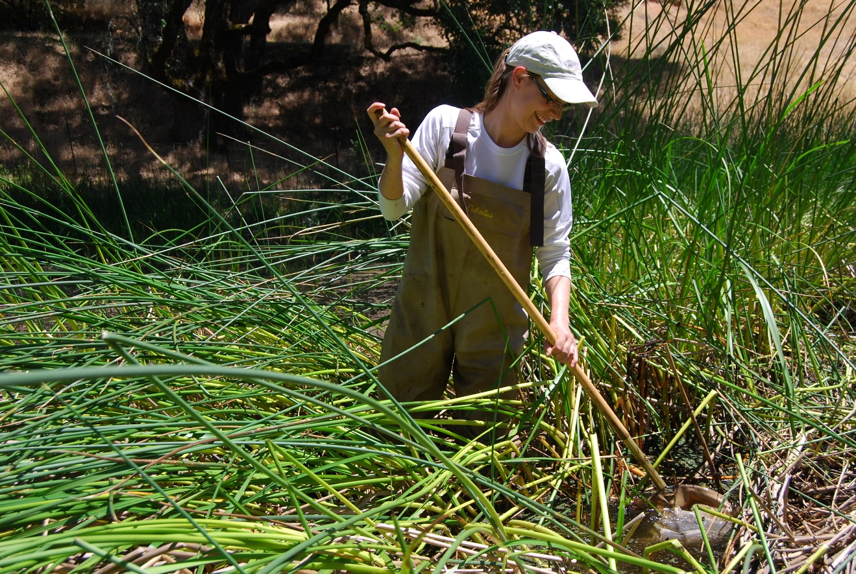

Field sampling for amphibians and aquatic invertebrates. (Photo courtesy of Clara Boland)

THE ECOLOGICAL QUESTION:
How does the presence of parasites influence characteristics of freshwater food webs?

ECOLOGICAL CONTENT:
Food web ecology, wetland communities, parasitism, disease ecology, complex life cycles, network modeling
WHAT STUDENTS DO:
Students will:
- evaluate the methodology for collecting and analyzing food web data
- investigate metadata provided with a well-resolved food web database including parasites
- explore parasite life cycles and interactions with other species in a food web context
- formulate research questions and propose hypotheses about how including parasites could influence properties of the entire food web as well as individual taxa.
- manipulate the food web data set to extract the relevant data, calculate food web metrics, and create figures that illustrate the results
- discuss their findings and relate it back to key ecological concepts.

STUDENT-ACTIVE APPROACHES:
Guided inquiry, open-ended inquiry, predict-observe-explain, small group discussion, computer-based projects, calculation
SKILLS:
- Hypothesis formation: Generate questions and propose hypotheses about how the inclusion of infectious agents may affect properties of aquatic food webs and individual taxa in those communities.
- Data management: Evaluate metadata connecting raw data and mathematical representations of feeding relationships to relevant ecological information.
- Data analysis: Organize and summarize spreadsheet data in MSExcel and calculate standard food web metrics using MSExcel or R
- Data visualization: Create and annotate figures of the data.
- Data interpretation: Interpret results and connect to ecological principles of food webs.

ASSESSABLE OUTCOMES:
Food web diagram and interpretation of hypotheses, tables and figures from spreadsheet data, written answers to questions

SOURCE:
Preston, D.L., Orlofske, S.A., McLaughlin, J.P, Johnson, P.T.J. 2012. Food web including infectious agents for a California freshwater pond. Ecology 93:1760. Ecological Archives E093-153.
ACKNOWLEDGEMENTS:
This data set was developed through the DIG into Data Faculty Mentoring Network through QUBES (Quantitative Undergraduate Biology Education and Synthesis) and I would like to thank all the members of that group for insightful discussions, useful resources, and helpful feedback. I would also like to thank Daniel L. Preston for support of this data set and access to file formats that assisted in adapting the dataset for classroom use. I would like to thank Robert C. Jadin for helpful feedback during each stage of the process.
OVERVIEW OF THE ECOLOGICAL BACKGROUND

Food webs show the interactions among resources and consumers, known as trophic relationships, by representing the links connecting species (Goldwasser and Roughgarden 1993). Ecologists and parasitologists have considered the diverse trophic interactions of parasites in food webs only recently (Sukhdeo and Hernandez 2005, Lafferty et al. 2008, Sukhdeo 2010). This is often attributed to their small size and being hidden from direct observation while within hosts, as well as challenging species level identification (Lafferty et al. 2008, Sukhdeo 2010).

To aid the understanding of how parasites influence food webs across different ecosystems, Preston et al. (2012) conducted a multi-year study of Quick Pond, a freshwater wetland in northern California. Researchers used a combination of approaches for free-living and parasite taxa resulting in a comprehensive food web for all areas of the pond as well as terrestrial organisms that interact with the aquatic community (Preston et al. 2012). In this activity, students use the food web database to explore how parasites influence properties of the entire food web as well as individual taxa. This data set includes two primary data sets, one that includes the taxa and life stages of the members of the Quick Pond community (Quick Pond Nodes) and one that includes the information on the trophic interactions (Quick Pond Links). Several other spreadsheets provide extensive metadata important to understanding how the food web was created as well as the background of the taxa included. This allows students to engage in the process of data management and organization in addition to the ecological content. The data presented here are published in Ecological Archives and have also resulted in two related publications that can provide an even more in depth understanding of the ecological concepts and authors’ interpretation of the data (Preston et al. 2013, Preston et al. 2014).

REFERENCES
Goldwasser, L. and J. Roughgarden. 1993. Construction and analysis of a large Caribbean food web. Ecology 74:1216-1233.
Lafferty, K.D., S. Allesina, M. Arim, C.J. Briggs, G. De Leo, A.P. Dobson, J.A. Dunne,
P.T.J. Johnson, A.M. Kuris, D.J. Marcogliese, N.D. Martinez, J. Memmott, P.A. Marquet, J.P. McLaughlin, E.A. Mordecai, M. Pascual, R. Poulin, and D.W. Thieltges. 2008. Parasites in food webs: the ultimate missing links. Ecology Letters 11:533-546.
Preston, D.L., S.A. Orlofske, J.P. McLaughlin, and P.T.J. Johnson. 2012. Food web
including infectious agents for a California freshwater pond. Ecology 93:1760. Ecological Archives E093-153.
Preston, D.L, S.A. Orlofske, J.P. Lambden, and P.T.J. Johnson. 2013. Biomass and productivity of parasites in pond ecosystems. Journal of Animal Ecology 82:509–517.
Preston, D.L., A.Z. Jacobs, S.A. Orlofske, and P.T.J. Johnson. 2014. Complex life cycles in a pond food web: effects of life stage structure and parasites on network properties, trophic positions and the fit of a probabilistic niche model. Oecologia 174:953-965.
Sukhdeo, M.V.K. and A.D. Hernandez. 2005. Food web patterns and the parasite’s perspective. In Parasitism and Ecosystems. Oxford University Press, Oxford, pp. 54-67.
Sukhdeo, M.V.K. 2010. Food webs for parasitologists: a review. Journal of Parasitology 96:273-284.

DATA SETS

Quick_Pond_Nodes – dataset that provides background information on all of the taxa and/or life stages included in the food web. Note: blank cells indicate that information was not collected or is not applicable.

Quick_Pond_Links – dataset that provides the information on trophic interactions using a two column format where consumers and resources are indicated as well as the type of evidence for that interaction and the source (if any).

Supporting files
Quick_Table_2A & Quick_Table_2B – Provides the metadata for the Quick_Pond_Nodes data set including the definitions and descriptions of each of the column headers (2A) and variables (2B)

Quick_Table_3A, Quick_Table_3B, & Quick_Table_3C – Provides the metadata for the Quick_Pond_Links data set including the definitions and descriptions of each of the column headers (3A) and variables (3B) and link types (3C).

Quick_Table_4 – Provides the metadata for the missing, under-represented groups and severely aggregated nodes for food web dataset.

Instructions for how to obtain the data set and associated files directly.
http://onlinelibrary.wiley.com/doi/10.1890/11-2194.1/abstract

This is the link to the article, which is an abstract that describes the data set.
By clicking on the hyperlink to Ecological Archives it will take you to fig share where all the files are stored.

To get the text of the “Data Paper” you need to search the Ecological Archives Website

http://esapubs.org/archive/search.php
Enter in the search window:
Journal: Ecology
Year: 2012
First Author (last name only): Preston
Search for Data Papers? Yes
Click Search
Click the Link

Gives the actual article on the website. The first page provides very basic info about the content of the article. Clicking the link for “Metadata” at the top gives detailed information about the study background, methodology, site location and data set components.

STUDENT INSTRUCTIONS
Overview: Food webs show interactions among resources and consumers by representing the links connecting species (Goldwasser and Roughgarden 1993). Ecologists and parasitologists have considered the diverse trophic interactions of parasites in food webs only recently (Sukhdeo and Hernandez 2005, Lafferty et al. 2008, Sukhdeo 2010). To explore how parasites influence food webs across different ecosystems, Preston et al. (2012) conducted a multi-year study of Quick Pond, a freshwater wetland in northern California. In this activity, you will use the food web database from this paper to explore how parasites influence properties of the entire food web as well as individual taxa. In order to implement the data set, it is important to understand the basics of food web construction. Food webs are created using three general steps: 1) defining the geographic location and extent of the biological community, 2) identifying and classifying the trophic units (taxa), and 3) detecting and incorporating the trophic links (interactions) (Cohen et al. 1993). The instructions and associated activities presented here will be used to guide you through these general steps.
Part 1: Constructing the food web
To begin a food web study researchers establish physical or conceptual boundaries of the biological community composing the food web (Cohen et al. 1993, Lafferty et al. 2006, Fath et al. 2007). Here you will use Google Earth to learn about the geographic and physical aspects of the habitat encompassed by this food web data set.

Identifying the biological community: Study site
Preston et al. 2012 describes a food web for Quick Pond, a freshwater ecosystem in California.
Locate the site on Google Earth. In order to use all the features use an installed version of the Google Earth Pro program (https://www.google.com/earth/desktop/) rather than a web version. Enter the latitude and longitude given in the dataset values into the search feature in the upper left corner: 37.66, -121.93

Activity 1: As the view zooms in locate the wetland just north of the road. Inspect the wetland and the surrounding habitat from the aerial view.
Using the most recent Google Earth imagery, write down some general observations about the aquatic habitat that is the focus of the food web as well as the terrestrial habitat and the surrounding land use.

In the bottom left corner of the Google Earth image window you can see the date. The most recent imagery date is given. Next to that is a button that will allow you to view historical imagery for the site. For this site, imagery is available back to 1993. You can scroll through the images to see how the ecosystem changes over time.

Activity 2: Using historical data, particularly the images from 2009-2011 when the data collection took place, write down some general observations about how the site changes over seasons and years. How do you think these observations help you understand the Quick Pond food web?

Nodes: Species and taxonomic resolution
Once the community is defined, researchers use a variety of field survey methods, including transects, visual encounter surveys, and other ecological sampling techniques, to identify the taxa or “nodes” that are interacting within that community (Polis 1991, Goldwasser and Roughgarden 1993, Kwak and Zedker 1997, Jaarsma et al. 1998, Lafferty et al. 2006, Coll et al. 2011, Figure 1). An important decision before beginning taxonomic surveys is the desired level of taxonomic resolution (level of identification of taxa, e.g. family, genus, or species) and aggregation (lumping of taxa into groups rather than species, e.g. phytoplankton or meiofauna). Some organisms are more easily inventoried and identified. If there are some groups (i.e., vertebrates), which are identified to species, while others (i.e., algae, bacteria) are only identified to order or family, it may impact certain properties of the final food web (Hall and Raffaelli 1991, Goldwasser and Roughgarden 1993,1997, Sugihara et al. 1997, Thompson and Townsend 2000).
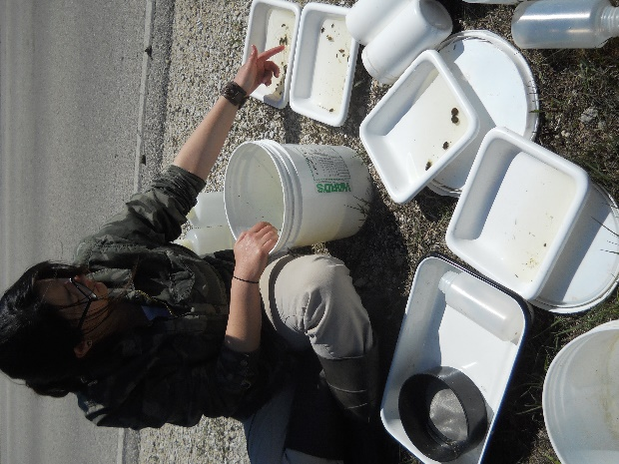
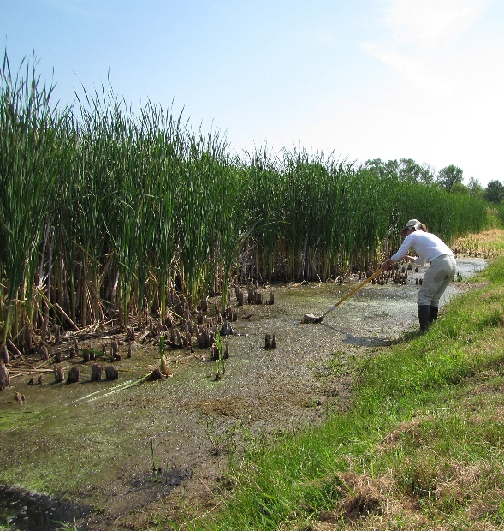
Figure 1. Examples of processes used in collecting aquatic food web data. A) Dipnet sampling along wetland edge (photo by Carole Orlofske), B) Sorting and preserving organisms according to taxonomic group (photo by Sarah Orlofske).
A
B
The complete Quick Pond food web contains 63 species, represented by 113 nodes. Some of the familiar species in this food web are snails, dragonflies, frogs, newts, snakes, and herons (Preston et al. 2012, Figure 2 A&B). The number of species and nodes differ from one another because some species are further divided into life stages (i.e. tadpole vs. adult frog, larval vs. adult dragonflies, Figure 2C&D) because the life stages each consume different resources.
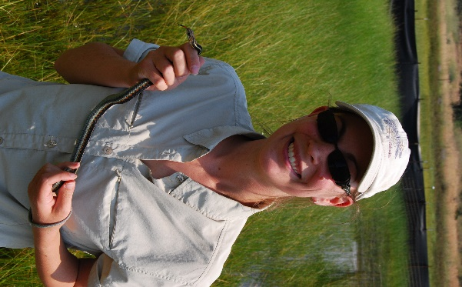
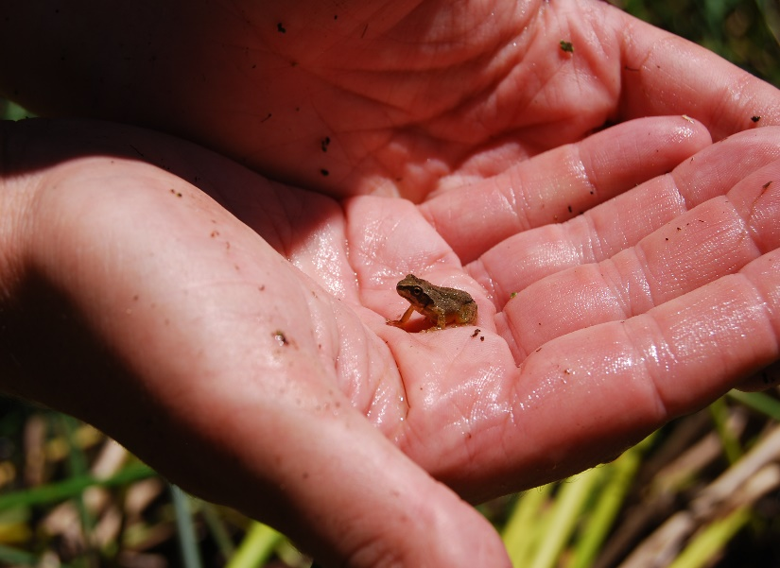
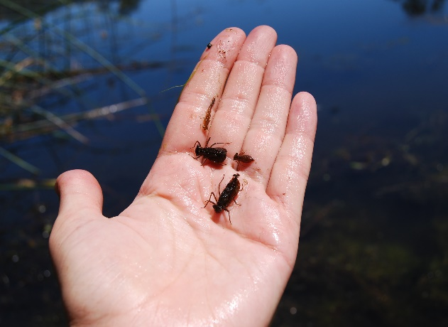
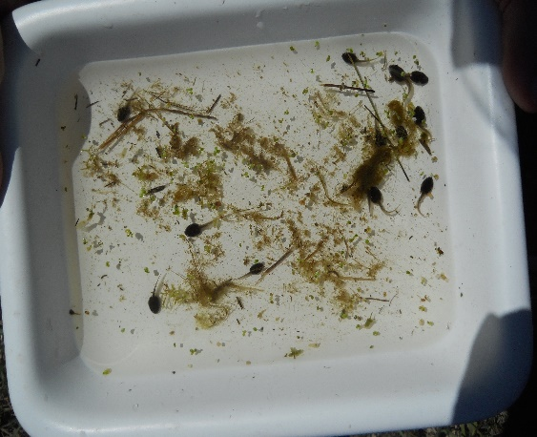
Less familiar species included are the trematode (flatworm) parasites Echinostoma trivolvis and Ribeiroia ondatrae (Preston et al. 2012, Figure 3). Although definitions of parasitism abound, from an ecological standpoint, the term has been defined as an organism that consumes the tissues or body fluids of the organism on which it lives (Cain et al. 2014, Loker and Hofkin 2015). Importantly, parasitism represents elements of both a symbiotic (long term, close physical interaction) as well as a trophic strategy (Lafferty and Kuris 2002). Furthermore, parasitism is a common trophic strategy across many taxonomic groups from arthropods to amoebas (Lafferty and Kuris 2002, Loker and Hofkin 2015). Because of fundamental differences in some aspects of the host-parasite interactions, it is helpful to consider parasites in different groups. According to Lafferty and Kuris (2002), there are 5 groups of infectious agents: macroparasites, pathogens, parasitoids, parasitic castrators, and trophically transmitted parasites. For this food web we can consider 1) pathogens including microparasites such as viruses, bacteria, fungi and protozoa and 2) macroparasites comprised of flatworms (trematodes), tapeworms (cestodes), and roundworms (nematodes) (Lafferty and Kuris 2002). For example, one pathogen is the amphibian chytrid fungus Batrachochytrium dendrobatidis, while
Figure 2. Examples of the taxa included in the Quick Pond food web and some representative life stages. A. Garter snake (Thamnophis sp.) (photo by Daniel Preston) B. Adult stage Pacific Chorus frog (Pseudacris regilla) (photo by Clara Boland), C. Larval dragonflies (multiple species) (photo by Sarah Orlofske), D. Larval amphibians (photo by Sarah Orlofske).
A
B
C
D

the trematodes Ribeiroia ondatrae and Echinostoma trivolvis are two macroparasites in their adult stage and trophically transmitted parasites in their metacercariae (larval stage) in amphibians (Lafferty and Kuris 2002, Johnson and McKenzie 2009, Koprivnikar et al. 2012). One of the best groups of parasite to reveal the role of parasites in food webs are trematodes because they depend upon multiple host species and trophic interactions to complete their complex life cycles (Koprivnikar et al. 2012).
A close examination of a basic trematode life cycle demonstrates numerous opportunities for parasites to interact with multiple species within food webs (Lafferty et al. 2008). An example trematode life cycle begins with the infection of a snail first intermediate host. Therefore, the first trophic interaction that takes place is the parasite consuming the tissues of the snail host. The parasite then reproduces asexually resulting in the release of large numbers of free-living infective stages called cercariae (Johnson and McKenzie 2009, Szuroczki and Richardson 2009, Koprivnikar et al. 2012, Figure 4). These free-living infective stages are non-feeding need to infect a second intermediate host such as another snail, insect, fish, or amphibian within a few hours. Within the second intermediate host, the parasites encyst forming a metacercaria within the tissues of the host, which is the next trophic interaction. Finally, the parasite exhibits trophic transmission where the infected second intermediate host is eaten by the appropriate, typically vertebrate, definitive host (where the parasite becomes an adult and sexual reproduction occurs) (Lafferty et al. 2008). From this example, we can see how trematodes interact with multiple hosts that represent different resources across a range of different trophic levels (herbivores to carnivores) Lafferty et al. 2008).
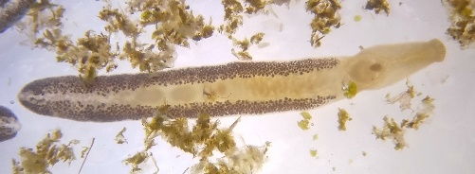
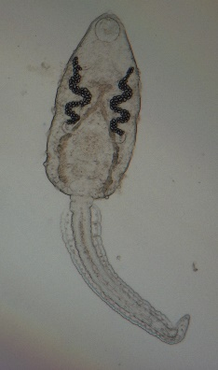
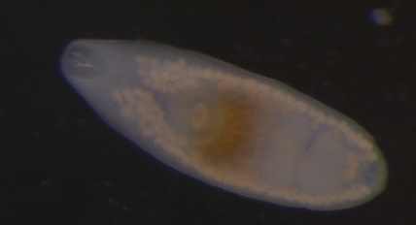
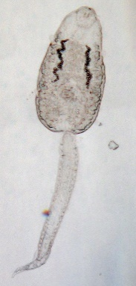
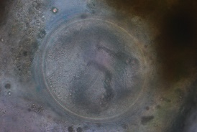
Figure 3. Examples of parasites and life stages in the Quick Pond Food Web. A. Ribeiroia ondatrae cercariae, B. Ribeiroia ondatrae adult, C. Echinostome cercariae, D. Echinostome metacercariae, E. Echinostome adult (Note: echinostomes shown here were not identified to species). (photos by Sarah Orlofske)
A
B
C
D
E

Figure 4. An example trematode life cycle of Echinostoma sp. Eggs are released from adult worms living in organs of typically a vertebrate within the definitive host (also called the final host; the host where sexual reproduction occurs. Eggs hatch into free-living infective stages that infect snails and reproduce asexually. Free-living infective stages are released and penetrate the second intermediate host, which can be another snail or amphibian. Within this host the parasite encysts and awaits trophic transmission to the definitive host when the second intermediate host is consumed. Diagram by S.A. Orlofske, parasite drawings modified from Schell 1985.

Activity 3: Open the excel spreadsheet file: Quick Pond Nodes. At the top of the page in row 1 locate the column titled “WorkingName”. This column includes the names of the taxa included in the food web database. Your instructor will give you instructions for how many and any specific taxa to examine. For your particular taxa write down some notes focused on their trophic interactions. In other words, what do they eat and what eats them? How big are they? What kind of life cycle do they have? Animal diversity web (http://animaldiversity.org/) is a useful resource for this purpose. NOTE: Be sure to note the SpeciesID number for your chosen taxa you will need it for subsequent activities.
For example in the “WorkingName” column you find Agelaius phoeniceus, the scientific name of the Red-winged Blackbird, a common inhabitant of wetland ecosystems. If you check the account in animal diversity web you find a lot of natural history information including diet. According to the animal diversity website, these organisms are ominvores (feed at several trophic levels), and their diets include other birds, insects and other arthropods, worms, as well as seeds, roots, and tubers of plants. The predators of this species include raccoons, mink, black-billed magpies, owls and hawks.
Metadata exploration and evaluation
In the most basic terms, metadata are data that provide information about other data. There are three general types of metadata: descriptive, structural and administrative. Descriptive metadata serves as a resource for data discovery and identification. Structural metadata includes information about how data relate to one another. Finally, administrative data supplies information to help manage the data, including information about the creation date and the authors.
Activity 4: Open the excel spreadsheet file: Quick Table 2A. Examine the spreadsheet. What type of metadata does this spreadsheet represent? How can you tell? How do you think it will help you understand the food web data set “Quick Pond Nodes” that you looked at in Activity 3?

Activity 5: Choose 3 characteristics from the “Quick Pond Nodes” data set for each of your taxa and explain what they mean using Quick Table 2A.

Links: Types of trophic interactions
Once the taxonomic inventory is completed, the final and perhaps most difficult step is adding the trophic interactions or “links” between species. Similar to the taxonomic inventory, there is not a single method for obtaining information about resource-consumer interactions. Most high quality food webs depend on a several techniques including directly observing trophic interactions through a variety of methods (camera traps, physical monitoring) and collection (gut content analysis, fecal analysis) (Hall and Raffaelli 1991, Cohen et al. 1993, Jaarsma et al. 1998). Molecular techniques including DNA sequencing of material from gut or fecal samples have also been used (Kling et al. 1992, Hansson et al. 1997, Vander Zanden et al. 1999, Carreon-Martinez and Heath 2010, Layman et al. 2012). Indirect methods can also be incorporated such as information about diet or interactions taken from the published literature (Cohen et al. 1993, Goldwasser and Roughgarden 1993, Lafferty et al. 2006, Coll et al. 2011). Experimental feeding trials in the laboratory coupled and experimental manipulations in the field are extremely important in verifying trophic interactions within food webs (Polis 1991, Cohen et al. 1993, Jaarsma et al. 1998, Memmott et al. 2000, Orlofske et al. 2012). Furthermore, parasite infections also represent a natural biological indicator of the tropic links between organisms (Marcogliese & Cone 1997, Marcogliese 2003).
The complete Quick Pond food web includes 1905 links between species or life stages. These links include familiar interactions such as herbivory (e.g., the consumption of phytoplankton by tadpoles of Pseudacris regilla), detritivory (e.g., the consumption of detritus by the snail Helisoma sp.), and carnivory (e.g., the consumption of P. regilla tadpoles by larvae of the Tramea sp. dragonflies). In addition, the links include several different types of parasite – host and parasite - consumer interactions (pathogen infection, trophically transmitted parasite, macroparasitism, and concurrent predation on symbionts). To better understand how parasites interact in all these different ways, it is helpful consider an example parasite life cycle (Figure 4). Each of the steps in the life cycle represents an interaction between parasite and host where the parasite obtains resources from the host that can be represented in a food web diagram as well as interactions with non-host organisms. Typical hosts are only a part of the story when it comes to putting parasites in food webs. Parasites can infect other species than simply those illustrated in a life cycle and can even become prey for other organisms (Johnson et al. 2010, Orlofske et al. 2012, Orlofske et al. 2015).
Using the excel spreadsheet Quick Pond Links you will explore species interactions. Focus on the columns “ConsumerSpeciesID” and “ResourceSpeciesID”. These columns represent the trophic interactions with each species. A link exists between two taxa if the numbers appear in the same row. For example, species 7 consumes species 1 because the 7 in the “ConsumerSpeciesID” is in the same row as the species 1 in the “ResourceSpeciesID”.
A more complete example taken directly from the dataset is given below. This example was generated using the “sort” function in Microsoft Excel. First the entire column ResourceSpeciesID is ranked in order and the chosen number is located. Alternatively “filter” can be used to select just those rows with the ID number of interest chosen.
Data from excel where Helisoma sp. (SpeciesID = 14) is the resource.
ConsumerSpeciesID ResourceSpeciesID
Note that there are two 22’s, 27’s and 28’s etc. This means it is one species that has different life stages. Check the metadata to learn more.
11 | 14
22 | 14
22 | 14
23 | 14
27 | 14
27 | 14
28 | 14
28 | 14
32 | 14
35 | 14
36 | 14
36 | 14
37 | 14
39 | 14
44 | 14
55 | 14
56 | 14
57 | 14
58 | 14
58 | 14
59 | 14
60 | 14
61 | 14
62 | 14

These species IDs correspond to parasites that use Helisoma sp. as a host.

Data from excel where Helisoma sp. (SpeciesID = 14) is the consumer

ConsumerSpeciesID ResourceSpeciesID
14 | 1
14 | 4
14 | 5
14 | 8
14 | 50
14 | 51
14 | 52
Activity 6: Locate your chosen taxa in both the “ConsumerSpeciesID” and “ResourceSpeciesID” columns. It may be helpful to use the “sort” and “filter” functions in excel as illustrated in the example above. How many resource items does each taxon have? How many consumers? List the SpeciesID number and identify up to ten taxa that are interacting with one of your focal taxa using the Quick Pond Nodes and metadata tables.
Helisoma sp. feed on seven different resources, three of which are infectious agents, or parasites.

Activity 7: Are any of the taxa you investigated parasites? If so, how do they interact with free-living species? If you have investigated free-living species, did you observe any interactions with parasites? If so, what were they? Share your thoughts with another student or group and compare their responses.

Food web diagrams and hypotheses
After completing the data collection, researchers use a network model to display and analyze specific properties of the food web (Dunne 2006, Fath et al. 2007, Figure 5). The properties of the food web are described using different metrics in order to investigate aspects of the number of connections individual taxa have to one another as well as the network as a whole (Pimm et al. 1991).
To gain a general understanding of how network diagrams work, here is a simple example network containing 5 taxa connected by 8 trophic interactions or “links”. The “links” represent “consumption” or the transfer of energy from one taxon (the resource: where the arrow begins) to a second taxon (the consumer: where the arrow head points). Therefore, each link can be identified and described by the two taxa joined by the link and the direction of energy flow. To begin, consider that sp1 is the resource consumed by two taxa (sp3 & sp4). However, there are some other types of arrows that can be included in food webs. For example, we see that sp4 and sp5 are both resources and consumers of each other, represented by the double-headed arrow. Sp 4 also shows a curved arrow back to itself. This means that individuals of sp4 can serve as resources of other individuals of sp4, which is defined as cannibalism.
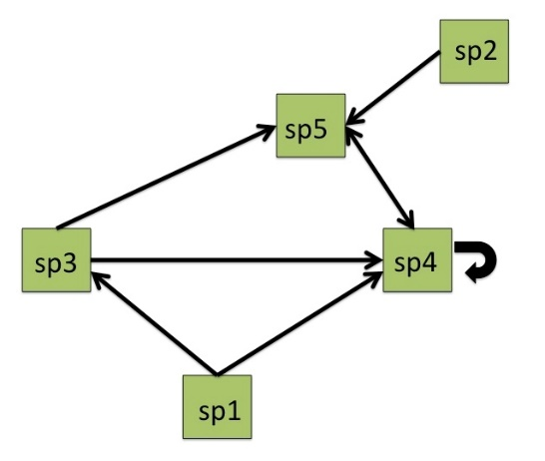
Figure 5. Simple network diagram. Nodes (colored squares) represent taxa and lines indicate trophic interactions. The arrow points from resource to consumer in the direction of energy flow.

Activity 8: Draw a simple food web module including your focal taxon from the final part of Activity 6 and all its consumer and resource interactions.

Simple metrics describing the network can be calculated such as degree – the number of interactions a single taxa has with others in the network. In this example, taxa 1 has two interactions “out” representing its role as prey, while taxa 4 has a total degree of six, two “out” where it is the resource and four “in” where it is the consumer.
In addition to degree, which is calculated for individual nodes or taxa, other food web metrics provide information about the entire community. For example, the number of taxa (S) and the numbers of links (L_{o}) can give important information about the size of the food web and number of the interactions. For this example, S = 5 and L_{o} = 8, which we discussed earlier but now we can use the appropriate terminology.
Building from there, number of possible links (L_{p} = S²) can also be calculated, which represents the maximum number of interactions if all taxa interacted with every other taxa. Continuing with our example, we find that L_{p} = 5² = 25.
From these foundation metrics, more advanced properties can be calculated such as link density (d), the average number of links per species. In other words, linkage density is the average degree of all the taxa in the food web. Here, we have 8 links over 5 species for a linkage density of 1.6.
Finally, connectance (C) is the proportion or percent of possible links realized (L_{o}/L_{p}). For our final example, we calculate 8 links observed over 25 possible links, for a connectance of 0.32 or 32%.
These metrics will be useful in the generating specific research questions, hypotheses and predictions below and for performing the calculations in Part 2: Data Analysis and Interpretation.
Activity 9: Based on the preliminary investigation of your specific taxa, as well as information you gained from group discussion, pose a scientific research question about the way in which parasites could affect the entire food web given some of the metrics defined above. Propose a testable hypothesis that answers your research question.
*For example, one question might be how do the parasites infecting the snail Helisoma sp. connect them to other species that they do not interact with directly? One hypothesis would be that each parasite connects the snail to one additional species than it would be connected to in a food web with just free-living species because of their complex life cycles. This hypothesis could then be tested by comparing the degree (number of connections) that snails have with and without including parasite taxa.

Activity 10: For your research question from Activity 9, state a prediction that would support your hypotheses. Illustrate your prediction using a properly labeled graph. See the figure on the left for the prediction from the example in activity 9 above.
Degree of Helisoma
With parasites
Without parasites

Part 2: Data analysis and interpretation
To test your hypothesis, you will use the data set to calculate some of the food web metrics. Based on these results you can interpret how parasites might be having an impact on individual species as well as the whole food web.
To continue our example, we will now calculate degree from your data set by returning to our excerpt from the data set for Helisoma sp. snails. First, you will need to decide if you will count each interaction or each species. Be consistent with whichever procedure you choose. Next you will count the number of interactions where the focal taxon is the resource. In this example there are 24 taxa or life stages that feed on Helisoma sp. snails. Then you need to do the same thing where Helisoma sp. snails are the consumer. In this case there are 7 taxa or life stages that Helisoma sp. snails feed on. If you were comparing the effect of parasites you would calculate your metrics with and without these links. By totaling the number of interactions as both resource and consumer, you can find the total degree = 31 in the total web with parasites compared to 18 without parasites.

Activity 11: The food web metrics presented above can be obtained similarly from carefully examining and manipulating the food web data set. The table below can help you organize potential methods of calculation. Brainstorm how you can use the excel spreadsheet to obtain estimates of some of the other food web metrics. Consult with a peer and your instructor for feedback.

Table 1. Methods for calculating food web metrics using the excel data set.
Food web metric | Procedure for calculating with excel data set. | How to test for differences due to including parasites.
Degree | Sort the Quick Pond Links excel spread sheet and identify the entries corresponding to the species ID number. Count the interactions with other species. | Use the metadata table to determine which species are parasites. Count the number of links with parasites and those without and compare.
Number of taxa (S)
Numbers of links (L_{o})
Link density (d)
Connectance (C) %

Activity 12: Using the methods you described in Activity 11, calculate the food web metrics you can use to address your scientific research question and test your hypothesis for the entire quick pond food web. Record your results here.

Activity 13: Create appropriate, correctly formatted graphs in excel illustrating your results and compare them to your predictions in activity 9.

Activity 14: Interpret the biological meaning of your results. First, was your hypothesis supported or not? Second, what do you think this means in terms of the individual species interaction and the entire food web?

Part 3: Data Synthesis
Activity 15: In small groups create a 5-minute presentation to share with the whole class. Include the background for your research question(s), hypotheses, predictions and the graphical representation of your results. Discuss whether the data supports your initial hypotheses. What are some of the potential biological mechanisms that could explain how parasites influenced the entire food web as well as the individual taxa you studied?

Extensions
What would the effects be of removing (or not including) other taxa in the food web? How could you use an experimental approach to test potential hypotheses?

Literature Cited:
Cain, M.L., W.D. Bowman, and S.D. Hacker. 2014. Ecology. Sinauer Associates.
Carreon-Martinez, L. and D.D. Heath. 2010. Revolution in food web analysis and trophic ecology: diet analysis by DNA and stable isotope analysis. Molecular Ecology 19:25-27.
Cohen, J.E., R.A. Beaver, S.H. Cousins, D.L. DeAngelis, L. Goldwasser, K.L. Heong, R.D. Holt, A.J. Kohn, J.H. Lawton, N. Martinez, R. O’Malley, L.M. Page, B.C. Patten, S.L. Pimm, G.A. Polis, M. Rejmánek, T.W. Schoener, K. Schoenly, W.G. Sprules, J.M. Teal, R.E. Ulanowicz, P.H. Warren, H.M. Wilbur, and P. Yodzis. 1993. Improving Food Webs. Ecology 74:252-258.
Coll, M., A. Schmidt, T. Romanuk, and H.K. Lotze. 2011. Food-web structure of Seagrass communities across different spatial scales and human impacts. PLoS ONE 6:e22591.
Dunne, J.A. 2006. The network structure of food webs. In Dunne, J.A. and M. Pascual (eds). Ecological networks: linking structure to dynamics in food webs. Oxford University Press. pp. 27-86
Fath, B.D., U.M. Scharler, R.E. Ulanwicz, and B. Hannon. 2007. Ecological network analysis: network construction. Ecological Modeling 208: 49-55.
Fretwell, S.D. 1987. Food chain dynamics: the central theory of ecology? Oikos 50:291-301.
Goldwasser, L. and J. Roughgarden. 1993. Construction and analysis of a large Caribbean food web. Ecology 74:1216-1233.
Goldwasser, L and J. Roughgarden. 1997. Sampling effects and the estimation of food-web properties. Ecology 78:41-54.
Hall, S.J. and D. Raffaelli. 1991. Food-web patterns: lessons from a species-rich web. Journal of Animal Ecology 60:823-841.
Jaarsma, N.G., S.M. de Boer, C.R. Townsend, R.M. Thompson, and E.D. Edwards. 1998. Characterizing food-webs in two New Zealand streams. New Zealand Journal of Marine and Freshwater Research 32:271-286.
Johnson, P.T.J. and V.J. McKenzie. 2009. Effects of environmental change on helminth infections in amphibians: Exploring the emergence of Ribeiroia and Echinostoma infections in North America. In B. Fried and R. Toledo (eds). The Biology of the Echinostomes. Springer pp. 249-280.
Johnson, P.T.J., A. Dobson, K.D. Lafferty, D.J. Marcogliese, J. Memmott, S.A. Orlofske, R. Poulin, and D.W. Thieltges. 2010. When parasites become prey: ecological and epidemiological significance of eating parasites. Trends in Ecology and Evolution 25:362–371.
Kling, G.W, B. Fry, and J.W. O’Brien. 1992. Stable isotopes and planktonic trophic structure in Arctic Lakes. Ecology 73:561-566.
Koprivnikar, J., D.J. Marcogliese, J.R. Rohr, S.A. Orlofske, T.R. Raffel, and P.T.J. Johnson. 2012. Macroparasite infections of amphibians: What can they tell us? Ecohealth 9:342-360.
Kwak, T.J. and J.B. Zedker, J.B. 1997. Food web analysis of southern California coastal wetlands using multiple stable isotopes. Oecologia 110:262-277.
Lafferty, K.D., S. Allesina, M. Arim, C.J. Briggs, G. De Leo, A.P. Dobson, J.A. Dunne, P.T.J. Johnson, A.M. Kuris, D.J. Marcogliese, N.D. Martinez, J. Memmott, P.A. Marquet, J.P. McLaughlin, E.A. Mordecai, M. Pascual, R. Poulin, and D.W. Thieltges. 2008. Parasites in food webs: the ultimate missing links. Ecology Letters 11:533-546.
Lafferty, K.D., R.F. Hechinger, J.C. Shaw, K. Whitney, and A.M. Kuris. 2006. Food webs and parasites in a salt marsh ecosystem. In Collinge, S. and C. Ray (eds.) Disease ecology: community structure and pathogen dynamics. Oxford University Press, pp. 119-134.
Lafferty, K.D. and A.M. Kuris. 2002. Trophic strategies, animal diversity and body size. Trends in ecology and evolution 17:507-513.
Layman, C.A., M.S. Araujo, R. Boucek, C.M. Hammerschlag-Peyer, E. Harrison, Z.R. Jud, P. Matich, A.E. Rosenblatt, J.J. Vaudo, L.A. Yeager, D.M. Post, and S. Bearhop. 2012. Applying stable isotopes to examine food-web structure: an overview of analytical tools. Biological Reviews 87:545-562.
Loker, E.S. and B.V. Hofkin, B.V. 2015. Parasitology a conceptual approach. Garland Science
Marcogliese, D. 2003. Food webs and biodiversity: are parasites the missing link? Journal of Parasitology 82:389–399.
Marcogliese, D.J. and D.K. Cone. 1997. Food webs: a plea for parasites. Trends Ecolology and Evolution 12:320–325.
Memmott, J., N.D. Martinez, and J.E. Cohen. 2000. Predators, parasitoids, and pathogens: species richness, trophic generality and body sizes in a natural food web. Journal of Animal Ecology 69:1-15.
Orlofske, S.A., R.C. Jadin, D.L. Preston, and P.T.J. Johnson. 2012. Parasite transmission in complex communities: predators and alternative hosts alter pathogenic infections in amphibians. Ecology 93:1247–1253.
Orlofske, S.A., R.C. Jadin, and P.T.J. Johnson. 2015. It's a predator-eat-parasite world: how characteristics of predator, parasite and environment affect consumption. Oecologia 178:537-547.
Pimm, S.L., J.H. Lawton, and J.E. Cohen. 1991. Food web patterns and their consequences. Nature 350:669-674.
Polis, G.A. 1991. Complex trophic interactions in deserts: an empirical critique of food web theory. The American Naturalist 138:123-155.
Preston, D.L., S.A. Orlofske, J.P. McLaughlin, and P.T.J. Johnson. 2012. Food web including infectious agents for a California freshwater pond: Ecological Archives E093-153. Ecology 93:1760.
Schell, S.C. 1985. Handbook of trematodes of North America north of Mexico. University Press of Idaho.
Sugihara, G., L.-F. Bersier, and K. Schoenly. 1997. Effects of taxonomic and trophic aggregation on food web properties. Oecologia 112:272-284.
Szuroczki, D. and J.M.L. Richardson. 2009. The role of trematode parasites in larval anuran communities: an aquatic ecologist’s guide to the major players. Oecologia 161:371-385.
Thompson, R.M. and C.R. Townsend. 2000. Is resolution the solution?: the effect of taxonomic resolution on the calculated properties of three stream food webs. Freshwater Biology 44:413-422
Vander Zanden, M.J., J.M. Casselman, and J.B. Rasmussen. 1999. Stable isotope evidence for the food web consequences of species invasions in lakes. Nature 401: 464-467.

Notes to Faculty
This dataset and teaching module could be used in many different courses ranging from introductory or general biology to upper level classes in applied ecology, aquatic ecology, parasitology or disease ecology. In its current form, the module and data set was developed for an undergraduate level general ecology course. The goal of the dataset module is to help students move beyond classic textbook depictions of food webs and examine the process by which researchers construct food webs to represent actual community interactions and analyze them to explore the emergent properties. The dataset provides the opportunity to address authentic issues, such as identifying the boundaries of a community, taxonomic resolution and aggregation, incorporating complex life cycles and developmental stages of organisms, and techniques to obtain and sources of food web information. Uniquely, the data set includes infectious agents (parasites and pathogens) giving students the opportunity to formulate and test hypotheses about how including this trophic strategy impacts our interpretation of species interactions and food web characteristics. Concurrently, students can learn more about data management and how multiple independent datasets are integrated and meta-data used to help interpret and organize information.

Classroom Management
Introduction: Depending on the particular instruction goals, the data set could be used to introduce students to food web topics before or instead of a traditional lecture on the topic. More traditionally, this dataset could be used as part of an assessment to have students demonstrate their understanding of a unit on food web topics. To be used in the present form students should at least be familiar with typical interactions of species pairs that build up into food webs (primary production, photosynthesis, consumption, herbivory, carnivory, omnivory, predation, symbiosis, parasitism). Furthermore, the dataset is based on excel spreadsheets so instructors should gauge the level of proficiency of the students prior to beginning the assigned tasks. The rubrics and explanations of the activities below provide some guidance and examples for how to use excel. Students vary in the amount of explanation for answers so some instructors may find it beneficial to have students answer the questions in a separate document or even turn in their excel files rather than being limited to the space to write on the page. Finally, for advanced courses or more in-depth extensions, there are suggestions and materials provided to support using the R programming language to produce food web diagrams and calculate additional food web metrics.
Depending on the particular purpose for the dataset, I recommend helping focus the students’ attention on the ecological purpose of what they are doing and connecting this back to the “Big Picture” of the natural ecosystem that the food web represents. It might be helpful to begin the activity with an overview of the purpose for the entire dataset and outline the specific objectives of each component. Overall, the module provides the opportunity for students to explore an authentic, well-resolved, yet manageable, dataset and use it to answer their own ecological questions. Specifically, part 1 of the dataset walks students through the steps of actual food web dataset development used by researchers – designating the community, identifying the members, assessing the linkages. Part 2 asks students to think about how they can use the dataset to calculate some standard metrics used to evaluate the properties of food webs using excel. Part 3 asks students to interpret the biological meaning of the results of their independent investigation and share those results with the class.
Instructors can modify the dataset activity including or excluding different sections of the document. However, in its current form, including the use of R to calculate metrics and illustrate food webs, it was completed in two 3 hour lab sections for a class of 12-17 undergraduate ecology students. This included a brief introductory lecture about food webs the first day of class and about half of a class period of the second class for the students to construct their group presentations and deliver them to the class. If students were instructed to complete their presentations outside of class then less time in class would be needed. Furthermore, the lab could be much shorter if an alternative assessment is used instead of the group presentation.

Activity:
Part 1 – Identifying the biological community: Study site
I recommend starting with the Google Earth activity provided to help the students visualize and place their observations of the food web database into context. This has the additional benefit of having students gain experience with different technology. However, other useful activities or extensions could be used to help students engage in the following activities. For example, students could visit freshwater wetland habitats, perhaps nearby their campus, similar to that described in the Quick Pond dataset. While the species identity might differ depending on the geographic region, many freshwater wetlands have similar groups, such as some species of snails, amphibians, dragonflies, etc. In addition, students could conduct simple surveys and use field guides or taxonomic keys to identify specimens that directly relates to the second activity. If an actual field trip isn’t possible, it might be useful to extend the Google Earth activity to include freshwater wetlands near the campus to help students gain an appreciation for these common and important habitats and observe some of the similarities. Depending on the amount of time for the activity, I would recommend giving the students coordinates to start their search for local wetlands.

Part 1 – Nodes: Species and taxonomic resolution
The next part of the food web activity can be shorted or expanded, as needed, depending on the goals and the time constraints of the class. There are 63 taxa represented in the food web so there are several ways the particular species could be assigned to individual or small groups (3-4 students). First, all taxa could be distributed randomly to students so that by the end of the activity most of the taxa could be covered and the entire food web presented and discussed by the groups. For example, if in a class of 24 students, there are 6 groups of 4 students 4-5 taxa per group could cover about half the food web. Alternatively, students could be asked to choose one or more taxa and then those would be off limits to the rest of the class. This would give students some choice and perhaps increase their motivation and interest in their taxa. Another option is for the instructor to choose a couple of taxa that have particularly interesting traits or food web impacts that can be used to illustrate certain concepts. For example, if the goal is to examine the role of parasitism in the food web, then species that interact strongly with the parasites as hosts or predators are likely good choices (snails, amphibians, dragonflies, damselflies, birds). Instructors could choose highly aggregated taxa or several taxa at different trophic positions (primary producers, primary consumers, secondary consumers) so that students can link their specific taxa to one another in food web diagrams. Because the inclusion of parasites is a unique aspect of the web, the activity provides additional background on these taxa and the answers here reflect that as well. However, instructors can choose to focus on particular taxa as suits the purpose of their class.

Part 1 – Metadata exploration and evaluation
An important component of any data management activity is metadata. This is a required component of a data set published on Ecological Archives like the one provided here. To implement this activity as provided make sure that students have downloaded the necessary files and have the correct names associated with each so that they can locate the information. The amount of time this step requires depends on the degree of previous experience students have with searching for information in excel and with the number of taxa they have to research. Depending on the experience of the instructor and the background of the class, it may make sense to explore the metadata prior to analyzing the nodes. If students are familiar with basic food web construction and terminology it may not be necessary. However, this material is not essential to the main ecological concepts presented. With some preparation, the instructor could supply some of the information and therefore skip this section and the associated questions entirely. Here, I provide the basic information needed to complete the rest of the module without the metadata section.
The simplest option is to modify the supplied dataset excel files to include only the data needed for the activity and distribute those new files for the class. For example, Quick_Pond_Nodes could be trimmed to include only the columns: SpeciesID, Stage, WorkingName, Resolution, and Lifestyle(species). This would be the minimum amount of information needed for the activity. The information the students would need about each column includes the following. SpeciesID is a code number used to designate the taxa in the Links spreadsheet. Stage is the life cycle stage of the organism. This is important because the diet of some organisms changes as they develop (tadpoles do not eat the same thing that adult frogs do). Therefore, because food webs represent trophic, or feeding interactions, some species may make more sense to include as separate life stages. WorkingName gives the identity of the taxa used in the food web. Resolution gives more information about the taxonomic level of those taxa given in WorkingName. From this information, students can evaluate which groups have been identified more specifically and which groups likely represent a group of distinct species rather than one (assemblages). Finally, Lifestyle(species) gives quick information about whether or not the species is free-living or infectious and lets students quickly recognize which species are parasites or not without having to be familiar with individual taxa.
Likewise, to modify the Quick_Pond_Links data set, remove all columns except: ConsumerSpeciesID, ResourceSpeciesID, LinkType, LinkEvidence, LinkEvidenceNotes. The first two columns (ConsumerSpeciesID and ResourceSpeciesID) represent the data for the food web itself. Each row represents a trophic interaction where the species ID number in the resource column is “consumed” by the species listed by ID number in the same row of the ConsumerSpeciesID column. LinkType gives the general definition of the type of trophic interaction that is occurring between the two species. LinkEvidence provides information on the source of the information used to make that link between the two taxa and finally, LinkEvidenceNotes gives references if the information was gathered from previously published sources.

Part 1 – Links: Types of trophic interactions
This section of the module provides background information on basic species interactions and introduces specific information about parasites and their life cycles that many not be covered in depth in a general ecology course. This information could be reduced or removed if the instructor chooses to focus on the food web in general rather than parasites, or could be expanded if adapted for a parasitology or disease ecology course.
The goal of this first section is to help students understand the convention for representing food web data in spreadsheet form. The students have an example written in the text as well as segments of the excel spreadsheet with associated annotations to help them interpret how the data are represented. Alternatively, the instructor could have the Quick Pond Links file open on a projector screen and show the students directly on the excel spreadsheet. This would allow the class to ask questions and get them answered together before they begin working on their own taxa. The example given in the module is for Helisoma sp. snails. This taxon was chosen because it has many interactions with both free-living and parasite taxa. It also illustrates how more than one life stage of an organism can interact with a given taxa. Students should be directed to collapse life stages or leave as presented at the discretion of the instructor. If students understand the activity they can quickly move on to their own taxa, but if there are questions or students are not as experienced with excel, it may be a good idea to show the students again how to use the Quick Pond Nodes table to look up the identities of the different taxa.

Part 1 – Food web diagrams and hypotheses
This part of the teaching module transitions from working with the dataset spreadsheets to visualizing the food web by creating network diagrams. The module describes this in basic terms and asks the students to diagram the food web by hand. Later in the faculty notes there are extensions provided for how to implement this activity in the R statistical programming language.
To help students make the connection between the data and the network diagram, instructors may find it helpful to draw the sample diagram from figure 5 on the board, or continue to use the example with the Helisoma sp. snails provided below. If students are advanced and have taxa from different trophic levels it might be useful for them to connect them in one diagram. If working in a group, students may want to discuss their diagrams and see how they would connect to one another.
Potentially the most difficult part of implementing the teaching module for the students is coming up with a testable hypothesis for the impact of parasites on the food web. It might be easier to have students start with the prediction directly related to the food web metrics just introduced and then have them think about why they made that prediction. This way the students can better make the connection between the metrics, predictions and the biological hypothesis underlying the prediction.

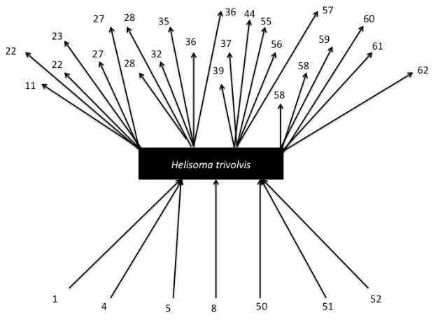

Part 2 – Data analysis and interpretation
There are several potential approaches that instructors can use to implement this section of the teaching module. As it is written, the students use the example and their experience manipulating the dataset to brainstorm potential ways to use excel to calculate simple food web metrics. This activity was designed to have students think critically about how to use excel to extract summary information from the dataset. There is opportunity for group work, feedback, and interaction with the instructor so that students have guidance while filling out table 1. By providing feedback instructors can ensure that students are on the right path before they start to collect their data and manipulate excel. However, depending on the amount of time and preparation of the students, one alternative is to give the students the completed version of table 1 from the answer key below, so that they can focus instead on choosing the correct metric and calculating the values. The final alternative is to wrap up a discussion of what the metrics mean, but skip the table and instead use the Network Analyses in R extension provided below to calculate the values. This alternative requires the instructor and/or students to be familiar with the basics of R, but the additional benefit is that students could gain experience with the some basic techniques used by researchers in the field.

Part 3 – Data Synthesis
The conclusion of the teaching module includes student groups preparing a 5-minute presentation to share with the whole class. Students will gain experience addressing their hypotheses and evaluating the evidence as well as interpreting the biological results. The students also benefit from having to teach others about their specific question and results, perhaps identifying areas of confusion or misunderstanding as they seek to explain their research to others. This activity allows students to develop written and oral communication skills. By sharing their small group work the students have an increased motivation to create a quality presentation. Furthermore, this activity gives students the opportunity to learn more about taxa and relationships they were not able to investigate on their own. Finally, instructors can build on other requirements to the presentation, such as asking students to propose future research directions or discuss issues, limitations, or challenges with working on the dataset. This has the benefit of having students share real life issues with the use of authentic research data as well as providing the instructor a source of information about challenges that should be addressed in future lessons or courses where the module is used.

Extensions
The first question provided in the instructions for extensions asks about effects of removing or not including other taxa. This could be used as a substitute guide for the entire module if the instructor chooses not to emphasize the inclusion of parasites in the food web. Alternatively, the way it could be used here is to move past comparisons of the food web with and without parasites to how the role of parasites compare to other taxa at different trophic levels. For example, students could be asked what would happen if a key producer were removed, or a key herbivore (primary consumer). Advanced students may have posed these types of questions on their own for their independent research questions. For the second question students could think of ways to “experiment” within the dataset, by choosing specific taxa and removing them and examining the changes to the food web. Alternatively, the second question could also be used to have students think beyond the descriptive food web data set presented to how experiments could be used to test whether inferred links exist, how strong links are between species, or the overall consequences to the food web of species addition (introduction) or removal (extinction). Most students in a general ecology course have received a basic introduction to experimental design. This question could be used to see how students can apply those skills and knowledge to a new situation. Instructors may choose to use these extensions as a homework assignment or part of another type of student learning assessment such as a take home exam.

Questions and Answers

Activity 1: Using the most recent Google Earth imagery, write down some general observations about the aquatic habitat that is the focus of the food web as well as the terrestrial habitat and the surrounding land use.

Answer: Students should note that Quick Pond is rather small, has an outer edge dominated by taller, non-woody vegetation but also includes some open water habitats. The surrounding land use is primarily grassland, some dirt roads and forest. Depending on how familiar students are with the habitat they may include that the land surrounding Quick Pond is used for grazing livestock, but that information may not be apparent from Google Earth Imagery.

Activity 2: Using historical data, particularly the images from 2009-2011 when the data collection took place, write down some general observations about how the site changes over seasons and years. How do you think these observations help you understand the Quick Pond food web?

Answer: Students should notice that during different years and seasons Quick Pond changes in size and depth depending on weather changes, likely based on the amount and timing of precipitation. Quick pond tends to be the largest in the spring and the smallest in the late summer. Students may indicate specific dates when Quick Pond is the largest and/or smallest. Students should address the specific period 2009-2011 and describe important changes that could influence species occurrence and abundance. Because the data were collected over this time period any changes would influence which taxa are included in the food web or not. Species that depend on permanent water, such as fish, may not be present in the Quick Pond food web. Furthermore, species like amphibians and dragonflies may be in the larval forms when the water is high and later in the season when water is low be present in their adult, terrestrial forms.

Activity 3: Open the excel spreadsheet file: Quick Pond Nodes. At the top of the page in row 1 locate the column titled “WorkingName”. This column includes the names of the taxa included in the food web database. Your instructor will give you instructions for how many and any specific taxa to examine. For your particular taxa write down some notes focused on their trophic interactions. In other words, what do they eat and what eats them? How big are they? What kind of life cycle do they have? Animal diversity web (http://animaldiversity.org/) is a useful resource for this purpose. NOTE: Be sure to note the SpeciesID number for your chosen taxa you will need it for subsequent activities.

Answer: A sample answer is given in the text of the teaching module. Below is a rubric for potential student answers.

Student Reponses | Sample Point Value
Student provides a complete and detailed answer for the specific taxa assigned or chosen. Important aspects of the species trophic interactions including resources and consumers of the taxa are given. In addition, the student includes pertinent information about the body size and life cycle that are likely to influence trophic interactions. | 4
Student provides an accurate and detailed answer but missing at least one important aspect of the diet or species interactions or natural history information. | 3
Student answer is missing more than one important aspect or is reporting inaccurate information about at least one important aspect. Answer is overly general or otherwise incomplete. | 2
Student does not follow instructions or provides inaccurate or misinformation for more than two important aspects of the question. | 1

Activity 4: Open the excel spreadsheet file: Quick Table 2A. Examine the spreadsheet. What type of metadata does this spreadsheet represent? How can you tell? How do you think it will help you understand the food web data set “Quick Pond Nodes” that you looked at in Activity 3?

Answer: Quick Table 2A represents descriptive metadata. You can tell because the title for the table and the final column “column description” both indicate that the information it contains are used to describe or identify the components of the other datasets. Answers for the final part of the question can vary, but should include that having this information can allow the user to better understand how to access and use the dataset as well as relate it back to the biological characteristics of the organisms and the community being described.

Activity 5: Choose 3 characteristics from the “Quick Pond Nodes” data set for each of your taxa and explain what they mean using Quick Table 2A.

Answers will vary depending on the taxa and the characteristics chosen, but should be reported accurately and completely.

Activity 6: Locate your chosen taxa in both the “ConsumerSpeciesID” and “ResourceSpeciesID” columns. It may be helpful to use the “sort” and “filter” functions in excel as illustrated in the example above. How many resource items does each taxon have? How many consumers? List the SpeciesID number and identify up to ten taxa that are interacting with one of your focal taxa using the Quick Pond Nodes and metadata tables.

Answer: Please see Quick_Pond_Nodes_Key excel file for the number of resources and consumers for each taxa. This file can also be used to check the species identification for the SpeciesID number in the student response.

Activity 7: Are any of the taxa you investigated parasites? If so, how do they interact with free-living species? If you have investigated free-living species, did you observe any interactions with parasites? If so, what were they? Share your thoughts with another student or group and compare their responses.

Answer: Answers will vary depending on the students’ taxa. Potential answers for the parasites include using particular free-living taxa as hosts in their life cycle or that the parasite can also serve as prey for a free-living species. Likewise, students could indicate that a free-living species was infected by or consumed a particular parasite at one or more stages of its life cycle.

Activity 8: Draw a simple food web module including your focal taxon from the final part of Activity 6 and all its consumer and resource interactions.

Answer: Answers will vary depending on the student’s taxa. Like the example provided above for Helisoma sp. snails, a complete and accurate answer will have the number of arrows equal to the number of interactions where the focal taxon is the resource and the consumer. When the focal taxon is the consumer the arrows will point from the resource to the focal taxon. If the focal taxon is the resource the arrows will point from the focal taxon to the consumer. If the focal taxon is cannibalistic (feeds on members of the same species), the arrow will curve back the same taxa.

Activity 9: Based on the preliminary investigation of your specific taxa, as well as information you gained from group discussion, pose a scientific research question about the way in which parasites could affect the entire food web given some of the metrics defined above. Propose a testable hypothesis that answers your research question.

Answer: A sample answer is given in the text of the teaching module. Below is a rubric for potential student answers.

Student Reponses | Sample Point Value
The question posed is related specifically to one of the chosen taxa and relates to an aspect of the food web that can be addressed with the specific metrics discussed. The hypothesis provided is testable with the available data and is distinct from a prediction. | 4
The question posed is of high quality (see above), but the hypothesis stated is not testable with the available data or is a prediction rather than a hypothesis. | 3
The question posed is only loosely based on the instructions. The question is based on concepts related to the food web, but not related to the food web metrics introduced and the hypothesis therefore is not testable given the data. | 2
The question posed is not related to the entire food web and instead focuses on individual taxa and is more descriptive in nature rather than addressing a food web concept. | 1

Activity 10: For your research question from Activity 9, state a prediction that would support your hypotheses. Illustrate your prediction using a properly labeled graph. See the figure on the left for the prediction from the example in activity 9 above.

Answer: A sample answer is given in the text of the teaching module. Below is a rubric for potential student answers.

Student Reponses | Sample Point Value
Student response includes an accurate, properly labeled graph that is consistent with the stated prediction. | 4
Student response is accurate and consistent with the stated prediction, but is missing labels. | 3
Student response is properly labeled but not consistent with the stated prediction. | 2
Student response is not consistent with the stated prediction and is missing or has unclear labels. | 1

Activity 11: The food web metrics presented above can be obtained similarly from carefully examining and manipulating the food web data set. The table below can help you organize potential methods of calculation. Brainstorm a couple ideas how you can use the excel spreadsheet to obtain estimates of some of the other food web metrics. Consult with a peer and your instructor for feedback.

Table 1. Methods for calculating food web metrics using the excel data set.
Food web metric | Procedure for calculating with excel data set. | How to test for differences due to including parasites.
Degree | Sort the Quick Pond Links excel spread sheet and identify the entries on corresponding to the species ID number. Count up all the interactions with other species. | Use the Quick Pond Nodes and metadata tables to determine which species are parasites. Total up the numbers of links with parasites and those without and compare.
Number of taxa (S) | Using the Quick Pond Nodes dataset the SpeciesID column provides a list of all unique species for a total of 63. | Using the Quick Pond Nodes dataset locate the Lifestyle (species) column and remove the species that are labeled infectious. The result is 48 free-living species.
Numbers of links (L_{o}) | Sort the Quick Pond Links excel spread sheet and identify the entries on corresponding to the speciesID number. Count all the interactions with other species. This is equivalent to degree above. If the goal is to calculate connectance or linkage density after excluding taxa use the sort function to identify and remove those links. Then use the function COUNT to find the total number of links. | Remove the links where at least one of the participants in the interaction is a parasite by sorting by SpeciesID number and removing the parasite rows. In the modified dataset use the COUNT function to total up the number of rows that are left in the Quick Pond Links Data set.
Link density (d) | This metric can be calculated by combining information from Numbers of taxa (S) and Numbers of links (L_{o}). Using the techniques described for those metrics above calculate the appropriate numbers of taxa and links. Divide the number of links by the number of taxa. | The same procedure can be used after removing one or more parasite taxa. Then those new values could be divided and compared to the value including all species.
Connectance (C) % | This metric can be calculated by combining information from Numbers of taxa (S) and Numbers of links (L_{o}). Using the techniques described for those metrics above calculate the appropriate numbers of taxa and links. With the correct S calculated, find the square of the number (S²), which represents L_{p}. Then divide the number of links calculated from the data set, by the L_{p}. | The same procedure can be used after removing one or more parasite taxa. Then those new values could be divided and compared to the value including all species.

Activity 12: Using the methods you described in Activity 11, calculate the food web metrics you can use to address your scientific research question and test your hypothesis for the entire quick pond food web. Record your results here.

Answer: The correct answer will depend on the particular question asked by the student and the particular metric needed. Correct answers should be based on obtaining the correct raw values from the data consistent with the research question, including making any required manipulations to the data, identifying and using the correct procedure or formula, and finding the correct value. Answers for degree of taxa in the web with and without all parasites are given in the Quick_Pond_Nodes_Key excel file. Instructions for obtaining other values using R are given as part of the optional extension activity below.

Activity 13: Create appropriate, correctly formatted graphs in excel illustrating your results and compare them to your predictions in activity 9.

Student Reponses | Sample Point Value
Student response includes an accurate, properly labeled graph that is consistent with the correct value obtained for the food web metric. A clear comparison is made between the actual results and the prediction. | 4
Student response is accurate and consistent with the results calculated, but is missing labels. A clear comparison is made between the actual results and the prediction. | 3
Student response is properly labeled but the values are not accurately represented in the figure. A comparison is made between the actual results and the prediction, but lacking depth or clarity. | 2
Student response does not accurately represent the results and is lacking a comparison between the actual results and the prediction. | 1

Activity 14: Interpret the biological meaning of your results. First, was your hypothesis supported or not? Second, what do you think this means in terms of the individual species interaction and the entire food web?

Student Reponses | Sample Point Value
Student clearly addresses the hypothesis based on evidence and clearly demonstrates an understanding of the biological meaning of the results. The student states a clear decision about whether or not the hypothesis was supported. The student clearly expresses scientific thoughts about both the individual species and entire food web level. | 4
Student clearly addresses the hypothesis based on evidence and clearly demonstrates an understanding of the biological meaning of the results but does not make a solid conclusion about the hypothesis itself. The student clearly expresses scientific thoughts about both the individual species and entire food web level. | 3
Student addresses the hypothesis but may not go into detail about the biological meaning or interpretation before coming to a decision about whether or not the hypothesis was supported. The student addresses both the individual species and entire food web level at only a minimal level. | 2
Student does not adequately provide a conclusion about the hypothesis or complete justification. Furthermore, the student is missing a satisfactory discussion about either the individual species or entire food web level. | 1

Activity 15: In small groups create a 5-minute presentation to share with the whole class. Include the background for your research question(s), hypotheses, predictions and the graphical representation of your results. Discuss whether the data supports your initial hypotheses. What are some of the potential biological mechanisms that could explain how parasites influenced the entire food web as well as the individual taxa you studied?

Student Presentation Rubric | Sample Point Value
Student presentation is the highest quality for four general criteria. First, students clearly and concisely address all of the required components of the presentation. Second, they provide a scientific justification for the hypothesis and an accurate interpretation of the results with respect to their hypothesis. Third, they explain the biological mechanisms and demonstrate understanding of key food web concepts, parasite-host and community interactions, and background on the specific study species. Fourth, the written and oral components of the presentation are professional. | 4
Student presentation is average quality and all but one of the four criteria described above is met at a satisfactory level. | 3
Student presentation is below average quality missing or inadequately addressing two of the four criteria described above. | 2
Student presentation is below average quality missing or inadequately addressing three of the four criteria described above. | 1

Extensions
What would the effects be of removing (or not including) other taxa in the food web?

Student Response | Sample Point Value
Student response is thoughtful and based on direct experience with the material in the teaching module and a firm grasp of food web concepts. | 4
Student response is thoughtful but perhaps more conceptual rather than related to the experience in the exercise and is more general than the specific. | 3
Student response is not thoughtful, but rather basic and superficial in the approach to the question. | 2
Student response contains inaccurate or incomplete information or does not completely address the question. | 1

How could you use an experimental approach to test potential hypotheses?

Student Response | Sample Point Value
Student responses are insightful and novel incorporating accurate ideas about how the dataset could be used to test hypotheses about the effects of other taxa or alternatively suggest actual experiments that could be conducted within the food web context. | 4
Student responses are complete, clear and accurate, but are basic and may lack specific connections to the hypotheses. | 3
Student responses are limited in scope and do not fully address the question. | 2
Student responses are inaccurate or include information that is not relevant or related to the specific question. | 1

Optional Extension Tasks
The main goal of working with the dataset is to show students how to use authentic data to answer their own research questions and this can be done in a number of different ways. The main teaching module focuses on using Microsoft Excel or similar spreadsheet programs to sort, count, remove, and otherwise manipulate the spreadsheet to obtain information for calculating simple food web metrics. For those instructors who would like to explore additional tools, an optional extension in R statistical programming software is provided below. The information assumes a working knowledge on the part of the instructor and it would be recommended that students know some basic processes in R, such as installing packages, uploading a dataset, using a function, and creating objects. The R code file included provides basic commands, examples, and annotations.

Network Analyses in R
In order to manipulate food web data and plot network diagrams, the program igraph is recommended. Make sure that you have this package installed prior to running the included R script file. The required formats for inputting data into R vary, but here I use .csv files. Note that the excel spreadsheets provided in the dataset module will not work directly in the basic R program, but must be converted to the appropriate file format first. If using R studio excel files can be directly imported. The dataset that is provided to use in R is recommended to be used by instructors, but could be used for the whole class depending on the specific learning objectives. Once this data file is uploaded it is converted into a ‘graph’ format for the igraph program to use.
One of the advantages of using the R program to manipulate the dataset is the ability for students to quickly and easily produce network diagrams representing the food web. In the first main section of the R code, there are two different versions of code to produce a food web diagram. The first gives a basic food web of all the taxa in the Quick_Pond_Links data set. The second gives this same food web but in addition the parasite nodes are outlined in yellow to help identify them in the diagram. Note that each plot of the food web differs so even though the numbers of links and specific connections are the same, the layout of the particular taxa will differ student to student.
The next portion of the R code gives examples of some functions in the igraph program used to obtain the simple food web metrics referenced in the teaching module. Specifically, the vcount() function gives the number of nodes (called vertices in igraph) and ecount() function gives the number of links (called edges in igraph). These are equivalent to S and L_{o}, respectively, and can then be used to calculate the other metrics. Similarly, degree() gives the total number of links going into and out of a particular node. By specifying “out” or “in” you can differentiate between the links where the taxa is the resource or the consumer. Again, this provides information needed for calculating other metrics.
Beyond the calculations of the specific metrics, the R script provides commands for how to modify the dataset, or ‘graph’. For example, the function delete_vertices() can be used to quickly remove individual or groups of taxa. In this way students can remove parasites and/or free-living taxa to address their research questions and hypotheses. There are two examples given in the script, one removing the free-living taxon Helisoma sp. snails that were discussed in the model. Second, all the parasite and pathogens are removed. Following the command to remove all the parasites and pathogens there is a revised command to build the network diagram, this time without any parasites. Students can use this to compare how the networks look with or without parasites included. If students are interested in particular species they can easily modify the code in the different versions of the graphing commands to plot diagrams with or without taxa of their choice and can highlight where they are when present. Similarly, the food web metric functions described above can also be used on the new modified dataset and compared to the complete food web including all taxa, free-living and parasites.
At the end of the R script are functions to complete Table 1. One of the metrics described in the food web teaching module is connectance. This is the percent of links out of possible links. The proportion is given by the function edge_density() in igraph and can then be converted to a percentage. igraph does not contain a function to calculate Link Density (although it sounds like edge density they are not equivalent). Therefore, the R script contains an example from the full dataset. The value is calculated simply by diving the total number of links by the number of taxa, so the calculation is straightforward where the values can be obtained by using vcount() and ecount() for any modified dataset.
This simple R script and demonstration represent a possible starting place for more advanced calculations and analyses and I would encourage instructors to consult the igraph online documentation http://igraph.org/r/ for more information and additional metrics that can be calculated and compared.

R function in igraph | Uses for Food Web Analysis
vcount() | gives the number of nodes (called vertices in igraph). Equivalent to S
ecount() | gives the number of links (called edges in igraph). Equivalent to L_{o}
degree() | gives the total number of links going into and out of a particular node. By specifying “out” or “in” you can differentiate between the links where the taxa is the resource or the consumer.
delete_vertices() | used to quickly remove individual or groups of taxa
edge_density() | gives the percent of links out of possible links

COPYRIGHT STATEMENT
The Ecological Society of America (ESA) holds the copyright for TIEE Volume 13, and the authors retain the copyright for the content of individual contributions (although some text, figures, and data sets may bear further copyright notice). No part of this publication may be reproduced, stored in a retrieval system, or transmitted, in any form or by any means, electronic, mechanical, photocopying, recording, or otherwise, without the prior written permission of the copyright owner. Use solely at one's own institution with no intent for profit is excluded from the preceding copyright restriction, unless otherwise noted. Proper credit to this publication must be included in your lecture or laboratory course materials (print, electronic, or other means of reproduction) for each use.
To reiterate, you are welcome to download some or all of the material posted at this site for your use in your course(s), which does not include commercial uses for profit. Also, please be aware of the legal restrictions on copyright use for published materials posted at this site. We have obtained permission to use all copyrighted materials, data, figures, tables, images, etc. posted at this site solely for the uses described at TIEE site.

GENERIC DISCLAIMER
Adult supervision is recommended when performing this lab activity. We also recommend that common sense and proper safety precautions be followed by all participants. No responsibility is implied or taken by the contributing author, the editors of this Volume, nor anyone associated with maintaining the TIEE web site, nor by their academic employers, nor by the Ecological Society of America for anyone who sustains injuries as a result of using the materials or ideas, or performing the procedures put forth at the TIEE web site, or in any printed materials that derive therefrom.

