ISSUES : DATA SET
Environment-Richness Relationships in Ephemeral and Permanent Wetlands: Guided Inquiry with Graph Interpretation

Amanda M. Little
University of Wisconsin - Stout; littlea@uwstout.edu

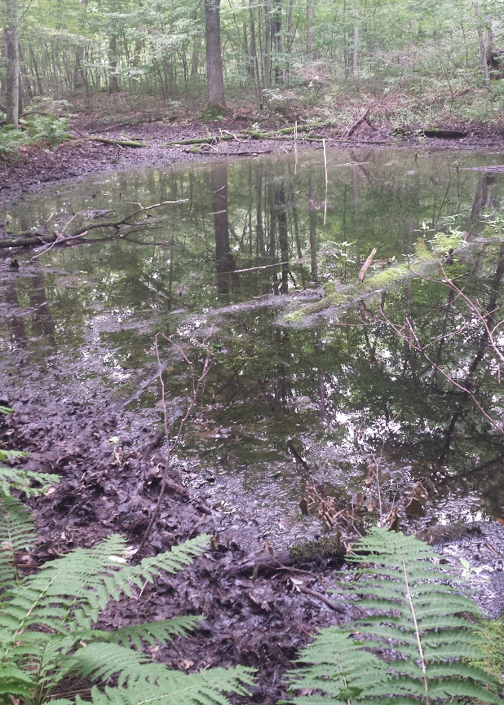
Ephermal wetland. (Photo by A.M. Little)

THE ECOLOGICAL QUESTION:
How do relationships between taxonomic richness and environmental variables differ in permanent and temporary wetland habitats?

ECOLOGICAL CONTENT:
Species richness, environmental variation, habitat permanency, aquatic ecology
WHAT STUDENTS DO:
  - Design hypotheses about how wetland hydroperiod may affect different groups of species (Knowledge, Comprehension, Application).
  - Produce and analyze graphs comparing permanent and temporary wetlands, with an emphasis on understanding linear models (Comprehension, Synthesis, Analysis).
  - Summarize relationships between environmental attributes and ecological communities (Synthesis).
  - Connect differences in relationships back to wetland hydroperiod (Comprehension, Synthesis).
  - Advanced student extension: Connect difference in relationships to wetland hydroperiod across multiple years (Comprehension, Synthesis).

STUDENT-ACTIVE APPROACHES:
Guided-inquiry, peer feedback, predict-observe-explain, small group discussion, possible jigsaw

SKILLS:
  - Hypothesis development
  - Data visualization using spreadsheets or statistical program
  - Data interpretation
  - Data quality evaluation
  - Connecting ecological concepts

ASSESSABLE OUTCOMES:
Student-made graphs, answers to short questions, student-made short presentations, brief paragraphs summarizing what they learned
SOURCE:
Data were collected as part of a five-year research study of ephemeral pond wetlands.

ACKNOWLEDGEMENTS:
Thank you to Jim Church and Matt Kuchta for collaboration on data collection and project administration. The QUBES DIG into Data Faculty Mentoring Network provided invaluable feedback, structure, and ideas for this module. The University of Wisconsin-Stout provided support for this project. This material is based upon work supported by the National Science Foundation under Grant DEB-1256142 to Little and Church. Any opinions, findings, and conclusions or recommendations expressed in this material are those of the authors and do not necessarily reflect the views of the National Science Foundation.

OVERVIEW OF THE ECOLOGICAL BACKGROUND

This activity is designed to give students an opportunity to generate and test hypotheses about taxa richness-environment relationships in wetlands with different hydroperiods. Students will compare differences in permanent wetlands and ephemeral wetlands using site-specific data and linear models. The data was collected as part of a large, long-term study of 57 permanent and ephemeral wetlands.
The data that students will be working with is part of the Chippewa Moraine Ephemeral Ponds Project, a five-year study of 57 wetlands in western Wisconsin. The data available to students includes two years (2013 and 2014) of environmental, plant, and aquatic macroinvertebrate data. Species/taxa richness metrics are included for macroinvertebrates and plants. For some variables, multiple samples were collected over the summer; this data is provided in annual mean format. 2013 was an average precipitation year (mean wetland water depth = 7.5 cm, SE = 1.4 cm), but 2014 was significantly above-average (mean wetland water depth = 28.5 cm, SE = 3.2 cm, P < 0.001, paired t = 2.00, df = 56). More advanced students may be interested in comparing relationships between years and speculating as to why these differences may be due to altered hydrology.
Aquatic macroinvertebrates were sampled three times during each growing season using funnel-type surface-associated activity traps (Figure 1) placed on the perimeter of each wetland. Wetlands were sampled using three traps (ephemeral ponds) or five traps (permanent wetlands), because the permanent wetlands were substantially larger than the ephemeral ponds.
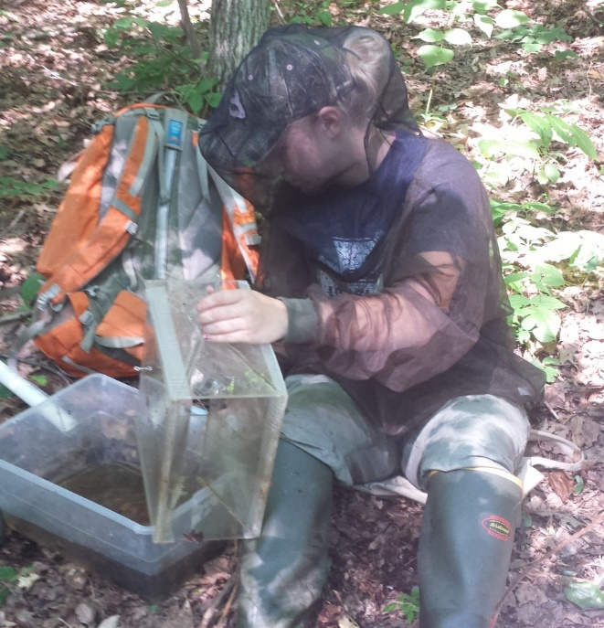
Figure 1. A student processes a funnel-type surface-associated activity trap. The trap was set and left overnight in the wetland. Creatures swim and crawl into the trap, and then we rinse the traps and filter the creatures into small sample vials for laboratory work. (Photo by A.M. Little)

We surveyed understory vegetation in all 57 wetlands from late July to early September 2013 and 2014. We sampled 1 m² plots along transects randomly within regularly spaced segments of the transects (in stratified-random fashion). Sampling intensity ranged from 10 to 30 quadrats/wetland, depending upon wetland size.
We assessed the environment at 2 different spatial scales. At the plot scale, we measured water depth and canopy cover (with a spherical densiometer). We also assessed water depth at the wetland scale, using staff gauges located in deep areas within each wetland. At the wetland scale, we assessed specific conductivity, pH, dissolved O₂, and temperature in triplicate with field instruments 3 to 4 times/season, depending upon pond dry dates. At each sampling period, we collected 3 water samples/wetland for further processing. We measured NO₃– and NH₄⁺ concentrations in the laboratory with ion-specific epoxy probes. We measured total P (TP) spectrophotometrically after persulfate digestion (U.S. EPA 1978) and soluble reactive P (SRP) spectrophotometrically (O’Dell 1993). We measured chlorophyll a (a measure of algal productivity) by spectrophotometry, extracting pigments using 90% alkaline acetone (Arar 1997). Variability was low among within-wetland compared to between-wetland samples for both phosphorus measures and chlorophyll a, so the 3 samples/wetland were pooled for analysis.
LITERATURE CITED
Arar, E. J. 1997. Method 446.0: In vitro determination of chlorophylls a, b, c1 + c2 and pheopigments in marine and freshwater algae by visible spectrophotometry. U.S. Environmental Protection Agency, Cincinnati, OH.
O’Dell, J. W. 1993. Method 365.1, Revision 2.0: Determination of phosphorus by semi-automated colorimetry. U.S. Environmental Protection Agency, Cincinnati, OH.
U.S. EPA. 1978. Method 365.3: Phosphorus, all forms (colorimetric, ascorbic acid, two reagent). U.S. Environmental Protection Agency.

DATA SETS
Each data set contains three worksheets. The first worksheet provides definitions and other information about variables. The second worksheet consists of the environmental and species richness variables for each wetland. The final worksheet contains some species information for a brief exploration of community composition.
- 2013 community data
- 2014 community data
STUDENT INSTRUCTIONS
Introduction
Wetland hydroperiod is the pattern of water level fluctuations in a wetland. Some wetlands dry completely on an annual basis, and these are called ephemeral ponds, vernal pools, or simply temporary wetlands (Figure 1, Colburn 2004, Calhoun and DeMaynadier 2008). Ephemeral ponds tend to be small, hydrologically isolated (with no permanent outlet or inlet), and surrounded by forest (Colburn 2004). Other wetlands, which for the purposes of this activity are called “permanent”, maintain water year-round although their water levels may fluctuate.
Ephemeral ponds are unique for many reasons. Because they dry completely during most years, they are fish-free. Without fish predation, amphibian larvae tend to have higher survival rates and so many amphibians use ephemeral ponds for breeding (Semlitsch and Skelly 2008). These amphibians include wood frogs, spring peepers, chorus frogs, and blue-spotted salamanders (Figure 2). Other fauna that inhabit these wetlands include fairy shrimp and fingernail clams (Figure 3). These invertebrates are able to tolerate desiccation (a prolonged period of drying) and benefit from the lack of fish predators in ephemeral ponds. There are still predators in the ponds, however. Macroinvertebrates like water tigers (Dytiscidae, Figure 3), the larval stage of predaceous diving beetles, are able to avoid predation and competition from fish by using ephemeral pond habitats.
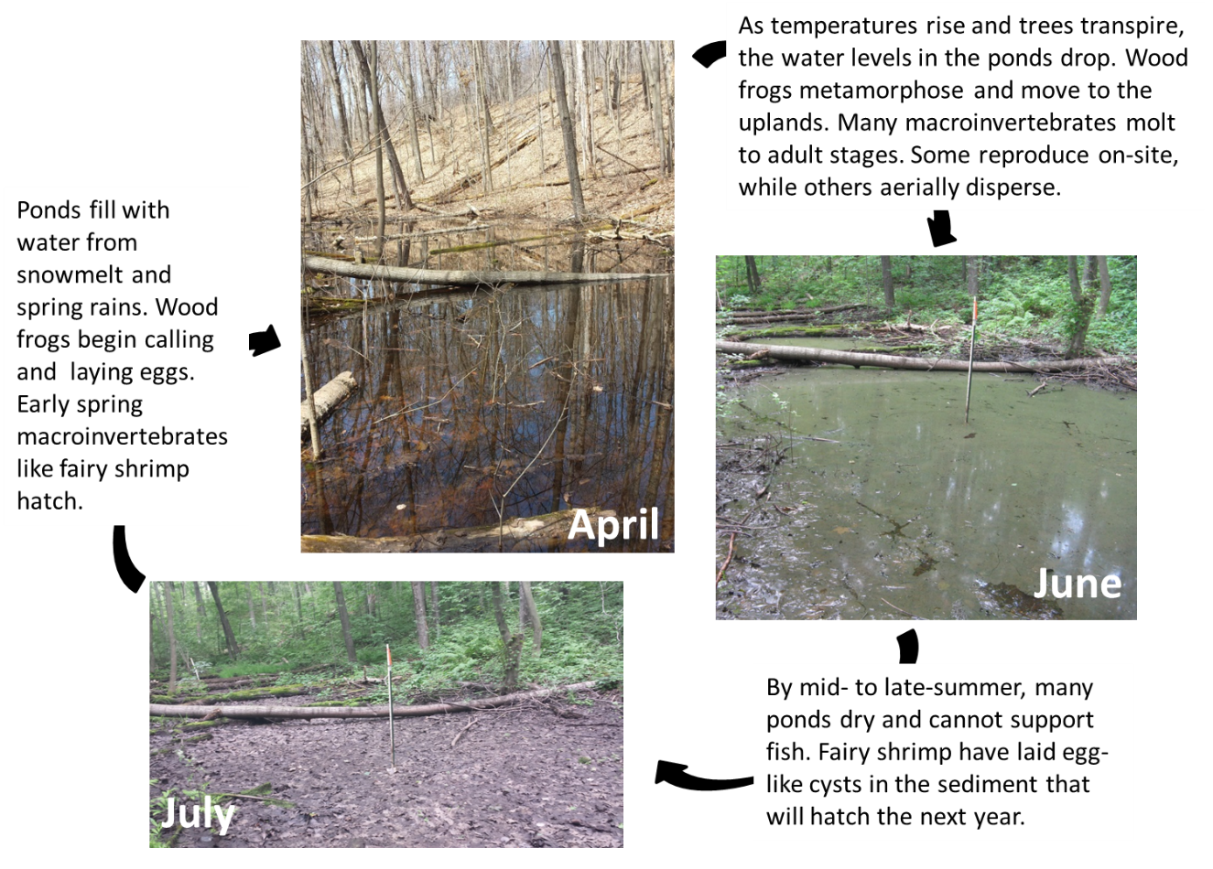
Figure 2. The life cycle of an ephemeral pond. Photographs are of wetland “Exile” from the study, by A.M. Little.
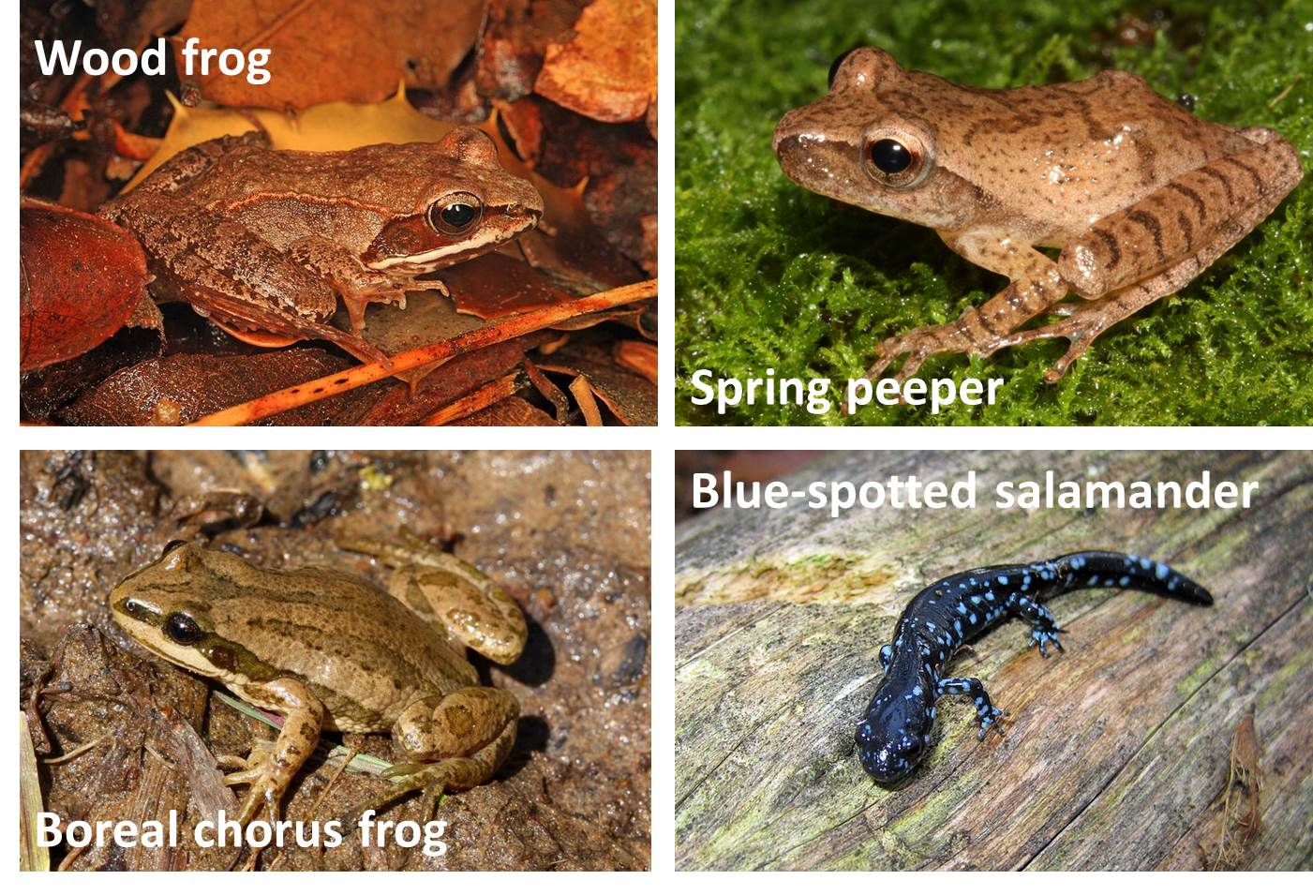
Figure 3. Amphibians of ephemeral ponds, including wood frog (Lithobates sylvaticus, photo by Judy Gallagher, https://www.flickr.com/photos /52450054@N04/26705058872), spring peeper (Pseudacris crucifer, photo by Kevin Enge, https://www.flickr.com/photos/ myfwc/14995946531), boreal chorus frog (Pseudacris maculata, photo by J.N. Stuart, https://www.flickr.com/photos/ stuartwildlife/4669446198), and blue-spotted salamander (Ambystoma laterale, photo by Greg Schechter, https://commons.wikimedia.org/wiki/File:Blue-spotted_salamander_(Ambystoma_laterale)01.jpg)
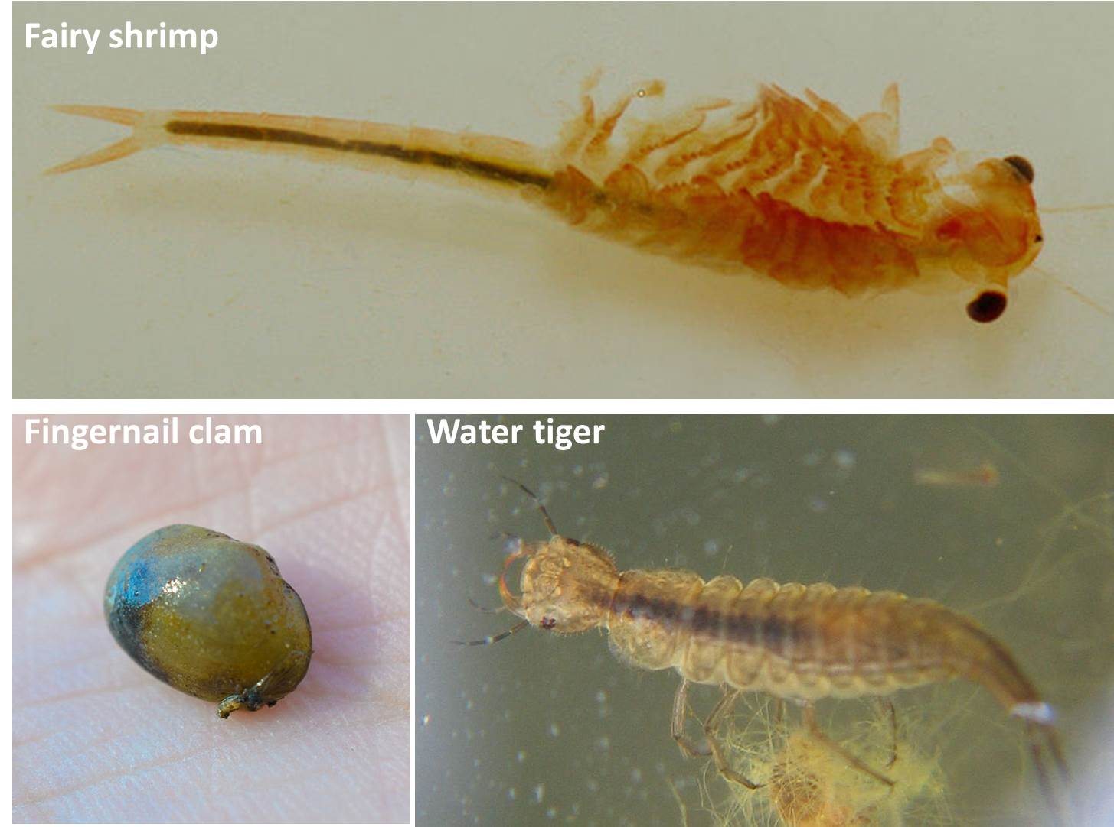
Figure 4. Macroinvertebrates of ephemeral ponds. Fairy shrimp (Eubranchipus, photo by Christian Fischer, https://commons.wikimedia.org/wiki/File:EubranchipusGrubii1.jpg) fingernail clam (Sphaeriidae, photo by Andrew Cannizzaro, https://commons.wikimedia.org/wiki/File:Fingernail_Clam_(Sphaeriidae)_(16938612779).jpg), and water tiger (Dytiscidae, photo by Ingo Dehne, https://commons.wikimedia.org/wiki/File:Dytiscidae_larva.jpg).
Although ephemeral ponds, or vernal pools, are most often of conservation interest as amphibian habitats, they are also home to a diversity of plant life. Annual plant species like Bidens spp. (beggars-ticks) and Persicaria spp. (smartweeds) grow quickly after water levels recede in late summer and avoid competition from perennials (Figure 4).
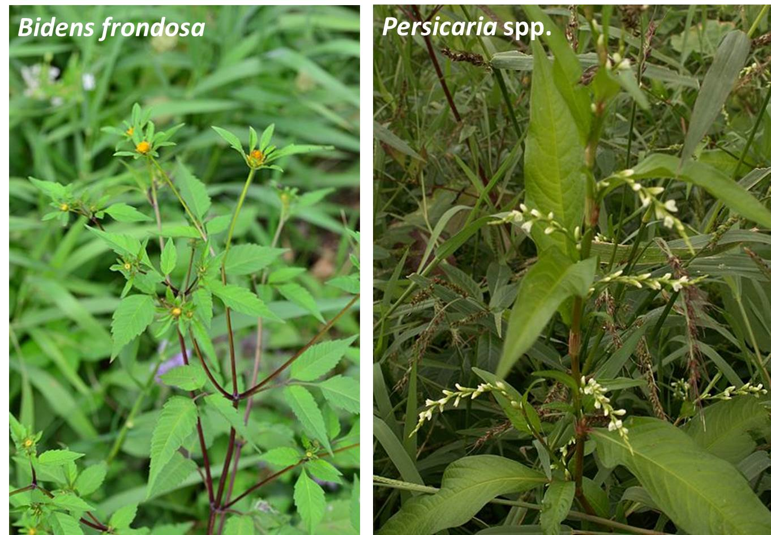
Figure 5. Common annual plants of ephemeral ponds, including Bidens frondosa (devil beggar’s ticks, photo by Radio Tonreg, https://commons.wikimedia.org/wiki/ File:Bidens_frondosa_ (7993113777).jpg) and Persicaria spp. (smartweed, photo by Aroche, https://commons.wikimedia.org/ wiki/File:Polygonum_ hydropiper1.jpg).

Wood frogs, fairy shrimp, and blue-spotted salamanders are ephemeral pond specialists, but many of the other species also thrive in permanent wetlands. Permanent wetlands tend to be larger and provide a wider variety of microhabitats. They also have greater primary productivity due to more light availability (Figure 6).
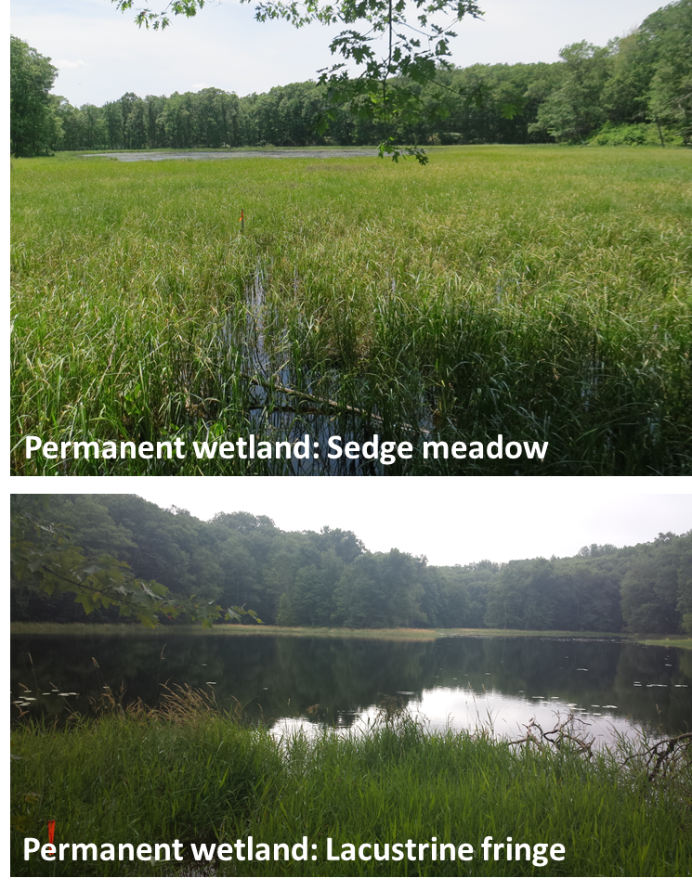
Figure 6. Examples of permanent wetlands from this study. Sedge meadows (wetland P7A) are dominated by sedges (Carex spp.) and have shallower water depths than lacustrine fringe wetlands (wetland N2B), which consist of a narrow band of vegetation surrounding deeper water. (Photos by A.M. Little)
In this study, green frogs, leopard frogs, and newts are more common permanent wetland specialists. Larger macroinvertebrates like water tigers, water scavenger beetle larvae (Hydrophilidae), and giant water bugs find plentiful food resources in these larger systems (Figure 7).
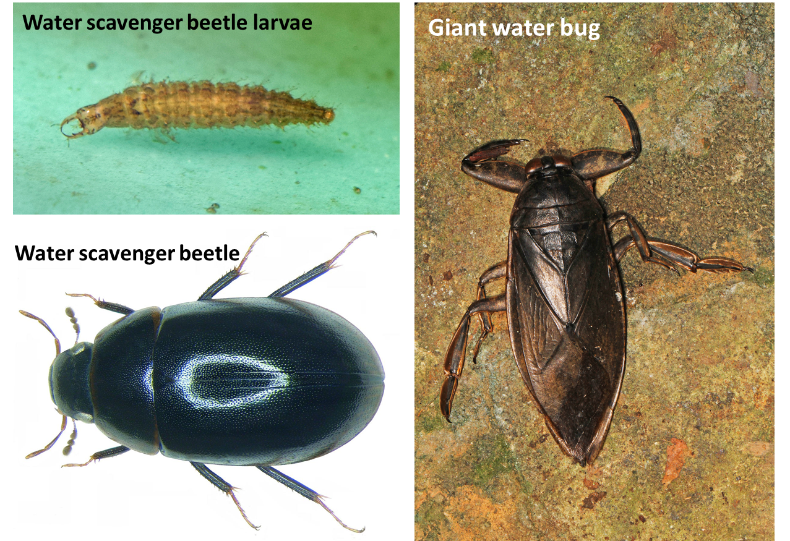
Figure 7. Examples of macroinvertebrate taxa found in permanent wetlands, including water scavenger beetles (Hydrophilidae, photos by Fredlyfish4, https://commons.wikimedia.org/wiki/File:Tropisternus_lateralis_larva.jpg, and Udo Schmidt, https://commons.wikimedia.org/wiki/File:Cymbiodyta_marginella_(Fabricius,_1792)_(3408978961).jpg) and giant water bugs (Belastomatidae, photo by Judy Gallagher, https://www.flickr.com/photos/52450054@N04/13166303263).
Permanent wetlands also tend to have more abundant vegetation due to greater light availability. Common groups in this study include various wetland sedges, cattails, reed canarygrass, and shrubs such as leatherleaf (Figure 8).
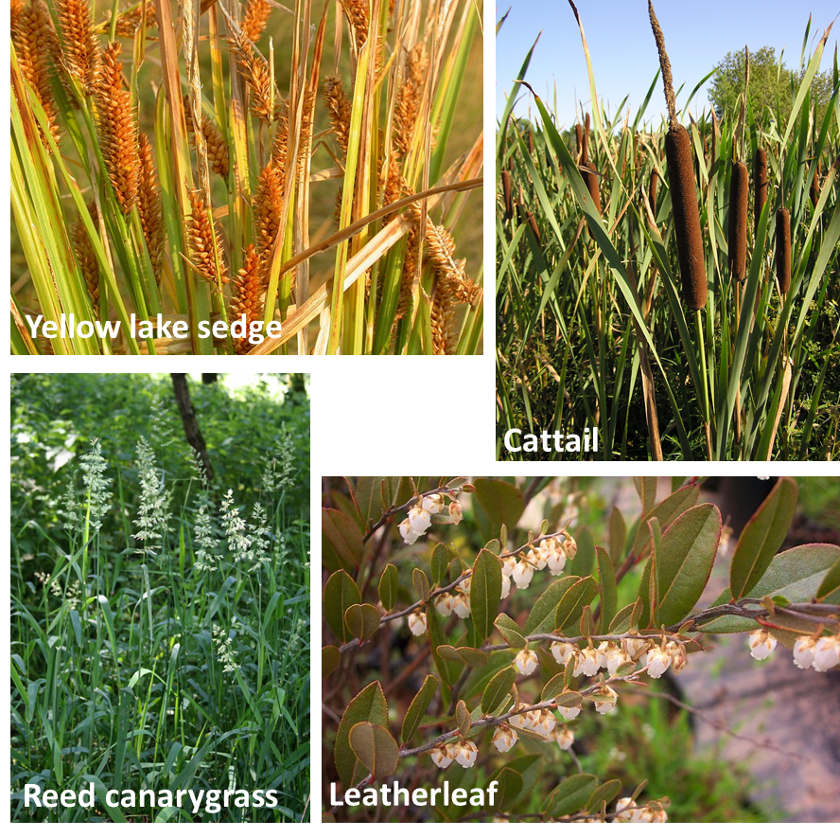
Figure 8. Examples of plants common in permanent wetlands, including yellow lake sedge (Carex utriculata, photo by Matt Lavin, https://commons.wikimedia.org/wiki/File:Carex_utriculata_(4155807958).jpg), broad-leaved cattail (Typha latifolia, photo by Le.Loup.Gris, https://commons.wikimedia.org/wiki/File:Typha_latifolia_(habitus)_2.jpg), reed canarygrass (Phalaris arundinacea, photo by Franz Xaver, https://commons.wikimedia.org/wiki/File:Phalaris_arundinacea_2.jpg), and leatherleaf (Chamaedaphne calyculata, photo by magnolia1000, https://commons.wikimedia.org/wiki/File:Chamaedaphne_calyculata_(2).jpg).
Species richness
Species richness is the number of different species in a given area. It is typically considered a community-level attribute. A basic and much-discussed question in ecology is why some areas have more species than others. For conservation purposes, it is important to know which types of habitats support more species. Because hydrology (water level) is so important to wetland organisms, it is informative to evaluate how hydrologic fluctuations/extremes can affect the biotic and abiotic aspects of wetlands. In this case, we will determine how the relationships between species richness and environmental factors may differ between ephemeral and permanent wetlands.
Some common factors that affect species richness include:
Theory of Island Biogeography: In general, the larger the area of an “island”, the more species it will support (MacArthur and Wilson 1967). There tend to be more resources, more heterogeneous habitats, and more sustainable population structures in larger areas. In addition, islands that are closer geographically to a large source mainland or other island may have more species because they are easier to colonize (MacArthur and Wilson 1963). In this study, the wetlands are considered “islands” in the surrounding upland.
Intermediate Disturbance Hypothesis: The level of disturbance, stress, and competition in the community. Generally, the higher level of stress or disturbance a community experiences, the lower the species richness. On the other extreme, areas with very low levels of stress or disturbance are associated with increased competition, which can also lead to lower species richness. As a result, intermediates levels of disturbance/stress can lead to higher levels of species richness (Connell 1978), although there is some debate in the literature (Fox 2013). In this study, the wetlands vary from fairly stable water levels in permanent wetlands to more variable hydroperiods in ephemeral ponds. Permanent wetlands could be considered less hydrologically “disturbed” than ephemeral wetlands.
Environmental heterogeneity: Different species frequently have different requirements for survival and reproduction. The greater the variety of habitats that a wetland provides, the greater number of niches available for different species (Menge and Sutherland 1976).
In this study, we do not measure any of these variables directly except wetland area. Rather, we measure specific environmental variables that reflect possible stress or resource levels. For example, water depth may act as a stressor variable for plants, in accordance with the intermediate disturbance hypothesis. Plants in wetlands with too little water may experience drought stress, while few plants may be able to survive in wetlands with very deep water levels.
Definitions of the environmental variables are provided in the associated MSExcel files, along with suggestions about how the affect resources and stress levels in the wetlands.

Linear Models
Many people think that a model has to be complicated or physical (such as a model plane) in nature. A scientific model is simply a description of how we think the world works and allows us to predict what might happen in the future. A linear model is a line that illustrates the relationship between two variables, typically represented by an equation (Figure 5). Sometimes a linear model is an appropriate representation of a relationship, but sometimes a non-linear model is a better fit. Today we will be exploring linear models, but that does not mean that all relationships can be modeled linearly.
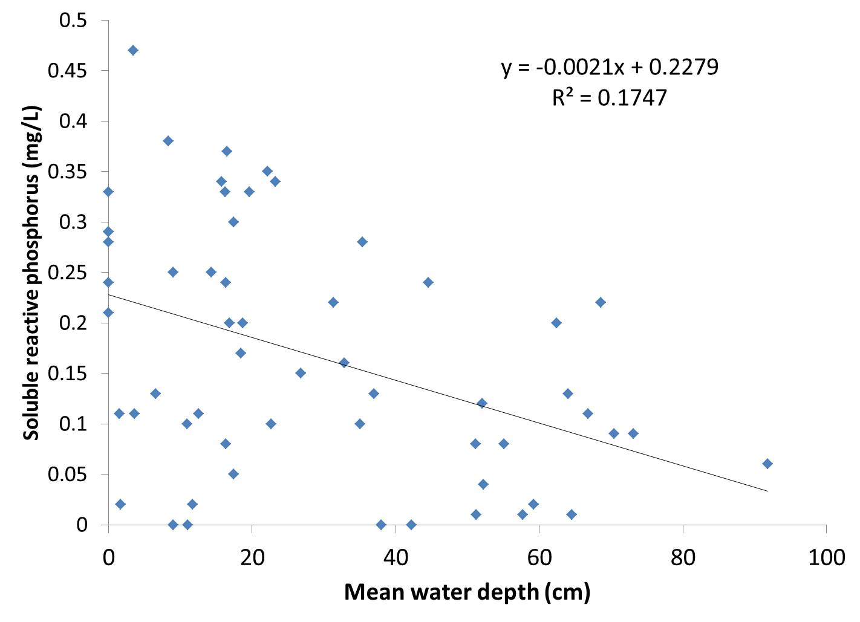
Figure 9. Linear model of the relationship between wetland water depth and soluble reactive phosphorus (SRP) concentrations. The equation describes the line and the R² value describes the scatter of points around the line.
The equation is in the form y = mx + b, where
- y = response variable value
- x = explanatory variable value
- m = slope of the line
- b = y-intercept of the line (where it crosses the y-axis)
Slope (m): models how fast or in what direction y changes with every change in x (Figure 6).

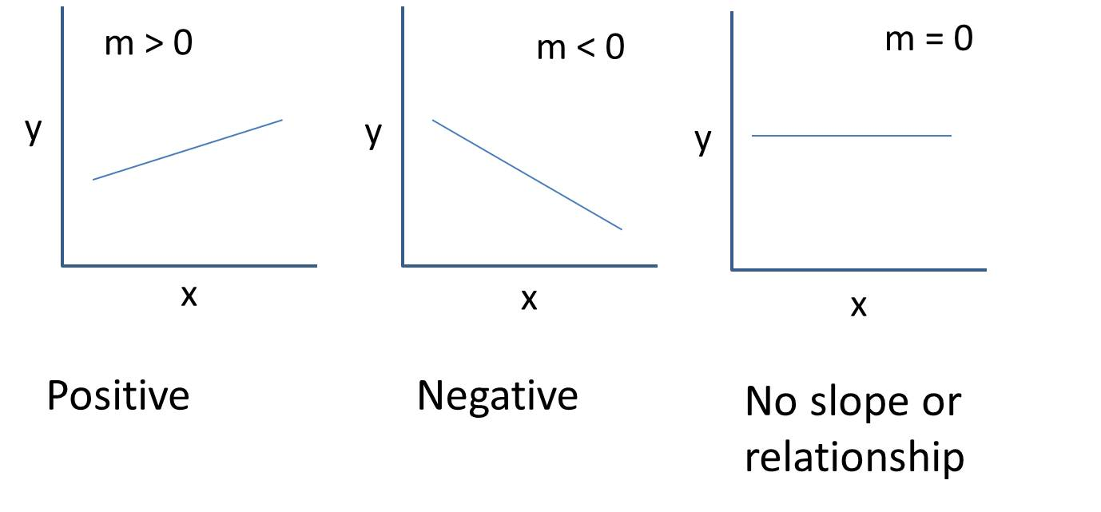
Figure 10. Positive relationship, negative relationship, and no relationship.
Intercept (b): models the value of y when x is zero (Figure 7).
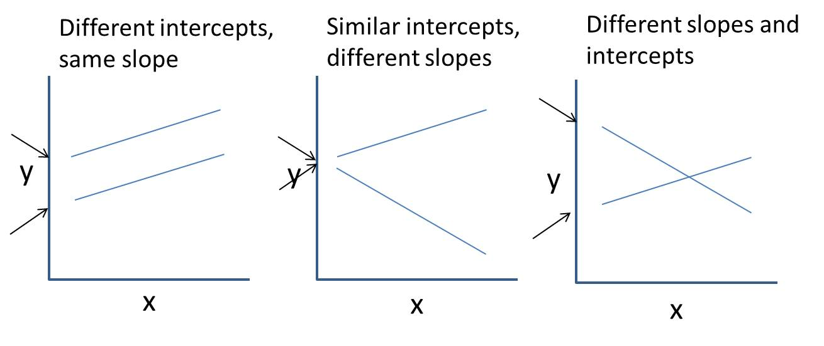
Figure 11. Illustration of linear models with different slopes and intercepts. Arrows indicate the approximate intercept locations.
R²: models how well the linear model (line) fits the data points. In other words, how “spread” the data are away from the line. R² ranges from 0 to 1. In general, the higher R², the better the linear fit (Figure 8).
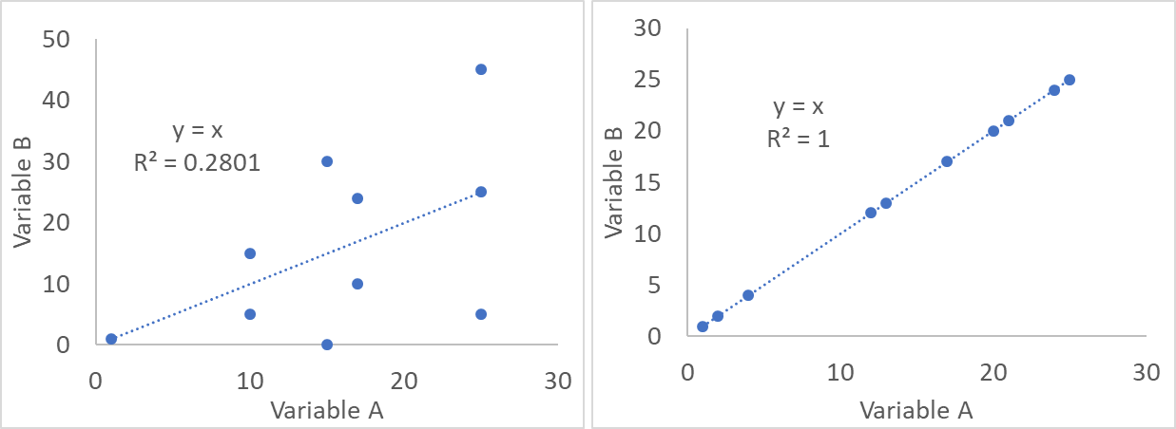
Figure 12. Linear model with a moderate R² (0.2801) showing poorer model fit and a high R² (1.0) showing ideal model fit with the data.
Linear models are typically tested statistically by determining whether the slope is significantly different from zero (a flat horizontal line). We will NOT be doing that in this activity due to the amount of data manipulation and assumptions-testing needed. However, we will be investigating the relative slopes, intercepts, and R² values (how well the lines fit the data points).

The study site
In this activity you will explore a set of data from 57 wetlands: 33 ephemeral ponds and 24 permanent wetlands. You will create and compare linear models of species richness between:
- Ephemeral and permanent wetlands
- Plant species and aquatic macroinvertebrate taxa
You will then share your results with other students asking questions about different environmental variables.
The study site is a hilly wooded area located in the Ice Age National Scientific Reserve located in northwestern Wisconsin (Figure 9). The region is part of the Chippewa Moraine, formed during the last Ice Age. Most of its wetlands are perched on a clay or thick glacial till substrate. Permanent and ephemeral wetlands are interspersed across the landscape, and permanent wetlands tend to be larger than ephemeral (Figure 10).
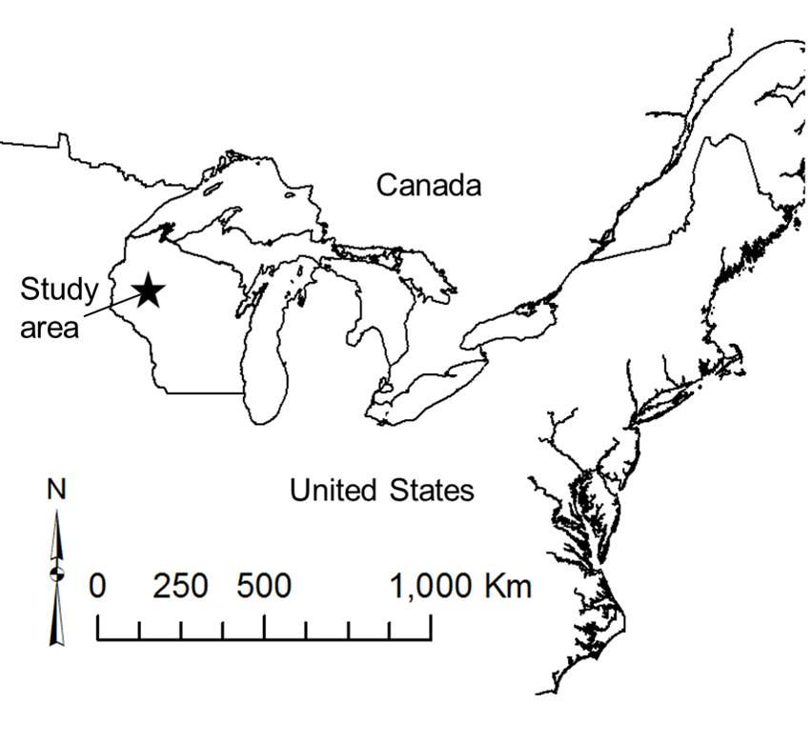
Figure 13. Study area is in the Ice Age National Scientific Preserve, New Auburn, Wisconsin, United States.
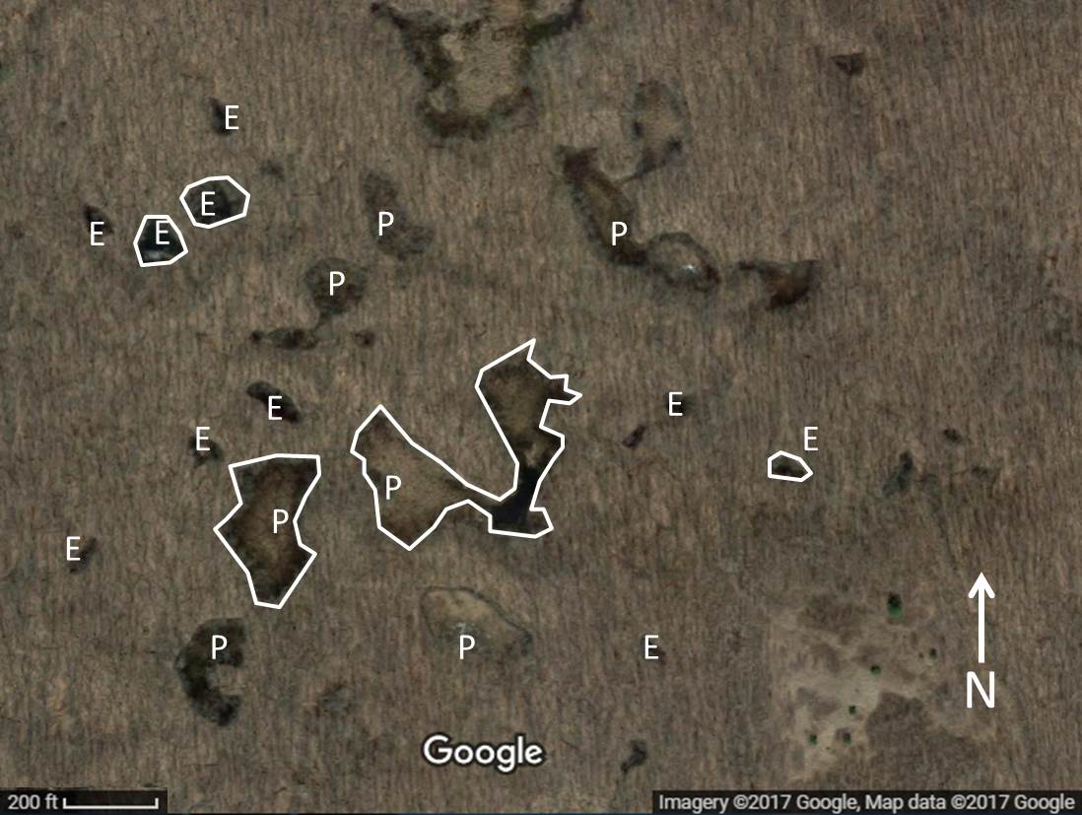
Figure 14. Aerial photograph showing the distribution of permanent and ephemeral wetlands in a portion of the study area. Wetlands sampled in this study are outlined in white. The photograph was taken in spring, with leaves off the trees. E = Ephemeral pond, P = Permanent wetland.
Types of data from the Chippewa Moraine Ephemeral Ponds Project
57 wetlands: 33 ephemeral, 24 permanent. These variables are defined in the spreadsheets.
- Environmental data
  - Hydrology:
    - Quadrat water level means
    - Mean staff gauge water depth
    - Standard deviation of staff gauge water depth
  - Geomorphology
    - Wetland area
    - Wetland elevation
    - Peat depth
  - Vegetation
    - Percent-cover of Sphagnum moss
    - Canopy cover (percent-cover)
  - Water chemistry
    - Dissolved oxygen (DO)
    - Temperature
    - pH
    - Specific conductivity (measure of the total ions in the water)
    - Total phosphorus
    - Soluble reactive phosphorus (measure of only the dissolved/soluble P)
    - Ammonium
    - Nitrate
    - Chlorophyll-a (measure of algal growth)
- Vegetation data
  - Percent-cover of plants in quadrats, identified to species level
- Macroinvertebrate data
  - Surface-Associated Activity Traps; 3 sampling periods per spring/summer with 3-5 traps per wetland, lowest taxonomic order identified counts

Student Questions
Part 1: Hypothesis Generation
1. Check out the study area. Go to Google Maps and type in “Chippewa Moraine State Recreation Area”. Switch to satellite view and zoom out. What do you notice about the topography and distribution of wetland areas?

2. What types of environmental stresses or disturbances would you expect to be present in each of these wetland types? Why types or amounts of competition between taxa would you anticipate (e.g., large competition for light).
Ephemeral ponds:

Permanent wetlands:

3. Speculate as to how plant and aquatic macroinvertebrate richness might differ between ephemeral and permanent wetlands. Provide your reasoning.

State this speculation as a hypothesis:
4. Which environmental variable do you think has the most impact on the species richness of plants and aquatic macroinvertebrates? Why? (Note: your instructor may assign you a variable).

5. Speculate how this environmental variable differs between ephemeral and permanent wetlands. Do some internet research and provide your reasoning.

State this speculation as a hypothesis:

6. You will be comparing the relationship between this variable and species/taxa richness in both ephemeral and permanent wetlands. Do you think that the relationship will be the same or different in these two types of wetlands and why?

7. Visualize it! Draw your hypothesis and label the graphs below with:
- Axes
- Lines showing whether species richness increases or decreases with your abiotic variable. Pay particular attention to the slope and intercept.
Plant species richness
Ephemeral Ponds: Permanent Wetlands: Explanation:

Aquatic macroinvertebrate taxa richness
Ephemeral Ponds: Permanent Wetlands: Explanation:

Which variable is your explanatory (independent) variable?
Which variables are your response (dependent) variables?

Part II: Create graphs to determine how the data compares to your hypotheses.
Visualize the relationship between plant species richness and your explanatory variable for the ephemeral wetlands by making a graph in the graphing software of your choice (such as R or Excel). In Excel, you can “add a trendline” as a model of the linear relationship between your two variables. Try to put permanent and ephemeral data on the same graph, with two lines (in Excel, these are called “series”).
8. Describe your findings. SAVE YOUR GRAPHS FOR YOUR PRESENTATION!
Relationship: Plant Species Richness vs_______________________
Ephemeral wetlands | Permanent wetlands
Rough drawing of graph: | Rough drawing of graph:
Slope:  Describe (flat, positive, negative) | Slope:  Describe (flat, positive, negative)
Interpretation of slope: | Interpretation of slope:
Relative intercept (high, low, same): | Relative intercept (high, low, same):
R² value and interpretation: | R² value and interpretation:
Overall interpretation of graph: | Overall interpretation of graph:

9. Inspect your graphs again. Do any graphs have data points that appear to be “outliers” (distant from other observations)? (Note: There are formal statistical tests to determine whether points are outliers and can be discarded. They should not be discarded without thorough consideration.) How do you think these points are affecting the slope of the line and your interpretation?

10. Given outliers, R² values, and the slope of your lines, are there strong relationships between plant species richness and the environmental variable that you chose? Why or why not?

11. Summarize your results for plant species richness, comparing ephemeral and permanent wetlands.
Now repeat these steps for macroinvertebrates. Try to put permanent and ephemeral data on the same graph, with two lines. SAVE YOUR GRAPHS FOR YOUR PRESENTATION!
12. Relationship: Macroinvertebrate Species Richness vs_______________________
Permanent Wetlands | Ephemeral wetlands
Rough drawing of graph: | Rough drawing of graph:
Slope:  Describe (flat, positive, negative) | Slope:  Describe (flat, positive, negative)
Interpretation of slope: | Interpretation of slope:
Relative intercept (high, low, same): | Relative intercept (high, low, same):
R² value and interpretation: | R² value and interpretation:
Overall interpretation of graph: | Overall interpretation of graph:

13. Inspect your graphs again. Do any graphs have data points that appear to be “outliers” (distant from other observations)? (Note: There are formal statistical tests to determine whether points are outliers and can be discarded. They should not be discarded without thorough consideration.) How do you think these points are affecting the slope of the line and your interpretation?

14. Given outliers, R² values, and the slope of your lines, are there strong relationships between macroinvertebrate taxa richness and the environmental variable that you chose? Why or why not?

15. Summarize your results for macroinvertebrate taxa richness, comparing ephemeral and permanent wetlands.

Part III: Explaining Results
16. What ecological processes might be responsible for the relationships that you found between plant species richness and your environmental variable? Be specific in differentiating between ephemeral and permanent wetlands.

17. What ecological processes might be responsible for the relationships that you found between macroinvertebrate taxa richness and your environmental variable? Be specific in differentiating between ephemeral and permanent wetlands.

18. Ephemerality and permanency both bring different habitat challenges for organisms. How might the specific challenges of the ephemeral habitats have affected your results?

19. Think about the differences in basic survival and reproduction requirements between macroinvertebrates and plants. How do you think these requirements may have affected any differences in your findings between the two groups?

20. Species/taxa richness was notably higher in one of the wetland types than the other. Using the methods of this activity, can you differentiate the effects of ephemerality versus that of wetland size alone? Why or why not?

21. Can you conclude anything about causation from your findings? What other environmental variables could correlate with the one you chose and possibly be affecting species richness?

22. Thought question: Plants were identified to the species level, while macroinvertebrates were identified only to order or family. This means that one macroinvertebrate taxa may equal ten or more species (or not). How would your graph change if we had identified macroinvertebrates to species?

How does this affect the validity of your findings? Why?

Part IV: Species Composition
Species richness is only one measure of community structure. Two wetlands could have identical species richness values, but different community compositions. This distinction is especially important when most of the species richness in a community is composed of invasive species. We have provided abundance values for a few key species in the “Community Composition” worksheet.
23. Examine the definitions of species on the “Definitions” worksheet. Then, sort the data in the “Community Composition” worksheet by taxonomic richness for macroinvertebrates. Inspect groups of wetlands that have the same taxonomic richness levels. Enter your findings in the table below.
Wetlands | Taxonomic richness | Number of taxa in common

24. Inspect whether these wetlands are ephemeral or permanent. Do you see any patterns?

25. Do the same exercise for plants.
Wetlands | Taxonomic richness | Number of taxa in common

26. Reed canarygrass (Phalaris arundinacea) is a highly invasive grass species. From a management perspective, why would knowing something about species composition and not just species richness be important?

27. Is knowing about taxonomic richness alone enough to describe an ecological community for conservation purposes? Why or why not?

Summary Activity: Present Your Results
Put together a 3-5 minute presentation on your findings. The presentation should include the following:
- Some background (1 slide) on your environmental variable of interest and why it might be important and/or differ in permanent and ephemeral wetlands.
- Your graphs. Try to put both permanent and ephemeral graphs on the same slide or both lines on the same graph so that you can compare.
  - Describe your analysis of the slope, intercept, and R² of your lines.
  - Describe what the lines mean for the relationship between your variable and species richness.
- Your ideas about why the relationships might differ or be the same between permanent and ephemeral wetlands.
- Your ideas about why the relationships might differ or be the same between plants and macroinvertebrates.

Part IV: Extensions and Variations:
For less advanced students, several options exist:
- Choose to compare either plants or macroinvertebrates, but not both. Students could then share their results and discuss differences as a class.
- Students could compare richness means instead of investigating relationships. They would create bar graphs instead of scatterplots with lines. The means in permanent wetlands are significantly higher than those of ephemeral ponds for both groups. Focus could then be on why.
For more advanced students, several options exist:
- Two years of data are provided: 2013 and 2014. Students could compare relationships between years. 2014 was a much wetter year than 2013.
- Students could conduct statistical tests of the linear relationships.

Literature Cited

Arar, E. J. 1997. Method 446.0: In vitro determination of chlorophylls a, b, c1 + c2 and pheopigments in marine and freshwater algae by visible spectrophotometry. U.S. Environmental Protection Agency, Cincinnati, OH.
Colburn, E. A. 2004. Vernal pools: natural history and conservation. McDonald & Woodward Pub. Co.
Connell, J. H. 1978. Diversity in Tropical Rain Forests and Coral Reefs. Science 199:1302–1310.
Fox, J. W. 2013. The intermediate disturbance hypothesis should be abandoned. Trends in Ecology & Evolution 28:86–92.
MacArthur, R. H., and E. O. Wilson. 1963. An equilibrium theory of insular zoogeography. Evolution 17:373–387.
MacArthur, R. H., and E. O. Wilson. 1967. The theory of island biogeography. Princeton University Press, Princeton, NJ.
Menge, B. A., and J. P. Sutherland. 1976. Species Diversity Gradients: Synthesis of the Roles of Predation, Competition, and Temporal Heterogeneity. The American Naturalist 110:351–369.
O’Dell, J. W. 1993. Method 365.1, Revision 2.0: Determination of phosphorus by semi-automated colorimetry. U.S. Environmental Protection Agency, Cincinnati, OH.
Semlitsch, R. D., and D. K. Skelly. 2008. Ecology and conservation of pool-breeding amphibians. Pages 127–147 in A. J. K. Calhoun and P. G. DeMaynadier, editors. Science and conservation of vernal pools of Northeastern North America. CRC Press, Boca Raton, FL.
U.S. EPA. 1978. Method 365.3: Phosphorus, all forms (colorimetric, ascorbic acid, two reagent). U.S. Environmental Protection Agency.

Notes to Faculty
Student Audience: This activity is geared toward freshman and sophomore-level students in a basic ecology or introductory biology course. However, it could also be used as an activity in an upper-level wetland ecology course – with the expectation of accelerated timeframe and more advanced answers.
Prior Knowledge: Students should have prior knowledge about species richness concepts and the ideas of disturbance, stress, and competition in an ecological context. Additional information about how to construct graphs in MSExcel, R, or some other software must be provided by the instructor. The instructor should also introduce the concepts of “slope” and R² to the students. These concepts can be introduced at the beginning or after initial hypothesis development and prior to graphing.
Logistics:
The entire activity could take up to three hours in a lab period. However, it can be broken into pieces to accommodate shorter time frames. There are multiple options for running this activity.
- Students could work alone or in pairs. If working in pairs, one student could work on plants and the other on macroinvertebrates.
- Students could work on it in class for a 1-2 hour time period and work on the presentation outside of class.
- The entire activity could be introduced in class and attempted as homework.
- Another option is to have the students combine this activity with hands-on collection of macroinvertebrate and chemical data in a local wetland.

Running the Assignment
Instructors should decide whether to use the 2013 or 2014 data (or both) prior to beginning the activity and make only that data set available to students.
Part I: Introduction and Hypothesis Development:
The introduction to the project should include an introduction to ephemeral ponds and an overview/reminder of species richness concepts. A powerpoint is included that instructors can use. A video of macroinvertebrates, including fairy shrimp, swimming in ephemeral ponds is also included. Students should then complete questions 1-3. They can this discuss in small groups and report back to class. Emphasize the challenges of shade (for plants) and hydrologic fluctuations for ephemeral wetlands, and possible competition and deep water in permanent wetlands.
Instructors should then introduce students to the data set(s), showing them the abbreviation page and then discussing what might be some of the more confusing variables, such as chlorophyll-a, conductivity, dissolved oxygen, total phosphorus and soluble reactive phosphorus. Students should then complete questions 4-6 and discuss very briefly in pairs.
Next, the instructor should do a short presentation on linear models, including the concept of outliers, using the material in the student handout and have students do question 7.
Part II: Creating Graphs:
Students should then complete Part II. If using Excel, students will need to sort the data into ephemeral and permanent classes prior to graphing. Remind students to save their graphs!! If working in Excel, students may also struggle putting both lines on the same graph.
It may be helpful for the instructor to do an example, filling in the table, so that the students know exactly what is expected.
This portion could be split into pairs of students (one working on macroinvertebrates and one on plants) and then they could share their data.
Be sure to walk around in the class asking students questions about their findings.
Part III: Explaining Results:
This section contains a substantial amount of speculation. Students may be reluctant to speculate because there are no clear-cut right and wrong answers. I share some ideas to watch for here and in Table 1. Think-pair-share can be used heavily with these questions.
Questions 16/17. Students may be unclear as to what ecological processes are. You could go through question 16 as a class with an example and then have students do their own. In some cases the process may be the same in ephemeral and permanent wetlands if there is a similar slope. If there are different slopes, then chances are that the process is different (Table 1).
Question 18. Students should emphasize the challenges of shade, small wetland size (dispersal) and water level fluctuations for ephemeral wetlands. They should emphasize deeper water (lack of oxygen) and competition in permanent wetlands. Permanent wetlands tend to have higher species richness in general (higher intercepts) and so the challenges of the ephemeral pond environment or dispersal seem greater.
Question 19. Students should emphasize that plants are non-motile and may be affected more greatly by deeper water depths (lack of oxygen) than macroinvertebrates that can swim at the surface. Shade also tends to be a greater challenge for autotrophs than heterotrophs.
Question 20. Since ephemeral ponds are both ephemeral and smaller in size, it is difficult to differentiate why there is lower species richness. That is the problem with correlation relationships.
Question 21. The short answer is “no”. For example, DO and temperature are typically correlated. SRP, TP, ammonium, and nitrate, which are all ions, may be correlated with specific conductivity. Many of the water chemistry variables are correlated with water depth.
Question 22. Certainly the Y-values for the points and the intercept of the line would be greater. The validity of the macroinvertebrate findings is lower because we do not know how many species are in each taxonomic group. Some groups may have one; some may have twenty or more.
Question 23. Students should just look at a few groupings of identical species richness. They don’t need to report all of them to get the point.
Question 24. Anisoptera (dragonflies) tend to be more common in permanent wetlands, as a top predator. As mentioned in the text, Eubranchipus, fairy shrimp, are ephemeral pond specialists.
Question 25. (Same as 23). Make sure that students look at the species definitions to see that they all have different attributes.
Question 26. Students should recognize that knowing about invasive species composition lets managers act against infestations if desired.
Question 27. They should understand that species richness data alone are not enough to describe a community. In this example, communities can be of different quality (with invasives vs. not) and dramatically different type (permanent vs. ephemeral). It is not enough to simply identify the wetlands with the highest richness for conservation.
Summary Presentation:
During the summary presentation portion, instructors should ask students in the class as a whole to compare findings between different variables. Be sure to ask the student why they think variable X affected species richness but variable Y did not. If you have a large group of students, have them present in groups of 2-3.
Following the presentation, students should write a short reflection paragraph about what they learned from this activity.
Outcomes/Results
The files PlantResults.docx and InvertResults.docx contain graphs for both 2013 and 2014 data for all environmental variables.
Permanent v Ephemeral Wetlands: The permanent wetlands have higher intercepts than the ephemeral ponds. This may be due to the larger area of the permanent wetlands, a greater diversity of habitat present within the larger permanent wetlands, and/or a more hospitable habitat (less hostile hydrologic conditions) present within the permanent wetlands.
Assigning variables and outcomes (2013 data only): If you are interested in ensuring that your students have interesting comparisons, consider including the combinations in Table 1.
Table 1. Variable combination results and possible rationales for linear relationships with plants (P) and macroinvertebrates (M).
Environmental Variable | Pattern | Possible Rationale
Water depth | P have a negative slope, while M have a positive. | Relate to P immobility and need to get oxygen to roots. M are mobile and not rooted in an anaerobic substrate.
Staff gauge depth | Same as water depth
Chlorophyll-a | Ephemeral P have a steeper slope than Permanent P | This relationship is not strong. Chl-a responds to nutrient and light levels. There may be a greater change in ephemerals due to a larger gradient in shade to sun.
Dissolved oxygen | Steeper slopes in M than P | M are more sensitive to dissolved oxygen than P. P photosynthesize and transport oxygen internally.
pH | P have a negative slope, M have a mixture | For P, some of the more species rich wetlands had less water and more acidic conditions.
SRP (soluble reactive P) | P have a negative slope, M have a mixture | Wetlands that dry very quickly had the highest SRP levels (due to decomposition), which may limit plant and macroinvertebrate species.
Specific conductivity | For P, ephemeral have a negative slope, permanent have a positive. For M, ephemeral have a steeper negative slope. | Many of the ephemeral wetlands that have high spc (2 points dominate) are quite small with very shallow water depths and substantial shade. The rapid drying leads to increased decomposition and substantial contact with mineral soil. For permanent wetlands, P have a positive slope because the deeper water wetlands with low spc have fewer species.
Temperature | P increase while M are flat. | Temperature can also be traced back to water depth. Shallower, sunnier wetlands had higher P richness and higher temp.
TP (total phosphorus) | For M and P, the relationship is negative. For P, ephemerals slightly more negative. | See SRP
Wetland area | P have positive slopes with ephemerals steeper than permanent. M have flat slopes | Very small ephemeral wetlands have a combination of shade and water fluctuations that can be stressful to plants. Sunlight increases quickly with small increases in area in ephemeral wetlands, resulting in a steeper slope. M may not have a strong relationship due to dispersal effects (wetlands are not really “islands” due to flight), or being measured at larger taxonomic levels.
Elevation | Positive slopes in permanent wetlands, negative or flat in ephemeral for both P and M | For P, permanent wetlands that were lower elevation tended to be lacustrine-fringe type low richness wetlands (ponds), while higher elevation wetlands had more peat and tended to be more acidic with higher richness. The flat slope P for ephemeral wetlands may relate to a lack of peat accumulation. With M, ephemerals with higher elevation may have fewer dispersers or lower water depth.
Canopy cover | Strong negative slopes in both P and M | Could be tied to resource (light) availability at low trophic levels.

Other variables have less interesting relationships with species richness.
Student Evaluation
1. Instructors can have the students complete the worksheet above and submit it for points. Some suggestions for things to look for while grading the discussion questions are given in red above.
2. Student presentations can be graded using the following rubric (out of 10 points)
- Clearly stated hypothesis and reason for hypothesis (1 point)
- Clearly showed predicted outcomes (1 point)
- Clearly presented results (2 points)
  - Graph(s) are easy to see and labeled properly
  - Slope, intercept and R2 properly described
- Explained ecological speculations about results (why they got those results, 2 points)
- Summarized their overall findings into a take-home message for the class (1 point)
- Maintained eye contact and spoke clearly to the class (1 point)
- Time limit: 5 minutes (2 points)
3. Students can write up a short summary paragraph about what they learned from the activity to be submitted quantitatively or simply for completeness. Suggestions for what to look for in the summary paragraph include:
- Complete sentences
- The three concepts of linear modeling introduced: slope, intercept and R² described appropriately
- Correct description of factors that affect species richness
- Correct description/interpretation of how habitat ephemerality may affect species richness

Advanced Additions/Extension: Cross-Year Comparisons:

A cross-year data comparison would examine the differences between an average (2013) and high (2014) precipitation year. The expectation is that some relationships between taxa richness and environmental variables might change.

Students should first connect what increased precipitation and flooding (in 2014) might mean for the environmental variable of interest, and then connect that change to taxonomic richness.

For example, the relationship between macroinvertebrate richness and specific conductance is different in 2013 compared to 2014 (see InvertResults.docx file). For ephemeral ponds, the relationship is negative in 2013 and neutral to positive in 2014. Specific conductance is as measure of the concentration of ions in water. Ephemeral wetlands that had higher specific conductance in 2013 most likely dried more quickly with lower macroinvertebrate richness as a result. In 2014, very few of the ephemeral ponds dried, and wetlands with higher specific conductance may have had a larger diversity of shallow-water habitats or been able to provide more ionic nutrients to macroinvertebrates. In addition, precipitation has a lower concentration of ions compared to groundwater. Ephemeral wetlands with higher relative precipitation contributions to their water budgets (possibly shallower) may have higher richness, which was accentuated in a high precipitation year.

Table 2. Interesting relationships for cross-year comparison (EP = ephemeral pond and PW = permanent wetland).

Macroinvertebrates | Plants
Dissolved oxygen (Dissolved oxygen was higher in 2013, in line with the cooler water temperatures in permanent wetlands in 2013. This is most likely due to an increased warm precipitation: cold groundwater ratio in the water budget. Lacustrine fringe-type permanent wetlands had the highest DO levels in 2013 and tend to have lower macroinvertebrate richness. This trend was | Dissolved oxygen (probably not direct causation. Higher DO levels are found in deeper lacustrine fringe wetlands whose vegetation was more affected by flooding in 2014)
Nitrate (may be lower in EPs in 2014 due to lack of oxidizing environment)
Specific conductance (see previous paragraph) | Specific conductance (probably not direct causation. Some more precipitation-dependent wetlands, such as bogs, had higher species richness. The conductivity in the wetlands declined dramatically in 2014 due to ion dilution, resulting in a more negative relationship in 2014).
Wetland area (larger EPs sustained more water and higher richness in 2013, but this relationship became negative in the high-water year, possibly due to lower diversity of habitats within the wetland).
 | Temperature (probably not direct causation. Lacustrine fringe-type permanent wetlands have lower plant species richness. These wetlands increased in temperature the most in 2014, probably due to an increased warm precipitation: cold groundwater ratio in the water budget.

Student instructions:

In this extension, you will compare taxonomic richness-environment relationships between two years with dramatically different precipitation. 2013 was an average precipitation year (mean wetland water depth = 7.5 cm, SE = 1.4 cm), but 2014 was significantly above-average (mean wetland water depth = 28.5 cm, SE = 3.2 cm, P < 0.001, paired T = 2.00, df = 56). Only two ephemeral ponds did not dry in 2013, whereas 14 did not dry in 2014. The water levels in permanent wetlands also increased dramatically, resulting in smaller lacustrine fringes, for example.

These differences between years mean that relationships may change for multiple reasons, including:

- Ephemeral ponds may have more similar water level variation to permanent wetlands in 2014.
- Numerous environmental variables, such as dissolved oxygen, specific conductivity, and pH change in response to higher water volumes.
- Different species may thrive in different environmental conditions. For example, species that are desiccation-tolerant may be less successful when ephemeral ponds do not dry.

- Select an environmental variable that interests you. It could be the same variable that you used in your original analysis. How do you think that it would change from 2013 (average water depth year) to 2014 (wet year) and why?

- Do you think that this change would be more or less dramatic in ephemeral compared to permanent wetlands? Why?

- Choose either plants or macroinvertebrates. Hypothesize how taxonomic richness relationships with your environmental variable would change for ephemeral ponds (e.g., how would the slope or relative intercept of the line change?) Provide a rationale for your hypothesis.

- Do the same for permanent wetlands.

- In order to test your hypothesis, run similar analyses to those you did in the original assignment and complete the table below for ephemeral ponds.
Relationship: Richness vs_______________________
Ephemeral wetlands in 2013 | Ephemeral wetlands in 2014
Rough drawing of graph: | Rough drawing of graph:
Slope:  Describe (flat, positive, negative) | Slope:  Describe (flat, positive, negative)
Interpretation of slope: | Interpretation of slope:
Relative intercept (high, low, same): | Relative intercept (high, low, same):
R² value and interpretation: | R² value and interpretation:
Overall interpretation of graph: | Overall interpretation of graph:

- What happened to the richness-environment relationships in ephemeral wetlands?

- Why do you think this happened? Connect your reasoning back to changes in your environmental variable that occur with changes in water depth.

- Do the same analysis for permanent wetlands.

Relationship: Richness vs_______________________
Permanent wetlands in 2013 | Permanent wetlands in 2014
Rough drawing of graph: | Rough drawing of graph:
Slope:  Describe (flat, positive, negative) | Slope:  Describe (flat, positive, negative)
Interpretation of slope: | Interpretation of slope:
Relative intercept (high, low, same): | Relative intercept (high, low, same):
R² value and interpretation: | R² value and interpretation:
Overall interpretation of graph: | Overall interpretation of graph:

- What happened to the richness-environment relationships in permanent wetlands?

- Why do you think this happened? Connect your reasoning back to changes in your environmental variable that occur with changes in water depth.

- Which had more dramatic changes - permanent wetlands or ephemeral ponds? Was this surprising or expected and why?

- Direct or indirect causation? Which of the diagrams below do you think is the most accurate representation of the system and why?
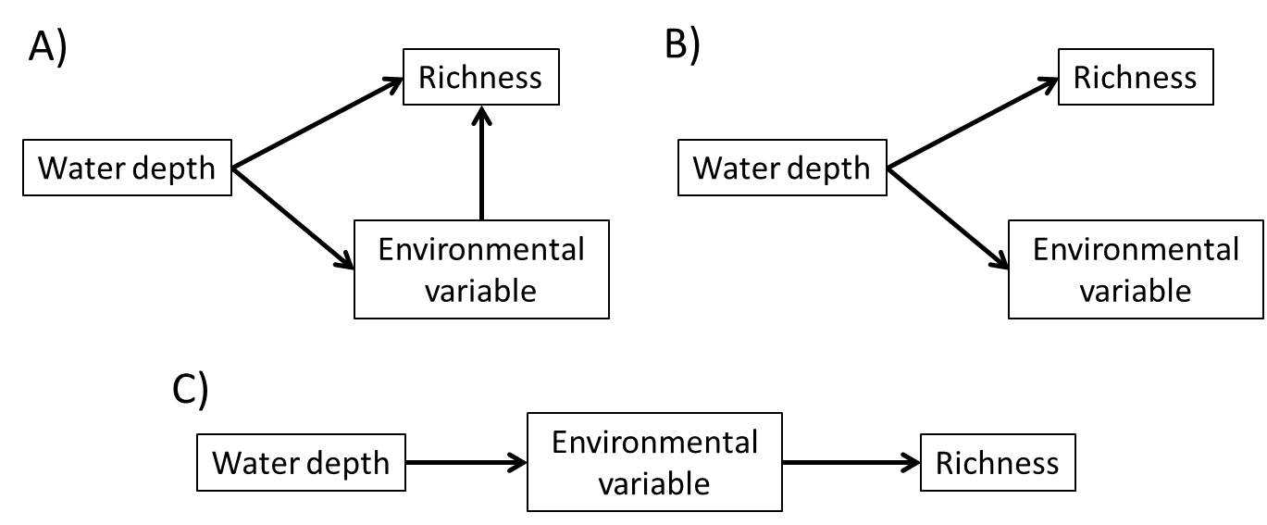

- Synthesize your findings in a paragraph discussing why richness-environment relationships changes differed between ephemeral and permanent wetlands. Be sure to explicitly connect your results to your conclusions.

COPYRIGHT STATEMENT
The Ecological Society of America (ESA) holds the copyright for TIEE Volume 13, and the authors retain the copyright for the content of individual contributions (although some text, figures, and data sets may bear further copyright notice). No part of this publication may be reproduced, stored in a retrieval system, or transmitted, in any form or by any means, electronic, mechanical, photocopying, recording, or otherwise, without the prior written permission of the copyright owner. Use solely at one's own institution with no intent for profit is excluded from the preceding copyright restriction, unless otherwise noted. Proper credit to this publication must be included in your lecture or laboratory course materials (print, electronic, or other means of reproduction) for each use.
To reiterate, you are welcome to download some or all of the material posted at this site for your use in your course(s), which does not include commercial uses for profit. Also, please be aware of the legal restrictions on copyright use for published materials posted at this site. We have obtained permission to use all copyrighted materials, data, figures, tables, images, etc. posted at this site solely for the uses described at TIEE site.

GENERIC DISCLAIMER
Adult supervision is recommended when performing this lab activity. We also recommend that common sense and proper safety precautions be followed by all participants. No responsibility is implied or taken by the contributing author, the editors of this Volume, nor anyone associated with maintaining the TIEE web site, nor by their academic employers, nor by the Ecological Society of America for anyone who sustains injuries as a result of using the materials or ideas, or performing the procedures put forth at the TIEE web site, or in any printed materials that derive therefrom.

