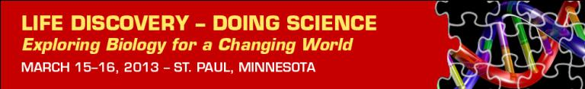
Inaugural Education Conference
Advanced Registration through Feb. 28  This conference will highlight the leading science, curriculum design and implementation and data exploration in a research-rich biology education for grades 9-16.  - Discover the science of life in a changing world  - Swap ideas for a robust biology classroom  - Build partnerships with scientists and educators  - Explore digital resources and new technologies  http://www.esa.org/ldc/registration/  NEW! Earn Continuing Education Units  We are excited to offer conference attendees the opportunity to earn one Continuing Education Unit (CEU) for participation in the conference.  For more information: http://www.esa.org/ldc/ceu/ |  | March 15 – 16, 2013  St. Paul, Minnesota  www.esa.org/ldc
 |  | Conference Partners
 |  | 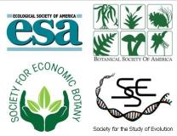
Keynote Speakers and Panels  The LDC Conference will have Keynote speaker and panels, to address pressing issues in Biology Education:  Building Partnerships with Scientists & Educators  Digital Resources and Learning for the Future  Building Pathways and Partnerships between K12 and College  Science of Life in a Changing World  For more information: http://www.esa.org/ldc/program/agenda/  Workshops  View the descriptions and schedule of the six hands-on workshops, available to all conference attendees.  Short Presentations  View descriptions of the short presentations, available to all conference attendees. Presentations are 20 minutes followed by 20 minutes of Q&A.  Fieldtrips  Take part in a field trip to the Raptor Center, at the University of Minnesota |  | Conference Sponsors
 |  | SimBio
 |  | Questions?
Contact:
Andrea McMillen
andrea@esa.org
(202) 833-8773 x 236
Many thanks our Conference Collaborators
who promote the conference to their professional networks:

Animal Behavior Society  American Institute of Biological Sciences (AIBS)  BEACON Center for the Study of Evolution in Action  Center for Excellence in Education (CEE)  Ecological Research as Education Network (EREN) | National Center for Ecological Analysis and Synthesis  National Education Association (NEA)  National Evolutionary Synthesis Center (NESCent)  National Socio-Environmental Synthesis Center  Virginia Association of Science Teachers

