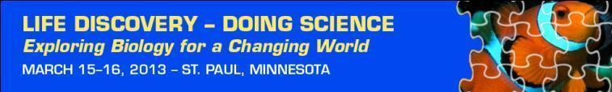
Inaugural Education Conference
Call for Share Fair Roundtable Topics  ** Deadline Extended until October 31, 2012 **  Do you have an idea for a new learning activity?  Do you have a lesson plan that you want to improve?  These 45 – minute sessions are designed for educators to create, revise and share lesson plans or activities with a peer working group.  More information available on: http://www.esa.org/ldc/program/call-for-proposals/ | March 15 – 16, 2013  St. Paul, Minnesota  www.esa.org/ldc
 | Proposal Deadlines
** Deadline extended **
Education Share Fair Roundtables
Accepting proposals until 10/31/2012
Keynote Speakers and Panels | Conference Partners
Jay B. Labov is Senior Advisor for Education and Communication for the National Academy of Sciences (NAS) and the National Research Council (NRC). He will address ‘Building Partnerships with Scientists & Educators’ for the future of science education. | 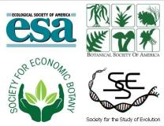
Carlos A. Botero, a Distinguished Postdoctoral Fellow in the North Carolina State University Initiative for Biological Complexity will talk about Science of Life in a Changing World, drawing upon his diverse experiences from across the globe to become a professional scientist.
The LDC Conference will have two Keynote panels, to address pressing issues in Biology Education:

Digital Resources and Learning for the Future

Building Pathways and Partnerships between K12 and College
More information: http://www.esa.org/ldc/program/agenda/speakers/
Workshops
View the descriptions and schedule of the six hands-on workshops, available to all conference participants.
More information: http://www.esa.org/ldc/program/agenda/workshops/
Conference Purpose
This conference will highlight the leading science, curriculum design and implementation and data exploration in a research-rich biology education for grades 9-16.
- Discover the science of life in a changing world
- Swap ideas for a robust biology classroom
- Build partnerships with scientists and educators
- Explore digital resources and new technologies

 | Conference Sponsors
 | 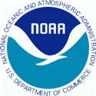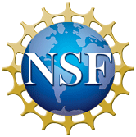
 | Questions?
Contact:
Andrea McMillen
andrea@esa.org
(202) 833-8773 x 236
Many thanks our Conference Collaborators
who promote the conference to their professional networks:
Animal Behavior Society  American Institute of Biological Sciences (AIBS)  BEACON Center for the Study of Evolution in Action  Center for Excellence in Education (CEE)  Ecological Research as Education Network (EREN) | National Center for Ecological Analysis and Synthesis  National Education Association (NEA)  National Evolutionary Synthesis Center (NESCent)  National Socio-Environmental Synthesis Center  Virginia Association of Science Teachers

