Inaugural Education Conference |  | http://www.esa.org/ldc
Workshop Proposals due in 2 weeks

Workshops are hands-on experiences...  1.5 hour sessions to teach the teachers  To implement techniques...  Lesson and curriculum design in the digital age  Classroom-true and field-tested technology  Data exploration in a research-based biology  Related to biological topics...  Ecology and Earth Systems Dynamics  Biodiversity and Ecosystem Services  Evolution in Action  Structure and Function  Proposals due July 31  Easy online form  [more details here]  Conference Purpose  This conference will highlight the leading science, curriculum design and implementation, and data exploration in a research-rich biology education for high school & undergraduate students  - Discover the science of life in a changing world  - Swap ideas for a robust biology classroom  - Build partnerships with scientists and educators  - Explore digital resources and new technologies  [more information] |  | Proposal Deadlines
Hands-on Workshops Submissions due July 31. Submit Workshop proposal

Short Presentations Submissions due Aug. 31 Submit Presentation proposal

Education Share Fair Submissions due Sept. 30 Submit Share Fair proposal
 |  | Conference Partners
 |  | 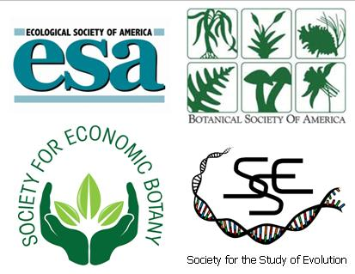
Many thanks to our Sponsors for their support for this event
Many thanks to our Conference Collaborators who promote this conference to their professional networks:
The American Association for the Advancement of Science (AAAS)  Animal Behavior Society (ABS)  American Institute of Biological Sciences (AIBS)  BEACON Center for the Study of Evolution in Action  Center for Excellence in Education (CEE)  Ecological Research as Education Network (EREN) | National Center for Ecological Analysis and Synthesis (NCEAS)  National Education Association (NEA)  National Evolutionary Synthesis Center (NESCent)  National Socio-Environmental Synthesis Center (SESYNC)  Organization of Biological Field Stations (OBFS)  Virginia Association of Science Teachers (VAST)
For more information: www.esa.org/ldc
Contact: Andrea McMillen, Education Programs Coordinator, andrea@esa.org, 202.833.8773 x 236

