Lab #5 Transmission dynamics of Robo Pox
Bio 347 - Disease Ecology

Objectives:
- Test a central assumption of transmission models
- Generate data
- Analyze data to assess support for a hypothesis

Background:
Skynet has been successful, and robots control the earth. You are a T-8000 logistics robot tasked with monitoring the performance of HexBugs (robot scavengers that collect metal dust and other debris to be processed into new machines). Recently, however, you’ve noticed that many of these HexBugs are becoming corrupted with a Robo Pox virus, which you suspect was cunningly released by John Connor, right before his death. The virus seems to transmit from HexBug to HexBug following collisions. You need to understand the transmission dynamic in order to develop a control plan otherwise your supervisor bot will wipe your memory and melt you down.

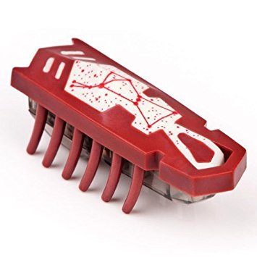
Figure 1: A) Your supervisor bot. B) HexBug

Questions
1. (1 point) What is the major assumption that distinguishes density-dependent transmission from frequency dependent transmission?

2. (1 point) How would you design an experiment to test the validity of this assumption for Robo Pox.

3. Conduct an experimental test of this prediction with the HexBugs and transmission arena available to you. Conduct at least 20 30-second trials. Record your data in a .csv file and import it into R

4. (1 point) Plot your data and conduct a linear regression to determine if your prediction holds.

5. (2 points) Submit a short (4-5 sentence) proposal to the Robot Board of Research outlining an experiment that you want to conduct next week to understand a different factor influencing Robo Pox transmission. Include the following information:
- The hypothesis you would like to test
- How you will represent the factor you are testing in our HexBug population
- The experimental set up (how many HexBugs in what experimental/control groups, how many replications, etc.)
- A one-sentence prediction of the results of this experiment
- A list of materials you will need to test your hypothesis
Note: if you supply this proposal to the Board by Monday this week, supplies may be made available to conduct your experiment next week. If no suitable proposals are found, then next week’s lab will consist of terrible, terrible ODE models.

