ISSUES: FIGURE SET
Applying a Lotka-Volterra predator-prey model in R to assess the effectiveness of a biocontrol for diamondback moths in Kenya
Linda A. Auker
Department of Biology, Misericordia University, Dallas, PA 18612
Corresponding author: Linda A. Auker (lauker@misercordia.edu)
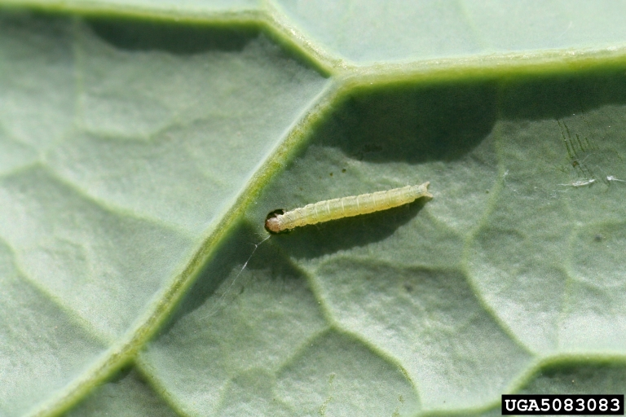
Late-instar larvae of the diamondback moth feeding on broccoli leaf. Source: Whitney Cranshaw, Colorado State University, Bugwood.org. Licensed under a Creative Commons Attribution 3.0.

THE ISSUE:
In this figure set, students examine the question as to whether an exotic parasitoid is an effective biocontrol for an herbivorous pest, the ubiquitous diamondback moth (DBM). Students will model Lotka-Volterra parasitoid-host interactions in R using authentic data collected from a host-parasitoid relationship in Kenya. In doing so they will answer several questions: does an exotic parasitoid biocontrol help reduce DBM populations in this case study? How can modeling be useful? How can Lotka-Volterra models be useful in conservation?

FOUR DIMENSIONAL ECOLOGY EDUCATION (4DEE) FRAMEWORK
- Core Ecological Concepts:
  - Organisms
    - Resources and regulators
  - Ecosystems
    - Predator-prey
- Ecology Practices:
  - Quantitative reasoning and computational thinking
    - Computer skills: R
    - Modeling and simulation
- Human-Environment Interactions:
  - How humans shape and manage resources/ecosystems/the environment
    - Natural resource management (biological control agents, ecological risk assessments)
    - Ecological stewardship
- Cross-cutting Themes:
  - Systems
  - Biogeography
    - alien/invasive species
STUDENT-ACTIVE APPROACHES:
Interrupted case study, think-pair-share, and coding in R
STUDENT ASSESSMENTS:
Written answers, codes and graphs. Depending on the course goals, instructors may wish to encourage students to modify their parameters under additional conditions.

CLASS TIME:
Suggested class time is over two 50-minute periods or one 75-minute period.

COURSE CONTEXT:
This figure set is recommended for ecology/biology majors at the junior, senior, or graduate level. This Figure Set could be used in conjunction with Jean et al. (2023), which introduces Type I and Type II functional responses (https://tiee.esa.org/vol/v19/issues/figure_sets/jean/abstract.html).

ACKNOWLEDGEMENTS:
This activity is an extension to Jean et al. (2023), which in turn is an update to Hsu (2018). The latter was created as part of ESA’s 2023 Transforming Ecology Education Faculty Mentoring Network, funded by the National Science Foundation (DBI 2120678), to revise previously submitted figure sets to the 4DEE framework. I am particularly grateful to Christopher Beck and the Ecological Society of America, as well as to my collaborators Rosny Jean, Suann Yang, and Jeremy Hsu, for their support and encouragement in writing this extension.

OVERVIEW
WHAT IS THE ECOLOGICAL ISSUE?
The diamondback moth (DBM) is considered one of the most universally distributed lepidopterans (Talekar and Shelton 1993). It is an herbivore and worldwide pest on cruciferous plants (e.g., cabbage, cauliflower, collards, broccoli, and other members of Brassicaceae), due to attractant chemicals produced by the plants (Nayar and Thorsteinson 1963). Generally, the life cycle of DBM consists of: egg incubation (2-20 days), 4 larval instars (a total of 20-28 days for full larval lifespan), a pupal stage within a silk cocoon (5-15 days), and a final adult stage lasting an average of 2 weeks (Harcourt 1957). DBM damages the leaves of cruciferous plants during its larval stage as first-instar larvae mine the leaf tissue and later instars consume the underside of leaves (Philips et al. 2014).
Pest management of DBM is estimated to be in the range of billions of dollars worldwide (Philips et al. 2014). Thought to originate from the Mediterranean (Talekar and Shelton 1993), the pest status of the moth is due to many factors, including lack of parasitoids and other natural enemies in invaded habitats (Lim 1986), easy migration of DBM but not its parasitoids (Talekar and Shelton 1993), and the increased resistance of the moth to insecticides and other forms of pest management, such as Bacillus thuringiensis (Tabashnik et al. 1990). The DBM is particularly detrimental to cruciferous crops in areas without effective indigenous parasitoids, such as sub-Saharan Africa, the Caribbean, Central America, and southeast Asia. Therefore, several studies have identified the impact of introduced parasitoid biocontrols on the DBM population (Sastrosiswojo and Sastrodihardjo 1986, Verkerk and Wright 1996, Liu et al. 2000, Gichini et al. 2008, Furlong et al. 2017).
One such parasitoid that has shown promising success in reducing DBM populations, and thereby ameliorating damage to crops, is Diadegma semiclausum, a parasitoid wasp (Hymenoptera). This species became established in Australia, and resulted in a reduction in damage to crops due to DBM suppression (Talekar and Shelton 1993). This parasitoid has also shown success in Taiwan and Malaysia (Talekar and Shelton 1993). Due to its success, it has been introduced to Kenya where cabbage and kale are important crops (Momanyi et al. 2006, Löhr et al. 2007, Tonnang et al. 2009). In Tonnang et al. (2009), parasitoid and DBM population density were estimated and a Lotka-Volterra model was created to predict the effectiveness of the exotic parasitoid in controlling DBM populations.
In this figure set, students will use R and RStudio to solve and visualize a simplified system of Lotka-Volterra equations, using data from the release in Werugha, Kenya (Tonnang et al. 2009). R is an open-source programming environment, increasingly used in ecology, and is customizable thanks to a number of packages created by users, some of which are tailored to solving ecological equations (R Core Team 2023). RStudio is an integrated development environment (IDE) that maximizes user experience through easier management of files and variables, in addition to integration of R Notebooks and other features (RStudio Team 2023). Students will need to download and install both R and RStudio for the exercises in this figure set. Auker and Barthelmess (2020) outline a number of reasons why undergraduate students should learn R in their ecology classes, including the fact that this program is becoming more and more popular in the field of ecology, due to its flexibility, ability to manage and analyze large sets of data, potential for striking visualizations, and that it is free to use.

FIGURE SETS TABLE

Figure Set | Student-active Approach | Cognitive Skill
The parasite-host relationship shown experimentally and using a modified Lotka-Volterra model before and after release of an exotic parasitoid (Tonnang et al. 2009). | Upper level (junior, senior, graduate) majors in biology, ecology, entomology, biostatistics, or environmental science courses, class size limited by available computers and teaching assistants (max = 30) | Comprehension, application, and synthesis

Learning Objectives:
- Students will use figures to describe how a parasitoid biocontrol regulates the DBM population in Kenya.
- Students will recognize how a Lotka-Volterra model visualizes parasitoid-host relationships and will identify parameters that regulate populations of an ecologically important species and its parasitoid invader.
- Students will apply these parameters to an ordinary differential equation (ODE) model in R.
- Students will create their own figures using ggplot2 in R to communicate how a specific parameter regulates the interaction between a parasitoid and its native host.

Student Assessment:
Students will respond to the embedded questions in the activity on their own, through think-pair-share or discussion groups in the classroom, or in an online setting. Students will also have the opportunity to modify provided R code to change parameters and to create visualizations of Lotka-Volterra models. Depending on the course goals, instructors may wish to encourage students to modify their parameters under additional conditions. Further suggestions can be found in the Notes to Faculty.

FIGURE SET BACKGROUND
The figures within this set come from Tonnang et al. (2009) and show the parasitoid-host population changes over a 35-week period before and after release of an exotic biocontrol parasitoid. In Kenya, important brassica crops, such as cabbage and kale, are at risk of defoliation due to the feeding habits of the introduced diamondback moth Plutella xylostella (referred to as DBM herein), which mines and consumes leaf tissue during its larval stage. To combat this costly damage, a parasitoid wasp Diadegma semiclausum, imported from Taiwan, was released into two areas in Kenya, Werugha and Tharuni, to test its ability to regulate populations of DBM. Tonnang et al. (2009) used the resulting data collected from these empirical studies to estimate parameters in a modified Lotka-Volterra model. In this figure set, two figures - one showing the experimental and predicted changes in parasitoid-host populations before Diadegma release and one showing these same changes after the release of the parasitoid. According to Tonnang et al. (2009), we can assume that the parasitoids in the “before” figure (Figure 1) are all indigenous to the region.

STUDENT INSTRUCTIONS
B
Part 1
Objective: Students will use figures to describe how a parasitoid biocontrol regulates the DBM population in Kenya.
A biocontrol is used as a pest management system and entails the release of a known parasite, parasitoid, or predator of the pest species (Wittenberg and Cock 2005). It is especially of use if the target pest species is already widespread in the habitat (Follett et al. 2000). Yet, there are important caveats in employing a biocontrol: the ecological impacts of releasing the biocontrol must be assessed, humans should be encouraged to minimize spread of the pest in addition to employing the control, and it should be understood that treatments come with a level of risk and uncertainty, such as selection against nontarget species (Perrings et al. 2005). It is unlikely that biocontrol causes eradication of the pest and will instead reduce the numbers of the pest to an “acceptable” level (Wittenberg and Cock 2005). One type of biocontrol is the release of parasitoids, which are insect specialists whose offspring feed on and develop in the body of another species (Krohne 2016.) While parasitoids may be seen as an environmentally friendly alternative to chemical pesticides, there are still risks in introducing new parasitoids, including unknown impacts on native species (Ricciardi 2005).
In order to predict the impacts of biocontrol, a scientist can use empirical (experimental data collection) studies, models, or both. A model is a simplification of reality, using mathematical equations. If you are familiar with the equation for a slope of a line (y = mx+b), you are familiar with an example of a simple model, in which a value of x is used to predict the value of y, given specific constants m, the slope, and b, the intercept.
Figure 1 shows the population dynamics of the diamondback moth and all indigenous parasitoids of the DBM within the region of Werugha, Kenya. This figure shows both empirical data and a prediction using a model. Look at Figure 1 and answer the following questions using the figure and your knowledge about this case.

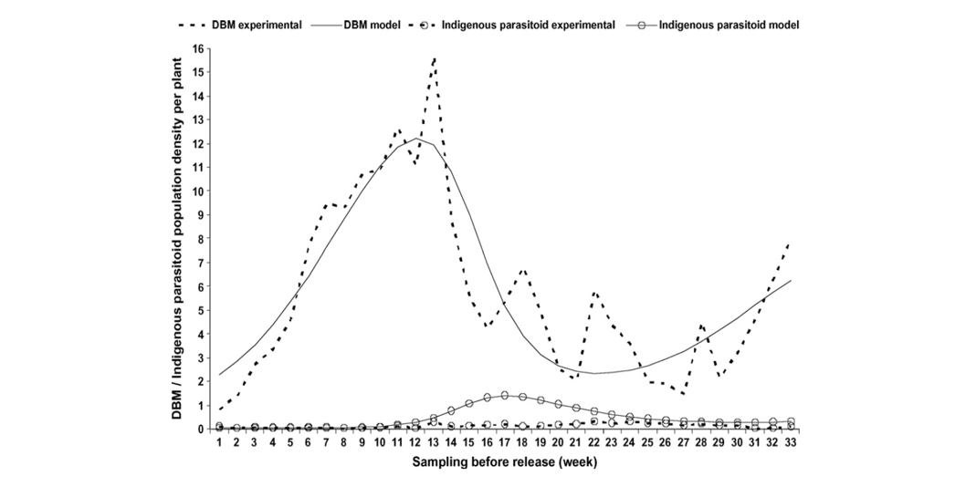 Figure 1: Empirical (dashed lines) and predictive model estimates (solid lines) of diamondback moth (line only) and indigenous parasitoid (line and circle) populations. These data were collected before the first release of the exotic parasitoid in Werugha, Wundanyi Division, Taita Taveta District, Coast Province of Kenya. Reprinted from Tonnang et al. 2009. Assessing the impact of biological control of Plutella xylostella through the application of Lotka–Volterra model, Ecological Modelling 220:60-70, with permission from Elsevier.
1. Describe, using the DBM experimental (dashed) line, how the moth population changes over time. Why is there a decrease in DBM populations several times throughout the experimental period? What might cause these oscillating population changes in a prey population?
2. Do the experimental data follow the expected population changes predicted by the “DBM model” populations and indigenous parasitoid populations?
3. Based on your answer to question 2, what are the advantages and disadvantages of:
- creating a model?
- collecting experimental data?
Figure 2 shows the response of DBM populations after the release of the exotic parasitoid Didegma semiclausum, again using both experimental data and a model. Examine the figure carefully and answer the questions that follow.
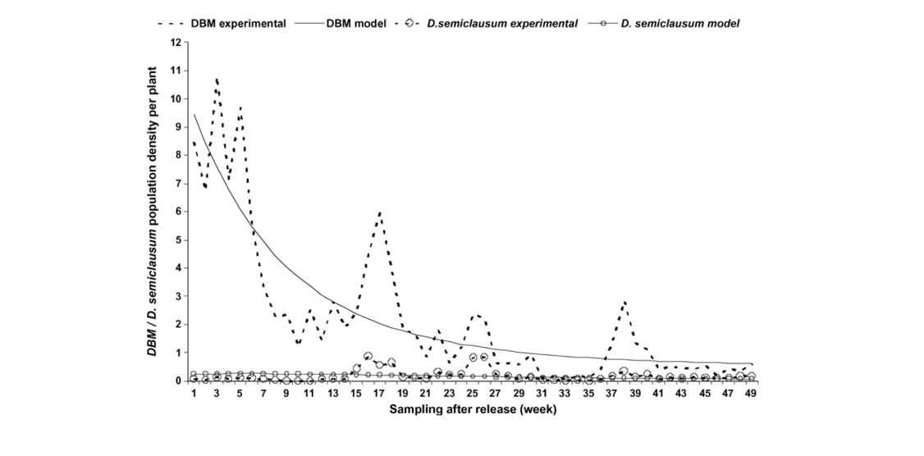
Figure 2: Empirical (dashed lines) and predictive model estimates (solid lines) of diamondback moth (line only) and indigenous parasitoid (line and circle) populations. These data were collected after the first release of the exotic parasitoid in Werugha, Wundanyi Division, Taita Taveta District, Coast Province of Kenya. Reprinted from Tonnang et al. 2009. Assessing the impact of biological control of Plutella xylostella through the application of Lotka–Volterra model, Ecological Modelling 220:60-70, with permission from Elsevier.
4. How is the response of the DBM population different from Figure 1? Is this reflected in both experimental and model data? Justify your answer.
5. Brainstorm a list of factors that might impact DBM populations differently when preyed upon by an indigenous versus an exotic parasitoid. Use the model/experimental lines in both figures for the parasitoid populations to help you construct your list.
Part 2
Objective: Students will recognize how a Lotka-Volterra model visualizes parasitoid host relationships and identify parameters that regulate populations of an ecologically important species and its host parasitoid invader.
In Kenya, cabbage and kale are commonly consumed by DBM, yet the moth is resistant to pesticides in this region as well (Tonnang et al. 2009). Thus, researchers in Kenya imported the parasitoid Diadegma semiclausum from the Asian Vegetable Research and Development Center in Taiwan to release in two areas within Kenya: Werugha in Taita Hills on July 2002 and at Tharuni in the Central Highlands in September 2002 (Momanyi et al. 2006, Löhr et al. 2007). In this study, parasitoid and DBM population densities were estimated.
From these data, Tonnang et al. (2009) endeavored to assess and predict the impact of the parasitoid with a mathematical model called the Lotka-Volterra predator-prey model*. The Lotka-Volterra predator-prey model is a pair of ordinary differential equations (ODE) that describe a relationship between a predator and its prey (Wangersky 1978). ODE have one independent variable, which in this case is time (t). The good news, perhaps, is that we do not need to employ any calculus in this exercise. However, we will be using the powerful programming language, R, to solve our Lotka-Volterra equations to determine how the DBM and parasitoid populations change over time with changing parameters.
Parasitoids are functionally equivalent to predators, and therefore the Lotka-Volterra predator-prey model can be applied to parasitoid-host relationships (Sher and Molles 2019). The Lotka-Volterra relationship is often visualized by oscillating predator-prey interactions in which the peak of the predator population always lags slightly behind that of the peak of the prey population.

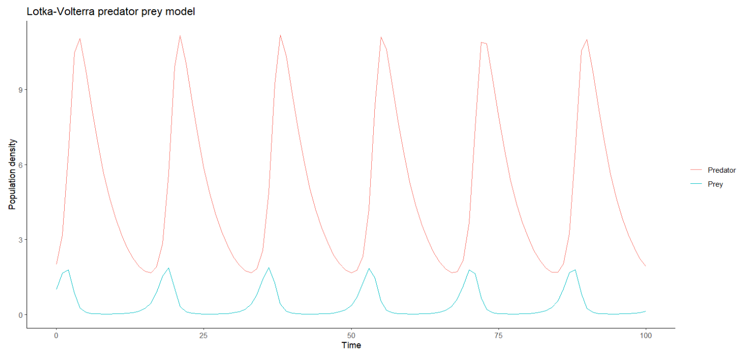

Figure 3: A hypothetical population showing Lotka-Volterra predator-prey interactions, created in RStudio.

*Note that there is another commonly discussed model by Lotka-Volterra for competition. This exercise will only focus on the Lotka-Volterra predator-prey model, and all references to “Lotka-Volterra model” herein reference predator-prey (or, parasitoid-host) interactions.
Tonnang et al. (2009) used multiple parameters to define their Lotka-Volterra equations in predicting DBM and parasitoid populations and used a slightly more complex version of the Lotka-Volterra model. For the purposes of this exercise, we simplified the Lotka-Volterra equations to follow that found in most ecology texts. The parameters are described below.

x = population size of the DBM at time t
y = population size of the parasitoid at time t
alpha (α) = intrinsic rate of increase (per capita population growth) of the DBM
beta (β) = per capita consumption rate of prey by the parasitoid, thus the mortality of the prey (Note: prey consumption is assumed to be directly proportional to prey abundance, thus a Type 1 functional response).
gamma (γ) = mortality of the parasitoid population
delta (∂) = uptake rate, a function of the predator’s ability to convert food into offspring and its consumption rate (dependent on intrinsic biological factors (i.e., trophic efficiency) in addition to prey consumed)

Therefore, dx/dt (change in DBM population) over time is shown by:

$$\frac{dx}{dt} = αx - βxy$$
$$\frac{dy}{dt} = δxy - γy$$

6. Describe each equation in your own words or draw a diagram that explains how these variables impact population change. In your answer, determine which parameters depend on the other species present.

Part 3
Objective: Students will apply parameters to an ordinary differential equation (ODE) in R.
For the next steps, you should open the R Markdown document in RStudio as directed by your instructor. This document is broken into multiple sections and it is important that you carefully read the instructions as you work through the rest of the exercises to follow.
The first step in creating and running our simulation is to install the necessary packages required by R. R itself comes with several base functions that will do simple calculations, plotting, and other analyses, but additional packages – built by users – can extend R’s capabilities. In the case of this exercise, you will be installing and loading three additional packages: tidyverse, deSolve, and ggplot2. Your instructor may require you to look at the documentation for these packages to understand their functionality a little better. Below are a few quick descriptions of these packages and why we are using them here:
Package | Description
tidyverse | This package gives the user tools to better manage their data and write cleaner code. (Wickham et al. 2019).
deSolve | This package contains “functions that solve initial value problems of a system of first-order ordinary differential equations (ODE)” (Soetaert et al. 2010). In other words, this package is necessary to solve the dx/dt and dy/dt equations using the ode function.
ggplot2 | This package provides tools to customize visualization (i.e., graphs) (Wickham 2016). We will look into the functions in our code regarding graphs in Part 3 a little more closely.

Let’s look at Part 1 of the code. This code sets the parameters, initial state and time step for the model. (Note: in the code, we will refer to the parameters described in the handout by their full Greek letter (spelled out) to ensure they match up with the description in the handout, without needing to use special characters.)
In this code “chunk,” we also set the initial state (starting conditions) of the model, where x = population at time 0 for DBM and y = population at time 0 for the parasitoid. These are the starting populations for our Lotka-Volterra model. You will note that Tonnang et al (2009) use fractional numbers of parasitoids and DBM. It may seem odd to use fractional numbers, but these were determined using average number of insects per plant, thus the decimal.
Finally, we see the time step of the model in which we set a sequence of time from 0-35 (in weeks according to Tonnang et al. (2009)) in steps of 1 week. Therefore, we should expect that our final graph will have an x-axis ranging from 0-35 weeks.
The parameters for Werugha before and after release of the exotic parasitoid are shown in Table 1.

Table 1: Estimated parameters collected from population data before and after release of an exotic parasitoid in Werugha, Kenya (Tonnang et al. 2009).
Parameter definitions | Estimated parameters | Before release of exotic parasitoid (assume parasitoids are indigenous) | After release of exotic parasitoid (assume parasitoids are exotic)
Intrinsic rate of increase (per capita growth) of the DBM | α | 27.76 | 27.76
Consumption rate of prey by the parasitoid (mortality rate of the prey) | β | 35.14 | 145.19
Mortality of the parasitoid population | γ | 7.07 | 0.95
Uptake rate, a function of the predator’s ability to convert food into offspring and its consumption rate | ∂ | 33.28 | 1.80
Population size of the DBM at time t | x | 1.91 | 8.48
Population size of the parasitoid at time t | y | 0.05 | 0.15

After reviewing these data, answer the following questions:
7. Why is β higher for exotic parasitoids than indigenous parasitoids? Think about this question from an ecological perspective. What are some of the differences between exotic and indigenous species in the indigenous species’ habitat?
8. What other factors might contribute to population changes in the DBM or parasitoid populations that are not included here?
9. Which case (indigenous or exotic parasitoid), if any, do you predict will result in an effective decline of the diamondback moth population? Justify your answer.
Carefully review the code in the R Notebook file provided by your instructor to understand what each line of code does. As you work through this exercise, you will run this code twice, first with the numbers provided in the file. During the second run of the model, as directed Part 4, you will change the parameters to match those of the exotic parasitoid (“after release”) conditions.

Part 4:
Objective: Students will create their own figures using ggplot2 in R to communicate how a specific parameter regulates the interaction between a parasitoid and its native host.
The ggplot2 package is useful because it makes visualization of data easier to customize. While R comes with the ability to create plots, ggplot2 provides additional functionality, using the “grammar of graphics” (Wickham et al. 2019).
Let’s break down the code. Review the code in the R Notebook file for Part III and answer the questions after you complete the graphing exercise.
Now that you know what the code does, let’s run each part of the code by clicking the green arrow in the upper-righthand corner of each chunk (see below).
Once you do this for all three parts of the code (Part I, Part II, and Part III), you will see a graph appear under Part III. Screenshot or save this graph. (Your instructor will give details on their requirements for this graph.)
Now, change the parameters in part I to match those of the population parameters and initial states AFTER release of the exotic parasitoid. See Table 1 above for these values. Once again, re-run ALL three chunks of code (Parts I, II, and III) in order once you change all of these values. Screenshot or save this graph as instructed. View both graphs side by side and answer the following questions. Be sure to take note of the y-axes; the two graphs have different scales.
10. How do your predictions align with that shown in the ggplot2 output?
11. What are the advantages of creating such a model in a program like R? What are the disadvantages?
12. Based on your analysis in this figure set, do you think that exotic parasitoids are adequate biocontrol for the diamondback moth? What evidence did you use to make your decision?
13. Using the parameters after release, change the initial conditions to 0.30 parasitoids - twice the initial conditions you ran earlier for the exotic parasitoids. How does the change in initial parasitoids released onto the plant change the populations of DBM? Identify this change by comparing the peak values of DBM at 0.15 exotic parasitoids per plant and 0.30 exotic parasitoids per plant. Does increasing the number of parasitoids impact DBM populations?
14. Turchin (2001) stated “I know of no ecological populations, laboratory or field, that could even be approximately described by the Lotka-Volterra predation model.” However, Tonnang et al. (2009) said that “The Lotka-Volterra model provided a quantitative estimate of the effectiveness of the newly introduced species and could therefore be used as a tool for decision-making in the implementation for strategies in pest management system in the region.” These two statements appear to conflict. Can you reconcile these two views, given the experience you now have analyzing the figures in Tonnang et al. (2009) and using R to visualize Lotka-Volterra? If so, how? If not, why not? If Lotka-Volterra is not an accurate model, what is its use in ecological applications?

NOTES TO FACULTY
Part 1
This part of the exercise gives students the opportunity to examine and interpret figures from the Tonnang et al. (2009) study. For the purposes of this figure set, only figures from the Werugha portion of the study were included. There are additional, similar, figures from a second site, Tharuni. If the faculty member wishes to build upon this figure set, they may wish to pull this figure from the original paper and ask additional questions. Faculty should make sure students have a strong understanding of experimental data versus predictions generated by a model.
Suggested answers to the questions posed in this part are below.
- The moth population oscillates, and decline is likely due to consumption from the parasitoid. Students may determine this by seeing the slight increase in parasitoid populations after the decline of the DBM. That said, some room can be made for students to argue that the noise within the experimental line indicates there are other factors affecting the population of DBM that are not due to parasitoid consumption. Students may want to “put a pin” in this idea for later consideration as they assess the value of models.
- The diamondback moth predicted line is smoother than the experimental line but shows the same general trend. For the parasitoid, the predicted line shows a higher peak of parasitoids than measured in the field.
- a. Models are helpful in making generalizations and can be useful to make predictions. They may also be cheaper and faster to create than collecting data from the field. However, they vary in accuracy and depend on quality parameters and input.
b. Experimental data show “reality” (if a good sample size is used!). However, such data can be time-consuming or expensive to collect. Care also needs to be taken when choosing which samples to take to avoid bias.
- In Figure 2, there is a continuous decline of the moth population compared to Figure 1. The decline is smoothed in the prediction, but there are still oscillations in the experimental data. There is also an overall lower population of diamondback moths in this case compared to the population in Figure 1. For parasitoids (which are exotic in this figure), the model predicts little population growth, yet experimental data show some peaks and valleys in the data.
- This list of factors may vary based on the focus of the course. Here are some suggestions: exotic parasitoids will not be limited by predators, disease, competitors, in comparison to their indigenous counterparts. Exotic parasitoids may have an advantage if their prey are not adapted to avoid the parasitoid.
Part 2
In Part 2, students will be introduced to Lotka Volterra equations, which are examples of ordinary differential equations. Note that this exercise will not cover the mathematical principles of solving ordinary differential equations, and it is optional to go into if that is the focus of the course. Also note that the parameter, beta, may be used to build a connection to Type I functional responses if this has been, or will be, covered in the course. (For additional exercises in functional responses and biocontrol, instructors may be interested in referring to Jean et al. (2023)).
- The purpose of this question is to make equations make sense to the students by challenging them to put mathematical equations into words or into a diagram. Here is a sample of what students might come up with: “Change in DBM populations over time is predicted by the intrinsic rate of increase of the DBM population and the consumption of prey by the parasitoid. Change in parasitoid populations over time is predicted by the uptake rate of the parasitoid – a function of the number of prey in the habitat, and its natural mortality.” For students who choose to draw a diagram, here is a sample: 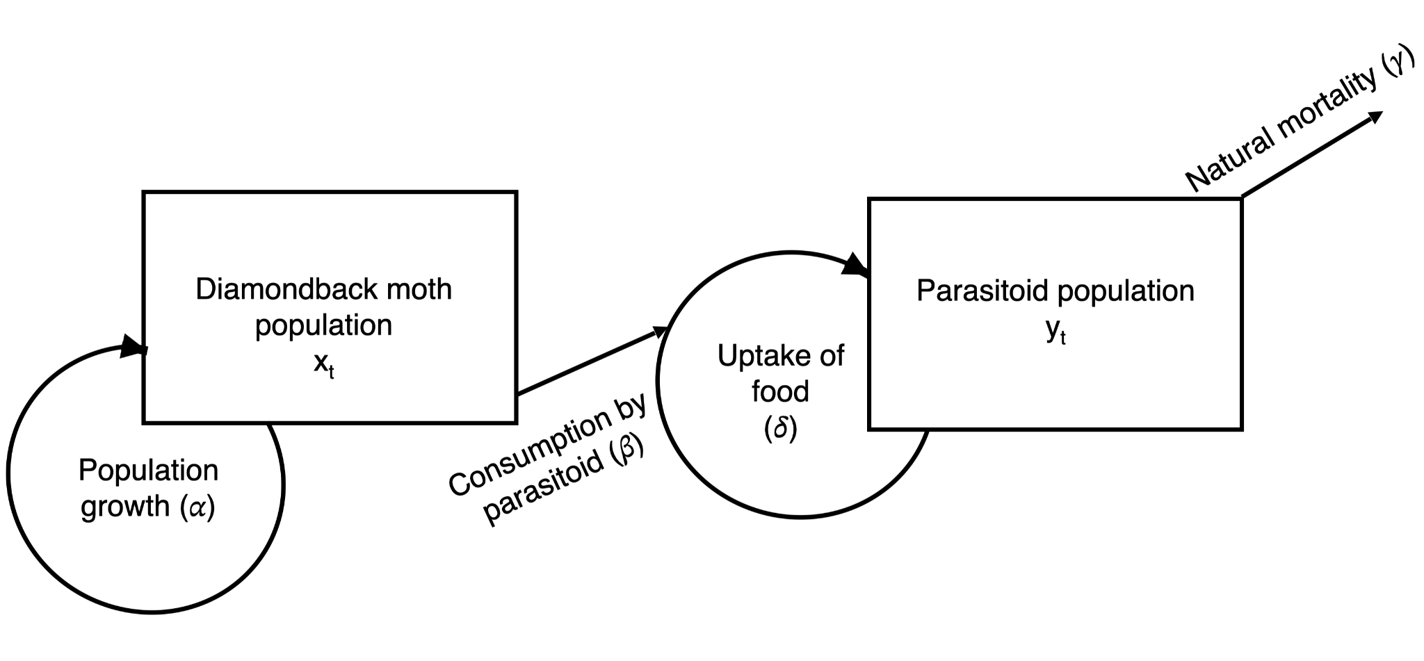
In the drawing above, note that while the equation for parasitoids does not explicitly include $β$, since it is the mortality of DBM caused by the parasitoid population, it is important to note that the uptake of food (and conversion to biomass) depends partly on how much food is consumed by the parasitoid.
Faculty may wish to have students compare their analysis of the equations and have the class come up with a consensus on the equations.
There is also a statement in this section that says “parasitoids are functionally the same as predators”. Faculty may want to build on this idea and add some follow-up questions (e.g., “Why would parasitoids be functionally similar to predators? How are they different?”), depending on the focus of the course.
Part 3
For the rest of the exercise, students will need to access the R Notebook file provided with the exercise. Instructors should include details on how to download R and RStudio if students are not familiar with the program. Faculty should also be prepared to include instructions on opening the R Notebook file and go over the basic structure of the code. I have included commentary and comments in the Notebook file to help both students and faculty.
If faculty wish to have students try to replicate the sample Lotka-Volterra model shown in Figure 3, they may have the students begin with the parameters shown below before continuing with the exercise.
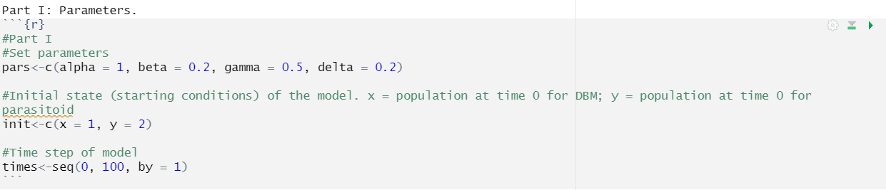
- The parameter β is mortality of prey due to predation. It is probably higher for exotic parasitoids than indigenous parasitoids because many exotic species are considered “voracious predators.” Even if this is not the case, there is likely little adaptation by the prey to avoid predation. Finally, if the biocontrol is done properly, it may be especially effective on a target prey species.
- This may be a good place to pick up where Question 1 left off. Answers for this question may include: environmental factors (weather patterns), competitors present for parasitoids, alternative food for parasitoids, and other abiotic and biotic factors.
- This question will rely on students carefully examining the equations and parameters to make a prediction. They should note that β is larger for exotic parasitoids and the larger this number, the greater the expected decrease in DBM moths. Students will also note that the mortality rate for parasitoids is lower in exotic parasitoids than indigenous parasitoids and will cause a slower decline in parasitoids, which means there are more predators to consume DBM.
Part 4
- Students should be able to create two graphs. Depending on faculty familiarity with ggplot2, they may wish to instruct students to either save the plots using ggsave() or simply screenshot and include the graphs. Below are what the graphs should look like (top: indigenous parasitoids; bottom: exotic parasitoids).
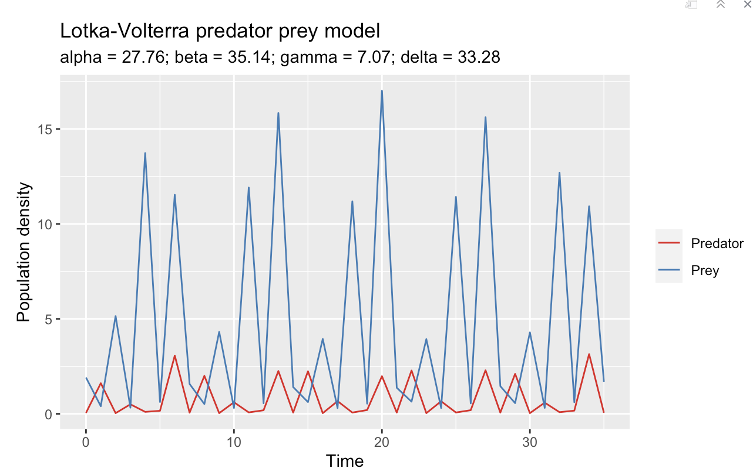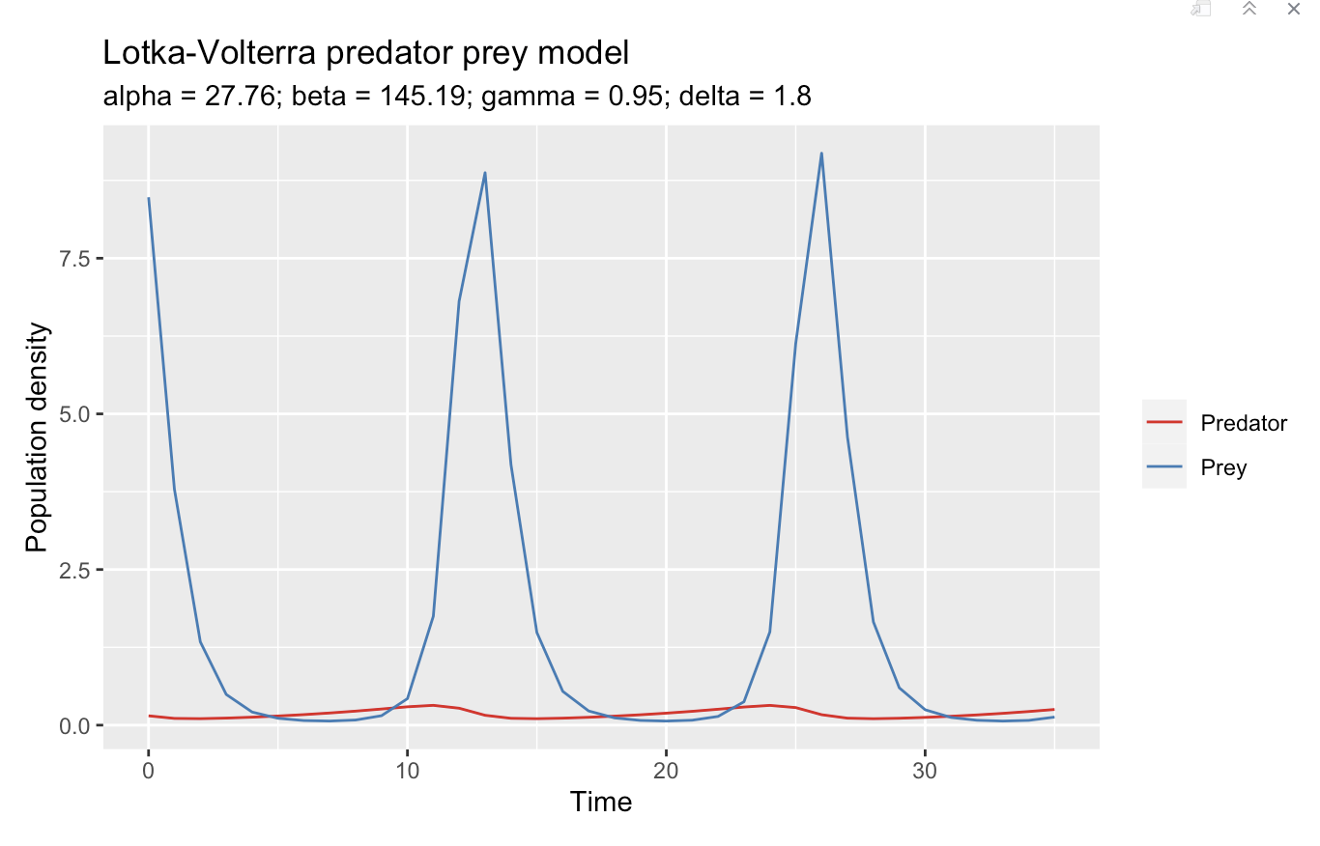
Depending on student predictions, their answers here may vary. They should pay close attention to the peaks of DBM in both cases and note that there is a lower population density of DBM with exotic parasitoids.
- Advantages to creating this model include: ease of changing parameters and rerunning code. Once the code is written, it is very easy to make minor changes to run a new simulation. Disadvantages may include not understanding how to write the code (depending on student experience) and the risk of leaving out important parameters that reduce reliability of the model’s predictions.
- This question is up to the student to make a determination, and faculty may find some variation within a single class as to students’ perceptions of the effectiveness of biocontrols. Students should support their answer with relevant examples and evidence. One thing that students might mention is the low population of exotic parasitoids making it ineffective as a biocontrol. If this comes up, one question faculty may want to pose to the students is whether it is good or bad that populations of exotic biocontrols stay low, and why. Perhaps the example of the cane toad in Australia is a good illustration of the risks of biocontrol getting out of hand!
- Below is the graph showing the exotic population with a higher starting number. Students should note that there is not necessarily a decrease in DBM populations if you increase the number of biocontrol parasitoids. A discussion with the class about how the two Lotka-Volterra equations interact with each other would be useful in response to this question.
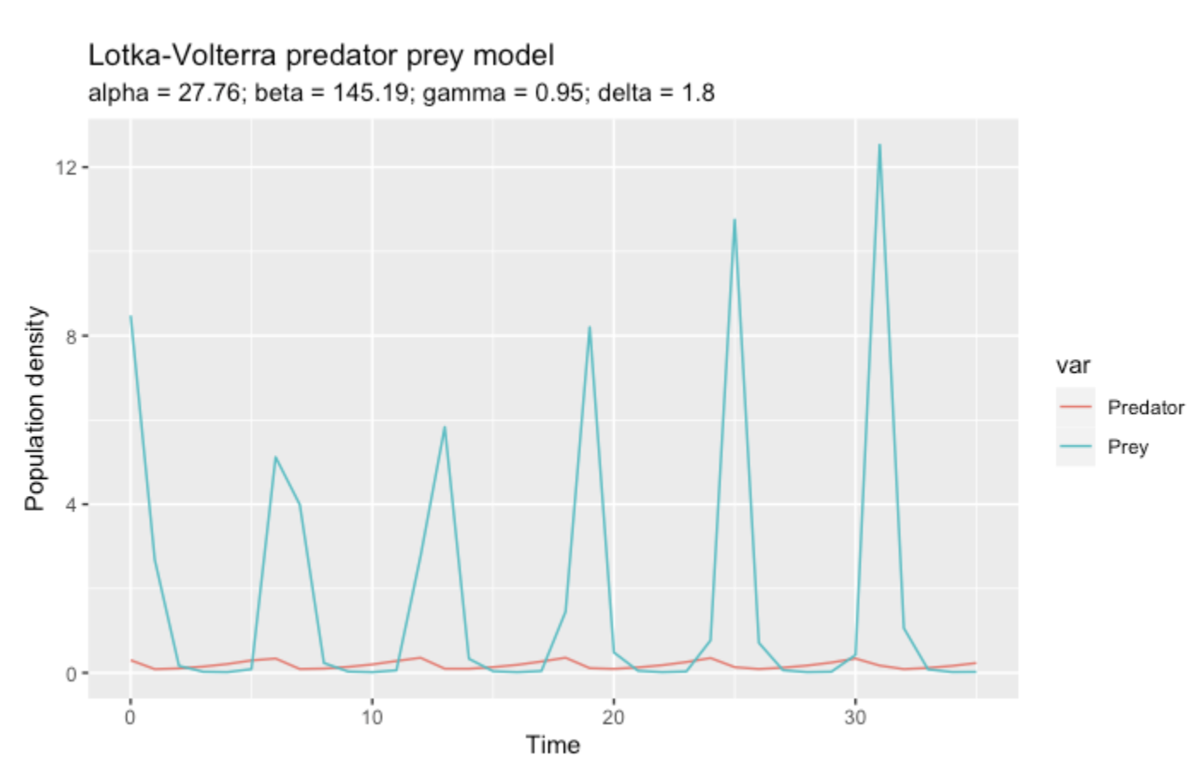
- This question may be a good candidate for a reflective essay homework assignment, discussion board post, or long-form homework assignment. Students should carefully consider the advantages and disadvantages of using models, of the purpose of using something as simple as Lotka-Volterra to explain a complex relationship between predators and prey, and the level of detail that may be missing from models and whether this level of detail is necessary. Faculty may want to use additional resources like Wangersky (1978) to further explore the value and usefulness of models in ecology.

LITERATURE CITED
Auker, L. A. and E. L. Barthelmess. 2020. Teaching R in the undergraduate ecology classroom: approaches, lessons learned, and recommendations. Ecosphere 11:e03060.
Follett, P. A., J. Duan, R. H. Messing, and V. P. Jones. 2000. Parasitoid drift after biological control introductions: re-examining Pandora’s Box. American Entomologist 46:82-94.
Furlong, M., M. P. Zalucki, A. Shabbir, and D. C. Adamson. 2017. Biological control of diamondback moth in a climate of change. The Mysore Journal of Agricultural Sciences 51A:115-124.
Gichini, G., B. Löhr, A. Rossbach, B. Nyambo, and R. Gathu. 2008. Can low release numbers lead to establishment and spread of an exotic parasitoid: the case of the diamondback moth parasitoid Diadegma semiclausum (Hellén), in East Africa. Crop Protection 27:906-914.
Harcourt, D. G. 1957. Biology of the diamondback moth, Plutella maculipennis (Curt.) (Lepidoptera: Plutellidae), in Eastern Ontario. II. Life-history, behaviour, and host relationships. The Canadian Entomologist 89:554-564.
Hsu, J. L. 2018. Using functional responses to investigate the ecological consequences of an introduced biological control agent. Teaching Issues and Experiments in Ecology 13: Figure Set #1. https://tiee.esa.org/vol/v13/issues/figure_sets/hsu/abstract.html
Jean, R., L. Auker, S. Yang, and J. Hsu. 2023. Figure Set update: An inquiry-based module aligned with the 4DEE framework for teaching about functional responses and biological control. Teaching Issues and Experiments in Ecology 19: Practice #8. https://tiee.esa.org/vol/v19/issues/figure_sets/jean/abstract.html
Kibata, G. N. 1996. The Diamondback moth: a problem pest of brassica crops in Kenya. In: Sivapragasam, A., W. H. Kole, A. K. Hassan, G. S. Lim. (Eds.), The Management of DBM and Other Crucifer Pests. Proceedings of the 3rd International Workshop, Kuala Lumpur. Malaysia. p. 47.
Krohne, D. T. 2016. Ecology: Evolution, Application Integration. Oxford University Press. 520 pp.
Liu, S., X. Wang, S. Guo, J. He, and Z. Shi. 2000. Seasonal abundance of the parasitoid complex associated with the diamondback moth, Plutella xylostella (Lepidoptera: Plutellidae) in Hangzhou, China. Bulletin of Entomological Research 90:221-231.
Löhr, B., R. Gathu, C. Kariuki, J. Obiero, and G. Gichini. 2007. Impact of an exotic parasitoid on Plutella xylostella (Lepidoptera: Plutellidae) population dynamics, damage and indigenous natural enemies in Kenya. Bulletin of Entomological Research 97:337-350.
Mesterton-Gibbons, M. 1996. A technique for finding two-species harvesting policies. Ecological Modelling 92:235-244.
Momanyi, C., B. Löhr, and L. Gitonga. 2006. Biological impact of the exotic parasitoid, Diadegma semiclausum (Hellen), of diamondback moth, Plutella xylostella L., in Kenya. Biological Control 38:254-263.
Nayar, J.K. and A.J. Thorsteinson 1963. Further investigations into the chemical basis of insect-host plant relationships in an oligophagous insect, Plutella maculipennis (Curtis) (Lepidoptera: Plutellidae). Canadian Journal of Zoology 41:923-929.
Perrings, C., S. Dalmazzone, and M. Williamson. 2005. The economics of biological invasion. In: Mooney, H. A., R. N. Mack, J. A. McNeely, L. E. Neville, P. J. Schei, and J. K. Waage (eds). Invasive Alien Species: A New Synthesis. Island Press: Washington. Pp.16-35.
Philips, C. R., Z. Fu, T. P. Kuhar, A. M. Shelton, and R. J. Cordero. 2014. Natural history, ecology, and management of diamondback moth (Lepidoptera: Plutellidae), with emphasis on the United States. Journal of Integrated Pest Management 5:1-11.
Piana, P. A., L. C. Gomes, and A. A. Agosthino. 2006. Comparison of predator-prey interaction models for fish assemblages from the neotropical region. Ecological Modelling 192:259-270.
R Core Team. 2023. R: A language and environment for statistical computing. R Foundation for Statistical Computing, Vienna, Austria.
Ricciardi, A. 2005. Facilitation and synergistic interactions between introduced aquatic species. In: Mooney, H. A., R. N. Mack, J. A. McNeely, L. E. Neville, P. J. Schei, and J. K. Waage (eds). Invasive Alien Species: a new synthesis. Island Press: Washington. Pp. 162-178.
RStudio Team. 2023. RStudio: Integrated Development for R. RStudio, PBC, Boston, MA.
Sastrosiswojo, S. and S. Sastrodihardjo. 1986. Status of biological control of diamondback moth by introduced parasitoid Didadegma eucerophaga in Indonesia. Diamondback Moth Management, Proceedings of the First International Workshop, Tainan, Taiwan, 11-15 March 1985. pp. 185-194.
Sher, A. and M. C. Molles, Jr. 2022. Ecology: Concepts and Applications. 9th edition. New York: McGraw Hill.
Soetaert, K., T. Petzoldt, and R. W. Setzer. 2010. Solving differential equations in R: package deSolve. Journal of Statistical Software 33:1-25.
Tabashnik, B. E., N.L. Cushing, N. Finson, and M.W. Johnson, 1990. Field development of resistance to Bacillus thuringiensis in diamondback moth (Lepidoptera: Plutellidae). Journal of Economic Entomology 83:1671-1676.
Talekar, N. S. and A.M. Shelton. 1993. Biology, ecology and management of the diamondback moth. Annual Review of Entomology 38:275-301.
Tonnang, H. E. Z., L. V. Nedorezov, H. Chanda, J. Owino, and B. Löhr. 2009. Assessing the impact of biological control of Plutella xylostella through the application of the Lotka Volterra model. Ecological Modelling 220:60-70.
Verkerk, R. H. J. and D. J. Wright. 1996. Multitrophic interactions and management of the diamondback moth: a review. Bulletin of Entomological Research 86:205-216.
Volterra, V. 1926. Fluctuations in the abundance of a species considered mathematically. Nature 118:558-560.
Wangersky, P.J. 1978. Lotka-Volterra population models. Annual Review of Ecology and Systematics 9:189-218.
Wickham, H. 2016. Elegant Graphics for Data Analysis. Springer-Verlag New York.
Wickham, H., M. Averick, J. Bryan, W. Chang, L.D. McGowan, R. François, G. Grolemund, A. Hayes, L. Henry, J. Hester, M. Kuhn, T. L. Pedersen, E. Miller, S. M. Bache, K. Müller, J. Ooms, D. Robinson, D.P. Seidel, V. Spinu, K. Takahashi, D. Vaughan, C. Wilke, K. Woo, and H. Yutani. 2019. Welcome to the tidyverse. Journal of Open Source Software 4:1686.
Wittenberg, R. and M. J. W. Cock. 2005. Best practices for the prevention and management of alien invasive species. In: Mooney, H. A., R. N. Mack, J. A. McNeely, L. E. Neville, P. J. Schei, and J. K. Waage (eds). Invasive Alien Species: A New Synthesis. Island Press: Washington. Pp. 209-232.

