ISSUES: DATA SET
Succession Case Study: Impact of Geographic Position on Biodiversity in Mid-Atlantic Forest Communities
Natasha N. Woods¹ and Julie C. Zinnert²
¹Department of Biological Sciences, Moravian University, Bethlehem, PA 18018
²Department of Biology, Virginia Commonwealth University, Richmond, VA 23284
Corresponding author: Natasha N. Woods (woodsn02@moravian.edu)

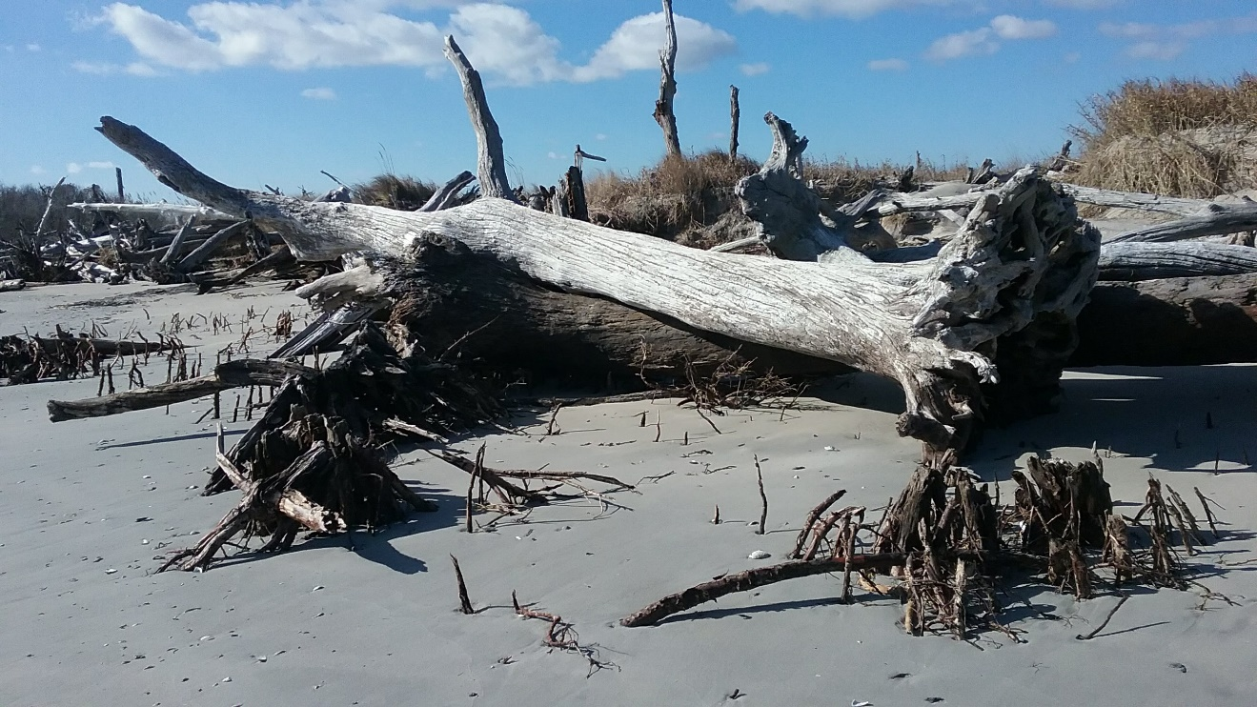

Parramore Island, Photo Credit: Natasha Woods
THE ECOLOGICAL QUESTION:
What is the impact of geographic location for the trajectory of coastal forests exposed to sea-level rise and storm disturbance?

FOUR DIMENSIONAL ECOLOGY EDUCATION (4DEE) FRAMEWORK
- Core Ecological Concepts:
  - Community
    - Species diversity-biodiversity-dominance
    - Succession
- Ecology Practices:
  - Natural history
    - Making observations and connections
  - Quantitative reasoning and computational thinking
    - Data skills - inputting and data-mining /data visualization
- Human-Environment Interactions:
  - Ecosystem services
- Cross-cutting Themes:
  - Spatial & Temporal
    - Scales
    - Stability and Change
  - Biogeography
    - Range

WHAT STUDENTS DO:
- Develop hypotheses about which coastal forest community (mainland or island) will recover biodiversity of plant species due to the combined effects of storms and sea-level rise.
- Interpret tree dominance tables to identify which community (mainland or barrier island) maintained biodiversity after several major storm events.
- Calculate Shannon diversity index using Excel or Google Sheets to understand if the plant communities maintained diversity after several major storm events.
- Produce and analyze graphs comparing the different size class of individual tree species at two timepoints with an emphasis on understanding the importance of species size for community dominance.
- Connect differences in community recovery back to the geographic location of the forests.

STUDENT-ACTIVE APPROACHES:
Students will learn about biodiversity, biogeography, and barrier islands in the following jigsaw activity:

In this in-class activity individual students in a group will learn about one of three topics and present it to their group. The purpose of this activity is to get students talking about the components of biodiversity in the geographically diverse ecosystems they are about to study.

STUDENT ASSESSMENTS:
Pre- and Post-Lab Assessments, Calculation and interpretation of species Shannon diversity index, Accurate graphing of stage class data, Written interpretation of figures from stage class data

CLASS TIME:
2-2.5 hours

COURSE CONTEXT:
This assignment was designed for (Fr., So., Jr., Sr.,) biology or ecology class. This can be used for majors, nonmajors, or for a general education course. This assignment was designed for (Fr., So., Jr., Sr.,) biology or ecology class. This can be used for majors, nonmajors, or for a general education course.

SOURCES:
Data associated with this research are available at:
- Richardson, D.L. 1999. Parramore Island of the Virginia Coast Reserve Permanent Plot Resurvey: Plot data 1996. Virginia Coast Reserve Long-Term Ecological Research Project Data Publication knb-lter-vcr.107.19 (doi:10.6073/pasta/7c5547d1f778e102fd4d05bd3c53d451).
- Richardson, D.L. 1999. Parramore Island of the Virginia Coast Reserve Permanent Plot Resurvey: Tree data 1997. Virginia Coast Reserve Long- Term Ecological Research Project Data Publication knb-lter-vcr.102.18 (doi:10.6073/pasta/7ade4c94f6a 6be7f239b873e4fd87ce4).
- Richardson, D.L. 1999. Parramore Island of the Virginia Coast Reserve Permanent Plot Resurvey: Shrub data 1996. Virginia Coast Reserve Long-Term Ecological Research Project Data Publication knb-lter-vcr.99.18 (doi:10.6073/pasta/0382ee52fbd0485325e8d052d3587399).

ACKNOWLEDGEMENTS:
We thank the Virginia Coast Reserve staff for logistical support, the Virginia Department of Conservation and Recreation for permitting access to collect data on the Eastern Shore of Virginia, and the Coastal Plant Ecology Lab at Virginia Commonwealth University for the collection of the 2018 data. This research was supported by the National Science Foundation Long-Term Ecological Research grants DEB-1237733 and DEB-1832221, the Virginia Commonwealth University Presidential Research Quest and Dean funds to J.C. Zinnert, and Ford Foundation Fellowship to N.N. Woods. The creation of this module was funded by the National Science Foundation (DBI-1730526 RCN-UBE: Biodiversity Literacy in Undergraduate Education-Data Initiative and DBI-2120678 RCN-UBE: Transforming Ecology Education to Four Dimensional Network). We would also like to thank Anna Monfils and Luanna Prevost for their instruction in the development of this module along with the editor and reviewers whose comments helped improve this module.
OVERVIEW OF THE ECOLOGICAL BACKGROUND
Coastal ecosystems are at the forefront of the impacts of climate change (i.e., sea level rise, increase in storm frequency and intensity). Species vary in response to disturbances such as sea-level rise and storm events. The responses could be mild (e.g., loss of branches that regrow) or extreme (e.g., death of species that do not regenerate). The extent to which a community is disturbed may depend on its geographic location. Barrier islands fringe the mainland and experience the brunt of storms while coastal communities behind barrier islands experience less wind and wave energy. This lab was designed to teach students how diversity and recovery of communities differ on the mainland and barrier islands and students will develop relevant analytical skills used in forestry today. The data sets show species diversity, size, and dominance of trees in a forested community on the mainland (Savage Neck Nature Preserve) and on a barrier island (Parramore Island) at two timepoints during which several major storms occurred (Figure 1).

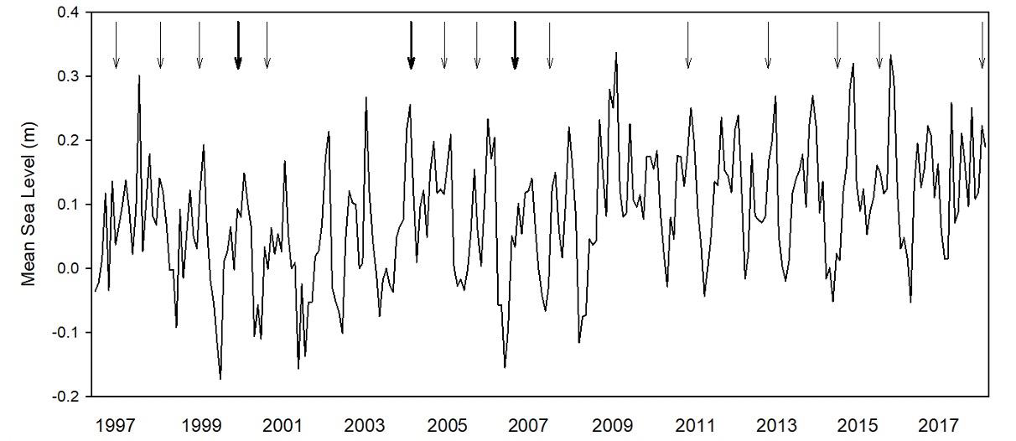
Figure 1. Mean sea level over the time period from 1997 to 2018 from Chesapeake Bay Bridge Tunnel, VA. Hurricanes and tropical storms that came within a 100 mi radius of Parramore Island are indicated by arrows. Bold arrows indicate more than one storm within that year.
LEARNING OBJECTIVES:
Upon completion of this module, each student should be able to:
- Compare and contrast the extent to which spatially distinct communities recover after temporal disturbances.
- Create graphs of changes in plant size over time and evaluate how succession in communities change after disturbance.
- Calculate Shannon Diversity Index of communities to formulate an argument about the importance of geographic position for the recovery of coastal communities.
- Identify ecosystem services that may be lost when dominant species in an ecosystem do not recover.
DATA SETS
- Faculty Tree Stage Class Data
- Faculty Shannon Diversity Index Data
- Student Tree Stage Class Data
- Student Shannon Diversity Index Data Interpretation
- Student Shannon Diversity Index Data
- Additional Information Regarding Trees and Shrubs

STUDENT INSTRUCTIONS
Pre-lab questions: The purpose of the prelab questions is to understand how salt intolerant species obtain freshwater on barrier islands (even though they are surrounded by saltwater), to determine the impact of climate change (i.e., sea level rise) on the capacity for salt intolerant species to obtain freshwater, and to think about the impact a lack of freshwater may have on salt intolerant species.

1) What are barrier islands?

2) Trees on barrier islands are surrounded by saltwater. How do trees on barrier islands obtain
freshwater?

3) Research studies show that freshwater on barrier islands is becoming contaminated with
saltwater. Why is this happening?

4a) What do you think would happen to trees if they could no longer take up freshwater through
their roots?

4b) Would the result you mentioned be the same for all plants? Why or why not?

5) What is the connection between forests on barrier islands and forests on the mainland when
hurricanes travel along the Atlantic Ocean of the US?

Background:
Succession
Maritime forests on barrier islands serve as a buffer to the mainland when hurricanes and nor’easters impact coastlines. Maritime forests along the Atlantic Coast are threatened by sea level rise, storm surge, and salinity flooding. At the ecosystem scale, succession often occurs in coastal areas based on salinity tolerance and time since disturbance. Proximity to the ocean increases saline conditions for species that establish near it. Overall, the most salt tolerant species such as grasses are closer to the ocean while species with a relatively low tolerance for salinity are more inland in the forest community. Within forests, trees can also vary in salinity tolerance. Tolerance levels can range from tolerant (e.g., black cherry, black locust, and eastern red cedar), moderate (e.g., eastern redbud, hackberry, sugar berry), and sensitive (e.g., flowering dogwood, loblolly pine, red mulberry).

Another factor for succession is when species appear in the forest. Species that establish first are called early successional species (e.g., American holly, Wax myrtle, sweet gum). These species are usually less than three meters tall. Mid-successional species become dominant next (e.g., northern red oak, sugarberry, tulip tree) and are usually less than 16 meters tall. Late successional species establish last (e.g., eastern redbud, swamp bay, sugarberry) and achieve heights greater than 16 meters in the canopy.

Island Biogeography
Which plants occur in forests will impact the wildlife that forage and form habitats in these communities. The study of where plants and animals are distributed on islands is called island biogeography. On the mainland, seed dispersal to different forest patches is relatively short. As a result, there is more diversity of species in forests on the mainland. In order for barrier islands to receive seed, seed must be dispersed over a longer distance, via wind, water, or avian transport. As a result, there are fewer species in forests on barrier islands. Recovery of tree species may be vital to the animals that depend on them for food and shelter.

Forest Recovery after Storms
Forests on barrier islands are at the forefront of storm disturbances, whereas forests on the mainland are positioned behind barrier islands and large dunes, potentially providing a geographic advantage during recovery. Forests play a crucial role in providing essential ecosystem services including reducing erosion and providing shelter for wildlife. These essential ecosystem services are threatened in coastal forests due to increased salinization into sensitive habitat when dunes are destroyed by hurricanes. Disturbances including salinization increases in coastal forested areas occur due to many factors such as sea-level rise, storms, and storm surges, and drought. Salination can reduce the biodiversity of forested plant communities.

You will study two forested communities one on the mainland, Savage Neck Dunes Nature Preserve, Virginia, here after, Savage Neck and a barrier island, Parramore Island, Virginia, that lies at the forefront of storms forming along the Atlantic Coast. Hurricane Isabel hit in 2003 and was the deadliest and most destructive hurricane of the season. It had wind speeds of 233 mph, the strongest instantaneous wind speeds recorded in the Atlantic Ocean at that time according to NOAA. Prior to Hurricane Isabel (2003), biodiversity in forests in both these locations were documented. Following Hurricane Isabel, several other major storms occurred, and sea-level rise rates continue to increase, impacting the recovery of these communities.

For additional information about succession and salt tolerance of species view this document.

Jigsaw Activity in lab: Biodiversity in Coastal Ecosystems
Students will get into groups of three at the start of the lab, research and teach one another about the following topics at the start of the lab:

Topics:
- Biodiversity- What is it and why does it matter?
- Island biogeography-Why are there fewer species on islands than the mainland?
- Barrier islands-What are they? Where can you find them? How do they protect people and property on the mainland?
Instructions for Students:
You will be examining biodiversity of forests on Savage Neck Dunes and Parramore Island at two timepoints separated by major storm events and continued sea-level rise (including Hurricane Isabel in 2003) to determine which community was able to recover through maintaining its original biodiversity and form conclusions about factors that may have impacted rates of recovery. Below you will find charts of biodiversity at two timepoints from each location. Follow the instructions below to understand the extent to which the biodiversity in these locations changed following repeated storm disturbance.

Part 1: Understanding species dominance by interpretation of data in tables
Biodiversity is defined as the amount of diversity between different species (e.g., plants, animals) in each habitat at a particular time. Ecologists, people who investigate biodiversity, community structure, and the abundance and distribution of species, are not typically interested in counting all the trees in a forest because it would take too long and not all species will have the same impact on the community (e.g., larger, older trees may have a larger impact than smaller, younger trees). Ecologists are interested in calculating the importance value, which considers multiple variables. The importance value is a measure of how dominant a species is in each forest area. Biodiversity on Savage Neck was first measured in 2003 before Hurricane Isabel hit and the biodiversity on Parramore Island was first measured in 1996. You will be examining the importance values of trees at each location before and after Hurricane Isabel and other major storm events. Importance values are a measure of how dominant a species is in a forest.

The importance value is calculated as the sum of the following:
Relative Density: Density is calculated as the total number of individuals of a species. Relative density is calculated by dividing the density by the sum of the densities of all species, multiplied by 100 (to obtain a percentage).
Basal Area: Basal area is calculated based on the area of a circle and tree diameter measured at breast height. Relative dominance is calculated by dividing the dominance by the sum of the dominance of all species, multiplied by 100 (to obtain a percentage).
Frequency: Frequency is calculated as the number of plots where a species is observed divided by the total number of survey plots. Relative frequency is calculated by dividing the frequency by the sum of the frequencies of all species, multiplied by 100 (to obtain a percentage).
The Importance Value is the sum of these three factors and ranges between 0 and 300.

Student Question:
Examine the data from time point 1 below in Table 1 (Savage Neck, 2003) and Table 2 (Parramore Island, 1997) and form a hypothesis regarding which community may return back (or near) to these levels of biodiversity.

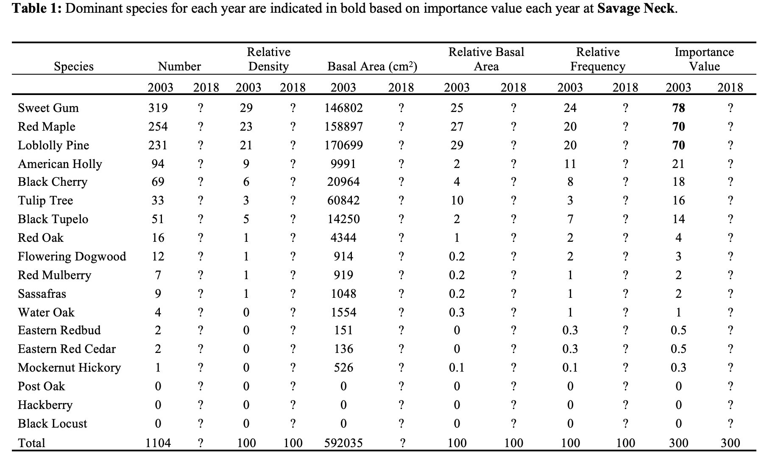

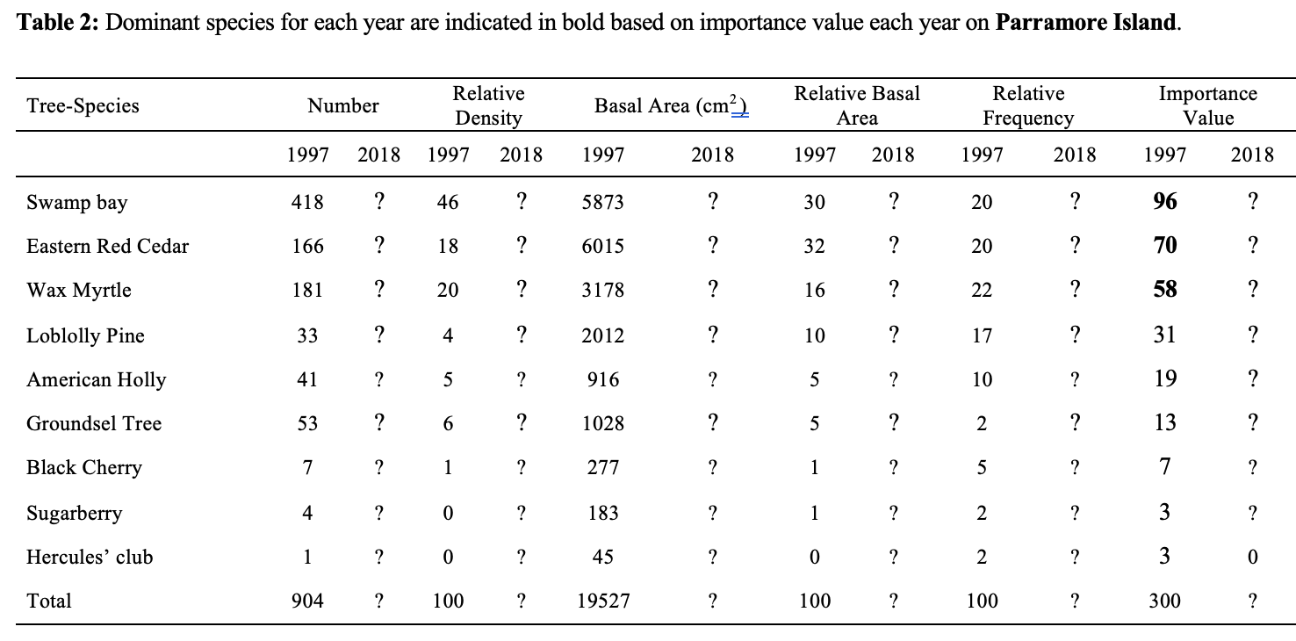
Hypothesis:___________________________________________________________________
_____________________________________________________________________________
_____________________________________________________________________________

What knowledge from your jigsaw or pre-lab activity did you use to form your hypothesis? _____________________________________________________________________________

_____________________________________________________________________________

Please do not proceed until your hypothesis is written down.
Now examine the results of the tables below for how the importance values change over time.
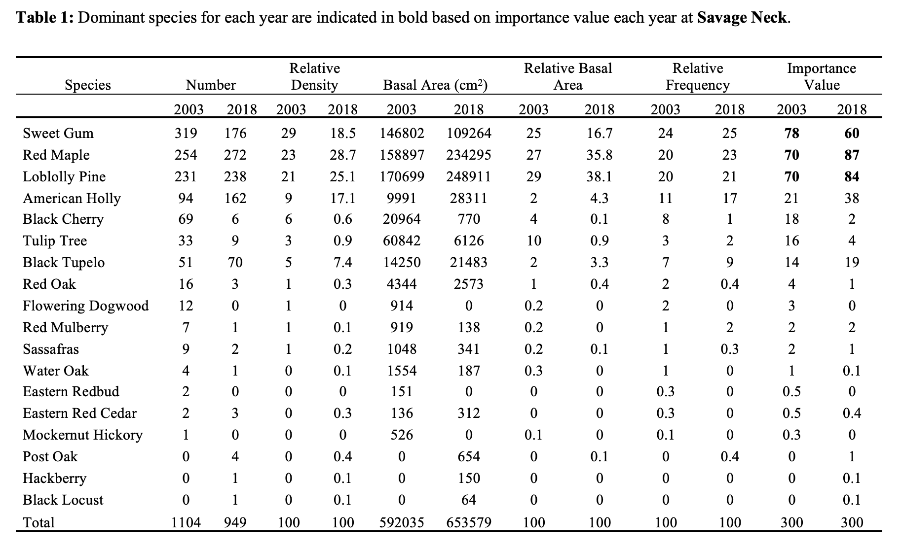
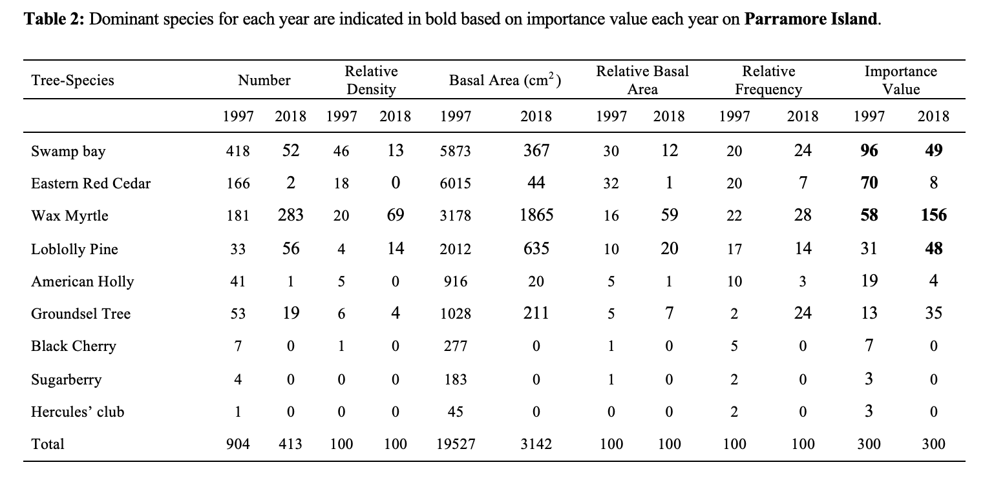
Student Question:

Was your hypothesis supported by the results? ________.

Interpreting the Importance Value Tables:
1. What were the three most dominant species on Savage Neck in 2003? What were the Importance Values? Fill out the table below with the results from table 1 above.

Savage Neck
2003 |  | 2018
Species | Importance Values | Species | Importance values
Sweetgum |  | Red maple
Red maple |  | Loblolly pine
Loblolly pine |  | Sweetgum

Write a summary of the findings in the space below, be as detailed as you can about the changes observed in the forested community:

2. What were the three most dominant species on Parramore Island in 1997? What were the Importance Values? Fill out the table below with the results from table 2 above.

Parramore Island
1997 |  | 2018
Species | Importance Values | Species | Importance values
Swamp Bay |  | Wax Myrtle (shrub)
Eastern Red Cedar |  | Swamp Bay
Wax Myrtle (shrub) |  | Loblolly Pine

Write a summary of the findings in the space below, be as detailed as you can about the changes observed in the forested community:

Student Questions:
1) Compare and contrast the post-disturbance data from both communities.

Savage Neck: Is the community recovering or declining? What evidence can you find in the chart to support your answer?

Parramore: Is the community recovering or declining? What evidence can you find in the chart to support your answer?

2) To what extent were the two forested communities similar in biodiversity before the disturbance? Examine changes in community dominance by looking at the changes in the importance values (i.e., compare importance values, 2003 for Savage Neck versus 1997 for Parramore Island).

3) To what extent are the two forested communities different in biodiversity in 2018 after the disturbance? Examine changes in community dominance by looking at the changes in the importance values (i.e., compare importance values from 2018 from Savage Neck and Parramore Island).

4) For the community that showed the most change, how did the biodiversity differ (i.e., were
trees still the dominant species?) Explain how species dominance changed from when the
the community was initially inventoried until 2018.

Part 2: Graphing species dominance by stage class
Species dominance is not just about how numerous a species is in a community. The importance values that were calculated in Part 1 also took into account how large a species is in the community. How large a species is is determined by its basal area which is a measure of the diameter at breast height of trees or the basal stem diameter of shrubs. A species can have a lower density and still be dominant because of its size. The diameter at breast height for trees and the basal stem diameter for shrubs were taken from a random selection of trees at the Savage Neck and Parramore Island sites. In the table provided in below, species are divided into stage classes. After graphing the data, it can be seen how species moved into older stage classes or were no longer present at a high enough abundance to be captured in this data set. When foresters examine how an entire community changes in species composition over time, ecologists call this ecological succession. Start by uploading the data to Google Sheets and then graph the stage class data to visualize ecological succession using the tips sheet below.

Data Sheet for Students:
https://tiee.esa.org/vol/v19/issues/data_sets/woods/resources/Student Tree Stage Class Data.xlsx

Tips on how to make graphs in Google Sheets:
https://tiee.esa.org/vol/v19/issues/data_sets/woods/resources/Instructions for Making Graphs in Google Sheets.docx

Questions for Students:

Describe in the space provided what happened to each species during the fifteen years of recovery. Give as much detail as you can.

Savage Neck

Top four tree species 2003/2018 | Impact of disturbance on recovery
Red Maple
American Holly
Sweet Gum
Loblolly Pine

Parramore Island

Top six tree species 1997/2018 | Impact of disturbance on recovery
Wax Myrtle
Groundsel Tree
Swamp Bay
Loblolly Pine
Eastern Red Cedar
American Holly

Part 3: Interpreting species diversity
After ecological succession takes place community diversity can change in a community, which could alter the services that community provides (e.g., wildlife habitat, soil nutrient quality, storm protection, etc.). In order to examine how species diversity changes pre and post disturbance, ecologists measure diversity indices such as species richness (i.e., total number of species in each community) and Shannon diversity index, which accounts for species abundance by calculating the proportion of individuals there are in a community compared to the total number of individuals in the community.

These data have been calculated for you, please see the table.

Use the data from the spreadsheet to fill out the following table with the species richness numbers for each community

Community | Species richness
Savage Neck (2003)
Savage Neck (2018)
Parramore Island (1997)
Parramore Island (2018)

Shannon diversity index is calculated using the following formula:

H = -SUM (Pi*ln(Pi))

Pi = species abundance/total abundance in the community
ln = natural log

The value of the Shannon-Weaver diversity index usually ranges from 1.5 to 3.5. Values less than 1.5 show low species diversity and numbers 3.5 or higher show high species richness.

Questions:

Which community was the most diverse? ______________.

List the Shannon Diversity index for this community____________.

Which community falls below the range of average diversity found in most ecological communities? _____________________.

List the Shannon Diversity index for this community___________

Part 4: Summary and Conclusions

Interpreting the data and Drawing Conclusions
Write a summary about the overall conclusions that you can make based on the data provided. In your summary, be sure to restate your initial interpretation of the data and address the following questions:

- What are the future trajectories of these two communities?

- What factors did you consider when predicting the future trajectories for these communities?

- What factors may have contributed to one community recovering faster than the other community?

- If barrier islands do not recover, what implications does this have for forests on the mainland?

References
Woods, N.N., Tuley, P.A. and Zinnert, J.C., 2021. Long-Term Community Dynamics Reveal Different Trajectories for Two Mid-Atlantic Maritime Forests. Forests 12:1063.

Post-lab questions:

1. If the trees on Parramore Island were shown to be resilient to storms, what would the
community look like? Name the top three trees/shrub that might have been present in great
abundance.

2. What do you think was the greatest factor in the differences in the recovery of these two
communities? Defend your answer.

3. If forests on barrier islands do not recover, what implications does this have for forests on the
mainland?

4. How might the lack of recovery of forest on the barrier island impact people and property on
the mainland?

5. Identify at least three ways we can protect these valuable plant communities on barrier
islands.

Notes to Faculty

Suggestions for Implementing Data Set:
The data in this lab are good for augmenting students’ understanding of succession, island biogeography, disturbance, species biodiversity (i.e., species richness), and recovery after disturbance. This data allows students to see a practical use for the concepts they are exploring in class. These real world data are important for increasing student enthusiasm and buy in for seemingly difficult concepts that impact our daily lives.

This lab comes with pre and post assessment questions with potential answers. Also, potential answers are provided in the Faculty Notes for all of the questions students are being asked throughout the student handout.

Pre-lab questions:

Students can look these answers up online.

Pre-lab questions: The purpose of the prelab questions is to understand how salt intolerant species obtain freshwater on barrier islands (even though they are surrounded by saltwater), to determine the impact of climate change (i.e., sea level rise) on the capacity for salt intolerant species to obtain freshwater, and to think about the impact a lack of freshwater may have on salt intolerant species.

      - What are barrier islands?

Full credit answer:
Deposit of sand parallel to the coast of the mainland that includes vegetation
The vegetation on barrier islands may include dune grasses, forests, and marshes
They erode and grow due to the impact of weather on wind and waves
They take the full force of storms and wave energy, decreasing the impact on the mainland

Partial credit answer:
A partial answer will include at least two of the statements above in the full credit answer.

2) Trees on barrier islands are surrounded by saltwater. How do trees on barrier islands obtain
freshwater?

Full credit answer:
Freshwater comes from rainwater
Freshwater is less dense than saltwater
A freshwater lens is formed beneath the surface and the roots of freshwater species obtain freshwater

Partial credit answer: Water comes from rainfall or water comes from the freshwater lens.

3) Research studies show that freshwater on barrier islands is becoming contaminated with
saltwater. Why is this happening?

Full credit answer: The freshwater lens becomes contaminated with sea level rise. As the sea rises it contaminates the freshwater lens.

Partial credit answer: None. Any answer that does not contain sea level rise does not receive any credit.

4a) What do you think would happen to trees if they could no longer take up freshwater through
their roots?

Full credit answer: Trees would die. The trees would die slowly, so they would still be standing until something such as a strong wind or erosion caused them to fall.

Partial answer: Trees would lose leaves. Trees would stop growing. Trees would stop reproducing. Note: This answer never states what will ultimately happen to the trees.

4b) Would the result you mentioned be the same for all plants? Why or why not?

Full credit answer: No. Some plants may be adapted to tolerate higher salt levels.

Partial answer: No. Some plants may not die. Note: This answer does not explain why some plants may not die.

5) What is the connection between forests on barrier islands and forests on the mainland when
hurricanes travel along the Atlantic Ocean of the US?

Full credit answer: Since barrier islands serve as a buffer to the mainland, forest on barrier islands receive the brunt of the wind and wave energy, decreasing the impact on trees on the mainland.

Partial credit answer: Trees on the mainland are protected from storms. Note: This answer does not mention how the forests on barrier islands protect forests on the mainland.

Jigsaw Activity in lab: Biodiversity in Coastal Ecosystems
Students will get into groups of three research and teach one another about the following topics at the start of the lab:

Topics:
Biodiversity- What is it and why does it matter?
Island biogeography-Why are there fewer species on islands than the mainland?
Barrier islands-What are they? Where can you find them? How do they protect people and property on the mainland?

Key points regarding biodiversity and impact on diverse ecosystems:
- Biodiversity is a measure of the variation of species in a particular ecosystem.
Some species provide unique services that help the ecosystem and if that species is lost the entire ecosystem may transition into a different ecosystem.
- Some species provide services that are redundant and if a particular species is lost the ecosystem remains similar.
- Drastic changes may occur when the dominant species transition from woody to grass or from grass to woody.

Key points regarding fewer species on barrier islands:
- There are more plants on the mainland than barrier islands because the further an island is from the mainland the fewer species that will be dispersed there
- Seed can be dispersed to islands by birds, water, or air. Not all species will be able to survive the dispersal process. Distance from the mainland will matter.
- It is more detrimental for plants not to recover on barrier islands because there are already fewer species there.

Key points regarding why barrier islands are important for protecting the mainland:
- Provide a buffer between the mainland and hurricanes that come up the Atlantic Ocean or nor’easters that come from the south.
- Absorb wave energy which decreases the impact on the mainland.
- Reduces flooding on the mainland.

Part 1: Understanding species dominance by interpretation of data in tables

Student Question:
Examine the data from time point 1 below in Table 1 (Savage Neck, 2003) and Table 2 (Parramore Island, 1997) and form a hypothesis regarding which community may return back (or near) to these levels of biodiversity. What knowledge from your jigsaw or pre-lab activity did you use to form your hypothesis?

Potential Hypotheses:
1) The forest on the mainland will have similar levels of biodiversity after multiple disturbances because it has more species, there is a greater chance some will survive.
2) The forest on the mainland will have similar levels of biodiversity after multiple disturbances because it is protected behind barrier islands.
3) Accept all other plausible answers.
Interpreting the Importance Value Tables:

      - What were the three most dominant species on Savage Neck in 2003? What were the Importance Values?

Students should be able to identify the following:
- Sweetgum was the most dominant species in 2003.
- Red maple and loblolly pine had the same dominance in 2003.
- Red maple increases in dominance in 2018.
- Sweetgum was the least dominant species in 2018.
- The top three dominant species remained the same.

      - What were the three most dominant species on Parramore Island in 1997? What were the Importance Values?

Students should be able to identify some of the following differences:
- Trees were more dominant in 1997.
- Swamp Bay was the most dominant species.
- A shrub, Wax Myrtle, was among the top three species in 1997 and 2003.
- Wax Myrtle became the most dominant species in 2018. Shrubs are increasing in dominance on Parramore Island.
- Only two out of three of the most dominant were the same in 2018.
- Loblolly Pine replaced Eastern Red Cedar in the top three dominant species ranking in 2018.
- This community is shifting from tree dominance to shrub dominance.

3. Compare and contrast the post-disturbance data from both communities.

Savage Neck: Is the community recovering or declining? What evidence can you find in the chart to support your answer?
- Answer: The forested ecosystem on Savage Neck appears to be recovering, as is typical of stable ecosystems after a disturbance. The evidence for this is that the top three species, which are of the same growth form, trees, remained the same. It appears that this community is recovering.Parramore: Is the community recovering or declining? What evidence can you find in the chart to support your answer?
- Answer: The forested ecosystem on Parramore Island appears to lack any substantial recovery. In fact, the top dominant species changed from tree to shrub, which may not perform the same function in this ecosystem. The top three dominant species did not remain the same. It appears that this community is declining.

Have Students Look at the entire data set to answer these questions below:

To what extent were the two forested communities similar in biodiversity before the disturbance?

Potential Answers:
- They were both primarily dominated by trees even though Parramore had two shrub species, one of which was in the top three for dominance both in 1997 and 2018.
- No one species was substantially more dominant than all others.

To what extent are the two forested communities different in biodiversity in 2018 after the disturbance?

Potential Answers:
- More species were on Savage Neck than on Parramore Island
- There were no shrubs identified on Savage Neck
- One species, Wax Myrtle, became substantially dominant on Parramore Island relative to all other species.

4. For the community that showed the most change, how did the biodiversity differ (i.e., were
trees still the dominant species?) Explain how species dominance changed from when the
community was initially inventoried until 2018.

Parramore Island showed the most change. Biodiversity was severely decreased. Shrubs became more dominant.

Part 2: Graphing species dominance by stage class

Tree stage class data can be found here.

Assignment for Students:

Describe what happened to each species during the fifteen years of recovery.

Savage Neck

Top four tree species 2003/2018 | Impact of disturbance on recovery
Red Maple | Most of the trees can be found in the 10-60 cm stage classes in 2003. In 2018 most trees can be found in the 10-70 cm stage classes. Succession has clearly taken place into the larger stage classes. In 2003, the highest DBH was found in the 90.1- 100 cm stage class and in 2018 it was the 130.1- 140 cm stage class..
American Holly | American Holly also underwent succession into larger stage classes. Most of the trees in 2003 and 2018 are found between the 10-40 cm stage classes. Many more young American Holly trees (i.e., 10.1-20 cm) were found in 2018 rather than in 2003).
Sweet Gum | It is clear that some succession took place because there were no trees in the 90.1-100 cm stage class in 2003 and in 2018 there were two individuals in this stage class. In 2003, most of the trees were found between the 10 and 60 cm stage classes. In 2018, most of the trees are found between the 10 and 70 cm stage classes.
Loblolly Pine | Many of the Loblolly Pine trees experienced succession into larger stage classes. This is particularly obvious in the 30-80 cm stage classes.

Parramore Island

Describe what happened to each species during the twenty-one years of recovery.

Top four tree species 1996/2018 | Impact of disturbance on recovery
Wax Myrtle | There were more individuals in the 0-20 cm stage classes found of Wax Myrtle in 2018 than in 1997. There were also more stage classes. In 2018 Wax Myrtle expanded out to the 30.1-40 cm stage classes. It was clear succession had taken place.
Groundsel Tree | In 2018 Groundsel Tree increased in stage classes from 1997. The maximum stage class in 1997 was 10.1-20 cm. In 2018, the maximum stage class was 30.1-40 cm. However, there were fewer shrubs found overall in 2018 relative to 1997. It was clear that succession took place with the shrubs that were found.
Swamp Bay | There were much fewer trees of Swamp Bay in 2018 than in 1997. The maximum amount of Swamp Bay in 1997 for the 0-10 cm stage class was 349. These species should have experienced succession into older stage classes over the 21 year time period. This is not the case.
Loblolly Pine | The stage classes of Loblolly Pine extended to 60.1-70 in 1997 and only to 50.1-60 cm in 2018. However, there are many more individuals in 2018 in the 10.1-30 cm stage classes than were present in 1997.
Eastern Red Cedar | In 1997, Eastern Red Cedar, had many trees present up until the 40-50 cm stage class. Have students come up with ideas about why data for Eastern Red Cedar is not present for 2018. 1) There may have been so few in number that they were never present in large enough number to be randomly selected.
American Holly | In 1997, young American Holly (0-10 cm stage class) were the most numerous and number of individuals decreased with each subsequent stage class until the 30.1-40 cm) stage class.

Part 3: Calculating species diversity

The data for calculating species richness and the Shannon diversity index can be found in Tables 1 and 2 in part 1 of this exercise.

Fill out the following table with the species richness for each community from the data provided in the Shannon diversity index table.

If you would like for students to do the calculations on their own, below is a link to a sheet that does not contain the calculations.

https://tiee.esa.org/vol/v19/issues/data_sets/woods/resources/Student Shannon Diversity Index Data.xlsx

Community | Species richness
Savage Neck (2003) | 15
Savage Neck (2018) | 14
Parramore Island (1997) | 9
Parramore Island (2018) | 6

Questions for students:

Which community was the most diverse? Savage Neck 2003.
List the Shannon Diversity index for this community 1.886.

Which community falls below the range of average diversity found in most ecological communities? Parramore Island.
List the Shannon Diversity index for this community 0.973.

Tips for Students:
- Calculate the numbers in the Google Sheet appropriately.
- Take the negative of the number that was calculated in the table.
- Round numbers to three significant figures.

Part 4: Summary and Conclusions

Interpreting the data and Drawing Conclusions
Write a summary about the overall conclusions that you can make based on the data provided. In your summary, be sure to restate your initial interpretation of the data and address the following questions:
- What do you predict are the future trajectories (e.g., directions) of these two communities?

Potential Answers:
Savage Neck is undergoing a typical successional pattern where smaller trees are moving into larger stage classes as diameter at breast height increases. The top three dominant species all are the same as they were prior to the disturbance. The top three species all remained of the same form, trees. The community is protected behind barrier islands.

The fate of Parramore Island is less certain. The community shrub Wax Myrtle has an importance value that went from 58 in 1997 to 156 in 2018. Another shrub is also increasing in dominance, Groundsel Tree went from an importance value of 13 in 1997 to an importance value of 33. These are both shrubs that are increasing in dominance in a community that was once dominated by trees. This could limit the habitat and food sources for wildlife. Also, it could change the extent to which the island responds to storms. Trees are tall and provide wind resistance, something shrubs would not be able to do. Additionally, the trees are not moving into larger stage classes on Parramore Island but are decreasing altogether.

- What factors did you take into account when predicting the future trajectories for these communities?

Potential Answers:
Some of the factors that were taken into account were succession into larger stage classes and capacity for communities to remain similar in dominant plant form, pre and post disturbance.

Accept any plausible answers.

- What factors may have contributed to one community recovering faster than the other community?

Potential Answers:

Wax Myrtle was not present on Savage Neck. It may have increased in dominance in the post disturbance community if it was present.

Savage Neck has many species, these tall trees may have served as a buffer to one another, increasing the survival of many species.

Savage Neck is protected behind barrier islands. It may have sustained less damage.

Accept any plausible answers.

- If barrier islands do not recover, what implications does this have for forests on the mainland?

Potential Answers:

Savage Neck and other communities will be at the forefront of Atlantic coast storms and may sustain the damage that is typically found on barrier islands. The consequences could be severe for people and property on the mainland if they were not protected behind barrier islands.

When considering biodiversity and island biogeography, would Parramore have been impacted so severely if it was closer to the mainland?

Potential Answer:

No, if Parramore was closer to the mainland, its species diversity would have probably increased and there may have been more salt tolerant species in the community.

Accept any plausible answers.

Post-lab questions:

1. If the trees on Parramore Island were shown to be resilient to storms, what would the community look like? Name the top three trees/shrub that might have been present in great abundance.

Full credit answer: The community would look a lot like the original community where the top three plants were Swam Bay, Eastern Red Cedar, Wax Myrtle.

Partial credit answer: An answer that answered the question but did not name the top three plants or vice versa.

2. What do you think was the greatest factor in the differences in the recovery of these two communities? Defend your answer.

Full credit answer: Geographic location. Barrier islands take the brunt of the storm and thereby incur more damage, typically greater erosion because erosion can occur on all sides. They can incur greater salt intrusion and sand burial (i.e., overwash) because of the greater force of wind and wave energy. This can have a negative impact on salt-intolerant and burial-intolerant plants.

Partial credit answer: Potentially, more salt intolerant species on Parramore Island or lack of resources due to the extensive spread of Wax Myrtle on Parramore Island could be defended as plausible answers. These answers must be defended. Students could look up the salt tolerance of species listed on each island and calculate the percent of salt intolerant species at Savage Neck versus Parramore Island. Students could look up the tolerance level of Wax Myrtle. Wax Myrtle is moderately salt tolerant. It may be more adapted to saline environments than tree species. Therefore, it could potentially usurp the available nutrients and freshwater, depriving the other species of freshwater and nutrients. Students may come up with other plausible answers.

3. If forests on barrier islands do not recover, what implications does this have for forests on the mainland?

Full credit answer: If forests on Parramore Island do not recover, then forests on the mainland may be at the forefront of storms and experience higher wind and wave energy due to the brunt of storms.

4. How might the lack of recovery of forest on the barrier island impact people and property on the mainland?

Give students permission to look up examples online.

Full credit answer: The forests protect the marsh. The marsh reduces flooding, if there are no forests, then the marshes will not be protected. More people will experience greater flooding and more property will be damaged.

After Hurricane Sandy marshes (also known as wetlands) prevented hundreds of million dollars in flooding damage:

https://www.pbs.org/newshour/science/wetlands-stopped-650-million-property-damage-hurricane-sandy-can-help-houston

5. Identify at least three ways we can protect these valuable plant communities on barrier islands.
Answers will vary:

- Learn more about the signs of climate change (e.g., sea level rise, increase frequency in storms)
- Educate people about the importance of barrier islands for people who live on the coastal mainland
- Do our part to reduce our impact on the environment.

