ISSUES: CASE STUDIES

Ethics in ecological forecasting: four case-based teaching modules
Abigail S. L. Lewis¹, Dexter W. Howard¹, Gerbrand Koren², Cazimir Kowalski³, Jason McLachlan³, Jody A. Peters³, Georgia Smies⁴, and Olivia Tabares ⁵
¹Department of Biological Sciences, Virginia Tech, Blacksburg, VA, USA
²Copernicus Institute of Sustainable Development, Utrecht University, Utrecht, the Netherlands
³Department of Biological Sciences, University of Notre Dame, Notre Dame, IN, USA
⁴Division of Natural Resources, Salish Kootenai College, Pablo, Montana, USA
⁵The American School Foundation, Ciudad de México, México
Corresponding author: Abigail S. L. Lewis (aslewis@vt.edu)
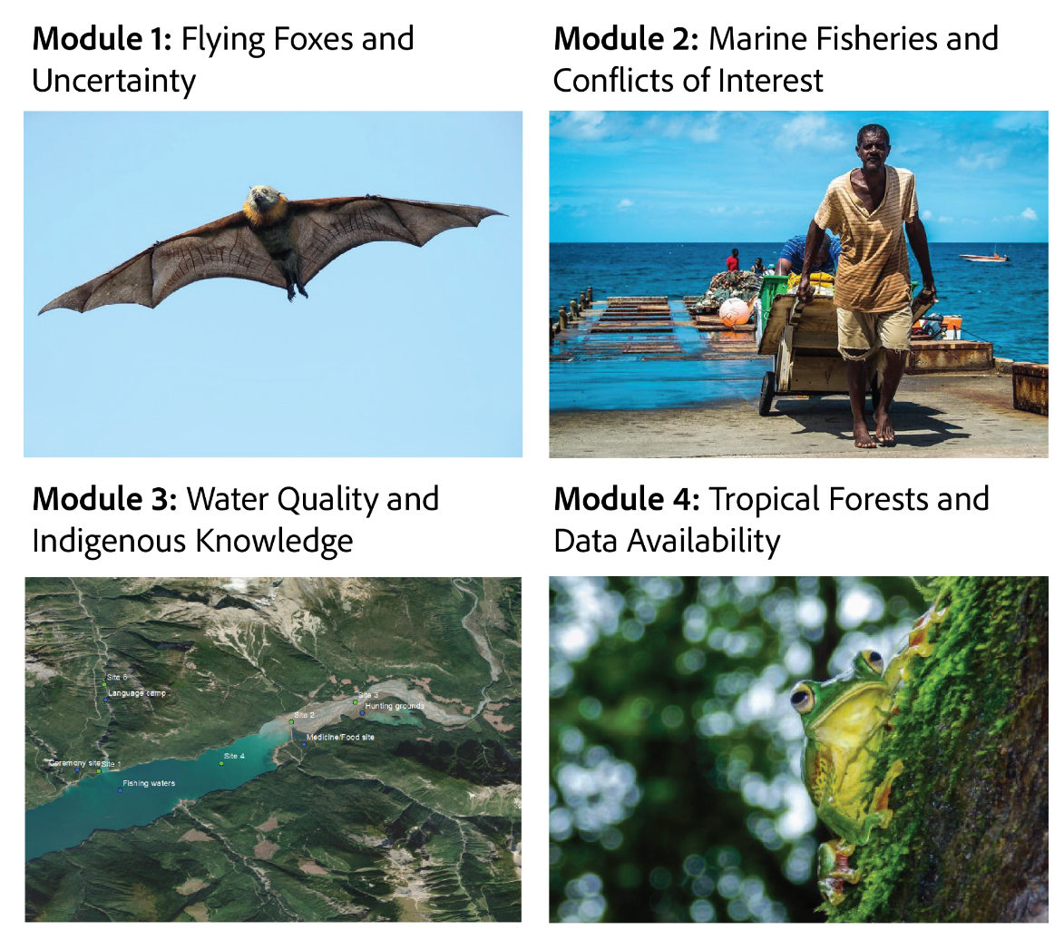

THE ISSUE:
Working with ecological data often involves ethical considerations, particularly when data are applied to address societal needs. However, data science ethics are rarely included as part of undergraduate and graduate training programs. Here, we present four modules for teaching ethics in data science, with real-world case studies related to ecological forecasting.
FOUR DIMENSIONAL ECOLOGY EDUCATION (4DEE) FRAMEWORK
- Core Ecological Concepts:
  - Organisms
    - Abiotic and biotic features of the environment
  - Community
    - Habitat types – terrestrial – marine – aquatic
  - Biosphere
    - Biogeography at the global level
    - Global climate change
- Ecology Practices:
  - Quantitative reasoning and computational thinking
    - Statistics
    - Data skills – inputting and data-mining / meta-analysis/ data visualization
    - Data analysis and interpretation
  - Working collaboratively
  - Communicating and applying ecology
- Human-Environment Interactions:
  - Human accelerated environmental change – there is no pristine ecosystem nor total equilibrium
    - Anthropogenic impacts, intentional and unintentional
  - How humans shape and manage resources/ecosystems/the environment
    - Agricultural ecosystems –fisheries
    - Natural resource management
    - Conservation biology
    - Ecological stewardship
  - Ethics – critical thinking about the values underlying how we approach and address environmental problems, challenges, and opportunities in environmental decision-making and policy
    - Environmental ethics – basic types of ethics and their sources/foundations (includes ecological)
    - Environmental justice
- Cross-cutting Themes:
  - Systems
  - Spatial & Temporal
    - Scales
    - Stability & change

STUDENT-ACTIVE APPROACHES:
Each of the modules are structured in “Think, pair, share” discussions. Students take the time to reflect individually, then discuss in small groups and share with the class.
STUDENT ASSESSMENTS:
Each module includes an optional essay assignment to assess student learning, with a suggested rubric.

CLASS TIME:
Four independent modules, one hour each

COURSE CONTEXT:
These stand-alone modules are designed to be flexible to a wide range of course contexts. We anticipate that in most cases, an instructor will choose to use only one of the four modules, and will choose the module that best matches their classes interests and needs (see descriptions below). However, each module covers a different topic related to ethics in ecological forecasting, and using multiple modules as part of a single course would provide increased training in the ethics of environmental data science.
All modules use a think-pair-share format for discussion, making them flexible to a wide range of class sizes. In very large courses, we note that it may be helpful to have teaching assistants who can help answer questions and engage with students during small group discussions.
Module 1: Flying foxes and uncertainty
- This module asks students to discuss ethical issues associated with the quantification and presentation of forecast uncertainty. As such, this module would connect well with data analysis lessons in an introductory ecology course or lab. In a forecasting-specific course, this module could be used as an introductory lesson to highlight the sources of forecast uncertainty and why uncertainty is necessary to include.
Module 2: Marine Fisheries and conflicts of interest
- This module focuses on the idea that forecasts may have multiple end users with different and potentially conflicting interests. This module would be beneficial in a general ecology or natural resources management class for discussing the benefits and challenges of public-facing research. In forecasting and data science classes this module would benefit discussions on end user engagement as a component of the forecast development process.
Module 3: Water Quality and Indigenous Knowledge
- This module focuses on the topic of scientific engagement with communities, with a case study of Indigenous communities and water quality. As such, this module would best be implemented in an introductory data science, forecasting, or ecology course, providing a discussion of how scientists can engage with impacted and marginalized communities. Due to the focus of this module, it may be most relevant for courses taught in the United States of America.
Module 4: Tropical forests and data availability
- This module addresses the (lack of) data availability to develop, validate or score ecological forecasts on a global scale. In particular, the module addresses underrepresentation of tropical ecosystems for studying vegetation dynamics. The themes of this module are broadly applicable to many classes, including courses in ecology and data science. The module is written to target advanced undergraduate students.

ACKNOWLEDGEMENTS:
Many thanks to Ryan McClure and Sydne Record for co-developing the idea for this project with co-author Abigail Lewis. This idea originated out of an Ecological Forecasting Initiative (EFI) Research Coordination Network meeting, which was supported by the U.S. National Science Foundation (NSF; DEB-1926388). Additionally, these case studies have been substantially improved by discussion and ideation within the EFI Education Working Group; many thanks to this group for their contributions. In developing these case studies, we were originally inspired in part by a blog post that discussed ethical considerations associated with COVID-19 forecasting (Record et al. 2020). Thanks to Nicholas Record and co-authors for writing that post, based on their experiences with ecological forecasting. Additionally, we thank Ian Shuman for developing one of the maps used in Module 3.
The development of these case studies was supported by numerous grants to individual collaborators. Abigail Lewis was supported by the U.S. National Science Foundation (NSF) graduate research fellowship program (DGE-1840995), US NSF grant DEB-1753639, the Institute for Critical Technology and Applied Science (ICTAS), and the College of Science Roundtable at Virginia Tech. Dexter Howard was supported by US NSF grants DBI-1933016 and DEB-1753639. Jody Peters was supported by funding from the Alfred P. Sloan Foundation. Many thanks to all of the funding sources that enabled the development of these teaching resources.

AUTHOR CONTRIBUTIONS:
ASL wrote the overview for this set of teaching modules, as well as the text of Module 1. DWH and OT wrote Module 2. CK, JM, and GS wrote Module 3. GK wrote Module 4. JAP made substantial contributions to the manuscript development process through meeting coordination and project management. All authors edited and approved the final manuscript.

OVERVIEW
As data availability and processing power have increased, ecology has undergone a “data revolution” (Farley et al. 2018, Hampton et al. 2013). Data science skills are now a necessary outcome of undergraduate ecology education (Barraquand et al. 2014, Farrell and Carey, 2018). To meet the growing need for data science education, a number of effective skills-based teaching modules have been developed (Carey et al. 2020, Farrell and Carey 2018, Moore et al. 2022, Willson and Peters 2021). However, comparatively few resources are available for discussing the ethical considerations inherent in data science, from the choice of data sources to the presentation of uncertainty and communication of results (Willson et al. 2023, Willson and Peters 2021).
The lack of education on data ethics in ecology reflects a broader need for undergraduate training in data ethics across multiple disciplines. For example, only 50% of the 25 major U.S. universities surveyed by Oliver and McNeil (2021) included any data ethics requirement in their data science programs. Due to this current gap in training, the National Academies of Science, Engineering, and Medicine consensus report on Data Science for Undergraduates (2018) includes ethics as one of their key recommendations: “Ethics is a topic that, given the nature of data science, students should learn and practice throughout their education. Academic institutions should ensure that ethics is woven into the data science curriculum from the beginning and throughout.” To incorporate data ethics in this way will require the development of new teaching materials, which demands substantial time and effort from instructors. Sharing teaching modules that can be incorporated into existing courses could significantly accelerate the introduction of ethics into data science training programs in ecology.
While ethical considerations are necessary in many areas of ecological data science, ecological forecasting presents a particularly compelling focal area. Ecological forecasting is a rapidly growing field (Lewis et al. 2022) focused on predicting future ecological states at daily to decadal scales (Dietze et al. 2018, Lewis et al. 2022). As an emerging field, ecological forecasting does not have many established protocols that could present default ethical norms (Woelmer et al. 2021). This ambiguity allows sufficient room for students to think through complex questions themselves. Moreover, because students are likely familiar with meteorological forecasts, they should already have a general awareness of the data science topics discussed, in contrast to other technical statistical methodology.
Here, we present four case studies for teaching ethics in ecological forecasting, based on our experience as educators and members of the Ecological Forecasting Initiative (EFI). All four case studies have been tested at the undergraduate or graduate level and updated based on feedback from students and instructors. The first module in this set discusses the importance of forecast uncertainty through an example of flying fox forecasting; the second discusses unintended consequences and potential conflicts of interest, focusing on marine fisheries forecasting; the third focuses on water quality and Indigenous Knowledge; and the fourth addresses global inequities and systematic biases in forecasting vegetation dynamics. An educator may choose to only highlight one topic or may use all four modules to provide a well-rounded background on ecological data science ethics.
The two primary objectives of the modules are for the students to be able to:
- Evaluate the types of ethical considerations that may be necessary when conducting ecological data science projects
- Compare the benefits and risks of potential forecasting decisions in ambiguous situations
These stand-alone modules are designed to be flexible and could be incorporated into a wide range of ecology, ethics, data science, or forecasting courses. All four modules are intended to fill approximately one hour each and could be taught to a class of any size, at undergraduate or graduate levels. Ecology courses may wish to highlight more of the ecological complexity inherent in each issue, while data science or forecasting-specific courses may explore more of the nuance of forecasting methods. In ethics classes, these modules would provide concrete examples to apply more theoretical frameworks. We hope that these modules provide a starting point from which to advance data science ethics in undergraduate and graduate education.

Module | Student-active Approach | Cognitive Skill
Module 1: Flying Foxes and Uncertainty | Think, pair, share  Case study discussion  Essay writing | Comprehension, analysis, application, synthesis
Module 2: Marine Fisheries and Conflicts of Interest | Problem Based Learning  Think, pair, share  Case study discussion  Essay writing | Comprehension, application, synthesis
Module 3: Water Quality and Indigenous Knowledge | Problem Based Learning  Think, pair, share  Case study discussion  Essay writing | Comprehension, interpretation, analysis, synthesis
Module 4: Tropical Forests and Data Availability | Think, pair, share (in class activities)  Case study discussion  Essay writing (self study) | Comprehension, analysis, abstraction and visualization (in class activities), synthesis, creation (self study)

Module 1: Flying Foxes and Uncertainty

Background
Being able to interpret the sources and magnitude of uncertainty in a scientific result is a critical skill for modern researchers. However, uncertainty is a notoriously difficult concept to grasp (Belia et al. 2005, Padilla et al. 2021). In the realm of ecological forecasting, uncertainty is rarely included in published forecast outputs (Lewis et al. 2021), despite the fact that uncertainty is typically cited as an essential component of an ecological forecast (Clark et al. 2001, Dietze et al. 2018). In this module, students are asked to consider how uncertainty drives decision making and how omitting forecast uncertainty may have unintended effects.
This module focuses on the example of flying fox forecasts, as documented in Ratnayake et al. (2019). Flying foxes are a genus of fruit bats that are large and charismatic, but subject to mass mortality events under extreme heat conditions, among other threats. The simple forecast model proposed by Ratnayake et al. (2019) predicts bat mortality events as a function of forecasted air temperature, where air temperatures above 42 ºC indicate likely mortality events. Using these forecasts, emergency responders can take steps to prevent bat mortality, including spraying down trees with fire trucks or rescuing bats off the ground. Of course, air temperature forecasts are not 100% accurate, and there is some uncertainty in the cut off for what temperatures will lead to mortality. This module encourages students to think through the ethical consequences associated with representing this uncertainty, and what effects different representations of uncertainty could have on bat rescue missions.

Student instructions
The primary learning objectives of this module are for students to be able to:
- Understand sources of uncertainty and how they affect ecological decision making
- Analyze how representations of uncertainty may need to differ between end users
- Evaluate how presenting forecast uncertainty may be an ethical responsibility

Assigned reading
This module is based upon the following academic paper. Reading the full paper is optional, but may enhance understanding of the forecast model used in this case study:
- Ratnayake, H. U., M. R. Kearney, P. Govekar, D. Karoly, and J. A. Welbergen. 2019. Forecasting wildlife die-offs from extreme heat events. Animal Conservation 22:386–395. https://doi.org/10.1111/acv.12476

Additionally, two news stories may provide useful context for the effect of heatwaves on flying foxes:
- “A Heat Wave in Australia Killed 23,000 Spectacled Flying Foxes”
  - Written by Jason Bittel (2019) and published by the National Resources Defense Council (NRDC)
  - https://www.nrdc.org/onearth/heat-wave-australia-killed-23000-spectacled-flying-foxes
- “How one heatwave killed 'a third' of a bat species in Australia”
  - Written by Frances Mao (2019) and published by the British Broadcasting Corporation (BBC)
  - https://www.bbc.com/news/world-australia-46859000

For background on ethical considerations in forecasting, we recommend these two resources that both originated from the COVID-19 pandemic:
- “Ecological forecasting ethics: lessons for COVID-19”
  - A guest post on the Dynamic Ecology blog, written by Record et al. (2020)
  - https://dynamicecology.wordpress.com/2020/06/08/ecological-forecasting-ethics-lessons-for-covid-19/
- “Five ways to ensure that models serve society: a manifesto”
  - A short “comment” article in the journal Nature. Written by Saltelli et al. (2020)
  - https://www.nature.com/articles/d41586-020-01812-9?WT.ec_id=NATURE-20200625

Case study

Flying foxes are not foxes at all!
Flying foxes (Pteropus sp.) are a genus of bat that includes around 65 different species, found commonly throughout tropical islands in Asia and Oceania (Figure 1). Some of these species are among the largest bats in the world, with wingspans that range up to 1.5 meters (5 feet). Unlike most bat species, flying foxes use sight, rather than echolocation to navigate, despite the fact that these bats are still predominantly nocturnal. Flying foxes have a diet composed primarily of flowers and fruit, and they consequently play an important role in seed dispersal and pollination for a variety of plant species across Australasia. Unfortunately, nearly half of all flying fox species are experiencing declining populations. The International Union for Conservation of Nature and Natural Resources (IUCN) has classified 15 species of flying fox as “vulnerable” to extinction, and an additional 11 species as endangered.
Flying foxes are social animals and tend to roost together during the day, often congregating in a group of trees that is called a "camp." Camps can sometimes be quite large, with up to 100,000 individual bats. Within the camps, bats have the opportunity to find mates, feed their young, and rest during the day.

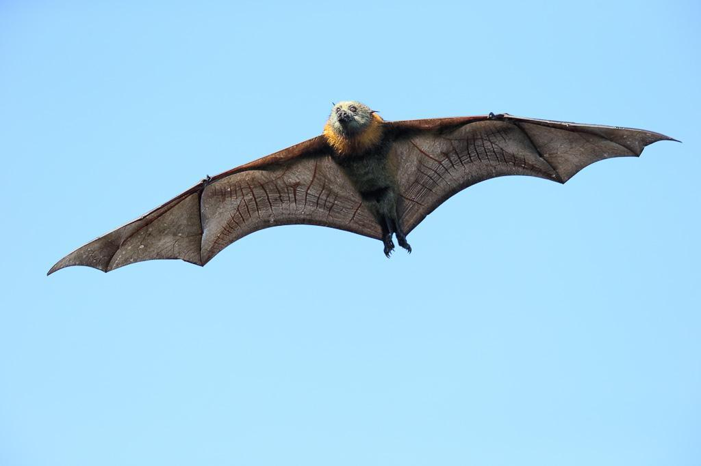
Figure 1.1: Photo of a grey headed flying fox, taken by Leo on flickr. Licensed under CC BY-NC-SA 2.0.

Mass mortality events
Flying foxes are highly sensitive to extreme heat: when temperatures rise above 42 ºC (107.6 ºF), colonies of bats have been known to die in massive quantities. For example, one heatwave in Queensland killed 45,500 flying foxes in a single day (Bittel, 2019). To help protect these species, volunteers will go out with firetrucks and wheelbarrows and spray down the trees with water or collect bats off the ground to try to save them.

Flying fox forecasts
Ratnayake et al. (2019) developed a forecast of bat die offs, based on weather forecasts, to help plan rescue missions in advance and target the areas that need the most help. Their simple forecast model predicts that a mortality event will occur if the forecasted temperature is greater than or equal to 42 ºC, and no mortality event will occur if the temperature is less than 42 ºC.
You can get a sense of the accuracy of these forecasts from the data presented in Table 1.1. When weather forecasts indicate that temperatures will be ≥42.0 ºC the following day (24-hr forecast), it is much more likely that flying fox colony death will occur (37) vs. not occur (8). Conversely, when air temperatures are forecast to be < 42 ºC, it is more likely that flying fox death will not occur (42) rather than occur (15). The same is true using 48-hr forecasts (Table 1.1), though you may expect that weather forecasts made two days in advance would be less accurate than forecasts made the day before.

Table 1.1: Relationship between forecast air temperature and flying fox die offs (Ratnayake et al., 2019). Table reproduced with permission from the publisher.
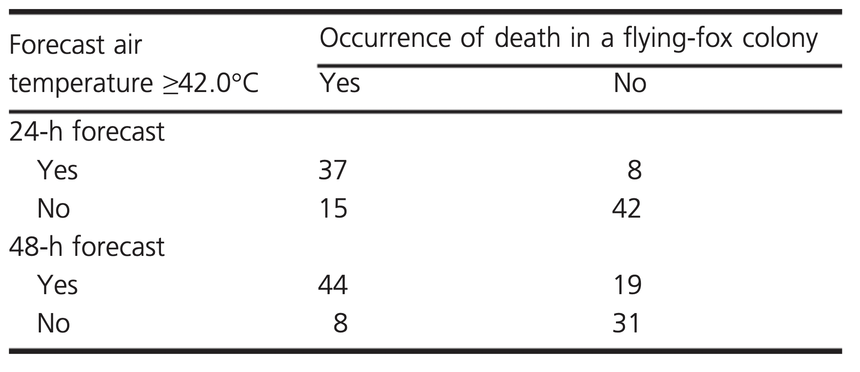

Discuss with a neighbor (1):
What types of ethical considerations do you think are necessary when developing this sort of forecast? In what way are they relevant?

Here are a few examples of potential ethical issues to begin your discussion:
- Conflicts of interest: a forecast designed to benefit one user may have disadvantages for other groups
- Uncertainty: no forecast is 100% correct. How uncertainty is represented (or omitted) may have consequences for the use of the forecast
- Sins of omission vs. commission: Is it better to provide a forecast even if you know it is not perfectly accurate? Or to not provide the forecast and risk being unprepared for something your forecast could have predicted?

Forecast uncertainty
Today, we are going to be focusing on the subject of uncertainty. Forecast uncertainty comes from many sources, including:
- Driver uncertainty: uncertainty in the inputs to the forecast model (an example is the uncertainty inherent in weather forecasts)
- Process uncertainty: uncertainty that the model itself is correct (for example, do we need to consider factors other than temperature when predicting bat die-offs?)
- Parameter uncertainty: uncertainty in the parameters of this model (here, the 42 ºC cutoff is an example of a parameter).
The flying fox forecasts developed by Ratnayake et al. are often, but not always, correct in their predictions of mortality events. Figure 1.1 shows the outcome of forecasts for one heatwave event (4 January 2014). During this heatwave, some mortality events were correctly predicted (“Hits”), some mortality events were predicted but did not occur (“False alarms”), some mortality events occurred in places where they were not predicted (“Misses”), and some areas were correctly predicted to not experience mortality events (“Correct negatives”). As you can see from this example figure, these flying fox forecasts are relatively good at predicting flying fox die offs, but they are not perfect (that is, they contain uncertainty!).

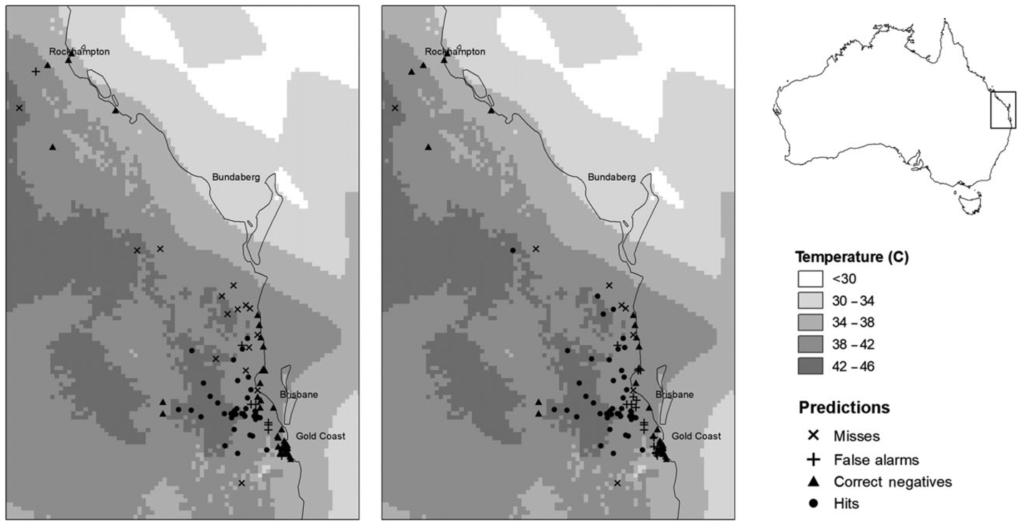
Figure 1.1: Flying fox heat stress forecasts from Ratnayake et al. (2019), reproduced with permission from the publisher. Here, different levels of shading indicate the observed air temperature, and symbols indicate whether or not bat mortality forecasts were correct. “Misses” (“X”) are cases where bat mortality conditions happened but were not forecast, “False alarms” (“+”) are cases where bat mortality conditions were forecast but did not actually occur, “Correct negatives” (▲) are cases where bat mortality conditions did not happen and were not forecast to happen, and “Hits” (⚫) are cases where bat mortality conditions were correctly predicted.

Discuss with a neighbor (2)
- What do you think would be the greatest sources of uncertainty in this forecast?
- Why does the uncertainty in this forecast matter?
- What happens if you (the forecaster) predict that a mortality event will occur (temperature will exceed 42 ºC) and it does not? What happens if you predict that a mortality event will not occur and it does? How might you take these different consequences into account?

Uncertainty visualization
Forecast uncertainty is notoriously difficult to communicate: your goal is to convey a range of likely outcomes, without overwhelming your audience with too much technical information. In this case, the challenge is particularly difficult because the forecast is for a broad geographic region. Here are some useful methods that people often use to visually communicate forecast uncertainty:
- Map of a likelihood metric across space (e.g., percent chance of a mortality event)
- Map of a summary index across space (e.g. low, medium, or high likelihood of a mortality event)
- Graph of likelihood metric (e.g., percent chance of a mortality event) over time for a given place
- Graph of summary index (e.g. low, medium, or high likelihood of a mortality event)
- over time for a given place
- Graph of your predicted variable of interest (e.g., air temperature) over time, with a range of uncertainty (e.g., error bar)

Working individually
- Make a list of 3–5 relevant people or organizations that might be interested in these forecasts. For the sake of this module we will call these people or organizations “end users”
- Pick one end user to focus on: what is this end user hoping to accomplish? Why are they interested in the forecasts? How do their motivations inform how they would like to receive this information?
- Now that you have decided what an end user wants to learn from a forecast, what would be the best way to visually communicate the forecast to that end user? Quickly sketch an example visualization for this end user

Now turn to a partner
- Partner 1: Show/explain to your partner the forecast visualization you designed
- Partner 2: Playing the role of the end user you chose, respond to the forecast visualization that your partner developed. Note: this is probably not the end user they originally developed the forecast for! What questions do you have about this forecast output?
- Repeat, with Partner 2 sharing their visualization and Partner 1 playing the role of their chosen end user
- Discuss:
  - What (if any) issues arose when you tried to use this forecast output for the new audience?
  - Now imagine a scenario where you portrayed forecast uncertainty poorly and this caused an end user to make a bad decision. Do you have any responsibility for their actions? Should you be held accountable?

NOTES TO INSTRUCTOR
This module provides a discussion-based framework for students to develop skills in understanding and communicating uncertainty, while also considering the ethical implications of uncertainty representation. The majority of this module takes place in short, small group discussions among peers; discussion questions are intended to be open-ended, with the goal of encouraging students to think deeply and critically about a complicated topic. After having students discuss in pairs, we recommend inviting students to share back with the whole class and discussing briefly as a group (i.e., “think, pair, share”).

Discussion question notes
Discuss with a neighbor (1) asks students which types of ethical considerations are necessary when developing this sort of forecast and in what ways they are relevant. The goal of this question is to get students to think through multiple ethical issues that may arise when developing a forecast, even when the forecast is well-intentioned and aims to address an important conservation issue. Uncertainty is clearly relevant here, as will be discussed throughout the module. However, students will likely also find connections between the case study and other ethical issues, which is great! For example, “Conflicts of interest” may be relevant if flying fox conservation efforts come at the detriment of other species, and “sins of omission vs. commission” come into play when forecasters have to weigh the risks and benefits of providing these forecasts despite forecast error and uncertainty. As the instructor, you can encourage students to think broadly about all of these possible ethical issues.

Discuss with a neighbor (2) encourages students to think about what uncertainty is present in this forecast and why this uncertainty matters. Students should come to realize that there is uncertainty in both the air temperature forecast and the model that researchers are using to predict bat mortality based upon air temperature. They are then asked to consider the implication of false positives (“What happens if you (the forecaster) predict that a mortality event will occur (temperature will exceed 42 ºC) and it does not?”) and false positives (“What happens if you predict that a mortality event will not occur and it does?”). Students will likely come to the conclusion that false negatives are worse for bat conservation than false positives, because false negatives result in a lack of preparation for die off events, while false positives result in over preparation. Giving forecast users the information they need to assess how likely a prediction is to be correct can help the user weigh these options.

Working individually, we ask students to think about the relevant people and organizations that would use these forecasts. This could include firefighters, conservation organizations, news media, etc. Focusing on one relevant end user, we ask students to outline their specific needs, and how forecast presentation could meet those needs. Some examples of potential visualizations include maps of summary metrics (e.g., 75% chance of bat mortality) or categorical scores (e.g., “high likelihood” of bat mortality), and graphs over time (e.g., time on the x-axis and mortality probability on the y-axis). As they think through these options, encourage them to consider how uncertainty is presented in their visualization.

After working individually, we ask students to turn to a partner and try out their visualization on a (likely) new audience, then discuss how things went. We hope that this will encourage students to think more critically about how small differences in visualization may affect interpretation. Possible follow-up questions include “what improvements could you make to this forecast visualization to tailor it to this audience?”, “Could you make the representation of uncertainty more explicit than you chose to?”, and “Is it possible to have too much information in a forecast visualization?”

Finally, we encourage all students to consider the broader ethical question of whether they are responsible for decisions that arise based on their predictions. This is an open-ended question and we expect that students may have diverging opinions.

Other resources for instructors:
For more examples of why forecast uncertainty matters (outside of an ecological perspective), Chapter 6 of The Signal and the Noise: Why Most Predictions Fail but Some Don't by Nate Silver provides several stories, including a particularly impactful narrative about how a lack of uncertainty in a flood forecast caused devastating damage in Grand Forks, North Dakota (Silver, 2015).
Joslyn and Savelli (2021) is a useful reference to consider for the forecast visualization component of this module, with research on effective forecast visualization techniques, and a description of common misunderstandings.

Student assessment
The final discussion questions provide the foundation for a short writing assignment that could reinforce the thinking done in class. Table 1.2 provides a sample rubric for the evaluation of this writing assignment.

In a short essay (300 words), please describe why it is important to include uncertainty in forecasts of flying fox mortality events. In your answer, please include (1) a discussion of what sources of uncertainty exist, (2) a description of possible consequences of uncertainty omission or misrepresentation, and (3) a discussion of how uncertainty representations may need to differ depending on interested parties' needs.

Table 1.2: Sample rubric for evaluation of student writing assessment
 | 0: No evidence | 1: Below proficient | 2: Emerging proficient | 3: Proficient | 4: Advanced
Forecast uncertainty sources | No mention of forecast uncertainty sources | Only one source of uncertainty mentioned or description of uncertainty sources is mostly incorrect | Multiple sources of uncertainty mentioned. Description lacks specificity or contains substantial errors | Multiple sources of uncertainty mentioned, with correct description | Multiple specific sources of uncertainty are thoroughly described and correctly explained
Possible consequences of uncertainty omission and misrepresentation | No mention of the consequences of uncertainty omission or misrepresentation | Consequences of uncertainty omission or misrepresentation are mostly missing or incorrect | Vague description of two or more consequences of uncertainty omission or misrepresentation | Mostly correct description of two or more consequences of uncertainty omission or misrepresentation | Convincing description of two or more consequences of uncertainty omission or misrepresentation
Variable user needs | No mention of user needs | Only one user’s needs discussed, or discussion of user needs lacks connection to forecast uncertainty | Multiple user needs discussed, with connections to forecast uncertainty. Discussion lacks specificity or contains errors | Multiple user needs discussed, with connections to forecast uncertainty. Discussion is mostly correct | Well-reasoned discussion of how uncertainty representations may need to vary between two or more forecast users
Writing quality | Major grammatical issues make text impossible for a general audience to understand | Major grammatical issues make text difficult to understand | Issues with grammar or organization hinder understanding | Minor issues with grammar or organization | Ideas are fully explained with clear logic, following assignment specifications

Module 2: Marine Fisheries and Conflicts of Interest

Background
“A forecast advantage for one group may be a disadvantage for another” - Hobday et al. (2019)

Forecasts contain valuable information that can help people make better anticipatory decisions. Sometimes having access to this information can provide a disproportionate advantage to some forecast users over others. More generally, whenever scientists apply their research expertise to engage with the public, they may need to consider how their expertise fits into a broader socioeconomic system, benefiting some groups, potentially at the expense of others. This module provides a structured format for thinking through the many potentially conflicting interests of forecast users.
The case study presented in this module focuses on conflicts of interest that may arise in marine fisheries management, which are summarized nicely by Hobday et al. (2019). While fisheries forecasts are economically beneficial tools, they have the potential to lead to overexploitation of marine fisheries and providing a forecast for one fishing entity (individual or corporation) may indirectly harm others that are competing for the same aquatic resources. Discussing conflicts of interest encourages students to not only think about how forecasts benefit decision-making, but also how each forecast user fits into broader economic and social systems. Here we provide a set of “think, pair, share” activities to allow students to explore the ideas and figures presented in Hobday et al. (2019).

Student instructions
The primary learning objectives of this module are for students to be able to:
- Examine how forecasts fit within broader socioeconomic systems, and the associated ethical responsibilities that arise for forecasters.
- Anticipate the direct and indirect effects of forecast development on diverse forecast users including industries, government offices, small and medium-size businesses, Indigenous communities, or other scientists.
- Develop and analyze best practices for the ethical development of marine forecasts.

Assigned reading
Before class, please read through Table 1 from Hobday et al. (2019), as well as the following Case Study.

Reading all of Hobday et al. (2019) is optional but would provide additional context for this module (link here).

Case Study
Throughout human history, fishing has been a vital pillar of coastal communities. However, overfishing can also have substantial consequences for marine ecosystems. Today, over one third of shark and ray species are threatened by overfishing, and three species are possibly extinct (have not been observed in over 80 years) as a result of overfishing (Dulvy et al. 2021). Overfishing not only risks the livelihoods of fishing communities but also has strong ecosystem-level impacts, as effects of fishing on large, predatory species such as tuna, cod, and pike, can affect smaller fish populations and other non-target species (Casey et al. 2017, Eriksson et al. 2009, Heithaus et al. 2008).
Forecasts of economically important species have become increasingly available due to better monitoring technology, open worldwide databases, and more accurate marine temperature and circulation data (Hobday et al. 2016, Payne et al. 2017). Yet, ethical issues arise because many end users are involved in each fishery; at any one location, government regulators, industrial fishing operations, academic and NGO organizations, and small-scale fishing communities and/or Indigenous communities may all have important connections to the fishing economy. Each of these groups may have different incentives and objectives, and their perspectives are not always considered by the forecast providers (Hobday et al. 2019). To examine these issues, a review by Hobday et al. (2019) provides insight into the different ethical considerations that must be made regarding marine forecasts for economically important species such as salmon, tuna, lobster, and sturgeon, among others.

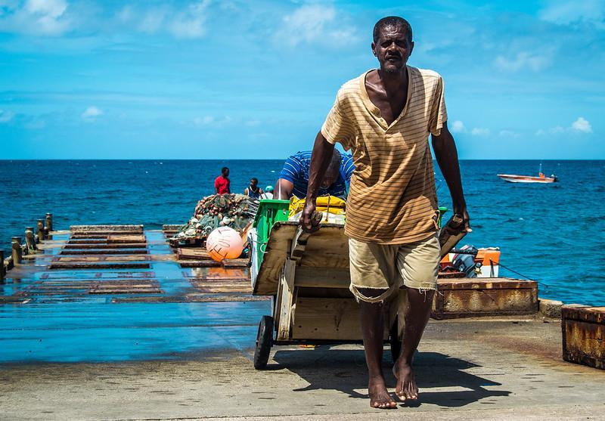
Figure 2.1: Small-scale fishermen bring in their harvest at the Old Road Fisheries in Saint Kitts and Nevis. Photo by St Kitts & Nevis Government on flickr, licensed under CC BY 2.0.

Think, Pair, Share: Context-dependent forecasting
Coordinate with a partner sitting near you and pick different forecasting examples from Table 1 in Hobday et al. (2019), then respond to the following questions.

On your own, write down brief answers to the following questions:
- What potential conflicts of interest could you see arising in this example?
- At what point in forecast development could these issues arise?
- How would you try to remediate these conflicts after an issue arises? What could you do earlier in the forecast development process to preempt these issues?

Discuss with your partner:
- Share a brief summary of your forecasting example and what potential conflicts you identified
- What similarities did you find between your examples?
  - If there were similarities, did you come up with similar solutions?

Come back together as a class to discuss
- Share brief summaries from each forecasting example
  - How did the end users and funding agencies differ between forecasting examples?
  - What conflicts and solutions did groups identify?
  - How and why did solutions differ between examples?

Think, Pair, Share: Avoiding ethical issues in forecasts
At the end of their manuscript, Hobday et al. (2019) highlight ten principles for creating ethical forecasts, particularly for marine ecosystems. These principles were developed based upon the case studies from Table 1 that you have reviewed and discussed. One of these principles is directly intended to address conflicts of interest, and others may also be relevant to managing conflicts of interest later in the forecast development process.

Working individually
First, read the text below from Hobday et al. (2019; reprinted with permission from the publisher), then respond to the questions following the text:

Principles for ethical forecasting

As a result of reviewing these case studies and our experiences, we suggest a set of principles that should be considered when scoping, developing, delivering, and evaluating ecological forecasts for marine resource users.

Phase 1. Scoping the forecast system
1. Conflicts of interest:
- Principle 1: Be open and transparent. Work with diverse stakeholders to understand their needs and concerns. Address these concerns if possible, striving for “win–wins.” Tread carefully around zero-sum situations, where a forecast advantage for one group may be a disadvantage for another.
2. Ecosystem health:
- Principle 2: Do not deliver forecasts that would lead to unregulated impacts on the ocean (e.g. for fisheries without clear catch limits and/or enforcement).

Phase 2. Developing the forecast system
3. Skill assessment:
- Principle 3: Undertake best practice skill assessment that tests the true skill of a model with out-of-sample testing. In forecasting science, this involves comparing a forecasted and a hindcasted fields once the climatology has been removed, using rigorous statistics.
4. Representation of uncertainty:
- Principle 4: Do not ignore uncertainty. Traditionally, uncertainty is computed through an ensemble or with permutations on the initial state and provided as a percent agreement between the trajectories of the simulations. While this mostly addresses the uncertainty in the forcing into the future, the uncertainty due to model construction is not easy to incorporate objectively and needs additional work. Provide a discussion and metrics of uncertainty that include a perspective based on model performance, and the interpretation of probabilistic forecasts.

Phase 3. Forecast delivery
5. Ongoing delivery:
- Principle 5: Plan for and manage stakeholder expectations regarding continued delivery. Planning for and enabling a mechanism for ongoing delivery after a project ends (if possible) and engaging stakeholder representatives early can be important for ensuring a smooth transition. Ultimately, a transition to operational forecasts as delivered by national weather services should be considered.
6. Engagement and education:
- Principle 6: Work to improve the literacy of all stakeholders around forecast use and interpretation, particularly on skill and uncertainty.
7. Delivery failures:
- Principle 7: Proactively explore the impact of loss of a predictor variable in a forecast system and be able to explain what the loss of performance is when one variable is removed. Prepare stakeholders for potential breaks in delivery, and never compromise with delivery of substandard forecast products.
8. Equity for end users:
- Principle 8: Be vigilant for inequity in use of forecasts between users, and the creation of winners and losers arising from provision of information. Decide when open access is warranted, and when it is not. Include stakeholders in the formulation stage to understand these risks. If risks remain, work at a scale where benefits are clear.
9. Unintended consequences:
- Principle 9: Scope the system context widely, seek deep domain and system knowledge, and consider scenario testing, as happens for fishery management regulations now (e.g., management strategy evaluation). Seek feedback and learn from mistakes.

Phase 4. Evaluation
10. Review of performance:
- Principle 10: Consider the holistic outcome of forecast system—if it is not achieving the overall goals, suspend delivery and work on improving the interaction of the forecast and the context in which it operates.

Questions for individual reflection:
- In the first activity (above) we asked you to write down initial thoughts on what conflicts of interest may arise for your chosen case study and how you would address these issues at multiple points in the forecast development process. After reading through the principles for ethical forecasting from Hobday et al. (2019; above), compare and contrast the ideas you developed with those presented in this list of principles.
- Is there anything you feel is missing from the list?

Discuss in small groups
- Is there anything you do not understand in the list of best practices? Try to help each other come to a better understanding of these principles.
- Which practices do you think are especially helpful, or points that you wouldn’t have thought of? Are there any that you disagree with?
- More broadly, what do you think is the value of “best practices” for ethical issues? If you were running a forecasting program, how would you make sure the people working on your team are considering these best practices in their work?

Discuss as a class
- Have each small group report back about what they discussed. Are there any points of clarification that need to be resolved as a whole class?
- Discuss as a class: what is the value of “best practices” for ethical issues?
- How could these principles be adapted for scientific engagement with the public more broadly (i.e., outside of a forecasting context)? For example, are any of these principles relevant for scientists that may be asked to provide expertise to inform environmental policy?

NOTES TO INSTRUCTOR
The goal of this module is to have students reflect and discuss how forecasts are not generated in a void, rather in a socioeconomic context where diverse end users have potentially conflicting interests. The forecaster needs to be aware of the possible uses of the information that they are generating, considering the impacts that end users might have on interconnected socio-ecological systems. Through discussing examples of multiple fisheries in pairs and later on in larger groups, students will compare and contrast examples of real-life scenarios that forecasters encounter and the ethical considerations they face when sharing forecasts with end users. The questions are meant to generate reflection on how context and knowledge of the socio-ecological system are key to ethically delivering a forecast.
Logistical notes for instructors: We strongly recommend the instructor reads Hobday et al. (2019), despite students not being asked to read the entire paper. This will help the instructor to facilitate group discussions more effectively by providing a greater context on the case studies and practices that students will be discussing. We also encourage the instructor to make sure students select different examples from their neighbor and that all seven examples are selected by at least one student in the activity ‘Think, Pair, Share: Context-dependent forecasting’.

Notes on discussion questions
Think, Pair, Share: Context-dependent forecasting
These questions are meant to be open-ended and a final answer from the students is not expected. We want them to think about how managing natural resources (in this case fish populations) involves many different groups, often with conflicting goals, and how we as forecast providers may participate in those dynamics. Students start by individually identifying the groups involved in the selected forecast example and thinking through potential conflicts that may arise between them. For example, students may identify conflict between the need for a given profit margin for a fishing industry and the livelihoods of smaller fishing operations or the need to comply with environmental law (“On your own, consider these questions”).
During the “discuss with a neighbor” questions, we want students to brainstorm solutions to the aforementioned conflicts in the fisheries and contrast them with those of a partner, and then revisit their ideas in a larger discussion (“Come back together as a class to discuss”). Again, the objective of these discussions is not to have a final answer to a given conflict but rather to identify groups, contrasting interests, and potential solutions. The ideas developed through these conversations will provide a foundation from which to analyze the “best practices” proposed by Hobday et al. (2019) in the next “think, pair, share” activity.
In moderating these discussions, we encourage you to draw in other examples that might be relevant to your students and the particular local context of your class (e.g., economically relevant forecasts for foraging, hunting, and tourism in your local area).

Think, Pair, Share: Ethical issues in forecasts
The second “think, pair, share” activity asks students to compare and contrast the solutions they came up with in the first half of class with those of Hobday et al. (2019). Working individually, we first ask students to read the list of practices, then reflect on similarities and differences with what they brainstormed earlier in the class. We then transition to small-group discussions (“Discuss in small groups”), where students have the opportunity to discuss things they didn’t understand from the list, thoughts and opinions on the practices suggested by Hobday et al. (2019), and more broadly, the utility of this set of best practices. These small group discussions are intended to help students transition through multiple levels of critical thinking, from understanding to analyzing and evaluating the text. Finally, we ask each group to report back to the class as a whole (“Discuss as a class”), helping to clarify any remaining gaps in understanding and extend these discussions to other questions of scientific engagement with the public.

Student assessment

The discussion questions throughout this module provide the foundation for a writing assignment that could reinforce the thinking done in class:

Identify a fishery of interest, preferably a local one or one with particular significance to you. It could be from your hometown, relevant to your region, a favorite species, or significant for your country. After researching this fishery, respond to the following questions in an essay of 500 words, maximum:
- Describe the fishery. Why did you choose this fishery? What are the local economic, environmental, cultural, and political interests in this fishery?
- Identify a specific end user to consider. How could forecasting benefit this end user?
- What other end users would a forecaster need to consider when developing this type of forecast? What are potential unintended consequences or conflicts of interest associated with developing a forecast for the end user that you identified?
- How would you adapt your forecasting approach or dissemination of the forecast to account for these conflicts of interest?

Table 2.3: Sample rubric for evaluation of student writing assessment
 | 0: No evidence | 1: Below proficient | 2: Emerging proficient | 3: Proficient | 4: Advanced
Fishery description | No description of the fishery of choice or economic, environmental, cultural, and political interests | Fishery description is mostly missing or inadequate | Describes a fishery of choice, including basic description of economic, environmental, cultural, or political interests in this fishery | Describes a fishery of choice, including some description of economic, environmental, cultural, and political interests in this fishery | Thoroughly describes a fishery of choice, including economic, environmental, cultural, and political interests in this fishery
Selected end user | No specific end user selected | Description of how forecasts may benefit a specific end user is vague or inadequate | Identifies an end user and at least one way a forecast may benefit them. Description lacks specificity | Identifies a specific end user and potential benefits a forecast might bring to them | Identifies a specific end user and provides a convincing argument for how forecasts may benefit them
Other end users and conflict of interests | No mention of other end users and/or potential conflicts of interest | Discussion of conflicts of interest is limited or mostly incorrect | Identifies at least one potential conflict of interest. Description lacks specificity. | Correctly describes other end users and how their interests could be conflicting | Thoroughly describes multiple other end users and how their interests could reasonably be conflicting
Solutions | No mention of how forecasting approach could be adapted to account for conflicts of interest | Minimal discussion of how forecasting approach could be adapted to account for conflicts of interest | Mostly correct discussion of how forecasting approach could be adapted to account for conflicts of interest | Discussion of how forecasting approach could be adapted to account for conflicts of interest is logical and mostly complete | Convincing and well-reasoned discussion of how forecasting approach could be adapted to account for conflicts of interest

Module 3: Water Quality and Indigenous Knowledge

Background
In this module, we utilize scientific literature and example figures to discuss the relationship between ecological forecasting, community ethics, and Indigenous Knowledge, and how this relationship can inform scientific inquiry. The figures employed here are adapted from a module developed by co-author Georgia Smies at Salish Kootenai College, in which a fictional Indigenous community attempts to reconcile community values with data collection and forecasting. The genesis of this module was one developed for a primarily Indigenous undergraduate student body that would teach basic R skills and data analysis over one course term, thus giving the students the baseline analytical and computational competencies. The module, as presented here, has been adapted to be run in one course section with both Indigenous and non-Indigenous students. It no longer includes hands-on data analysis activities, and rather focuses on the community values and cultural context of data on Indigenous land.

Student instructions
The primary learning objectives of this module are for students to be able to:
- Analyze the relationship between Indigenous Knowledge, community values, and ecological monitoring
- Discuss how community values can be incorporated into data science

Assigned reading
Please read and be prepared to discuss “A global assessment of Indigenous community engagement in climate research” (David-Chavez and Gavin 2018). To facilitate classroom discussion, please also read the Case Study in the module below before the start of class.

Discussion (1)
In groups of 3 or 4 discuss the paper assigned before class and answer the following questions:
- In this context, what is Indigenous Knowledge? What forms does it take?
- What are the different metrics the authors use to assess Indigenous engagement in research?
- What characteristics of successful Indigenous participation in research do the authors identify? Where do the authors suggest future researchers should focus their efforts?

Record your group’s answers to the above questions. Return to the full class and have each group share their thoughts.

Case study
While Indigenous Knowledge has historically been undervalued by ecologists due to the marginalization of the communities which produce it (Rattling Leaf Sr 2022), these knowledge systems have immense inherent value and applicability to ecological problems (Kimmerer 2002, Whyte 2018). Here, we use a definition of Indigenous Knowledge as “dynamic systems of knowledge collectively held by Indigenous community members that draw from intergenerational, place-based, culturally embedded relationships and experiences” as written by Indigenous researcher Dominique David-Chavez and Michael Gavin (David-Chavez and Gavin 2018). Indigenous Knowledge and Western scientific approaches have long been separate, parallel intellectual traditions, but the harmonization of the two can produce more effective research and management outcomes (Dawson et al. 2021). For this collaboration of knowledge systems to produce positive impacts, the research must be a joint effort; where scientists, decision-makers, and affected communities work together to define the problems and approaches to solving them.
Indigenous Knowledge and values directly inform the needs of Indigenous communities (Whyte 2018). In spite of this, there is a lack of incorporation of community input into ecological monitoring (David-Chavez and Gavin 2018). For example, the U.S. Environmental Protection Agency (EPA) has been working with tribes for decades to strengthen protection of Tribal water by monitoring water quality (e.g., water temperature, dissolved oxygen, pH, etc.), but these conservation efforts have largely failed to incorporate cultural values. Tribes are required to submit an annual Quality Assurance Action Plan (QAAP) that must describe how long-term monitoring efforts will be undertaken at each location, and how the data will be stored and analyzed. For Indigenous communities, these reports are often produced via a costly outsourcing of data analysis to scientists trained in Western scientific methods, because Tribal members may not be adequately trained in quantitative scientific methods. This results in reports that do not reflect the values of the Tribal land for which the EPA report was prepared, and disregards important qualitative metrics such as cultural and spiritual value (e.g., food and medicinal resources and ceremonial priorities).
The EPA only considers quantitative metrics of site performance when prioritizing sites for conservation. Sites with higher water quality from this perspective are thus assumed to be more important and given greater prioritization for conservation efforts, as they serve as reference points for more degraded sites. This analysis does not address the full breadth of Indigenous Knowledge, ignoring important components such as cultural and spiritual practices and traditional food gathering, as well as cultural awareness of the historical ecological conditions and biota of the area. As a result, Tribes do not have a means to communicate to the EPA what is important to them, and sites that are important culturally may not be given the same protection as those that are identified using only the EPA assessment of physical, chemical, and biological variables. In short, Western scientific approaches fail to embrace the Native world view, even when engaging Native communities in mandatory reporting procedures, and this negatively impacts research and management results.
Here we use the specific example of EPA water monitoring on a reservation to explore the relationship between data collection, Indigenous Knowledge, and community values. This case study uses a thought experiment of a fictional Indigenous community and the monitoring of its water resources as an example 10 years of simulated water temperature data at five monitoring sites, each of which is in the proximity of a site of cultural importance.

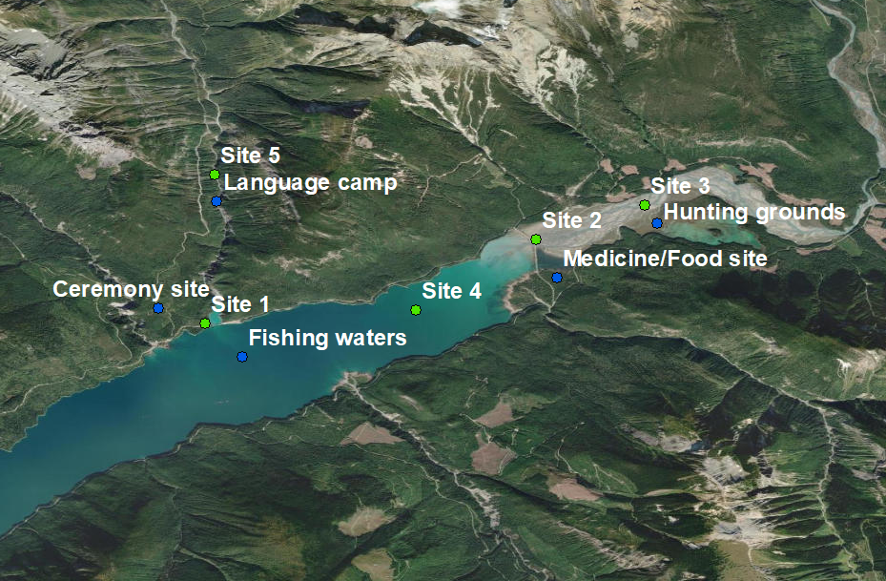
Figure 3.1: Map of the cultural sites and associated monitoring stations in this fictional case study.

In this case study, members of the fictional Indigenous community were surveyed, with each being asked to rank the five sites based on perceived importance in terms of cultural and spiritual value. The fictional land in this case study represents a target ecosystem and community with cultural values and Indigenous Knowledge for ecological monitoring and management, with the poll representing one possible way of identifying community values.
Two plots were then made to visualize the data: water temperature of each site over time (Figure 3.2a) and the average ranking of each site’s cultural importance plotted against average water temperature (Figure 3.2b). Water temperature is a convenient aspect of water quality to monitor because it is easy and inexpensive to measure, and it has wide-ranging effects on the biology and chemistry of the system. For example, the solubility of dissolved oxygen (an important resource for aquatic organisms) decreases with increases in water temperature, which can play an important role in making bodies of water less suitable for certain aquatic organisms. Likewise, increases in water temperature can lead to certain organisms growing faster, or having altered sex ratios; for example, some turtles produce more female offspring in warm water. In general, an increase in water temperature may be associated with a decrease in water quality or habitat suitability for culturally important organisms. However, water temperature is only one of many parameters that interact to shape water quality. Think to yourself: are there other important qualitative or quantitative metrics of water quality that are important for you to use water resources? Which of these would be easy to measure for an EPA report? Which might be better characterized by Indigenous Knowledge or personal knowledge of a system?

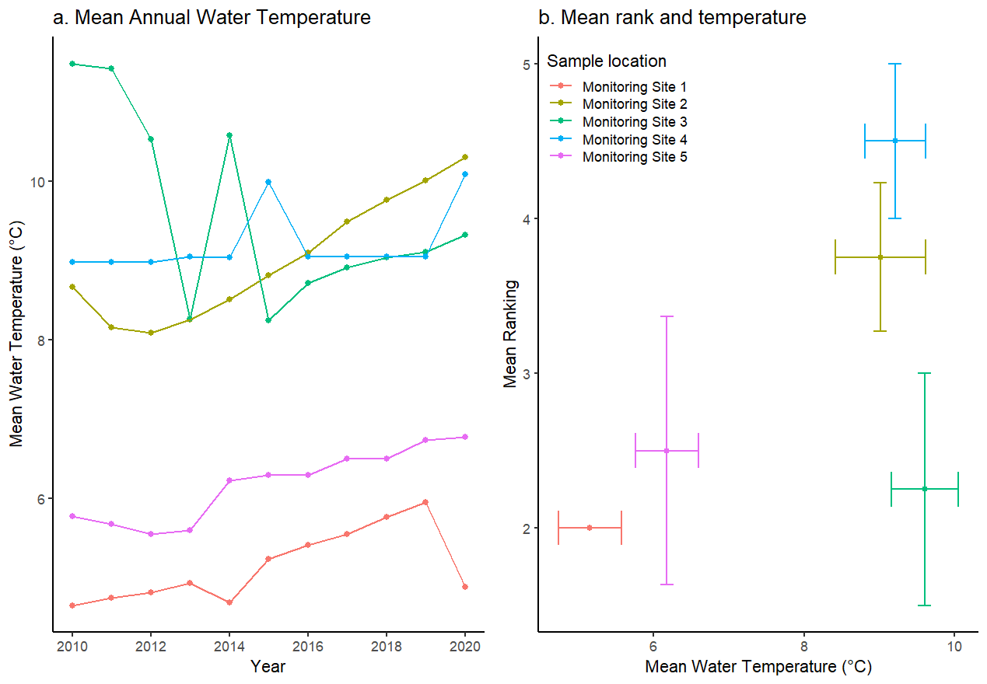
Figure 3.2a: Time series of water temperature at each site over time. Figure 3.2b: Mean water temperature plotted against mean site ranking (1 lowest, 5 highest). The horizontal line through each point represents the standard error of the temperature observation, and the vertical line is the standard error of the community ranking.

Discussion (2)
Examine the above figures and answer the following questions individually:
- What visual evidence is there for rising temperatures, and how could you confirm this? What cultural sites are associated with the rising trendlines? Are these trends potentially concerning for the community?
- Describe the axes of Figure 3.2b. What relationships can you identify between the axes? Are the sites that were identified as most important based on water quality also most important to the community? How much uncertainty is there surrounding these observations, and how might that affect decision making?
Returning to the small groups:
- Using the answers from the above two questions, assess the trajectory of the sites identified as most important, and if the water quality at those sites is of potential concern.
- Using the scale in Figure 3.3, identify the level of community participation in the above scenario. Discuss any positive or negative consequences of the level of community participation that you identified.
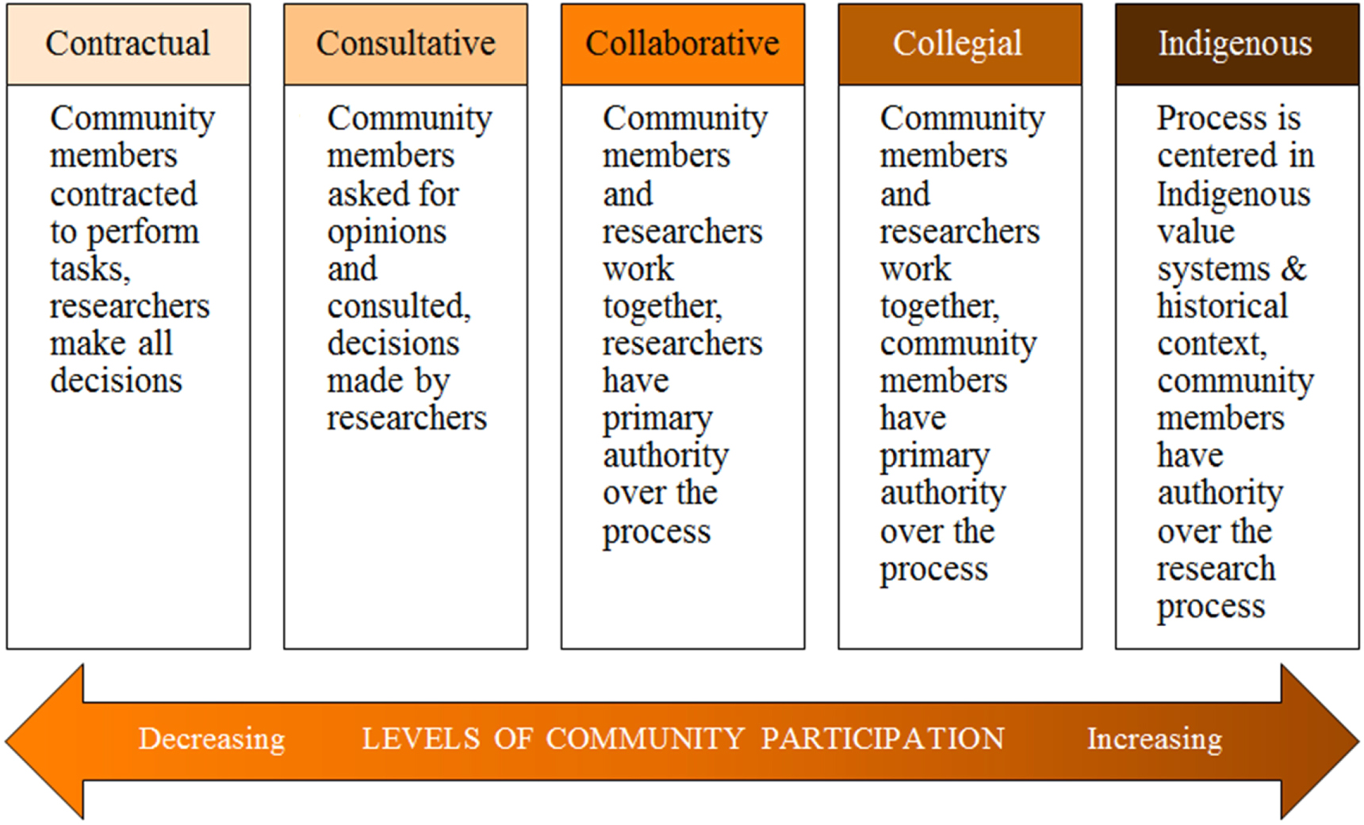
Figure 3.3: Scale of the level of community participation in a research project. Reproduced from David-Chavez and Gavin (2018); licensed under CC BY 3.0.

NOTES TO INSTRUCTOR
This module was originally developed by co-author Georgia Smies (Salish Kootenai College; SKC) and Helena Kleiner (University of Notre Dame) for the student body of SKC. Smies’s classroom was primarily Indigenous, with students representing six different Tribes with homelands mainly in the Mountain West, U.S. Providing these students with hard skills such as statistical analysis and R coding with direct application to students’ communities’ needs was the primary motivator for the original module. It has now been adapted from this specific purpose to a module intended for the general U.S. undergraduate population. This adaptation has been done to create a tool for teaching students concepts that are often neglected: ethics within forecasting and Indigenous Knowledge.
As a consequence of adapting the original module for a different population, careful consideration in the planning and execution of the current module is necessary so as not to project and potentially perpetuate the inherent biases of the teacher and student. As such, it is strongly recommended that instructors read, Rattling Leaf Sr. (2022), which provides a brief but effective primer on the importance of Indigenous Knowledge. Additionally, Whyte (2018) elaborates on the inherent value of Indigenous Knowledge to Indigenous communities in the form of governance value, and how it can be a basis for Indigenous nation building. This section is strongly recommended so the instructor is more acquainted with what Indigenous scholars are saying about their knowledge systems, and to provide important social and cultural context.
Note that for this example, we are not focusing on any particular Indigenous community, and therefore wanted to create a generalized case with relatively universal application. That being said, instructors may tailor the premise of the module to better suit their classroom, and we would especially encourage Indigenous instructors to adapt this in ways that better suit their students’ context.

Discussion (1): The first set of discussion questions is meant to remind the students of the reading and solidify that knowledge, specifically the key parts that come up later in the module. The students are asked to define Indigenous Knowledge, ensuring they are familiar with the topic before they evaluate it in context. Similarly, they are asked to discuss the metrics used to gauge the level of community engagement from the reading. This is the second key takeaway from this set of discussion questions. Finally, they are asked to identify components of successful engagement between scientists and Indigenous communities. This is to focus on the interface between these two groups. Ideally the students will reference the reading while answering the questions.

Discussion (2): The second set of questions is intended to synthesize concepts from the reading and the case study. First, the student is asked to individually interpret the figures for possible trends, as well as discuss why this may be the case. Here they are encouraged to get as much information from the figures as possible, and draw ecological conclusions from them. Once the students have individually answered the first two questions, they should come together in small groups to compare their answers. Once they have settled on solutions, they are then asked to identify the sites with the lowest water quality and highest priority. This is to demonstrate the disconnect between ecological monitoring and community values, and how this is not always obvious purely through data visualizations. Finally, the figure from David-Chavez and Gavin (2018) is used for the last question to tie everything together. The students are asked to identify the level of community engagement exhibited in the relationship in the case study. There is no clear-cut right answer, and the students should be encouraged to debate about which aspects fit into which category.

Student assessment

The discussion questions throughout this module provide the foundation for a writing assignment that could reinforce the thinking done in class:

Utilizing the outcomes of the above group discussions, work with your group to come up with a short (~300 words) statement answering the following questions:
- What role could Indigenous Knowledge play in the management decisions relevant to the above community?
- How might scientists better benefit the communities they work with given the reading (David-Chavez and Gavin 2018) and case study?
- Why is direct collaboration with communities important for ecology, monitoring, and forecasting?
- Finally, think about the environmental issues facing your community. How could increased community input surrounding ecological decision-making benefit your community?

Table 3.1: Sample rubric for evaluation of student writing assessment
 | 0: No evidence | 1: Below proficient | 2: Emerging proficient | 3: Proficient | 4: Advanced
The impact of Indigenous Knowledge | No mention of Indigenous Knowledge or its relationship to management | Understanding of Indigenous Knowledge has substantial errors or does not describe its effect on management | Discusses the role of Indigenous Knowledge with some grasp but misses details or lacks specificity | Discusses the role of Indigenous Knowledge with a thorough grasp and minimal error | Discusses the role of Indigenous Knowledge thoroughly and with a strong understanding of its impact
Scientist community engagement | Does not discuss how scientists can better engage with communities | Does not understand the potential problems with lack of community participation | Demonstrates a vague understanding of community participation, does not reference specific qualities | Discusses multiple levels or qualities of community participation, but may lack detail or contain some error | Shows a thorough understanding of the reading and case study, referencing specific parts of both and drawing new connections
Community participation and forecasting | No mention of community participation or forecasting | Only discusses one component of participation and forecasting, or contains significant misunderstandings | Relates community participation to forecasting and discusses either the scientific impacts or ethical impacts but contains error | Relates participation and forecasting both in terms of scientific and ethical impacts but lacks detail | Thoroughly relates participation and forecasting ethically and scientifically with reference to the reading and case study
Community response | Does not talk about their community or its environment | Makes little effort to discuss potential environmental issues and solutions | Mentions an environmental problem and a brief solution with no depth or relation to the reading or case study | Clearly explains an issue in their community and how increased participation could be beneficial | Fully explains an issue and its link to participation, with specific positive impacts identified for the community

Module 4: Tropical Forests and Data Availability

Background
Observations are key inputs in ecological monitoring, modeling and forecasting. Collecting these measurements can be labor-intensive and/or costly, especially for remote locations (e.g., dense tropical forecasts). Observing remote ecosystems depends critically on the availability of resources for the purchasing of measurement equipment, the planned and unplanned maintenance, and the retrieving or processing of the actual data. Since the distribution of resources varies between regions, there are regions that have better spatial coverage, more advanced sensors, and/or greater availability of dedicated staff for routine inspection or maintenance of instruments.
When the distribution and maintenance of measurement networks is not solely based on scientific priority, but also on financial resources, there are likely to be “blind spots” that can hinder scientific understanding. For example, if researchers were to develop a model to forecast plant phenology and apply that model on a global scale, they may disproportionately base their model on the seasonal variations observed in temperate climate zones, where data are abundant. In reality, leaf phenology in tropical forests behaves markedly different than in temperate regions, throughout its seasonal progression (Restrepo-Coupe et al. 2013, Wu et al. 2016) and during or following severe drought episodes (Botía et al. 2022, Gonçalves et al. 2020). Consequently, forecasts would be likely to perform worse in tropical areas. This represents a key scientific gap and may create a potential equity concern, as people living in tropical areas would not be able to benefit from accurate forecasts to the same extent as those living in temperate regions.
In this module, students are challenged to explore the extent to which observational networks are representative for global data and the implications of data gaps. In graduate and undergraduate courses in ecology, datasets (e.g. ‘phenocam’ data from the US National Ecological Observatory Network (NEON), https://www.neonscience.org/data-collection/phenocams) are used to explain processes and test forecasting models (e.g., Thomas et al. 2023). In many cases the existence of these networks is taken as a given. Here, we take one step back and discuss how these networks are developed and what the consequences may be. The first part of this module discusses research funding, which usually does not have a prominent role in curriculum. The second part deals with data, an indispensable input for any forecasting problem that is also linked to sustainable capacity building in under-resourced regions.

Student instructions
The primary learning objectives of this module are for students to be able to:
- Understand that the unequal distribution of resources is one of the reasons behind the non-uniform distribution of measurement networks.
- Explain how underrepresentation in data collection can lead to systematic biases in forecasting, but also to lack of career opportunities for researchers in developing countries that are already in a disadvantaged position.
- Discuss the implications of biased forecasting for climate change mitigation policies for already vulnerable communities.

Assigned reading
Before class, please read these short and accessible articles on underrepresentation of measurement networks and meaningful international collaborations:
- Wheeling, K. 2021. The gaps in environmental networks across Latin America, Eos 102, https://doi.org/10.1029/2021EO156506
- Adame, F. 2021. Meaningful collaborations can end ‘helicopter research’, Nature, https://doi.org/10.1038/d41586-021-01795-1
Further (optional) reading on inequities in data coverage and career prospects for researchers:
- Dwivedi, D., A. L. D. Santos, M. A. Barnard, T. M. Crimmins, A. Malhotra, K. A. Rod, K. S. Aho, S. M. Bell, B. Bomfim, F.Q. Brearley, and H. Cadillo‐Quiroz. 2022. Biogeosciences perspectives on Integrated, Coordinated, Open, Networked (ICON) science. Earth and Space Science 9:e2021EA002119. https://doi.org/10.1029/2021EA002119
- Villarreal, S. and R. Vargas. 2021. Representativeness of FLUXNET sites across Latin America. Journal of Geophysical Research: Biogeosciences 126:e2020JG006090. https://doi.org/10.1029/2020JG006090

Case study

Data are essential for conservation
Tropical forests are complex ecological systems and hotspots of biodiversity (Figure 4.1; e.g., ter Steege et al. 2013) and are key in regulating the global and local flows of carbon and water (e.g., Staal et al. 2023). Tropical forests are resilient ecosystems but facing increasingly large pressures from climate change and deforestation (Boulton et al. 2022). Better understanding, monitoring and forecasting of this ecological system will require high-quality observational data.

Discuss with a neighbor (1)
- Tropical forests are of global significance. Is the conservation of these forests solely a task for the national governments that harbor these forests? If not, what other organizations or entities are responsible?
- What can or should the international community do to support conservation of tropical forests?
- What are potential unintended consequences to be aware of when working in another country?

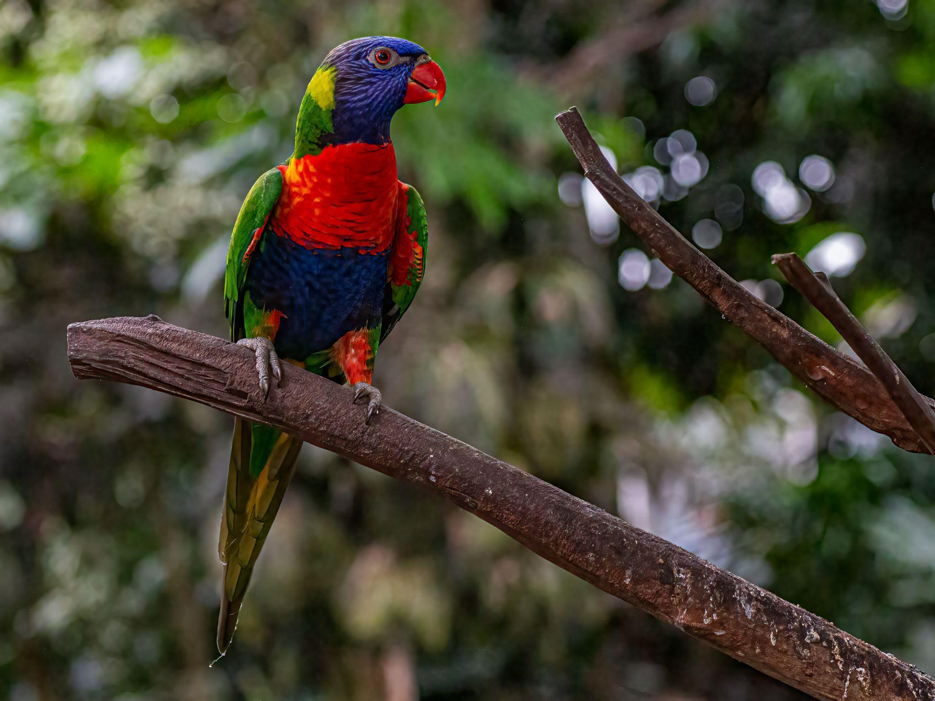
Figure 4.1: Tropical forests are complex ecosystems and hotspots of biodiversity, including tree species (top photo, from the Amazon rainforest; source: Conscious Design on unsplash), amphibians (bottom left photo, from India; source: Sonika Agarwal on unsplash) and birds (bottom right photo, from Costa Rica; source: Kenny Goossen on unsplash). All photos are licensed for reuse under the Unsplash license.

How we see the world
Observations underpin how we see and understand the world around us. Observational networks are not uniformly distributed, and in many cases determined by the availability of economic resources in the region. Figure 4.2 shows the distribution of measurement sites across the globe for the PhenoCam Network and the FLUXNET carbon and energy flux measurement sites. Clearly, there is a large discrepancy in the observational coverage over tropical ecosystems and those in moderate climate zones (Villarreal and Vargas 2021, Wheeling 2021).

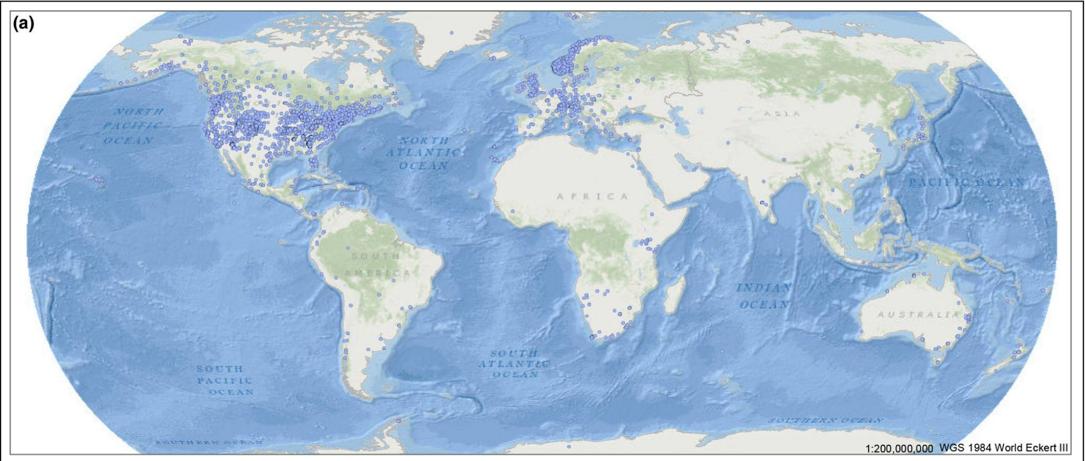
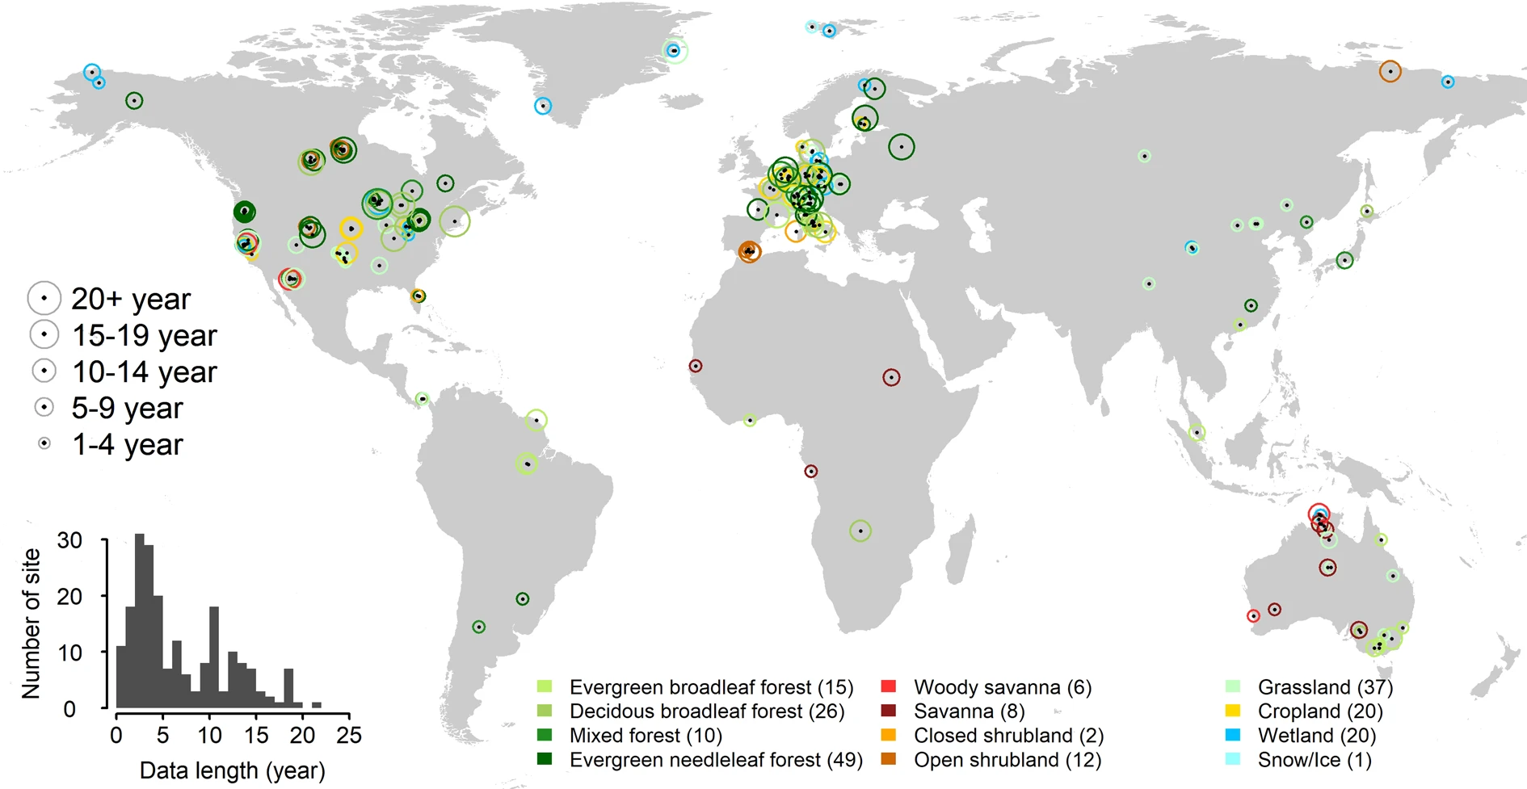

Figure 4.2: Ecological measurement sites are often biased towards North America and western Europe. Top: spatial distribution of vegetation phenology monitoring sites in the PhenoCam Network (blue dots are the sites); reproduced from Pastorello et al. (2020) with permission from the publisher. Bottom: spatial distribution of sites that monitor water and carbon exchange as part of the FLUXNET network. Here, the size of the marker indicates the length of the records and the color refers to the different vegetation types. Reproduced from Brown et al. (2016); licensed under CC BY 4.0.

It is not always summer in the tropics
When data is not available from the region of interest, researchers tend to look for other data that is available, which can lead to biased forecasts. This can also happen when machine learning models are trained on large datasets and are projecting relations derived in temperate climate zones onto tropical climate zones. For instance, biased models might predict typical spring or summer behavior or phenological development, as displayed in temperate climate zones, for vegetation in warm tropical conditions. Availability of sufficient high quality in situ data remains essential for different models (Adiku et al. 2021, van Schaik et al. 2018, Smallman et al. 2021).

Satellites to the rescue?
In recent years, monitoring capabilities of satellites have improved substantially and new missions with superior sensory equipment are being developed. This results in better monitoring capacity for remote areas, including tropical forests (e.g., Deblauwe et al. 2016, Naus et al. 2022). Unfortunately, this does not resolve the data problem, as validation with local data (e.g., Donnelly et al. 2022) remains an essential step in the development of the satellite retrieval algorithms that translate the measured irradiance into a more meaningful ecological property. High quality measurement sites in tropical regions are thus still an indispensable resource for validation of satellite observations (e.g., Koren et al. 2018, Mengistu et al. 2021).

Discuss with a neighbor (2)
- Satellites provide an opportunity to observe remote regions without needing access to a region. Could this have negative consequences for local researchers?
- Improved monitoring capacity results also in increasingly large datasets, which in turn requires stable internet and reliable computing infrastructure. How would this influence researchers in under-resourced environments?

Capacity building
There exist initiatives where funds from developed countries can flow to underrepresented regions to support the development of measurement networks. In these projects, it is essential that there is not only financial support for equipment, but also for local capacity building, such that local researchers can sustain the operation of measurement networks (the practice of short-term funds without any long-term commitment or vision is sometimes referred to as ‘helicopter science’). Capacity building should not be limited to practical execution of tasks but should be directed at advancing independent scientific research careers, including publication of scientific papers led by local researchers.

Below is an excerpt from Adame (2021), who shared her experience with ‘helicopter’ science:
“I was born in Mexico, and my first postdoctoral position was at Cinvestav in Yucatan, part of the National Polytechnic Institute. For many years, I read papers on the rainforest and freshwater sinkholes of Yucatan, the mangroves of the Mexican Caribbean and the Maya ruins of southern Mexico. Most of those papers do not include Mexican authors or agencies, and they often lack an acknowledgement to the Maya people who live in the region. I saw foreign scientists come to our laboratory carrying high-tech instruments that we didn’t have access to. We took the scientists to our field sites and taught them about the unique ecology of the mangroves. Sometimes they used our small laboratory to store or analyse their samples. Neither I nor anyone else on the team was ever asked to contribute to the papers that were published.”

Reflect and conceptualize
- Based on the Adame (2021) article, what are the most important factors for meaningful and long-term collaborations? Try to summarize the most important concepts and their relations in a visual diagram.
- Compare your drawing with the schematic diagram in Figure 4.3. Reflect on the differences and similarities and update your drawing if you feel you missed something.

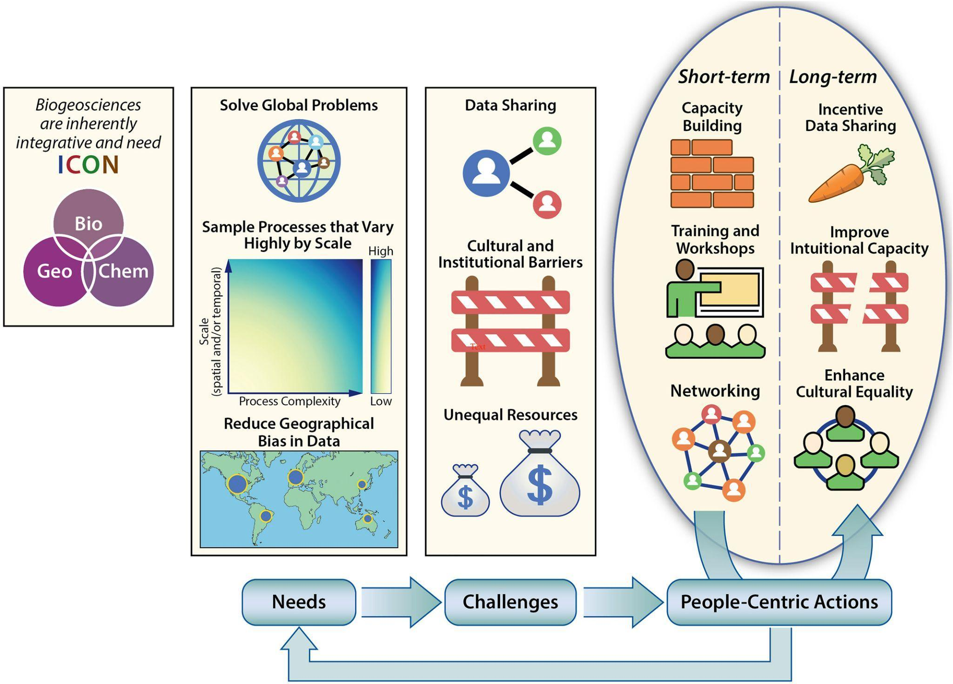
Figure 4.3: Conceptual overview of needs, challenges and required actions to advance biogeosciences. Geographical bias in data and unequal access to resources are identified as important issues. Source: Dwivedi et al. (2022); licensed under CC BY 4.0.

NOTES TO INSTRUCTOR
The main goal of this module is to have students take a step back and let them realize how data not only helps us to understand, monitor and forecast in ecology, but how the selection and creation of data can provide a biased view. An important aspect is the role that humans play in the process of selecting and creating data: they are developing, maintaining, and operating the observational networks. In addition, we highlight how practices around data sharing, and the participation in analysis and paper writing are also impacting career opportunities.

Discuss with a neighbor (1): this first discussion is intended for students to think about the responsibilities and rights of different countries when it comes to the management (e.g., protection or use for extraction of resources) of tropical forests. Tropical forests are considered to be biomes of global significance and many Western countries support or demand better protection. This can give rise to tensions with the sovereign countries that harbor these tropical forests, especially when deforestation or extraction of resources is mainly driven by exports to these Western countries. After completing this activity, students should be able to express rights, responsibilities and interests of different countries and their potential overlaps or conflicts.

Discuss with a neighbor (2): this second discussion aims to let students reflect on the role that satellites can play for studying tropical forests, but this also extends to other under-resourced environments. On the one hand, remote sensing technology provides a wealth of data which both international and local researchers can benefit from. On the other hand, there is a risk of enlarging the gaps between local and international researchers, when the data is used without bringing in local knowledge and validation. Here, it is also important to realize that researchers in developing countries do not always have the computer infrastructure (e.g., internet access, or storage facilities) to effectively work with satellite data. As a potential follow-up for students that quickly address all questions, teachers can challenge students further to define some general rules for the responsible use of satellite data for monitoring tropical forests.

Reflect and conceptualize: the purpose of this assignment is to extract abstract concepts from the anecdote quoted from Adame (2021) and place this in a conceptual framework. Students are challenged to visualize this in a diagram (e.g. a flowchart linking the different aspects with arrows), after which students compare their drawing with Figure 4.3. We provide Figure 4.3 as a separate handout to encourage students to develop their own figure first, before referring to this existing figure. The intention of the activity is that abstract concepts become more meaningful and the drawing aims to reinforce the comprehension and memorization of the concepts.

Student assessment
Through in-class discussions, students are challenged to think about the representativeness of data and the implications for forecasting phenology of tropical vegetation. This forms the basis for a short individual writing assignment (prompt below). If helpful, students can further narrow down the focus to a single geographical location, type of measurement and/or species. The students are assessed based on the structure of the text, formulation of arguments and appropriate use of literature (see rubric in Table 4.1).

Take the perspective of one specific actor (e.g., governments, funding agencies, universities, researchers) and describe how this actor can contribute to improved availability and accessibility of measurement data in tropical forests. Here you can distinguish between short-term and long-term strategies. Highlight the dependency on other actors, their responsibility, and potential ethical conflicts (500 words, excluding literature references)

Table 4.1: Sample rubric for evaluation of student writing assessment
 | 0: No evidence | 1: Below proficient | 2: Emerging proficient | 3: Proficient | 4: Advanced
Description of case and conflict of interest | No mention of specific case or conflict of interest | Description of case or conflict of interest is unclear or incomplete | The case and conflict of interest are described reasonably for the most part, with some minor omissions or errors | Adequate description of specific case and conflict of interest with minimal error | A clear and to the point description of the case and conflict of interest. Written in an engaging way.
Formulation of arguments from actor perspective | Does not provide arguments from the actor perspective | Some arguments are formulated, but formulation is weak or logical reasoning is flawed | There are arguments provided, but overall not convincing | Clear formulation of arguments, most of which are convincing | Clear and convincing argumentation, also addressing potential counterarguments
Structure of text and use of literature | No clear structure and no use of literature | Some structure in the text and limited references to literature | There is an overall structure, with some flaws and there are several references included, that are in most cases relevant. | A clear structure in text and proper use of literature | Structure of text is clear and facilitates effective communication. Excellent use of literature, including several recent publications

References

Adame, F. 2021. Meaningful collaborations can end ‘helicopter research.’ Nature. https://doi.org10.1038/d41586-021-01795-1
Adiku, S. G. K., D. S. MacCarthy, and S. K. Kumahor. 2021. A conceptual modelling framework for simulating the impact of soil degradation on maize yield in data-sparse regions of the tropics. Ecological Modelling 448:109525. https://doi.org10.1016/j.ecolmodel.2021.109525
Barraquand, F., T. H. G. Ezard, P. S. Jørgensen, N. Zimmerman, S. Chamberlain, R. Salguero-Gómez, T. J. Curran, and T. Poisot. 2014. Lack of quantitative training among early-career ecologists: a survey of the problem and potential solutions. PeerJ 2:e285. https://doi.org/10.7717/peerj.285
Belia, S., F. Fidler, J. Williams, and G. Cumming. 2005. Researchers misunderstand confidence intervals and standard error bars. Psychological Methods 10:389.
Bittel, J. 2019. A Heat Wave in Australia Killed 23,000 Spectacled Flying Foxes. NRDC. Retrieved from https://www.nrdc.org/stories/heat-wave-australia-killed-23000-spectacled-flying-foxes
Botía, S., S. Komiya, J. Marshall, T. Koch, M. Gałkowski, J. Lavric, E. Gomes-Alves, D. Walter, G. Fisch, D. M. Pinho, B. W. Nelson, G. Martins, I. T. Luijkx, G. Koren, L. Florentie, A. Carioca de Araújo, M. Sá, M. O. Andreae, M. Heimann, W. Peters, and C. Gerbig. 2022. The CO2 record at the Amazon Tall Tower Observatory: A new opportunity to study processes on seasonal and inter-annual scales. Global Change Biology 28:588–611. https://doi.org/10.1111/gcb.15905
Boulton, C. A., T. M. Lenton, and N. Boers. 2022. Pronounced loss of Amazon rainforest resilience since the early 2000s. Nature Climate Change 12:271–278. https://doi.org10.1038/s41558-022-01287-8
Brown, T. B., K. R. Hultine, H. Steltzer, E. G. Denny, M. W. Denslow, J. Granados, S. Henderson, D. Moore, S. Nagai, M. SanClements, A. Sánchez-Azofeifa, O. Sonnentag, D. Tazik, and A. D. Richardson. 2016. Using phenocams to monitor our changing Earth: toward a global phenocam network. Frontiers in Ecology and the Environment 14:84–93. https://doi.org10.1002/fee.1222
Carey, C. C., K. J. Farrell, A. G. Hounshell, and K. O’Connell. 2020. Macrosystems EDDIE teaching modules significantly increase ecology students’ proficiency and confidence working with ecosystem models and use of systems thinking. Ecology and Evolution 10:12515–12527. https://doi.org/10.1002/ece3.6757
Casey, J. M., A. H. Baird, S. J. Brandl, M. O. Hoogenboom, J. R. Rizzari, A. J. Frisch, C. E. Mirbach and S. R. Connolly. 2017. A test of trophic cascade theory: fish and benthic assemblages across a predator density gradient on coral reefs. Oecologia 183:161–175. https://doi.org/10.1007/s00442-016-3753-8
Clark, J. S., S. R. Carpenter, M. Barber, S. Collins, A. Dobson, J. A. Foley, D. M. Lodge, M. Pascual, R. Pielke Jr., W. Pizer, C. Pringle, W. V. Reid, K. A. Rose, O. Sala, W. H. Schlesinger, D. H. Wall, and D. Wear. 2001. Ecological forecasts: an emerging imperative. Science, 293:657–660. https://doi.org/10.1126/science.293.5530.657
David-Chavez, D. M. and M. C. Gavin. 2018. A global assessment of Indigenous community engagement in climate research. Environmental Research Letters 13:123005. https://doi.org/10.1088/1748-9326/aaf300
Dawson, N., B. Coolsaet, E. Sterling, R. Loveridge, N. Gross-Camp, S. Wongbusarakum, K. K. Sangha, L. M. Scherl, H. Phuong Phan, N. Zafra-Calvo, W. G. Lavey, P. Byakagaba, C. J. Idrobo, A. Chenet, N. J. Bennett, S. Mansourian, and F. J. Rosado-May. 2021. The role of Indigenous peoples and local communities in effective and equitable conservation. Ecology and Society 26:19. https://doi.org/10.5751/ES-12625-260319
Deblauwe, V., V. Droissart, R. Bose, B. Sonké, A. Blach-Overgaard, J.-C. Svenning, J. J. Wieringa, B. R. Ramesh, T. Stévart, and T. L. P. Couvreur. 2016. Remotely sensed temperature and precipitation data improve species distribution modelling in the tropics. Global Ecology and Biogeography 25:443–454. https://doi.org10.1111/geb.12426
Dietze, M. C., A. Fox, L. M. Beck-Johnson, J. L. Betancourt, M. B. Hooten, C. S. Jarnevich, T. H. Keitt, M. A. Kenney, C. M. Laney, L. G. Larsen, H. W. Loescher, C. K. Lunch, B. C. Pijanowski, J. T. Randerson, E. K. Read, A. T. Tredennick, R. Vargas, K. C. Weathers, and E. P. White. 2018. Iterative near-term ecological forecasting: Needs, opportunities, and challenges. Proceedings of the National Academy of Sciences 115:1424–1432. https://doi.org/10.1073/pnas.1710231115
Donnelly, A., R. Yu, K. Jones, M. Belitz, B. Li, K. Duffy, X. Zhang, J. Wang, B. Seyednasrollah, K. L. Gerst, D. Li, Y. Kaddoura, K. Zhu, J. Morisette, C. Ramey, and K. Smith. 2022. Exploring discrepancies between in situ phenology and remotely derived phenometrics at NEON sites. Ecosphere 13:e3912. https://doi.org10.1002/ecs2.3912
Dulvy, N. K., N. Pacoureau, C. L. Rigby, R. A. Pollom, R. W. Jabado, D. A. Ebert, B. Finucci, C. M. Pollock, J. Cheok, D. H. Derrick, K. B. Herman, C. S. Sherman, W. J. VanderWright, J. M. Lawson, R. H. L. Walls, J. K. Carlson, P. Charvet, K. K. Bineesh, D. Fernando, G. M. Ralph, J. H. Matsushiba, C. Hilton-Taylor, S. V. Fordham, and C. A. Simpfendorfer. 2021. Overfishing drives over one-third of all sharks and rays toward a global extinction crisis. Current Biology 31:4773-4787.e8. https://doi.org/10.1016/j.cub.2021.08.062
Dwivedi, D., A. L. D. Santos, M. A. Barnard, T. M. Crimmins, A. Malhotra, K. A. Rod, K. S. Aho, S. M. Bell, B. Bomfim, F. Q. Brearley, H. Cadillo-Quiroz, J. Chen, C. M. Gough, E. B. Graham, C. R. Hakkenberg, L. Haygood, G. Koren, E. A. Lilleskov, L. K. Meredith, S. Naeher, Z. L. Nickerson, O. Pourret, H.-S. Song, M. Stahl, N. Taş, R. Vargas, and S. Weintraub-Leff. 2022. Biogeosciences perspectives on Integrated, Coordinated, Open, Networked (ICON) science. earth and space science 9:e2021EA002119. https://doi.org10.1029/2021EA002119
Eriksson, B. K., L. Ljunggren, A. Sandström, G. Johansson, J. Mattila, A. Rubach, S. Råberg, and M. Snickars. 2009. Declines in predatory fish promote bloom-forming macroalgae. Ecological Applications 19:1975–1988. https://doi.org/10.1890/08-0964.1
Farley, S. S., A. Dawson, S. J. Goring, and J. W. Williams. 2018. Situating ecology as a big-data science: current advances, challenges, and solutions. BioScience, 68:563–576. https://doi.org/10.1093/biosci/biy068
Farrell, K. J. and C. C. Carey. 2018. Power, pitfalls, and potential for integrating computational literacy into undergraduate ecology courses. Ecology and Evolution 8:7744–7751. https://doi.org/10.1002/ece3.4363
Gonçalves, N. B., A. P. Lopes, R. Dalagnol, J. Wu, D. M. Pinho, and B. W. Nelson. 2020. Both near-surface and satellite remote sensing confirm drought legacy effect on tropical forest leaf phenology after 2015/2016 ENSO drought. Remote Sensing of Environment 237:111489. https://doi.org/10.1016/j.rse.2019.111489
Hampton, S. E., C. A. Strasser, J. J. Tewksbury, W. K. Gram, A. E. Budden, A. L. Batcheller, C. S. Duke, and J. H. Porter. 2013. Big data and the future of ecology. Frontiers in Ecology and the Environment 11:156–162. https://doi.org/10.1890/120103
Heithaus, M. R., A. Frid, A. J. Wirsing, and B. Worm. 2008. Predicting ecological consequences of marine top predator declines. Trends in Ecology & Evolution, 23:202–210. https://doi.org/10.1016/j.tree.2008.01.003
Hobday, A. J., C. M. Spillman, J. Paige Eveson, and J. R. Hartog. 2016. Seasonal forecasting for decision support in marine fisheries and aquaculture. Fisheries Oceanography 25:45–56. https://doi.org/10.1111/fog.12083
Hobday, A. J., J. R. Hartog, J. P. Manderson, K. E. Mills, M. J. Oliver, A. J. Pershing, and S. Siedlecki. 2019. Ethical considerations and unanticipated consequences associated with ecological forecasting for marine resources. ICES Journal of Marine Science 76:1244–1256. https://doi.org/10.1093/icesjms/fsy210
Joslyn, S. and S. Savelli. 2021. Visualizing uncertainty for non-expert end users: the challenge of the deterministic construal error. Frontiers in Computer Science 2. https://doi.org/10.3389/fcomp.2020.590232
Kimmerer, R. W. 2002. Weaving Traditional Ecological Knowledge into biological education: a call to action. BioScience 5:432–438. https://doi.org/10.1641/0006-3568(2002)052[0432:WTEKIB]2.0.CO;2
Koren, G., E. van Schaik, A. C. Araújo, K. F. Boersma, A. Gärtner, L. Killaars, M. L. Kooreman, B. Kruijt, I. T. van der Laan-Luijkx, C. von Randow, N. E. Smith, and W. Peters. 2018. Widespread reduction in sun-induced fluorescence from the Amazon during the 2015/2016 El Niño. Philosophical Transactions of the Royal Society B: Biological Sciences 373:20170408. https://doi.org10.1098/rstb.2017.0408
Lewis, A. S., W. M. Woelmer, H. L. Wander, D. W. Howard, J. W. Smith, R. P. McClure, M.E. Lofton, N.W. Hammond, R.S. Corrigan, R.Q. Thomas, and C.C. Carey. 2022. Increased adoption of best practices in ecological forecasting enables comparisons of forecastability. Ecological Applications, 32:e2500. https://doi.org/10.1002/eap.2500
Mao, F. 2019. How one heatwave killed “a third” of a bat species in Australia. BBC.
Mengistu, A. G., G. Mengistu Tsidu, G. Koren, M. L. Kooreman, K. F. Boersma, T. Tagesson, J. Ardö, Y. Nouvellon, and W. Peters. 2021. Sun-induced fluorescence and near-infrared reflectance of vegetation track the seasonal dynamics of gross primary production over Africa. Biogeosciences 18:2843–2857. https://doi.org10.5194/bg-18-2843-2021
Moore, T. N., R. Q. Thomas, W. M. Woelmer, and C. C. Carey. 2022. Integrating ecological forecasting into undergraduate ecology curricula with an R Shiny application-based teaching module. Forecasting 4:604–633. https://doi.org/10.3390/forecast4030033
National Academies of Sciences, Engineering, and Medicine. 2018. Data Science for Undergraduates: Opportunities and Options. Washington, D.C.: National Academies Press. https://doi.org/10.17226/25104
Naus, S., L. G. Domingues, M. Krol, I. T. Luijkx, L. V. Gatti, J. B. Miller, E. Gloor, S. Basu, C. Correia, G. Koren, H. M. Worden, J. Flemming, G. Pétron, and W. Peters. 2022. Sixteen years of MOPITT satellite data strongly constrain Amazon CO fire emissions. Atmospheric Chemistry and Physics 22:14735–14750. https://doi.org10.5194/acp-22-14735-2022
Oliver, J. C. and T. McNeil. 2021. Undergraduate data science degrees emphasize computer science and statistics but fall short in ethics training and domain-specific context. PeerJ Computer Science 7:e441. https://doi.org/10.7717/peerj-cs.441
Padilla, L. M. K., M. Powell, M. Kay, and J. Hullman. 2021. Uncertain about uncertainty: how qualitative expressions of forecaster confidence impact decision-making with uncertainty visualizations. Frontiers in Psychology, 11. https://doi.org/10.3389/fpsyg.2020.579267
Pastorello, G., C. Trotta, E. Canfora, H. Chu, D. Christianson, Y.-W. Cheah, and others. 2020. The FLUXNET2015 dataset and the ONEFlux processing pipeline for eddy covariance data. Scientific Data 7:225. https://doi.org/10.1038/s41597-020-0534-3
Payne, M. R., A. J. Hobday, B. R. MacKenzie, D. Tommasi, D. P. Dempsey, S. M. M. Fässler, A. C. Haynie, R. Ji, G. Liu, P. D. Lynch, D. Matei, A. K. Miesner, K. E. Mills, K. O. Strand and E. Villarino. 2017. Lessons from the first generation of marine ecological forecast products. Frontiers in Marine Science 4:289. https://doi.org/10.3389/fmars.2017.00289
Ratnayake, H. U., M. R. Kearney, P. Govekar, D. Karoly, and J. A. Welbergen, 2019. Forecasting wildlife die-offs from extreme heat events. Animal Conservation 22:386–395. https://doi.org/10.1111/acv.12476
Rattling Leaf Sr, J. 2022. What is Traditional Ecological Knowledge and why does it matter? Frontiers in Ecology and the Environment 20:3. https://doi.org/10.1002/fee.2465
Record, N. R., J. Ashander, P. B. Adler, and M. C. Dietze. 2020. Ecological forecasting ethics: lessons for COVID-19. Retrieved May 10, 2023, from https://dynamicecology.wordpress.com/2020/06/08/ecological-forecasting-ethics-lessons-for-covid-19/
Restrepo-Coupe, N., H. R. da Rocha, L. R. Hutyra, A. C. da Araujo, L. S. Borma, B. Christoffersen, O. M. R. Cabral, P. B. de Camargo, F. L. Cardoso, A. C. Lola da Costa, D. R. Fitzjarrald, M. L. Goulden, B. Kruijt, J. M. F. Maia, Y. S. Malhi, A. O. Manzi, S. D. Miller, A. D. Nobre, C. von Randow, L. D. Abreu Sá, R. K. Sakai, J. Tota, S. C. Wofsy, F. B. Zanchi, and S. R. Saleska. 2013. What drives the seasonality of photosynthesis across the Amazon basin? A cross-site analysis of eddy flux tower measurements from the Brasil flux network. Agricultural and Forest Meteorology 182–183:128–144. https://doi.org/10.1016/j.agrformet.2013.04.031
Saltelli, A., G. Bammer, I. Bruno, E. Charters, M. Di Fiore, E. Didier, W. N. Espeland, J. Kay, S. L. Piano, D. Mayo, R. Pielke Jr, T. Portaluri, T. M. Porter, A. Puy, I. Rafols, J. R. Ravetz, E. Reinert, D. Sarewitz, P. B. Stark, A. Stirling, J. van der Sluijs, and P. Vineis. 2020. Five ways to ensure that models serve society: a manifesto. Nature 582:482–484. https://doi.org/10.1038/d41586-020-01812-9
van Schaik, E., L. Killaars, N. E. Smith, G. Koren, L. P. H. van Beek, W. Peters, and I. T. van der Laan-Luijkx. 2018. Changes in surface hydrology, soil moisture and gross primary production in the Amazon during the 2015/2016 El Niño. Philosophical Transactions of the Royal Society B: Biological Sciences 373:20180084. https://doi.org10.1098/rstb.2018.0084
Silver, N. 2015. How to drown in three feet of water. In The Signal and the Noise. New York, NY: Penguin Books.
Smallman, T. L., D. T. Milodowski, E. S. Neto, G. Koren, J. Ometto, and M. Williams. 2021. Parameter uncertainty dominates C-cycle forecast errors over most of Brazil for the 21st century. Earth System Dynamics 12:1191–1237. https://doi.org10.5194/esd-12-1191-2021
Staal, A., G. Koren, G. Tejada, and L. V. Gatti. 2023. Moisture origins of the Amazon carbon source region. Environmental Research Letters 18:044027. https://doi.org10.1088/1748-9326/acc676
ter Steege, H., N. C. A. Pitman, D. Sabatier, C. Baraloto, R. P. Salomão, J. E. Guevara, and others. 2013. Hyperdominance in the Amazonian tree flora. Science 342:1243092. https://doi.org10.1126/science.1243092
Thomas, R. Q., C. Boettiger, C. C. Carey, M. C. Dietze, L. R. Johnson, M. A. Kenney, J. S McLachlan, J. A. Peters, E. R. Sokol, J. F. Weltzin, A. Willson, W. M. Woelmer, and Challenge contributors. 2023. The NEON ecological forecasting challenge. Frontiers in Ecology and the Environment 21:112–113. https://doi.org/10.1002/fee.2616
Villarreal, S. and R. Vargas. 2021. Representativeness of FLUXNET sites across Latin America. Journal of Geophysical Research: Biogeosciences 126:e2020JG006090. https://doi.org/10.1029/2020JG006090
Wheeling, K. 2021. The gaps in environmental networks across Latin America. Eos 102. https://doi.org10.1029/2021EO156506
Whyte, K. 2018. What do Indigenous Knowledges do for Indigenous peoples? In D. Shilling & M. K. Nelson (Eds.), Traditional Ecological Knowledge: Learning from Indigenous Practices for Environmental Sustainability (pp. 57–82). Cambridge: Cambridge University Press. https://doi.org/10.1017/9781108552998.005
Willson, A. and J. Peters. 2021. Ecological forecasting repository of online educational resources. QUBES. https://doi.org/10.25334/XAW7-JW16
Willson, A. M., H. Gallo, J. A. Peters, A. Abeyta, N. Bueno Watts, C. C. Carey, T. N. Moore, G. Smies, R. Q. Thomas, W. M. Woelmer, and J. S. McLachlan. 2023. Assessing opportunities and inequities in undergraduate ecological forecasting education. Ecology and Evolution 13:e10001. https://doi.org/10.1002/ece3.10001
Woelmer, W. M., L. M. Bradley, L. T. Haber, D. H. Klinges, A. S. L. Lewis, E. J. Mohr, C. L. Torrens, K. I. Wheeler, A. M. Willson. 2021. Ten simple rules for training yourself in an emerging field. PLOS Computational Biology, 17:e1009440. https://doi.org/10.1371/journal.pcbi.1009440
Wu, J., L. P. Albert, A. P. Lopes, N. Restrepo-Coupe, M. Hayek, K. T. Wiedemann, K. Guan, S. C. Stark, B. Christoffersen, N. Prohaska, J. V. Tavares, S. Marostica, H. Kobayashi, M. L. Ferreira, K. Silva Campos, R. da Silva, P. M. Brando, D. G. Dye, T. E. Huxman, A. R. Huete, B. W. Nelson, S. R. Saleska. 2016. Leaf development and demography explain photosynthetic seasonality in Amazon evergreen forests. Science 351:972–976. https://doi.org/10.1126/science.aad5068

