EXPERIMENTS

Use of historical death certificates as a tool to study the changing dynamics of human populations

Diana I. Ortiz¹ and Tia M. Kowalo²

¹Biology Program, Westminster College, New Wilmington, PA
16172
²Environmental Science Program, Westminster College, New Wilmington, PA 16172

Corresponding author: Diana I. Ortiz, ortizdi@westminster.edu

ABSTRACT
Population characteristics change through time and in response to shifting environmental and demographic conditions. A life table uses information about age-specific mortality rates to determine patterns of survivorship and mortality. In this demography and ecology exercise, small groups of students learn about the concept of demographic and epidemiological transition, using a web-based, statewide historical death certificate database. Students create life tables, survivorship curves, and causes of mortality tables to analyze the data collected. This exercise could be modified to study a diverse number of topics and compare other demographic characteristics, such as geographic regions, time periods, sex, and race/ethnicity.

KEYWORD DESCRIPTORS
- Ecological Topic Keywords: life history, life table, mortality, population, population ecology, survivorship curve, demography, demographic transition, epidemiological transition

- Science Methodological Skills Keywords: question generation, formulating hypotheses, random sampling, collecting and presenting data, use of spreadsheets, use of graphing programs, graphing data, quantitative data analysis, correlation versus causation, oral presentation

- Pedagogical Methods Keywords: alternative assessment, bounded inquiry, brainstorming, peer evaluation, self-evaluation, formative evaluation, alternative assessment, cooperative learning groups, group work assessment, scoring rubrics

CLASS TIME
Three, three-hour labs. In the first lab period, students learn how to navigate through the online death certificate database, conduct background research, define their study questions, hypothesis and predictions, design their study methods, and collect data. During the second period, students complete their data collection, construct life tables, calculate survivorship curves, and cause-specific mortality. During the last lab period, students present the results of their projects through a poster or oral presentation.

OUTSIDE OF CLASS TIME
Approximately three to four hours per student team (2-3 students per team) to collect and analyze data and prepare a presentation for the class.

STUDENT PRODUCTS
In order to assess the students’ work, each group provides a presentation during class. Students present: (1) background that provides a rationale for their question(s), (2) their research question(s), hypothesis, and methods, (3) their results, including tables and graphs generated, (4) their interpretation on the significance of the results, and (5) weaknesses and strengths of their study. Alternatively, each group may produce a research poster or research paper as part of their lab assessment. Guidelines for presentations are provided to students ahead of time (Project Guidelines and Rubric).

SETTING
One of the strengths of this learning experience is that it can be done year-round using student or school-owned computers connected to the internet. The last lab period may require a room with a projector for presentations. Students also need access to a random number generator (e.g., Open Epi website) or a random number table and the Arizona Genealogy Birth and Death Certificate (AGBDC) database, which they can access online (http://genealogy.az.gov). This database contains microfilmed images of county or state-issued death certificates from 1870 to 1969 that have been made available to the public. Students could also conduct this exercise using the open-access digitized Missouri Death Certificates database (1910-1969) https://s1.sos.mo.gov/records/archives/archivesmvc/deathcertificates. However, we selected the AGBDC for this exercise since it offers a more robust, user-friendly search engine and it covers a longer time period than the Missouri death certificate database.

COURSE CONTEXT
This lab can be taught at any time of the year. We have used it in a junior-level or senior-level epidemiology course with 10-20 students. Students work cooperatively in groups of two to three.

INSTITUTION
This lab is used at a private, liberal arts college.

TRANSFERABILITY
This lab can be used in any general biology, introduction to biology, and environmental science course. More extensive study designs, data collection, and analysis could be required in advanced courses, such as ecology and epidemiology, especially if students have basic statistical knowledge. This exercise also could be modified for non-majors by scaling down the scope of the exercise. No specialized equipment is necessary. Easy access to the AGBDC online database reduces the limitations imposed by geography, travel time and expense, and any mobility impairments students may have. Since time available for oral presentations could be a limiting factor, poster presentations or written reports also could be used as assessment tools.

ACKNOWLEDGEMENTS
The laboratory exercise described here was conceived by the desire to provide biology students with a hands-on, comprehensive, data-rich exercise that assessed their critical thinking skills in ecology, demography, and epidemiology. A few years ago, we developed an ecology exercise utilizing an online database of Mennonite obituaries used to analyze life tables and survivorship curves. The exercise is also inspired by previously published cemetery and public obituary laboratory exercises (Flood 1993, Lanza 2012). We want to extend our gratitude to Dr. Helen Boylan-Funari and Eloise Stevens at Westminster College for their thoughtful suggestions on improving this article and finding sources of information.
SYNOPSIS OF THE EXPERIMENT

Principal Ecological Question Addressed
With this laboratory exercise, students can explore differences in human demography over time and among populations that differ in factors like geography, ethnicity, or cause of death. Students can develop their own specific research questions and then investigate them by constructing and comparing life tables, calculating survivorship curves, determining causes of mortality, and analyzing other related demographic characteristics.

What Happens
Students are initially introduced to the concepts of demographic and epidemiologic transition and are shown how to calculate life tables, survivorship curves, and cause-specific mortality. Then, students are tasked to research historical demographic and geographic information about the state of Arizona to gain a broader context on their chosen research topic. Students also learn to navigate through the AGBDC database in order to search more efficiently for the data they need. Lastly, they learn methods to randomize their data collection in order to help reduce data selection bias.

Experiment Objectives
At the conclusion of the project, students should be able to
- Describe basic concepts of population demography and epidemiologic transition.
- Identify and describe factors that affect human demography, such as improvement or degradation in public health and environmental conditions.
- Become familiarized with an online historical death certificate database of a diverse population and learn how to tabulate and organize important identifying data found in death certificates.
- Design research questions, collect, and analyze data.
- Construct static life tables and survivorship curves from ages at time of death and explain differences in survival rates and cause-specific mortality between groups in a human population.
- Develop teamwork and project management skills.

Equipment/ Logistics Required
Access to the internet and the AGBDC website http://genealogy.az.gov are necessary. This database contains microfilmed images of county or state issued death certificates from 1870 to 1969 that have been made available to the public. Alternatively, students could conduct this exercise using the open access digitized Missouri Death Certificates database (1910-1969) https://s1.sos.mo.gov/records/archives/archivesmvc/deathcertificates. However, use of the AGBDC site is highly recommended for this exercise since it offers a more robust, user-friendly search engine and it covers a longer time period than the Missouri death certificate database.

Summary of What is Due
Students use a presentation to explain to the rest of the class the study background, research questions, methods, results, and conclusions. Included will be life tables, survivorship curves, and cause of death analysis of the populations studied. Alternatively, students could provide poster presentations, submit a written report, or a combination of the two. During the course of the projects, students submit drafts of their presentations and meet with the instructor for feedback.

DETAILED DESCRIPTION OF THE EXPERIMENT

Introduction
A population can be generally defined as a group of interbreeding individuals of the same species occupying a given area at a given time. Populations are dynamic entities that undergo change over time. Demography is defined as the study of the characteristics of populations, such as size, age, sex ratio, growth, density, distribution, and mortality. These characteristics change through time and in response to changing environmental and social conditions. Human populations experience similar ecological changes when compared to other living organisms.
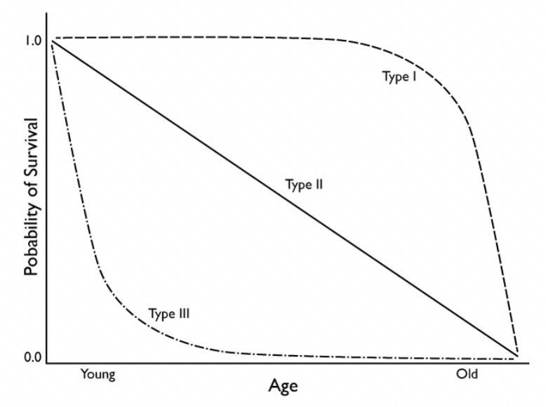
A life table uses information about age- and sex-specific mortality rates to determine patterns of survivorship and life expectancy. Life tables can be constructed in two ways: cohort and static. A cohort life table follows the survival and reproduction of all members of a cohort from birth (or fertilized eggs) to death. A static life table records age-distribution data from a cross-section of the population at one particular time or during a short segment of time using mortality data. A practical approach for studying human population ecology is to construct a static life table using data from cemeteries, obituaries, and even death certificates. Using this technique, one may sample a given population at a snapshot in time. Data from life tables then can be used to construct survivorship curves and examine age-specific mortality. A survivorship curve is simply a graphical representation of the chance that an individual will survive from birth to a particular age. They are generally classified into three typical shapes:
Type I: individuals survive well early in life and generally live many years. At an advanced age, however, the death rate increases dramatically.
Type II: individuals have an even chance of dying at any age (constant death rate at any age).
Type III: individuals initially have a low chance of survival, but after a certain age, they are much more likely to survive.

Taken from: Human and wildlife ecology, Fleming College https://humanwildlifeecology.wordpress.com/home/curbing-population-growth-effective-population-management/

Vital records, defined as recorded life events kept under government authority (e.g., birth and death certificates), have been utilized in many ways to better elucidate factors related to the prevalence of health-related events, such as infectious diseases or accidents (Dahal et al., 2017). Vital records also can be a good resource to measure changes in human demography. For instance, birth and death certificates have played an essential role and starting point in numerous retrospective studies involving calculation of death rates and survivorship curves of cohorts (Moriyama 1964, Susselder et al. 1996, Dodge et al. 2007). By comparing survivorship curves, researchers can look for historical trends in demography over different time periods (Bell and Miller 2005). Data obtained from death certificates are of fundamental importance to study demographics, because they contain information on specific characteristics of decedents, causes of death and its circumstances. Therefore, these demographic data are a core resource for understanding patterns of morbidity (state of disease or condition) and mortality (Manganello 2018).
Over the last 100 years, advances in healthcare and large-scale global political conflict have had significant impact on the demographic structure of human populations. For instance, the periods before and after the 1950s represent critical time points in global human demographics. People who died before the 1950s witnessed the advent and expansion of the industrial revolution, the devastating effects of infectious diseases, and two World Wars. People born after the 1950s experienced biotechnological and public health advances (i.e., development of vaccines and antibiotics), improvements in sanitation, and a relative absence of global scale wars (CDC 1999). A distinctive consequence of these environmental and societal changes is demographic transition, a period of robust population growth in which human populations experienced shifts from high mortality and high fertility (ability to produce offspring) to low mortality and low fertility (Blue and Espenshade 2011). Demographic transition can result in epidemiological transition, a change in patterns of high prevalence of infectious diseases to a period of high prevalence of chronic degenerative diseases (Sarukhan 2017). The use of death certificates data can help identify patterns of demographic and epidemiological transition within and between populations over different periods of time.
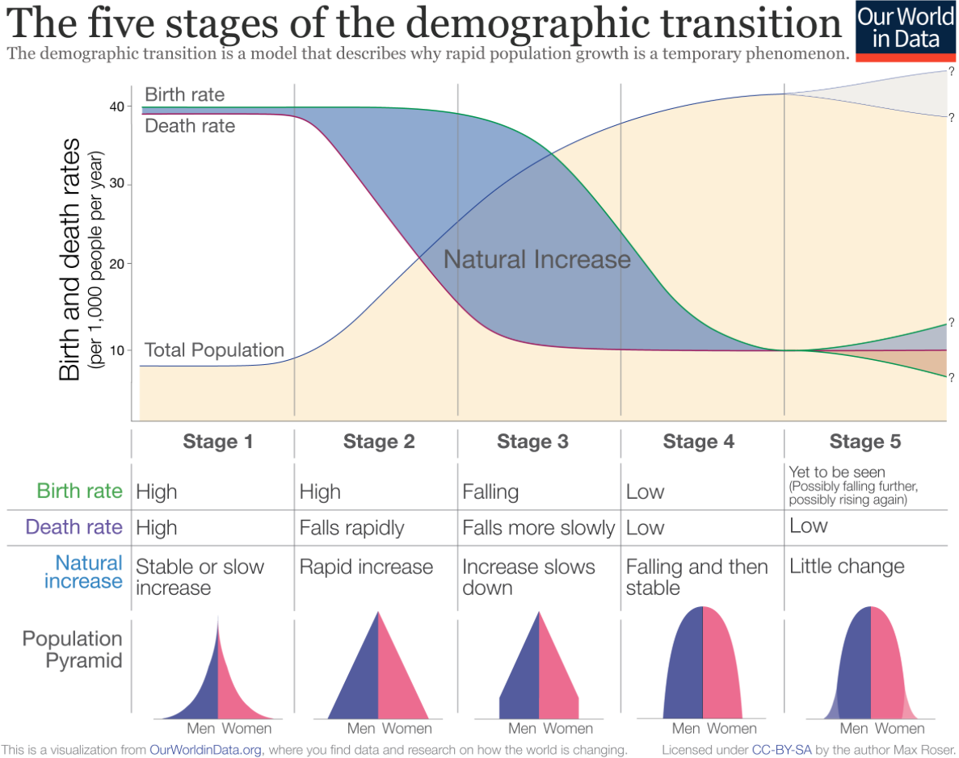

The five stages of demographic transition. https://ourworldindata.org/uploads/2018/11/Demographic-Transition-Schematic.png (From: Our World in Data https://ourworldindata.org/world-population-growth)

Death certificates are highly standardized and regulated. They generally consist of an upper portion containing personal information of the decedent and a lower portion describing the circumstances of death. The certifier, the person completing the lower portion of the death certificate, can be a physician, mid-level practitioner, or coroner, whereas the upper portion is typically completed by a funeral director. A number of quality problems associated with death certificate data have been identified, including diagnostic difficulties, data not being collected in a uniform way across the entire population or over time periods, bias in data processing, and inaccuracy and misclassification in death certification. The usefulness of the data depends on many factors, including the completeness of records and the accuracy in assigning the underlying causes of death (Johansson et al. 2001). Nevertheless, despite these limitations, death certificate data can serve as an important source of demographic information that could be used to study and compare demographics, historical public health control and prevention measures, disease ecology, and population dynamics.
This exercise is centered on a publicly available online database of historical death certificates. It is likely that most students will not have enough background knowledge to develop robust research questions for their project. In order to understand the demographic characteristics of Arizona over time, it will be important for the instructor to provide students with a brief introduction into the most important historical background and demographic characteristics of the state within the context of the exercise.

Starting your project
Your task is to compare life tables, survivorship curves, and causes of death for different groups of deceased people in Arizona using death certificates found in the AGBDC database. This database offers a great abundance of information and data collection flexibility. Use the following exercise as an example to develop unique research questions for your project. For the purpose of conducting this exercise and navigating the AGBDC database, you will be searching for death certificates from 1918 and 1958 (pre- and post 1950, see Introduction above). However, this parameter could be changed to a time period of your choice after consulting with your instructor. In addition to mortality, you could also collect other data available in the death certificates, such as sex, race/ethnicity, or geographic region that will help you answer your research questions. First, brainstorm within your group about the kind of questions that interest you and conduct some background research on your topic. Then, develop a hypothesis about variation in human demography between populations that may differ in time periods, sex, geographical areas, or race/ethnicity, among other characteristics. You will collect and analyze the data, interpret your results, and provide an in-class lab presentation, poster, or written report.

Materials and Methods
Overview of Data Collection and Analysis Methods
*Week 1
- Pick your lab project partner(s).
- Conduct a short exercise to become familiarized with the AGBDC database and learn how to navigate through it and to use other online resources (see Pre-project Lab)
- Brainstorm project ideas with your group; start with a list of potential project topics (see Research Topic Suggestions to help you generate some ideas).
- Your instructor can provide a list of independent variables on the board to further stimulate your group discussions. It is especially important to consider variables that could cause differences in survival curves.
- Pick your variables and comparison groups. Because of potential time constraints, it is recommended that each group picks one variable and one comparison group.
- Consult and obtain approval from your instructor on your topic, variable, and comparison group.
- Develop a short proposal that should include background information, a rationale for the topic, hypothesis, prediction(s), approach, variables and comparison groups, and statistical analysis.
- Coordinate the division of project tasks with your group and start collecting data, if time allows.

Homework between Week 1 and Week 2
- Continue to gather data.

Week 2
- Work in groups to collect and summarize the data.
- Prepare tables, including life tables and causes of death tables.
- Prepare survivorship curves graphs and causes of death graphs.
- Discuss and interpret the data; research the scientific literature to compare and contrast with your study.
- Start work on presentations or written reports.

Homework between Week 2 and Week 3
- Continue to prepare presentations or written reports.

Week 3
- Present your project to the class or submit written reports.

PART 1. Learning to navigate through the database: searching for 1918 death certificates
a. You will conduct a series of queries in the AGBDC database http://genealogy.az.gov/index.htm, which contains microfilmed images of historical death certificates from 1870 to 1969. Because this is an extensive, publicly available database that is not designed for advanced searches, it is critical that you become familiarized with it.

b. In the AGBDC database, place a query for the year “From: 1918, Through: 1918” (Figure 1). This query will allow you to search only for death certificates from 1918.

c. Check only “Search Public Death Certificates” then click “County of death” and select “Any county” to select data from all 15 Arizona counties. Make sure to uncheck “Search Public Birth Certificates”, otherwise your search will result in a mix of birth and death certificates. Then, click “Submit.”

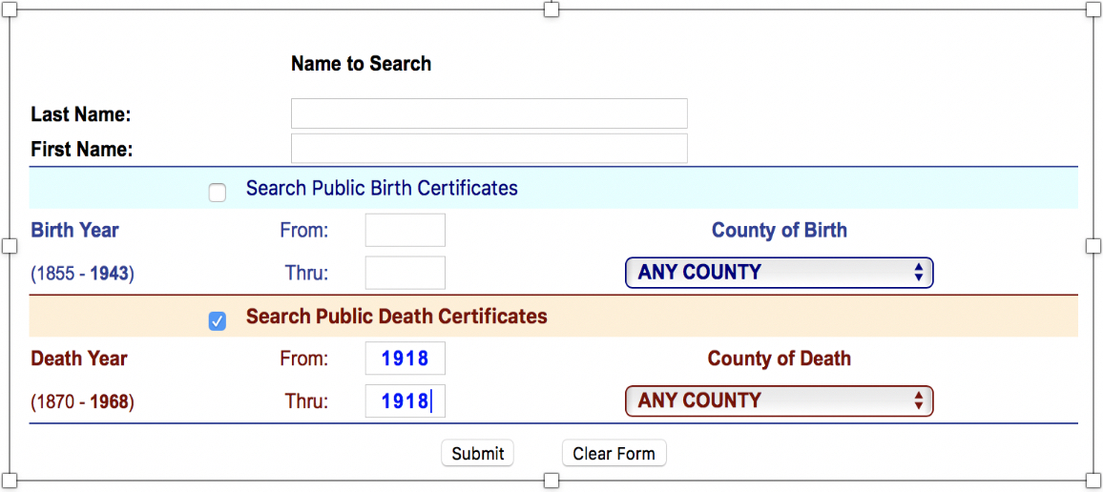

Figure 1. Screenshot of the AGBDC website with a query for 1918 death certificates.

d. Once you get to the results page, you can see how many records are available based on your query. The total number of death certificates generated in your search are shown in two places within the results page, at the right hand bottom and the top of the first page (“# Found”). How many death certificate records did the 1918 query produce?

e. To find out how many pages are included in the 1918 query, go to the bottom left of the screen (Figure 2). You will see the “Page” section, which tells you how many pages containing certificates are included in your query. Each page typically contains about 100 death certificates. How many pages did the 1918 query produce?

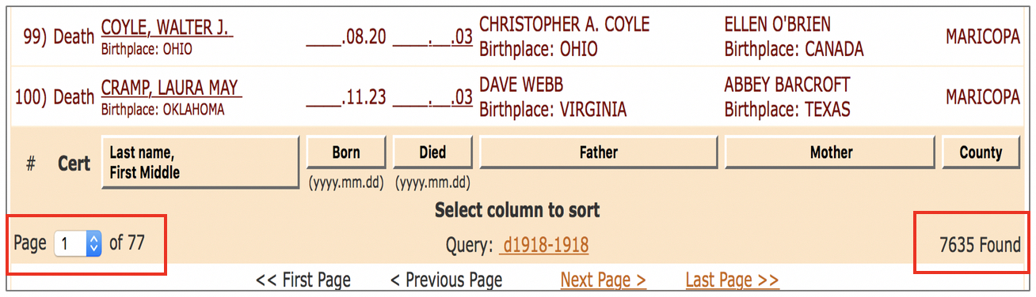
Figure 2. Screenshot of the AGBDC website with results of a query for 1918 death certificates. Page number search box and number of documents found are at the bottom of the page (red boxes).

f. Next, you will return to the main AGBDC database query page. Go to the top of your current 1918 results page and click on “Query: d1918-1918” (Figure 3).
g. Now that you are back to the main AGBDC page, you will place a query for records from another population. Follow previous steps (Part 1, b-e), this time requesting death certificate records from 1958, which you will use to compare to the 1918 population.
Figure 3. Screenshot of the AGBDC website with results of a query for 1918 death certificates. After going to the top of the page, clicking in the “Query: d1918-1918” (red box) will return you to the main AGBDC page.
h. Once you are back at the main AGBDC database query page, click on “Clear” to remove the previous query request and then place a query for 1958 (Figure 4).
i. After placing your query for 1958 death certificates, how many records did your search produce? How many pages did your search produce?

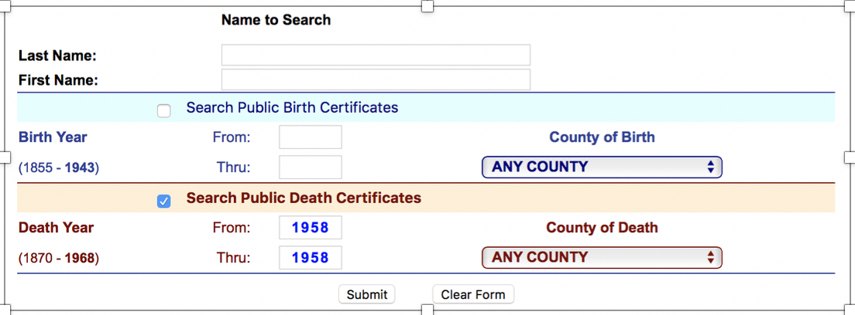
Figure 4. Screenshot of the AGBDC website with a query for 1958 death certificates.

PART 2: Generating random numbers to reduce bias in data selection
a. When studying populations, ecologists often use sample randomization to collect data. The main goal of selecting samples from a larger population in a random manner is to ensure that the samples selected are representative of the larger population and less likely to be subject to selection bias. Since the AGBDC database is very extensive, you will be collecting death certificates using randomly selected numbers.
b. One way to produce random numbers is to use the publicly available biostatistical site Open Epi https://www.openepi.com/Menu/OE_Menu.htm. In the main Open Epi webpage, on the left of the page, you will find the Menu list. Click on the “Random numbers” folder (Figure 5).
c. At the top of the page, click on the “Enter” tab. Next, in the “Random number generator” box, enter the lowest value, the highest value, how many random numbers would you like to generate, and in how many columns you want your generated numbers to be (Figure 6). Results of this query are depicted in Figures 5 and 6.
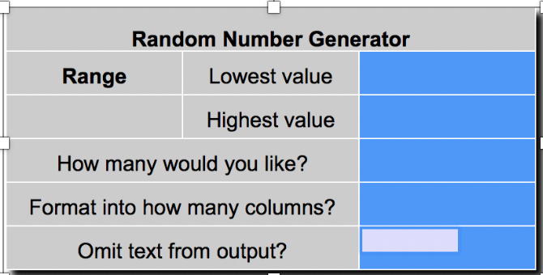
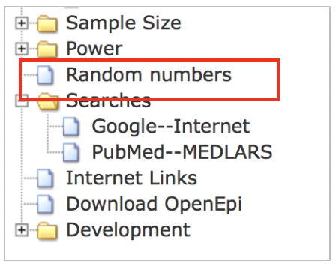
Figure 5. Screenshot of the Open Epi website showing the link to the Random number generator in the menu (bottom, left).
Figure 6. Screenshot of the Open Epi website showing the Random number generator page.

d. Notice that the same number of 1918 records depicted in Figure 2 (7635 records) was used to generate 20 random numbers shown in Figures 7 and 8.

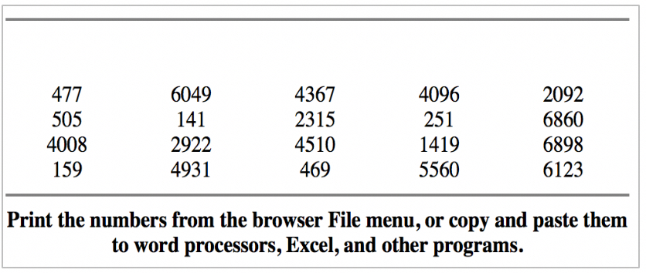
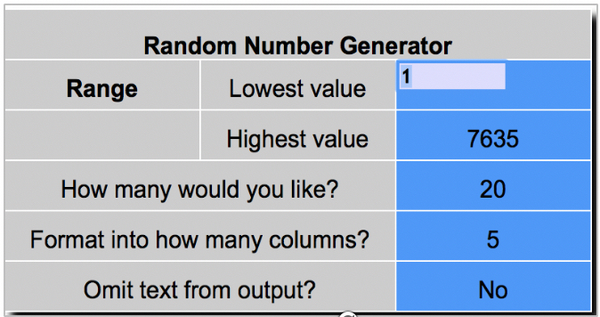
Figure 8. Results of the random number search for random numbers from 1 to 7635.

Figure 7. Screenshot of the Open Epi website showing the random number generator page with a request to generate 20 random numbers from 1 to 7635.

e. It is recommended that your group generate a separate set of random numbers for each cohort (1918 and 1958) since the total number of queried records for each will be different.
f. Students can opt to generate random numbers in various other ways, including accessing online random number tables or websites (i.e., Google® number generator).

PART 3: Searching for records using random numbers

a. For this exercise, you will be selecting two specific cohorts, one pre-1950 (1918) and another post-1950 (1958). Your group could choose any other year based on the same criteria; however, make sure to consult with your instructor first. In this exercise, you could use the 1918 and 1958 populations as an example.

b. Using the information available on the death certificates, you will collect and analyze several demographic characteristics of these two populations and compare them using life tables, survivorship, and causes/antecedents of death.

c. After generating a random number list using information from the 1918 population query results, you can now start collecting data from your first death certificate. For example, the random number list shown in Figure 8 starts with number 477. In the 1918 query results shown in Figures 1 and 2, go to the bottom left of the page and then select Page 5 to search for record number 477 (Figure 9).
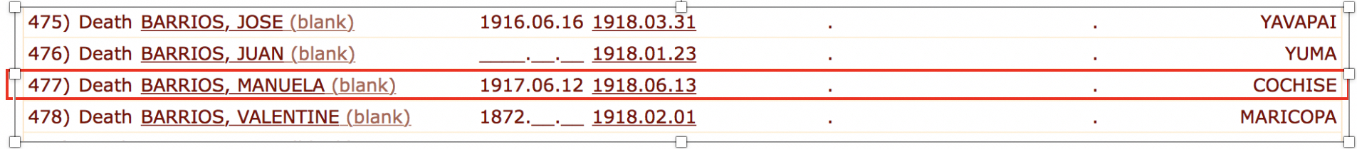
Figure 9. Screenshot of the AGBDC website with results of a query for 1918 death certificates, page 5, death certificate #477.

Note: In the AGBDC database, for each cohort selected, you could only query for one year (e.g., 1918 to 1918), or you could define each cohort as a period range (e.g., 1918 to 1922). Because the database contains an extensive number of records, it is recommended that you query only for one year rather than a range. However, you could consult with your instructor if you have any other ideas for your cohort selection.

PART 4. Navigating through the death certificates

Although there is great research value in investigating historical death certificates, it is also important to recognize the limitations of using these documents as sources of demographical data. Before you decide on the topic and population cohorts in your project, there are several things that you need to consider with the help of your instructor:
      - First, learn about the history of Arizona, its diverse population, and the demographic changes that the state experienced from 1870 to 1969. The sections “Useful Websites, Books, and Articles” below provide several research resources.
- Consider the advantages and limitations of using death certificates.
- Recognize the limitations of the data available and challenges of your project.
- Based on your background research and questions, develop logical and consistent methods for data collection and analysis.

a. Once you consult with your instructor regarding your specific project research questions and generated random numbers, you can start collecting death certificate data. For this exercise, start collecting data from the “1918” and “1958” queries as indicated in Part 1-4 using the AGBDC database http://genealogy.az.gov.
b. Figures 10 and 11 show examples of death certificates from 1918 and 1958, respectively. To help you navigate through these records and find the information needed for your project, sections in the records are indicated with red arrows. This information includes: sex, date of birth, date of death, age, cause of death, contributory or antecedent factors to the death. Once you are familiarized with the structure of these documents, it will be easier to extract the information that you will need for your project.

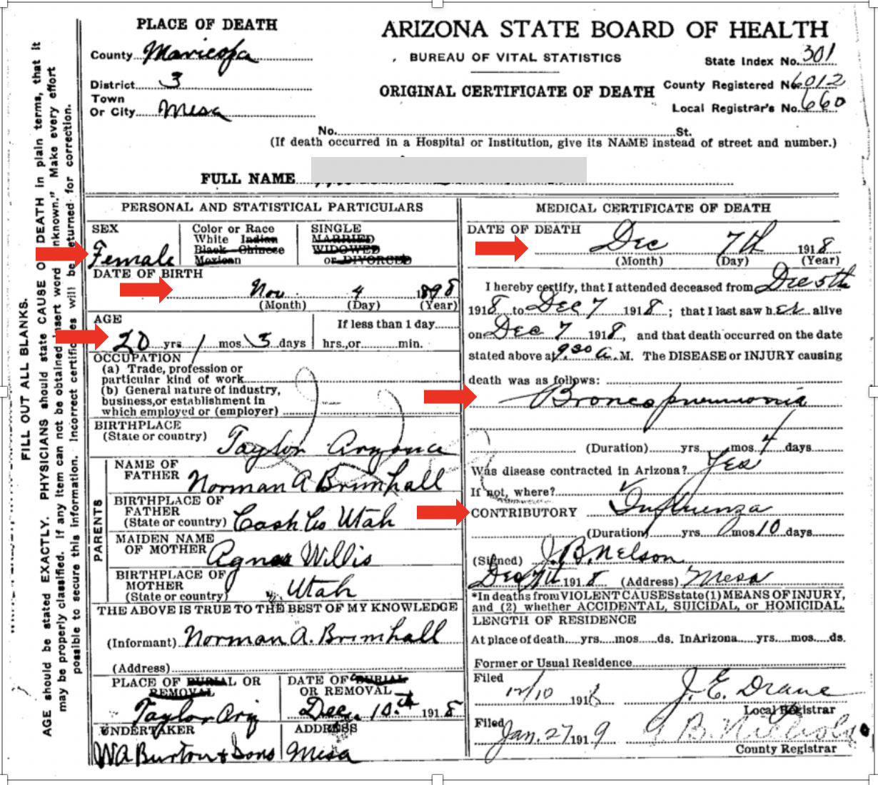

Figure 10. Example of a 1918 death certificate found in AGBDC website. The red arrows show parts of the document with important demographic information.

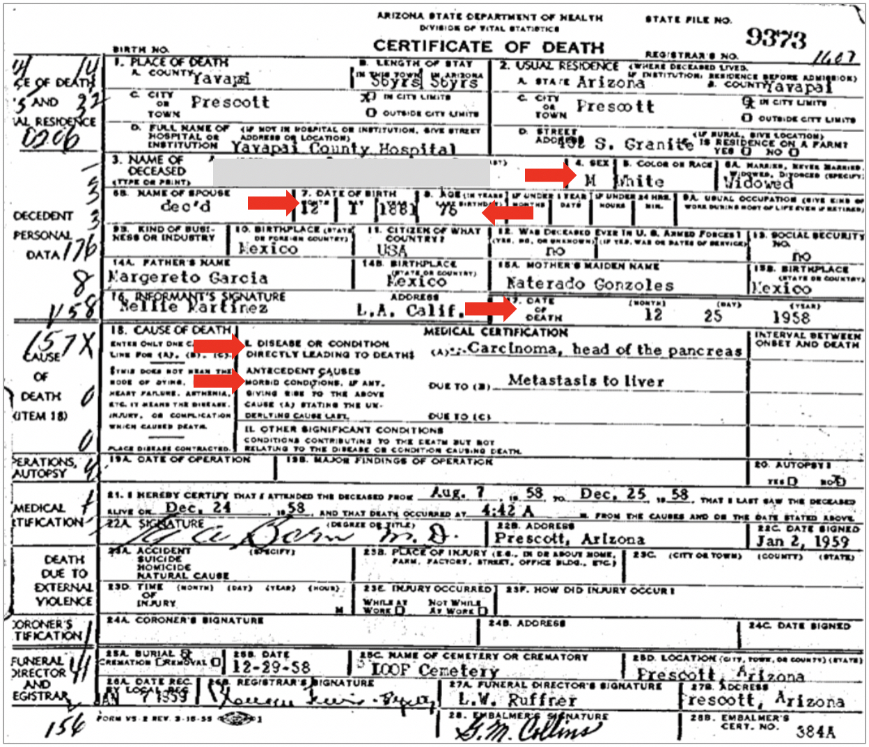

Figure 11. Example of a 1958 death certificate found in AGBDC website. The red arrows show parts of the document with important demographic information.

PART 5. Collecting data for life tables
a. Using Tables 1 and 2, you will be collecting data found in the death certificates that will be used to construct your life tables. Make sure to write down the certificate number just in case that you need to return to the record at a later time.
Note: there are a few minor challenges related to reviewing records. Make sure to always carefully review each document since some records from different years may be misplaced in your query results. Also, some records may be difficult to read since many are fully or partially handwritten. If the certificate found using a random number is not from the year requested, data are missing in the certificate, or the document is difficult to read, then choose the next most suitable record. You could do that by selecting another record two or three certificates up or down from the death certificate you originally chose. This will help maintain randomness in your record selection. As an option, you could also use the next generated random number in the list.

b. You will be collecting death certificate data for 100 male and female individuals for each cohort (1918 and 1958) (Tables 1 and 2). In the table, you will include record number, age at death, and cause of death. You may also choose a larger or smaller death certificate sample size and additional demographic variables (e.g., sex, race/ethnicity) depending on your project design and recommendations from your instructor.
Note: For the purpose of this exercise, data for both males and females can be collected together. However, in some projects including both sexes in one cohort could introduce bias because of known differences in variables by sex (e.g., breast cancer in females versus males). You should consult with your instructor about what will be the best way to collect your data.

c. For example, click on the previously found 1918 record #477 (see Part 3c) and search for the following information in the record: sex, date of birth, age, date of death, and cause of death/contributory factor (Figure 9). What does this data tell you about the deceased individual?

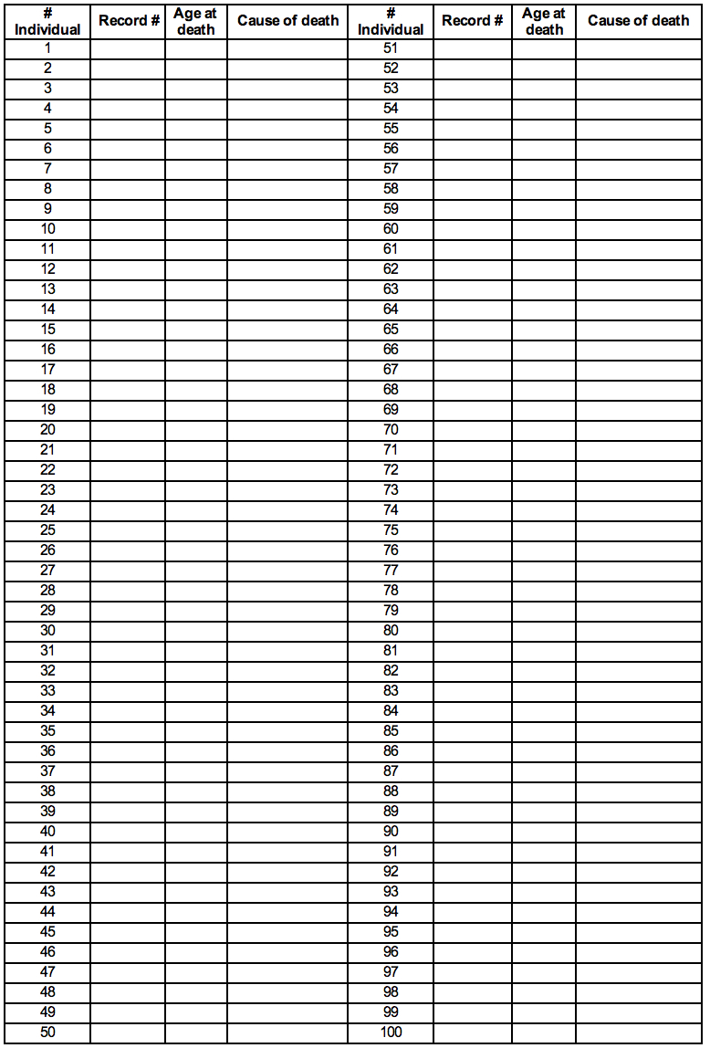
Table 1. Death certificate data for

Table 2. Death certificate data for

Part 6. Determining Causes of Death
a. One of the objectives of this exercise is to gather information regarding the manner in which people died or causes of death (Tables 1 and 2). Using these data, you will be preparing another set of tables (Tables 3 and 4) depicting the causes of death by age group.
b. Before you start collecting data on causes of death, brainstorm with your lab partners on creating general categories of causes of death (e.g., infectious diseases, cancer, accidents/suicides, chronic diseases). It will be easier to classify the causes of death that you find in the death certificates if you place them in general categories. Consult with your instructor if you have questions about creating different categories and how to classify a cause of death accurately.
c. Collecting information on causes of death is like conducting detective work. For some records, you may need to take notes on contributory or antecedent causes since this variable can provide additional information on the circumstances behind the death of individuals.
Note: As you review each death certificate, you will find medical terms that are unfamiliar to you or outdated. Create a list of those terms with your group and research their definitions. Doing this will help you sort each cause of death into a specific category and also determine how the medical terminology in the document is related to the actual cause of death.
d. Based on cause of death data collected in Tables 1 and 2, classify every certificate found in a category in Tables 3 and 4. Also, determine the percentage (%) in each category and the age range for each category (youngest to oldest ages). Why is determining age range for causes of death important?

Table 3. Causes of death for

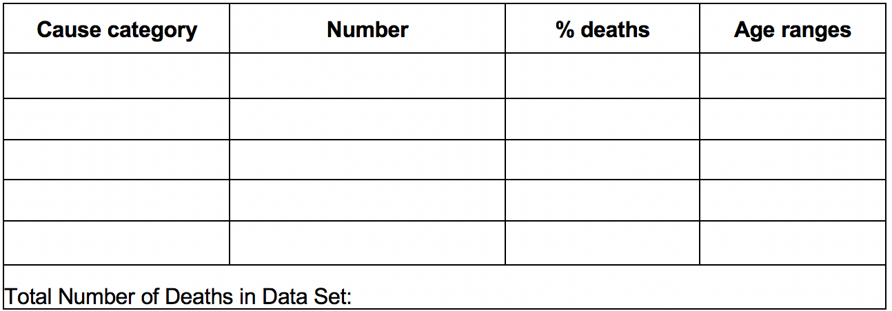

Table 4. Causes of death for

Part 7. Data Analysis (Life Tables)

Life table notations and calculations used in this exercise are similar to those depicted by Smith and Smith (2014).

a. Column A and B: To summarize your data for both study cohorts, you will prepare two life tables (Tables 5 and 6). To start, sort the number of individuals dying into age groups (Column A and B) of ten-year intervals. For instance, for the age class 0-9, count all of the individuals that died at 9 years old or younger.

b. Continue to record the number of deaths for each age group. Make sure to record the total number of deaths, which equals the total number of death certificates you reviewed for the period studied.
c. Column C: Next, calculate the number of individuals surviving to next age interval; these calculations are cumulative. First, write the total number of certificates reviewed or total cohort on the first row of Column C (age group 0-9).
d. Then, to calculate the second row in Column C, subtract the number who died in the first age interval from the number of individuals surviving to next age interval on the same row to the right. Write the result of the subtraction in the next age interval in Column C, one row below. Repeat to fill out the rest of Column C (see example in Table 7).
e. Column D: Calculate the proportion of original cohort surviving to age interval (Survivorship) by dividing, in each age group, survivorship (Column C) by the total number of certificates reviewed for that year or total cohort. This resulting number is defined as the proportion of individuals that survived to each age interval. By definition, the survivorship of the first age group equals 1.0 (all living newborns have survived to that point).

f. Column E: The proportion of original cohort dying during each age interval can be calculated by dividing the total number of individuals dying at each age interval by the total number of death certificates reviewed (or total cohort).

Table 5. Life table data for

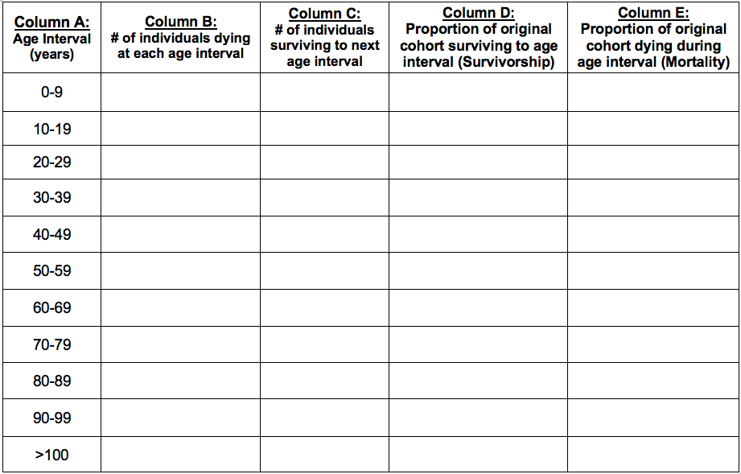

Table 6. Life table data for

Table 7. Example of life table calculations.
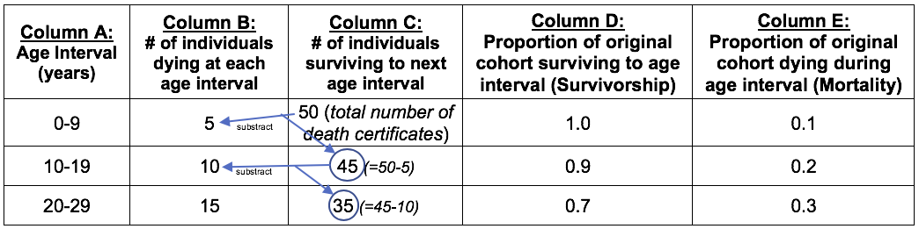

Part 8. Data Analysis: survivorship and mortality graphs
a. Students could produce their own graphs or they can produce the following graphs described below. Consult with your instructor if you have any questions about what other types of graphs you could produce.
b. In Excel (or Google Sheets), make a scatterplot of survivorship proportion (y axis) as a function of age group (x axis) using data from Tables 5 and 6. Each population studied (i.e. 1918 and 1958) should have its own line. Make sure to label each axis and include a descriptive figure legend.

c. In Excel (or Google Sheets), make a scatterplot of mortality proportion (y axis) as a function of age group (x axis) also using data from Tables 5 and 6. Each population studied (i.e. ,1918 and 1958) should have its own line. Make sure to label each axis and include a title.
d. Produce a column graph using Excel (or Google Sheets) depicting mortality % (y axis) as a function of disease Category (x axis) for both populations studied (i.e. 1918 and 1958) using data from Tables 3 and 4. Make sure to label your graph properly. Alternatively, you could produce two separate bar graphs for each cohort group.
e. Based on the data collected, you have some flexibility in creating different types of graphs to analyze your data. If you would like to create other types of graphs than what it is suggested above, consult with your instructor.

Questions for Further Thought and Discussion:

1. How did the 1918 and 1958 survivorship curves compare? Do they differ or look the same? Explain your answer.

2. How did the mortality proportion compare between the 1918 and 1958 cohorts? Did they differ or look the same? Explain your answer.

3. Did the two populations studied (1918 and 1958) differ on the main causes of death? If so, in what way? Explain your answer.

4. Prior to answering this question, review and discuss the CDC (1999) article with your lab partners. The article describes some of the most important achievements in public health and it will provide context to your answer. If differences in survivorship, mortality, and causes of death are found between the 1918 and 1958 cohorts studied, what type factors may be driving these differences?

5. In the context of this exercise using human populations pre-1950s and post-1950s, are life tables, survivorship curves, and mortality data useful in helping you understand demographic and epidemiological transition between two human populations? Explain your answer.
6. What shifts in survivorship, mortality, and causes of death in human populations would you expect if environmental problems, such as climate change, antibiotic resistance, and overpopulation continue to worsen?

7. Review the article by Nelson et al. (2007) which discusses several demographic factors as indirect global drivers of ecosystem change. How do changes in demographic composition (e.g., life expectancy, mortality, and fertility) influence other indirect or direct ecosystem drivers mentioned in the article? Provide one example.

8. Now that you are familiarized with the data available in the historical Arizona death certificates, what other population characteristics found in these documents would you evaluate to measure demographic and epidemiological transition? Generate two to four additional research questions that could be studied using the AGBDC database.

References
Arizona Department of Health Services, Arizona Bureau of Vital Records. Arizona Genealogy Birth and Death Certificates (AGBDC) database. http://genealogy.az.gov.

Bell, F. C. and M. L. Miller. 2005. Life tables for the United States social security area 1900–2100. U.S. Social Security Administration, Office of the Chief Actuary, Baltimore, MD, SSA Pub. No. 11–11536. https://www.ssa.gov/oact/NOTES/pdf_studies/study120.pdf

Blue, L. and T. J. Espenshade. 2011. Population momentum across the demographic transition. Population and Development Review 37:721–747.

Boone, E. 2017. Uncovering the Past: Using Human Demography to Promote Civic Engagement. Article 49 In: McMahon K, editor. Tested studies for laboratory teaching. Volume 38. Proceedings of the 38th Conference of the Association for Biology Laboratory Education (ABLE). http://www.ableweb.org/volumes/vol-38/?art=49

Centers for Disease Control and Prevention (CDC). 1999. Achievements in Public Health, 1900-1999: Control of Infectious Diseases Morbidity and Mortality Weekly Review (MMWR) 48:621-629.

Centers for Disease Control and Prevention (CDC). 2012. Principles of epidemiology and public health practice: an introduction to applied epidemiology and biostatistics. Lesson 3: measures of risk. https://www.cdc.gov/csels/dsepd/ss1978/lesson3/section3.html
Cobos, A. J., C. G. Nelson, M. Jehl, C. Viboud, and G. Chowell. 2016. Mortality and transmissibility patterns of the 1957 influenza pandemic in Maricopa County, Arizona. BMC Infectious Diseases 16:405.
Dahal, S., M. Jenner, L. Dinh, K. Mizimuto, C. Viboud, and G. Chowell. 2017. Excess mortality patterns during 1918-1921 influenza pandemic in the state of Arizona, USA. Annals of Epidemiology 28:273-280.

Dean, A. G., K. M. Sullivan, and M. M. Soe. OpenEpi: open source epidemiologic statistics for public health. www.OpenEpi.com

Dodge, J. A., P. A. Lewis, M. Stanton, and J. Wilsher. 2007. Cystic fibrosis mortality and survival in the UK: 1947–2003. European Respiratory Society 29:522-526.

Flood, N. 1993. Cemetery demography. In: Experiments to Teach Ecology (edited by J.M. Beiswenger). Ecological Society of America 1:155-168.
https://tiee.esa.org/vol/expv1/cemetery/cemetery.pdf

Forstall, R. L. 1996. Population of states and counties of the United States: 1790 to 1990. US Bureau of the Census, US Department of Commerce, Washington DC.
https://www2.census.gov/library/publications/decennial/1990/population-of-states-and-counties-us-1790-1990/population-of-states-and-counties-of-the-united-states-1790-1990.pdf

Grineski, S. E., B. Bolin, and V. Agadjanian. 2006. Tuberculosis and urban growth: class, race and disease in early Phoenix, Arizona, USA. Health & Place 12:603–616.

Human and wildlife ecology, Fleming College. https://humanwildlifeecology.wordpress.com/home/curbing-population-growth-effective-population-management/

Johansson, L. A., R. Westerling, and H. M. Rosenberg. 2006. Methodology of studies evaluating death certificate accuracy were flawed. Journal of Clinical Epidemiology 59:125-131.

Lanza, J. 2012. Demography from physical cemeteries, “virtual cemeteries,” and census data. Teaching Issues and Experiments in Ecology 8: Experiment #1. http://tiee.esa.org/vol/v8/experiments/lanza/abstract.html

Manganello, R. 2018. Public Health Post. Saving lives begin with death certificates.
https://www.publichealthpost.org/viewpoints/saving-lives-begins-with-death-certificates/

Moriyama, I. M., 1964. Uses of vital records for epidemiological research. Journal of Chronic Diseases 17:889-897.

Nelson, G. C., E. Bennett, A. A. Berhe, K. Cassman, R. DeFries, T. Dietz, A. Dobermann, A. Dobson, A. Janetos, M. Levy, D. Marco, N. Nakicenovic, B. O’Neill, R. Norgaard, G. Petschel-Held, D. Ojima, P. Pingali, R. Watson, and M. Zurek. 2006. Anthropogenic drivers of ecosystem change: an overview. Ecology and Society 11:29.
Nusselder, W. J. and J. P. Mackenbach. 1996. Rectangularization of the survival curve in the Netherlands, 1950-1992. The Gerontologist 36:773-782.
Petitti D. B., Harlan S. L., G. Chowell-Puente, and D. Ruddell. 2013. Occupation and environmental heat-associated deaths in Maricopa County, Arizona: a case-control study. PLoS ONE 8:e62596.
Pyke, D. A. and J. N. Thompson. 1986. Statistical analysis of survival and removal rate experiments. Ecology 67:240-245.

Sarukan, A. 2017. The epidemiological transition (or what we died, die and will die from). Health IS Global Blog, Barcelona Institute of Global Health. 05/9/2017. https://www.isglobal.org/en/healthisglobal/-/custom-blog-portlet/la-transicion-epidemiologica-o-de-que-moriamos-morimos-y-moriremos-/3098670/0

Smith, T. M. and R.L. Smith. 2015. Elements of Ecology. 9th edition Pearson, 704 pages.

United States National Committee on Vital and Health Statistics. 1968. Uses of vital records for epidemiological research, a report of the United States National Committee on Vital and Health Statistics. National Center for Health Statistics. DHEW Publications No. (HSM) 73-1265.
https://www.cdc.gov/nchs/data/series/sr_04/sr04_007.pdf

Useful Websites, Books, and Articles

- American History from Native American to Independence - “Native American tribes of Arizona”
http://theamericanhistory.org/native-american-tribes-arizona.html
Describes Native American tribes of Arizona, which has one of the highest total Native American population amongst in the US.

- Arizona Department of Health Services
https://azdhs.gov/index.php
Describes infectious diseases occurring in Arizona, disease data, statistics, and reports.

- Arizona Department of Health Services – “A history of the Arizona State Public Health Laboratory”
https://www.azdhs.gov/documents/preparedness/state-laboratory/centennial/AZ-State-Lab_The-Early-Years.pdf
Describes the early years (1903-1932) of the Arizona State Public Health Laboratory and the health issues occurring during that period.

- Arizona Geological Survey Document Repository
http://repository.azgs.az.gov
Provides geologic information on the nature and geologic setting of Arizona.

- Arizona Memory Project
https://azmemory.azlibrary.gov/digital/
Provides access to primary sources in Arizona archives, museums, libraries, and other cultural institutions, including government documents, photographs, maps, and multimedia that chronicle Arizona’s past and present.

- Arizona State Library, Archives, and Public Records
https://azlibrary.gov
Provides access to historical and contemporary resources in the areas of law, genealogy, and history of Arizona

- Arizona State Library, Archives, and Public Records – Japanese American relocation and internment during World War II
https://azlibrary.gov/dazl/learners/research-topics/japanese-american-relocation-and-internment-during-world-war-ii
Brief description of the Japanese American relocation and internment camps in Arizona.

- Arizona State Library, Archives, and Public Records - Residential Indian Schools
https://azlibrary.gov/dazl/learners/research-topics/residential-indian-schools
Brief history of the Indian Residential Schools established by the US government in Arizona with the objective of forced assimilation of Native American children into Anglo-American Christian culture.

- Arizona State Library, Archives, and Public Records - World War II prisoner of war camps
https://azlibrary.gov/dazl/learners/research-topics/world-war-ii-prisoner-war-camps
Provides a brief description of World War II prisoners of war camps in Arizona.

- Baesa, J. 2011. “Arizona centennial: the making of a state – TB epidemics brings health seekers to Arizona”
https://www.wmicentral.com/news_premium/arizona-centennial-the-making-of-a-state---tb-epidemic-brings-health-seekers-to/article_91002a8a-f393-11e0-a9d9-001cc4c002e0.html
Article on the history of tuberculosis in Arizona.
- Barnett, J. and E. Lueck. 2019. “From Louisiana to Arizona: A sawmill town moves”
https://www.laforestry.com/single-post/2019/07/22/From-La-to-Ariz-A-sawmill-town-moves?fbclid=IwAR357H8uJ6BGgxqYUB1X_NWrLBdy4t-zBr4UcLy8QLRwcZKMukEM3HuwIhM
Article on the migration of experienced black timber workers in the 1920’s from the Louisiana to the newly established town of McNary, Arizona. The town became known for its diversity and relatively composed race relations.

- Bureau of Labor Statistics
http://www.bls.gov/iif/oshcfoi1.htm#19922002
Census data of fatal occupational injuries by multiple categories.

- CDC WONDER
http://wonder.cdc.gov/
Contains public-use data on US births, deaths, cancer diagnoses, tuberculosis cases, vaccinations, environmental exposures, and population estimates.
- Civil Liberties Public Education Fund, Education Resources
http://www.momomedia.com/CLPEF/edu.html
Website is dedicated to providing information and resources to help educate the public on issues related to the wartime incarceration of Americans of Japanese ancestry.

- Densho Encyclopedia
http://encyclopedia.densho.org
Information resource about the history of the Japanese American WWII exclusion and incarceration experience.

- Densho Encyclopedia - Medical care in camp
http://encyclopedia.densho.org/Medical%20care%20in%20camp/
Describes medical care available in Japanese internment camps.

- Densho Encyclopedia - Sites of Incarceration
https://encyclopedia.densho.org/Sites_of_incarceration/
Describes the type of government-run incarceration sites in the US for persons of Japanese descent during World War II.

- Gregory, J. “Arizona migration history: 1860-2017”. University of Washington, America’s Great Migrations Projects.
https://depts.washington.edu/moving1/Arizona.shtml
Most residents of Arizona came from somewhere else, either another state or another country; briefly describes history of human migration in Arizona.

- GenTracer: World War I and World War II prisoner of war deaths and burials in the United States.
https://www.gentracer.org/powdeathindex.html
Database of World War II prisoners of war deaths in the US and other related information.

- Gratton, A., and E. Klancher. 2015. An immigrant’s tale: the Mexican American Southwest 1850 to 1950. Social Science History 39:521-550. https://www.jstor.org/stable/90017481?seq=1#metadata_info_tab_contents
History of Mexican Americans migration to the American Southwest between 1850 to 1950.
- Jensen, G. 2008. “Dysentery, dust, and determination: healthcare in the World War II Japanese American detention camps”. Discover Nikkei.
http://www.discovernikkei.org/en/journal/2008/6/21/enduring-communities/
Article describes the establishment of medical facilities for Japanese Americans held in detention camps during World War II.

- Journal of Arizona History
https://www.jstor.org/journal/jarizhist
Scholarly publication of the Arizona Historical Society, it contains articles, reminiscences, documents, and photo essays pertaining to the history of Arizona, the Southwest, and northern Mexico.

- Lewis, J. 2012. “McNary, Arizona: A town on the move”. Forest History Society.
https://foresthistory.org/mcnary-arizona-a-town-on-the-move/
Article on the history of the town of McNary, Arizona, a logging town established after the migration of experienced black timber workers in the 1920’s from Louisiana. It became known for its diversity and relatively composed race relations.

- Mark, J. 2015. “Mesa history: be thankful for modern medicine”. AZCentral.
https://www.azcentral.com/story/news/local/mesa/contributed/2015/08/26/mesa-history-thankful-modern-medicine/32452207/
Description of infectious diseases once prevalent in Arizona, especially in the Mesa region, that have been eradicated by modern medicine.

- Naylor, R. 2020. “A century before coronavirus, Arizona was a haven for people fleeing another fearsome disease”, AZCentral.
https://www.azcentral.com/story/travel/arizona/roadtrips/2020/05/11/arizonatuberculosis-history-sunnyslope-sanatoriums-doc-holliday/3101543001/
History of tuberculosis in Arizona and how the influx of patients streaming west led to a population boom in the state.

- Prine Pauls, E. “Southwest Indian people”. Encyclopedia Britannica.
https://www.britannica.com/topic/Southwest-Indian/The-Pueblos
Describes Native American cultures in the US Southwest.

- Sheridan, T. A., 2012. “Arizona: a history”. 1st edition (revised edition), University of Arizona Press, 504 pages.
https://uapress.arizona.edu/book/arizona
Explores the ways in which Native Americans, Hispanics, and Anglos have inhabited and exploited Arizona.

- Whitaker, M. C. 2007. “McNary, Arizona”
https://www.blackpast.org/african-american-history/mcnary-arizona/
Brief description of the migration of experienced black timber workers in the 1920’s from Louisiana to the newly established town of McNary, Arizona. It became known for its diversity and relatively composed race relations.

- US Census
http://www.census.gov/en.html
Leading source of demographic data about the US people, health, and economy.

- US Census Population and Housing Reports
https://www.census.gov/prod/www/decennial.html
Census reports on US demographics and housing from 1790 top 2010.

Tools for Assessment of Student Learning Outcomes:

Students will be assessed in several ways:
- Discussion questions in the lab exercise (see Questions for Further Thought and Discussion). These questions need to be answered by every group and submitted as a written report.
- A culminating in-class presentation or a research poster. As an option, students could write a research paper. Use the attached project assessment guidelines to help you design your project and presentation (Project Guidelines and Rubric).

NOTES TO FACULTY

Challenges to Anticipate and Solve

This exercise, which uses publicly available historical death certificates, provides several advantages over more conventional approaches to teaching life tables and survivorship curves using cemetery and obituary data. Cemetery lab exercises examine changes in human demographic patterns by visiting local cemeteries to collect birth and death dates recorded on tombstones. The use of obituaries depends on publicly available online records but can be a richer source of demographic information than cemeteries, with information such as number of children and place of birth. Although cemeteries and obituaries could help produce a graphical representation of their survivorship and mortality (Flood 1993, Lanza 2012, Boone 2017), these two methods pose several constraints, including travel required, limited access to online data, and limited amount of demographic data. Comparatively, death certificates may serve as a better source for demographic data and a great teaching tool due to the broader range of data points found in these documents, including cause of death, sex, race/ethnicity, time periods, and place of birth and death. Moreover, students can get free access to thousands of documents online and spend more time conducting background research and data analysis. Nevertheless, the use of online death certificate data, such as the AGBDC database, still presents some challenges that could be minimized using various strategies.

Challenge #1. Navigating the death certificate online database: Once students access the online database, they may find it challenging to navigate since its search query design is limited to only a few items, such as death year. Nevertheless, there are several key features in the database that can facilitate searches, such as time period queries. We highly recommend that instructors initially spend time teaching students how to navigate through the AGBDC database. Typically, we spend about one hour during the first lab session exploring the website. We often use a screen projector to “walk” students through the website and other online resources. In our experience, students highly favor using part of the first lab session to explore the database and discuss potential research questions. Parts 1-4 of the lab handout also contains information that will help students become familiarized with the AGBDC database and identify important the data points within the documents. In Parts 1-4, students conduct a series of queries in the database to explore the website, learn how to randomly select death certificates, and identify demographic data within the documents. Because the whole class will be working on Parts 1-4 at the same time, and search results are usually consistent, all students should have similar answers. Instructors should encourage the class to collaborate in finding information, as some students can become facilitators for others that may experience initial difficulties navigating the database and documents. We find that most students become proficient in navigating the database within one hour of working with it. Alternatively, we developed a pre-project lab exercise (Pre-project Lab) that introduces the class to the AGBDC database 1-2 weeks prior to starting their project, in which they conduct a series of search queries and identify specific information in death certificates from different time periods. We have found that teaching this pre-project lab has been very effective in helping students familiarize themselves with the database ahead of starting their project.

Challenge #2. Lack of background knowledge of their target populations: This exercise is centered on a publicly available online database of historical death certificates. It is likely that most students will not have enough background knowledge to develop robust research questions for their project. In order to understand the demographic characteristics of Arizona over time, it will be important for the instructor to provide students with a brief introduction into the most important historical background and demographic characteristics of the state within the context of the exercise. Instructors can provide students with several resources for historical and demographic information on Arizona. There are few academic documents about the history of Arizona demographics; however, students can find specific information on historical events in encyclopedias or tertiary/peer reviewed, or online sources. Weblinks to these resources have been listed in the “Useful Websites, Books, and Articles” section above. Several book publications could also provide helpful insight, including Arizona Medical Association: the first hundred years, 1892-1991 and Arizona: a history. Moreover, census documents from the 1940s and earlier have helpful information, such as the US Census of Population and Housing reports. If looking for specific supporting information on history and sociology, some general databases may help; these vary by institution but the Journal Storage (JSTOR, https://www.jstor.org) is a common search engine. For example, a journal that could be helpful to instructors and students in formulating research questions is the Journal of Arizona History, which can be set for targeted searches in JSTOR. Websites hosted by the State of Arizona have information on topics including, Infectious Diseases Found in Arizona, A History of the Arizona State Public Health Laboratory, and Arizona Health Services through the Century. Additionally, there are journal articles that could be helpful in preparing for the lab exercise, such as Cobos et al. (2016) and Grineski et al. (2006), which could help students investigate further through death certificates.
As part of their background research, students can use the list of topics on the rich history of Arizona, especially on issues related to the environment and public health (Research Topic Suggestions). Although students may find the initial background research time consuming, we have found that they quickly become engaged in the process as they realize the importance of acquiring historical context when conducting background research.

Challenge #3. Selection and scope of the project: The AGBDC database used in this lab exercise is very extensive and data-rich. Once students are familiarized with the database, it is important that each group gather background information, discuss potential research questions, and decide on the scope of their project. The instructor should prime student discussions with questions related to factors that might affect human survival and mortality, which may include time periods, ethnicity/race, gender, geographic region, socioeconomic conditions, access to medical care, wars, and health-related events or disease. Because of the size and richness of the AGBDC database and diversity of potential topics, we found that students may become quickly overwhelmed and have difficulty in deciding on a specific project. Moreover, some groups tend to be overly ambitious and miscalculate how much time and effort their project might take to complete.
In our experience, it is important to encourage students to consult with the instructor prior to starting their project. As part of the project’s assessment, we ask students to submit a short, one paragraph proposal, which include background information, hypothesis/prediction, methods, variables studied, and knowledge impact (Project Guidelines and Rubric). Students are also asked to complete a series of peer and self-assessments to measure their project management skill development and meet with the instructor during the project to give them the opportunity to ask questions. However, use of these assessments maybe optional, depending on the instructor, scope and timeline to complete the lab project. Lastly, instructors could provide students with a list of potential topics that they can explore using the AGBDC database (Research Project Topics). These topics are based on the socioeconomic, demographic, public health, and environmental history of Arizona, from 1870s to the 1960s. Using this list, students may pick study topics that may be too broad. It is important that once students chose their topic, they further research it and consult with the instructor in order to adjust the scope of their data collection and analysis, if needed.

Challenge #4. Data collection drawbacks and analysis: The historical death certificates found in the AGBDC database range in time from 1870 to 1969. When reviewing the cause of death and antecedent causes, students may find it difficult to understand this information since some of these documents are handwritten and maybe difficult to read. In addition, the medical terminology included in the cause of death and antecedent section may contain outdated or unfamiliar jargon to most students. Most certificates are relatively easy to read and, as students become more familiarized with the documents, they will learn to recognize the handwritten terms. If students find the handwriting in some certificates difficult to understand, they will have the option of choosing another record by picking another random number in the generated table or choosing records before or after their previously selected death certificate. Moreover, if data are missing or incomplete in the death certificate selected, students can follow the same strategy.
The lack of student familiarity with medical terminology in the documents could be resolved by suggesting that, as data is collected, students also create a list of terms that they can further research online. In our experience, creating a glossary of medical terms represent an additional and valuable learning opportunity that students really enjoy. Lastly, as indicated in the introduction to the project, several quality problems are associated with death certificate data, including lack of uniform data across the population studied or over time periods and inaccuracy or misclassification in death certification. It is important to explain to students, at the beginning of the exercise, the limitations of using and interpreting data from these documents, but also the value that death certificates provide as an important source of demographic data.
Challege #5. Length of the lab project: Some instructors may find this lab experience to be too long and they may want to shorten the lab to one or two sessions. It is important to note that this lab experience requires that students briefly learn to navigate the database, conduct research to develop questions and hypothesis, carefully collect and analyze data, arise to conclusions, and communicate the information through a presentation or research paper. These are some of the most important skills that students can acquire in this lab, which in our experience could take three, three-hour lab sessions. However, if the instructor wishes to reduce the number of sessions to two, there are several ways (individual or in combination) that could be used to scale down the lab experience while maintaining student independence in creating their own reseaech questions.
Alternative lab project design, pooled group data collection and analysis: During the first lab session, and depending on the class size, groups of two to four students work together to get familiarized with the database, investigate potential topics, and generate research questions. After each group chooses a specific research question, they present it to the rest of the class, including relevant information, such as peer-reviewed literature and historical evidence. After these brief group presentations, the class as a whole will vote to choose one research question, decide on the specific data search criteria, and the sample size of the cohort. The instructor can help guide the class in designing the project criteria. Once the class agrees on these project elements, each group of students are tasked with gathering a subset of death certificate data. The subset number will depend on the total sample size but, generally, each group could review and gather data from 20-30 death certificates within an hour. The data collected from each group is then entered into a shared spreadsheet (e.g., Google Sheets) and used to produce one or more graphs. During the second lab session, each group is tasked with discussing the graph results, performing statistical analysis, and formulating conclusions about the project. In the last hour of the second lab session, the instructor will ask questions to each group related to their specific tasks. This discussion session section is designed to provide students with perspective on the research question selected, advantages and drawbacks of data collection methods used, data quality, and general conclusions. This alternative group project will only require two laboratory sessions, reduce the amount of time that students spend collecting and analyzing data, stimulate teamwork, and encourage group discussions.

Comments on Introducing the Experiment to Your Students:
It is important to introduce students to the concepts of life tables, survivorship curves, demographic transition, and risk factors in human mortality prior to the lab exercise. Typically, these concepts are introduced during class. Thus, students can focus their time and effort during lab time on learning about the AGBDC database, developing research questions, and collecting and analyzing data. In addition, we highly recommend that the instructor use the pre-project exercise (Pre-project Lab), or an adapted version of it, to introduce students to the database and the death certificate documents prior to starting the research projects. This lab exercise could be completed one or two weeks before their project is introduced.

Comments on the Data Collection and Analysis Methods:
Publicly available death certificate databases provide a rich, flexible, and highly accessible alternative to using other data sources, such as cemeteries or obituaries, for demographic data collection and analysis. Comparatively, cemetery surveys pose several constrains, including travel required, limited access to online data, and limited availability of demographic data. In our experience, data collection using death certificates is relatively quick, especially if students have well-focused research questions, have a consistent data collection approach, and understand how to effectively navigate the database to find information. Deciding on the project’s sample size will depend on the topic studied, frequency of the data available in the certificates, number of students per group, amount of data to collect, and time allotted by the instructor for students to complete their project. A reasonable sample size for the lab project could range between 50 and 200 certificates. The instructors are highly encouraged to navigate the AGBDC database and practice data collection prior to the lab to get an estimate on a reasonable sample size.
A drawback in using death certificate data is that students could get easily overwhelmed with the amount of information in the database and the documents. This problem could lead to students generating research questions that are too broad or too narrow. To minimize this issue, instructors should provide guidance during the development of specific research questions, data collection, and analysis methods. It is often helpful for instructors to ask each group to write a short project proposal, that could define the specific elements of their project.

To evaluate survivorship differences between populations, we allow students to estimate differences in survivorship by observing the graphed curve trends for the populations studied (see Introduction, types of survivorship curves) rather than conducting further statistical analysis. However, biostatistical analysis could also be an option, depending on the student’s level of statistical knowledge. Before starting group projects, it is important to introduce to students the concept of causation versus correlation. Observational studies, like those using death certificate data, can only show correlation but they cannot show causation. Studies that are merely observational examine the association between risk factors (e.g., age, sex) and an outcome (e.g., cause of death). Because multiple risk factors that cannot be completely accounted for can be present simultaneously, such studies cannot provide evidence of cause and effect; they can only provide evidence of some relationship between exposure and outcome. Therefore, statistical analysis, must be used very carefully, especially when drawing conclusions based on the fact that two quantities are correlated (Borwein and Rose 2014).
As recommended by Lanza (2012), an applicable statistical test to compare survivorship curves between different populations would be the log-rank test, also called Mantel-Cox test. A good discussion of the log-rank test can be found in Pyke and Thompson (1986). Instructors could also recommend students to include analysis on factor-specific mortality rates (e.g., by cause of death, by age, by gender) in their project. Calculating mortality rates, which is defined as “a measure of the frequency of occurrence of death in a defined population during a specified interval” (CDC 2012) will require historical census information for the state of Arizona and more advanced analytical skills. Forstall (1996) is a great resource of US census information, which includes Arizona state and county census data from 1860 to 1990 (see pages 14-15).

Comments on Questions for Further Thought:
Questions 1-3 ask students to contrast the results of survivorship, mortality, and cause of death between two population cohorts. These three factors provide evidence of demographic and epidemiological transition between the two time periods studied. Because of advances in public health, such as vaccinations, improvements in sanitation, and antibiotic use, the post-1950s cohort will show increases in age-related survivorship and a decrease in age-related mortality, when compared to the pre-1950s cohort. Moreover, causes of death will differ between the two cohorts, with a high prevalence of infectious diseases in the pre-1950s population and a marked increase in cardiovascular diseases and cancer in the post-1950s cohort.
Question 4 asks students to use scientific literature to review specific factors involved in differences in survivorship and mortality between the two populations studied. The CDC (1999) article provides historical and public health context to the results obtained by the class. Moreover, this question is designed to encourage students to conduct further research, develop critical thinking, and generate discussions in class.
Question 5 addresses the connection and usefulness of survivorship curves and mortality data in describing demographic and epidemiologic transition in human populations. Although specific selection of these populations may not reflect a full picture of demographic transition over time, it offers the researcher a view into how environmental and social changes affects human survivorship and mortality.
Question 6 asks students to make predictions about future trends in human population’s survivorship and mortality when facing new environmental and health challenges. It is expected that population dynamics, such as survivorship, will change due to environmental pressures. However, it is important that student recognize that these effects may vary by geographic location, socioeconomic conditions, and race/ethnicity, among other characteristics.
Question 7 asks students to review a scientific article and discuss how demographic factors serve as indirect influence on ecosystem change. This maybe a challenging question for students since it requires initial reading, analysis, critical thinking, and discussion of the article. We recommend that instructors introduce this article during class, allow time for students to review it, and spend some time discussing it in order to establish connections between demographic and ecosystem changes prior to starting their project.
Question 8 asks students to explore alternative research questions. Based on our experience, by the conclusion of their project, students acquire an interest in other research topics. It is expected that as they develop, conduct, and conclude their project, they will be generating additional research questions. Students may generate questions related to other demographic characteristics found in the death certificate documents, such as gender, occupation, race/ethnicity, or specific geographic regions.

Comments on the Assessment of Student Learning Outcomes:
This lab research project could be assessed in several ways and at different levels, which represents a great advantage to this lab experience. Two main tools for assessment were developed in order to evaluate the learning outcomes: discussion questions and in-class presentations. In addition, instructors could require or include as options, peer group assessments or a written report. Instructors should provide students with guidelines and rubrics for both the presentations and the written reports, as this will delineate instructor expectations and improve student performance (Project Guidelines and Rubric).
We designed the discussion questions to assess student knowledge about background information, project methodology/results, scientific literacy, and critical thinking. As the groups answer these questions, instructors should strongly encourage open discussions with the class, rather than working in isolation within small groups. In our experience, these open discussions encourage and enrich collaboration and exchange of ideas. Every group, however, is required to generate a unique report for grading based of these discussion questions. As an option, the instructor could reduce or increase the number of questions, depending on the size of the groups or course level.
Criteria for grading reports include presentation skills, time management, team work, clarity, and quality of the presentation document. In addition, we have used peer and self-assessments in our grading approach for presentations. In our experience, peer assessments improve general group performance since students often place great value on their classmates’ feedback in order to correct mistakes and improve future assignments. We recommend that feedback from peer assessments are also included with the overall feedback for their presentations. In the past, in addition to providing an in-class presentation, we have required students to write a research paper on their project. The guidelines (Project Guidelines and Rubric) were developed for junior/senior level students and include expectations for both the paper and presentation. This document could also be modified depending on student academic levels. For instance, the main assessment tools for our freshman/sophomore students in a lower level course (i.e., general biology, environmental science) could be the submission of a one paragraph proposal at the beginning of the project and a culminating presentation in front of class at the end. As an alternative, instructors also could require the submission of a paper draft prior to the final paper in order to provide feedback before the final submission. If instructors have a large class, non-majors or younger students (i.e., college freshman or high school students), they could opt to assess the project through poster presentations. Instructors could make this a special event and invite others outside class to view the posters and presentations.

Comments on Formative Evaluation of this Experiment:
Teamwork is one of the most important barriers to successful group projects, including issues with time management, task delegation, leadership, and work efficiency. A formative strategy that we have utilized to ensure a successful hands-on, group laboratory experience is the application of a series of formative self and peer assessments and project consulting meetings. This strategy specifically focuses on project management skills and its main objective is to help students become more aware of their own learning, inform the instructor about how students perceive their own learning, and provide feedback on project progress (Pre-Project Self-Assessment, Midpoint-end Self-Assessment, Peer Assessment). Instructors can adjust the number and type of questions in the assessments, depending on their needs.
Data from these assessments can also assist instructors in evaluating the strengths and weaknesses of student project management skills and inform how to best assist each group in navigating through a team-based project. Both assessments could be administered three times during the project, at the beginning, the middle point, and at the end. Alternately, instructors can administer assessments at two time points, at the beginning and at end of the project.
For peer assessments, the instructor could prepare a summary of the results that could be shared anonymously within each group. In our experience, anonymous peer assessment data could help reduce potential conflicts between group members after the information is shared. On the other hand, self-assessments do not need to be anonymous and group members should be encouraged to share their self-assessment with others in the group, with the purpose of teaching students about the importance of sharing responsibility for their own and their peers’ learning. Both self and peer assessments should include a rubric and should not be too lengthy.
After assessments are administered and summarized, we recommend that instructors schedule short, 10-minute consulting meetings with every group to share the comments generated from the assessments. These meetings could take place two to three times during the project, once a week, at the proposal stage (Pre-Project Self-Assessment), midpoint, and at the end of the project (optional) (Midpoint-end Self-Assessment). The specific goal of these consulting meetings is to briefly discuss the assessments results, provide valuable feedback on the project’s progress, and give students an opportunity to ask questions. We recommend that instructors focus the discussion on how the strengths and weaknesses of the group relate to the successful completion of their project. The table below is a representation of the self/peer assessments and meetings schedule, which instructors could use for planning.

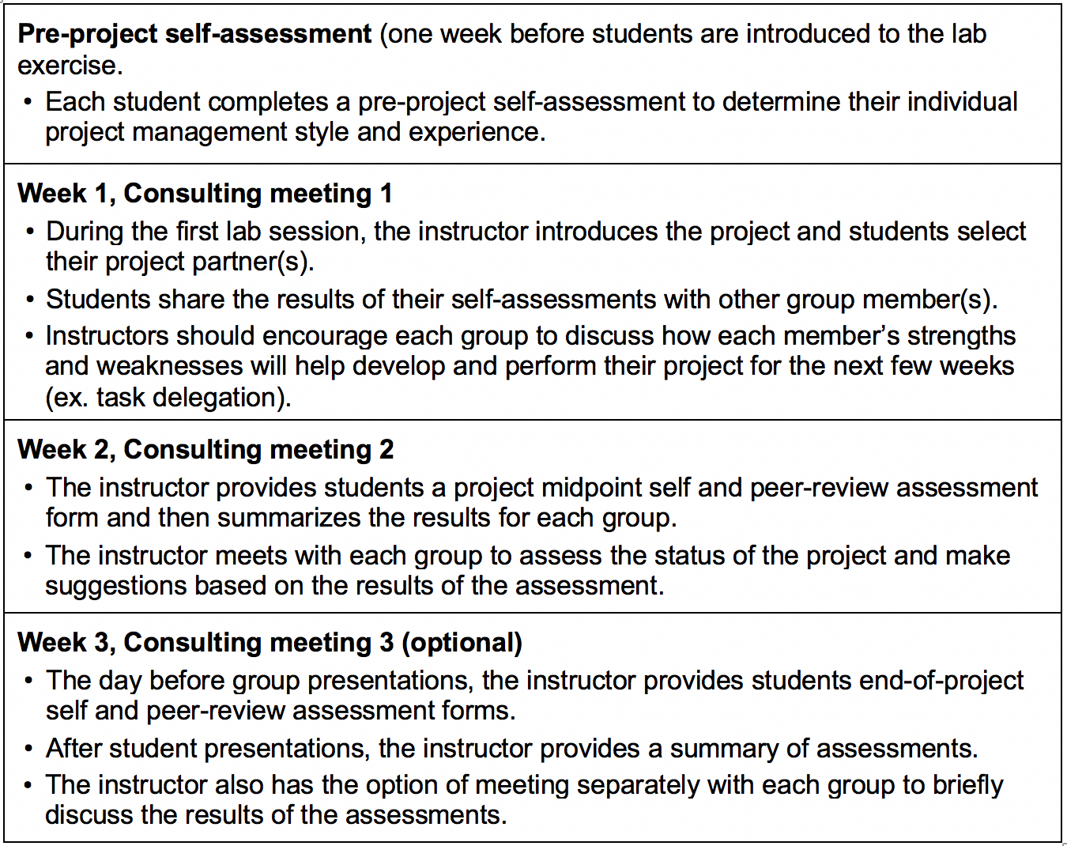

General description of the schedule for assessments and consulting meetings. Instructors can lift and adapt this formative assessment strategy to better suit their class and lab project schedule.

The formative assessment strategy previously described could be adjusted by the instructor, depending on the size of the course. In large classes with more than 20 students, consulting meetings with each group could be a limiting factor since it will be more time-consuming for the instructor to meet with every group. Alternately, the instructor could make consulting meetings optional and, instead, provide written summaries of peer assessments to each group.
It is important to remember that both self and peer assessments require a supportive and collaborative classroom environment. Both in the classroom and the lab, instructors should emphasize that students bear a shared responsibility for their own learning. They are also responsible for providing constructive, respectful, and non-judgmental feedback to their peers while instructors hold the critical role of establishing a consistent culture for peer assessment.

Comments on Translating the Activity to Other Institutional Scales or Locations:
Although this lab project could be conducted with any size group, it may be more challenging to perform with large groups (50 or more students) since it could limit the availability of the instructor to assist each individual group. An alternative to in-class presentations, if lab time is limited or the class is too big, is to have students submit a final written report or produce posters presentations. One of the great advantages of this lab exercise is that all resources needed are readily available online, which makes it easier for students to conduct their project and prepare their presentations from any geographic location, as long as they have access to the internet. Likewise, students with disabilities that experience limited movement will largely benefit from the lab format and will be able to fully participate in all lab tasks.
This lab can also be adapted for senior high school students; however, instructors may consider modifying the scope of the project and provide additional conceptual knowledge. It is also highly recommended that instructors provide consultations on their research questions before starting their project, which will help younger students gain more focus and improve their research questions.

STUDENT COLLECTED DATA FROM THIS EXPERIMENT

Here, we provide data that were collected and analyzed by our students in an epidemiology course (Example of Death Certificate Analysis). Students in this example specifically studied the survivorship and mortality of Japanese individuals in an internment camp during World War II in Yuma, Arizona.

COPYRIGHT STATEMENT
The Ecological Society of America (ESA) holds the copyright for TIEE Volume 16, and the authors retain the copyright for the content of individual contributions (although some text, figures, and data sets may bear further copyright notice). No part of this publication may be reproduced, stored in a retrieval system, or transmitted, in any form or by any means, electronic, mechanical, photocopying, recording, or otherwise, without the prior written permission of the copyright owner. Use solely at one's own institution with no intent for profit is excluded from the preceding copyright restriction, unless otherwise noted. Proper credit to this publication must be included in your lecture or laboratory course materials (print, electronic, or other means of reproduction) for each use.
To reiterate, you are welcome to download some or all of the material posted at this site for your use in your course(s), which does not include commercial uses for profit. Also, please be aware of the legal restrictions on copyright use for published materials posted at this site. We have obtained permission to use all copyrighted materials, data, figures, tables, images, etc. posted at this site solely for the uses described in the TIEE site.
Lastly, we request that you return your students' and your comments on this activity to the TIEE Managing Editor (tieesubmissions@esa.org) for posting at this site.

GENERIC DISCLAIMER
Adult supervision is recommended when performing this lab activity. We also recommend that common sense and proper safety precautions be followed by all participants. No responsibility is implied or taken by the contributing author, the editors of this Volume, nor anyone associated with maintaining the TIEE web site, nor by their academic employers, nor by the Ecological Society of America for anyone who sustains injuries as a result of using the materials or ideas, or performing the procedures put forth at the TIEE web site, or in any printed materials that derive therefrom.

