ISSUES: DATA SET
Quantifying the impact of a brood parasite on crows

Clare Trinder

School of Biological Sciences, University of Aberdeen, Cruickshank Building, St Machar Drive, Aberdeen, AB24 3UL, Scotland

c.j.trinder@abdn.ac.uk
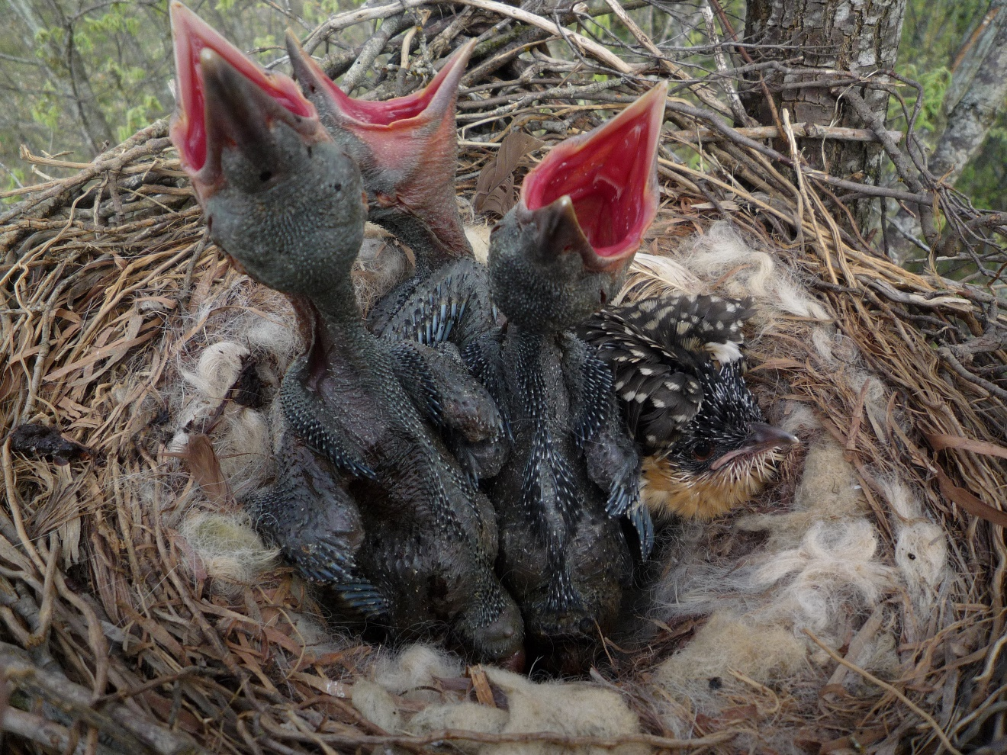

Great spotted cuckoo Clamator glandarius chick (right) with crow Corvus corone nestlings. Photo © Vittorio Baglione. Used with permission.

THE ECOLOGICAL QUESTION:
What is the nature of the impact of a brood parasite on its host and how much effect do brood parasites have?

ECOLOGICAL CONTENT:
Parasitism, mutualism, shifting nature of interactions
WHAT STUDENTS DO:
This class was designed for an introductory ecology course. Students are introduced to Microsoft Excel PivotTables by amending an existing PivotTable, then create their own PivotTables to explore the main data sets. These data sets provide information on the breeding success of carrion crows parasitised by great spotted cuckoos in Spain. Students summarise the large data sets, produce bar charts, calculate standard errors and add error bars to their plots. As they work through the exercises, students are asked to summarise the results they have obtained and to think about what this means ecologically. Finally, they use the whole set of results to understand the nature of the interaction between cuckoos and crows in this area.

STUDENT-ACTIVE APPROACHES:
Guided inquiry, peer feedback, small group discussion, problem-based learning

SKILLS:
- Application of existing knowledge on parasitism and mutualisms.
- Analysis of data using Excel PivotTables.
- Interpretation of data to evaluate the nature of species interactions.
ASSESSABLE OUTCOMES:
- Generation of a set of PivotTables and bar graphs to summarise two large data sets.
- Answers to a set of questions to demonstrate understanding of the interaction between great spotted cuckoos and crows in Spain.
- After the data analysis is complete, students can be directed to the paper (Canestrari et al. 2014) and asked more detailed questions based on the findings.

SOURCES:
- Data from Canestrari et al. 2014. From parasitism to mutualism: unexpected interactions between a cuckoo and its host. Science, 343: 1350-1352.
- Supplementary materials available from: www.sciencemag.org/content/343/6177/1350/suppl/DC1
- Data available from: DRYAD (DOI:10.5061/dryad.j81r0).

ACKNOWLEDGEMENTS:
I am grateful to Daniela Canestrari for kindly granting permission to use this data set and to Vittorio Baglione for providing the photo. The students in BI2020 Ecology in 2018 and 2019 generously engaged in this exercise and provided helpful feedback as I fine-tuned the activity. The teaching assistants who helped these classes run have also been invaluable. Two anonymous referees and Kathy Winnett-Murray provided helpful comments on the manuscript.

OVERVIEW OF THE MODULE
The data are arranged in 4 sheets (plus 2 optional sheets).
- Sheet 1: for each crow’s nest, the researchers recorded whether the nest was successful (i.e. raised at least one hatched chick to the fledgling stage), the number of crows successfully fledging from the nest and whether or not a great spotted cuckoo chick was present. As an introduction, there is a PivotTable already on this sheet showing number of successful nests in each year. Students can experiment with different combinations of data in the PivotTable to see what summary data are available and how changes here affect the layout of the final data table. Students then add in data to show successful nests in the presence and absence of cuckoos. They can also arrange the fields in the PivotTable ‘rows’ section to see how this changes the output.
- Sheet 2 contains the same experimental data as sheet 1. Students create a PivotTable to summarise the impact a cuckoo chick has on number of crows fledging.
- Sheet 3 shows the same data set and this time students look at nest success and how this is affected by the presence or absence of a cuckoo nestling.
- Sheet 4 shows data from 82 nests in 2009 and 2010. Researchers recorded number of eggs laid and whether the nest was ultimately successful (coded as ‘0’ unsuccessful and ‘1’ successful). Cuckoo chicks were removed from 16 nests and 14 chicks were added to nests without a cuckoo chick. A set of nests with a cuckoo present naturally (not manipulated by the researchers) was also recorded, plus a set of nests that naturally did not have a cuckoo chick.
- Sheets 5 and 6 (cuckoo dataset for faculty only) provide additional datasets testing the repellence of a secretion produced by young cuckoos on predatory species. These are not part of the main exercise but can be used for assessment. The interesting finding of this work is that the relationship between the crow and the cuckoo can be mutualistic or parasitic, depending on other aspects of the environment. In years when predation on crow nests is high, having a cuckoo in the nest may be an advantage as the cuckoo nestlings can deter predators by producing a smelly cloacal secretion. However, there is a cost to the crows of bringing up a cuckoo (slightly fewer chicks are fledged) and when predation is low, this cost typically outweighs the potential benefit of raising a cuckoo.
DATA SETS
Daniela Canestrari granted permission for the use of this dataset as a TIEE Dataset. Funding for the data collection and analysis from: Spanish Plan Nacional I+D (grants CGL2008-01829BOS, SEJ2007-29836-E, and CGL2011-27260) and Junta of Castilla y León (grant VA059A11-2)

- Cuckoo dataset student version - The student version of the Excel file contains 4 worksheets: 1 annual nest data, 2 crow fledglings, 3 nest success, 4 experimental data.
- Cuckoo dataset faculty version - The faculty version includes these 4 worksheets with completed PivotTables and bar charts and 2 additional sheets with optional data sets for predation at crow nests and for testing the effectiveness of cuckoo cloacal secretions in deterring nest predators.

STUDENT INSTRUCTIONS
Introduction
Most of us are familiar with cuckoos – birds that ‘cheat’ by laying their eggs in other birds’ nests. These are known as ‘brood parasites’; in fact, not all cuckoos are brood parasites and not all brood parasites are cuckoos. For example in North America, the most common avian brood parasite is the brown-headed cowbird (Molothrus ater). Among brood parasites, there is a range of behaviors: the parasite may throw out the host eggs and any hapless chicks that hatched earlier or the cuckoo chick may grow up alongside the hosts’ chicks, competing with them for food. Either way, the naïve host parents are left bringing up a giant foster chick, causing us to wonder why the parents don’t notice the deception and abandon the cuckoo chick.

Presumably, cuckoos have an impact on their host species by reducing reproductive success. Cuckoos and hosts are thought to have been interacting for around 80 000 years (Spottiswoode et al. 2012). As far as we know, host birds haven’t been driven to extinction due to this interaction and brood parasites persist today, implying that at least sometimes, the relative costs and benefits of brood parasitism have been balanced. However, there appears to be an evolutionary arms race between cuckoos and their hosts. On the one hand, there is selective pressure on cuckoos to be able to deceive prospective avian hosts and, on the other hand, there is selective pressure on hosts to be able to recognize an alien egg and/or nestling. So, how much impact do cuckoo brood parasites have on the birds that they target? In this exercise, we will use a data set from Spain to quantify the cost to carrion crows (Corvus corone) of bringing up the chicks of great spotted cuckoos (Clamator glandarius).

The great spotted cuckoo is found throughout Africa and the Mediterranean. Its host species are the magpie Pica pica (the primary host) and carrion crow (a secondary host). This species of cuckoo is non-evicting – the newly hatched cuckoo doesn’t throw out the host eggs or chicks. Young magpies are smaller than cuckoo chicks and don't fare well when competing with one (Soler 1990). Adult magpies will eject cuckoo eggs if they spot the deception and vigorously mob adult cuckoos. Crows have considerably larger chicks that apparently do not suffer as much when sharing a nest with a cuckoo nestling; adult crows do not respond to adult cuckoos in the same way as do magpies (Soler et al. 2002).

Note – when eggs hatch, the resulting chicks are called nestlings. Nestlings that have grown sufficiently to be able to fly and leave the nest (and therefore, have embarked on a more or less independent phase of growth) are said to have ‘fledged’ and are referred to as ‘fledglings’.

The exercise is in five parts. As you complete each section, check with a teaching assistant that you have completed that section successfully. When the teaching assistant has checked your work, you will be given the next section of the exercise.

Section 1: Nest success

- Open ‘sheet 1 annual nest data’ on the Excel spreadsheet. There are 550 rows of data, from 1995 to 2011. Study the column labels to make sure that you understand what variables are represented before going any further:

- Nest success: nests were coded as either successful (at least one chick survived to fledging, regardless of the number of eggs laid) or failed (no chicks survived to fledging); you will see that all nests listed as failing had 0 crow fledglings;
- N crow fledglings: the number of crow chicks that successfully fledged from each crow nest;
- Treatment: this shows whether there was a cuckoo present (par, short for parasitised) or there was no cuckoo (non par short for non-parasitised).

- There is already a PivotTable on sheet 1, showing the count of nest successes in each year of the study (Table 1). The version in Table 1 shows less detail than the one in the spreadsheet. In the spreadsheet, you can see the full breakdown of number of nest failures as well as successes.

Table 1. PivotTable showing summary data for number of successful nests; failed nests are not shown for each year.
 | Count of nest success
failed | 238
succeeded | 312
1995 | 20
1996 | 15
1997 | 22
1998 | 16
1999 | 26
2000 | 24
2001 | 19
2002 | 19
2003 | 20
2004 | 16
2005 | 22
2006 | 14
2007 | 27
2009 | 22
2010 | 4
2011 | 26
Grand Total | 550

- This is a fairly straight-forward PivotTable. You are now going to add some data as an introduction to how PivotTables work.

- Click on any of the cells within the PivotTable. The ‘PivotTable Fields’ menu should appear on the right hand side of the screen. If it doesn’t, in the ‘Analyse tab’ at the top of the screen, select ‘field list’ at the right hand side, as shown in Fig 1.
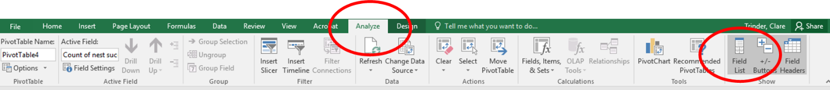
Fig. 1. Tool bar in Excel for making the PivotTable fields box visible (‘Analyse’ and ‘Field list’).

- At the top of the ‘PivotTable Fields’ box (Fig. 2), you can see the headings from the columns in the data-table. ‘Year’ and ‘nest success’ have ticks against them, showing that they are in use in the PivotTable. At the bottom of this panel are 4 boxes. Currently, there are no filters in use in this PivotTable. The columns box is currently empty but will include information when you have more fields in the ‘Σ values’ section later. The ‘rows’ section shows that we are using ‘nest success’ and ‘year’ to summarise data. The ‘Σ values’ shows that we have summarised ‘nest success’ to give a count of each of these in the output. We have ‘nest success’ in both the ‘rows’ and ‘Σ values’ boxes because we want successes broken down into success and failure as categories (this is what the ‘rows’ box does) and a number (‘count’) for each of these, from the ‘Σ values’ box.
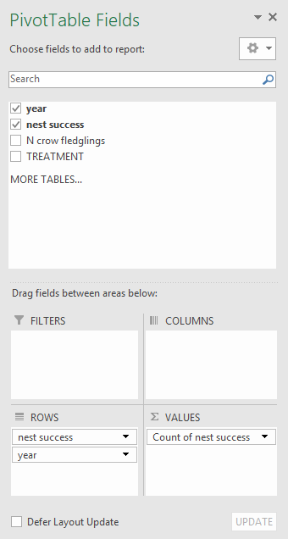
Fig. 2. PivotTable Fields screen showing the data selected for the PivotTable on sheet 1 of the Excel spreadsheet.

- You can add any of the columns in the spreadsheet to the ‘rows’ and ‘Σ values’ boxes to provide more detailed breakdowns of the data. Add ‘Treatment’ (i.e. whether a nest was parasitised or not) to the ‘rows’ box by dragging and dropping the column heading from the field list (‘fields’) into the ‘rows’ box.

- You can change the order that you display variables by dragging and dropping the headings within the ‘rows’ box. Try this and you will see how the PivotTable changes: the summarised data are the same but are shown in a different order. Display data in a way that best organizes your question of interest. For example, are you most interested in how parasitism varies with nest success or how nest success may depend on the nest being parasitised or not?

- To remove any of the fields, you can simply drag them outside the box or by using the down arrow next to each and choosing the appropriate option.

Section 2: Crow Clutch Fledglings

- You are now going to create your own, slightly more complex PivotTable to summarise the impact that a cuckoo nestling has on the average (mean) number of crow fledglings per nest. Move on to the next sheet in Excel, called ‘Sheet 2 crow fledglings’.

- Highlight the data (it doesn’t matter whether you include the headings or not) in the first 4 columns on this sheet. Go to ‘Insert’ on the top Menu and choose ‘PivotTable’ at the far left hand end (Fig. 3). A new dialogue box appears; you’ve already selected the range of data so you don’t need to do anything for the top 3 choices. You can choose if you want the PivotTable to appear in a new Excel sheet (the default) or on the same sheet as the data, in which case you need to choose a suitable place for it. Click OK.

Fig. 3. Excel menu showing PivotTable command

- Now you need to decide which fields to add to your PivotTable. You are investigating the question: ‘Is the mean number of crow fledglings different in parasitised nests as compared to non-parasitised nests?’ so you will need to include the 2 variables, ‘Treatment’ and ‘N Crow Fledglings’ in the PivotTable. Which is the best way to display these? The ‘Rows’ section should list the factors that we want to summarise in some way (i.e. the independent variable), so ‘Treatment’ should go in this box, leaving ‘N crow fledglings’, a dependent variable, to go in the ‘Σ values’ box. The two variables are now arranged so that we can see how N crow fledglings might be related to the treatment.

- The default setting in ‘Σ values’ is to show ‘sum’, but we want ‘average’ of ‘N crow fledglings’. Click on the down arrow next to ‘sum of N crow fledglings’ which will show a menu, then choose ‘value field settings’ to see the range of options available to you as shown in figure 4:

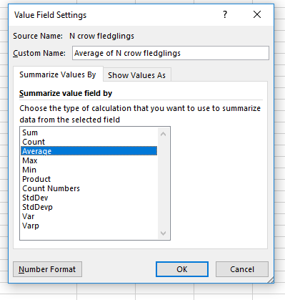
Fig. 4. PivotTable dialogue box showing value field settings.

- Select ‘average’. You can also use the ‘show values as’ tab on this menu to carry out more complex ways of displaying data if needed.

- You can make selections in this dialogue box to change what is displayed in the PivotTable. The most useful ones will be sum, count, average and StdDev. Although there isn’t an option for standard error, by generating the standard deviation and count (N) for each treatment, you can then easily calculate this in a new column next to your PivotTable.

- If you want to have the same field in the PivotTable twice with a different type of summary (e.g. count and average), you can drag the relevant field from the top of the PivotTable panel to the ‘Σ values’ box multiple times; then select the type of summary for each column of your PivotTable.

- The main data-table includes data from nests that failed; these show as 0 crow fledglings. But crow nests can fail for a wide range of reasons and we don’t know if each failure was due to the cuckoo or some other reason. Several non-parasitised nests also failed. So we need to exclude the nests that failed from our overall average or it may give misleading data on the impact of a cuckoo nestling. To do this, we need to include ‘nest success’ as an additional factor. Since we are only interested in the average number of crow fledglings from successful nests, we can use the ‘filters’ option in the PivotTable fields menu (see paragraph 5 and Fig. 2). When we add ‘nest success’ into the filters box, a new section appears above the PivotTable (Table 2).

Table 2. PivotTable showing filter symbol to select different options for display in the table (here the options are ‘succeeded’ or ‘failed’).

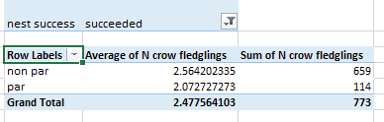
- Click on the filter symbol on the right hand side, select the option you want displayed in the PivotTable (in this example: ‘succeeded’) and click OK.

- Plot a bar chart to show your results. You can use PivotTable options to create your bar chart but the resulting plot can be difficult to edit so you may find it easier to copy the numbers from your PivotTable to another part of your spreadsheet and use these to plot your graph.

- You have plotted an average, so what needs to be included on your graph to show the spread around the average? The PivotTable won’t calculate the Standard Error (SE) for you, but you can calculate this from the Standard Deviation and N. Add ‘N crow fledglings’ to your PivotTable twice more under ‘Ʃ values’, and using the same procedure as paragraph 12, change one to ‘StdDev’ and one to ‘Count’. You can then do the calculation (StdDev/sqrt(N)) in an adjacent column on the spreadsheet. Note that here, N is the number of fledglings for each treatment (parasitised and non-parasitised).

- Adding error bars to charts requires a few steps. Fig. 5 shows the menu for adding elements to your graph.

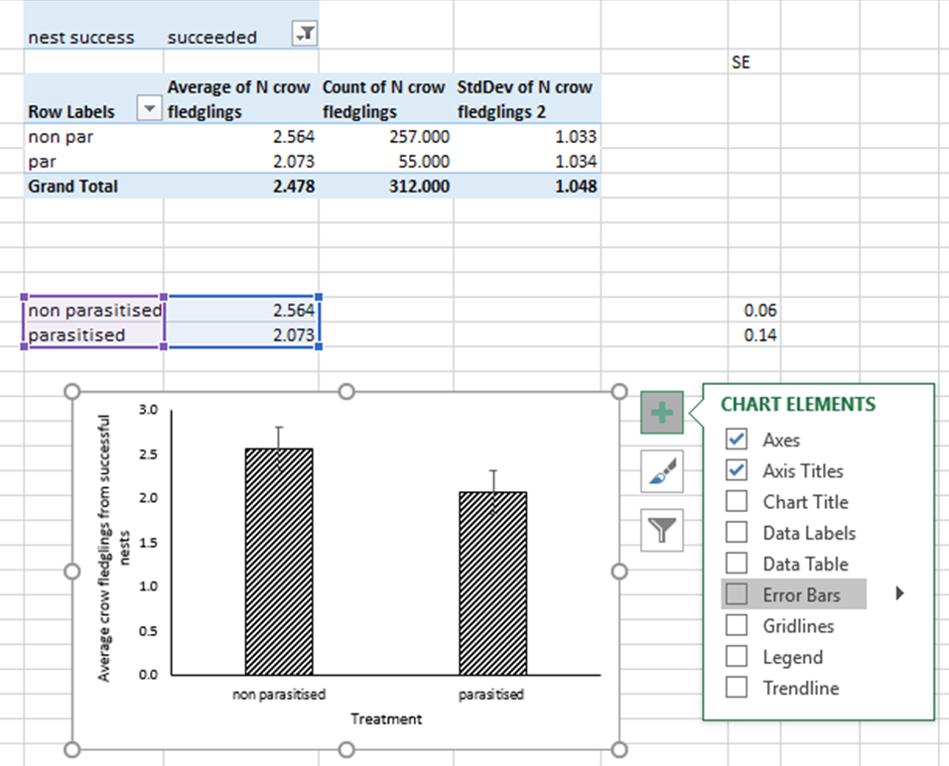
Fig. 5. Excel spreadsheet showing first step of adding error bars.

21. When you click on your graph, the green + sign appears and when you click on this, the ‘chart elements’ menu appears. Choose ‘Error Bars’. You will now see that there are error bars on your chart. However, these are ones generated by Excel and a quick check will show that these are not the ones you calculated in paragraph 19. To add the correct error bars, click on the arrow next to ‘error bars’ and choose ‘More options’. At the bottom of the ‘Format Error Bars’ dialogue box, select ‘custom’ and then ‘specify value’. The dialogue box in Fig. 6 appears; select the cells where you have the values you calculated for your error bars (note that these need to be in the same orientation as the values you used to create the bar chart; see Fig. 5).

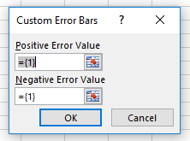
Fig. 6. Dialogue box for selecting values for error bars.

- Now evaluate your results:

- What does this result show regarding the average reproductive output of crows (in terms of average number of crow fledglings per nest) in the presence or absence of a cuckoo nestling?
- On the basis of this result, construct a hypothesis regarding the influence of cuckoo parasites on the proportion of crow nests that are successful or not. Do you predict that the proportion of crow nests that are successful (i.e. that produce at least one crow fledgling) will be higher when a cuckoo parasite is present, or lower?

Check your answers with a teaching assistant before moving on to the next section.

Section 3: Nest success

- Move on to ‘sheet 3 nest success’. With the same dataset used in Section 2, you are going to create a new PivotTable to investigate a related question: does presence of a cuckoo chick influence the proportion of crow nests that are successful vs. failed?

- What information do you need to include in the PivotTable to show proportion of crows’ nests that are successful when a cuckoo chick is present and when a cuckoo chick is absent? Your PivotTable will have just 4 numbers in it, plus 2 ‘grand totals’. To calculate the proportion, we need to know how many nests there were that were parasitised or not, and then see how many of these were successful and how many failed.
- Plot a bar chart to show your results for non parasitised and parasitised nests. Will your bar chart need error bars? Why or why not?

- What do these data suggest, ecologically?
- How does this result compare with the results you obtained in section 2?
- Do these results support your hypothesis stated in Paragraph 22 (Section 2)? Explain your reasoning.

Check your answers with a teaching assistant before continuing to section 4.

Section 4: Experimental manipulation

- Move on to ‘sheet 4 expt data’. This work was carried out over 2009 and 2010. The researchers measured nest success (failed or successful was evaluated as before). They also manipulated nests to test experimentally the impact of the brood parasite (cuckoo chick) on crow nest success. In this experiment, Treatment has 4 ‘levels’:

ADD a cuckoo chick was added to a nest that didn’t already contain a cuckoo
PAR a nest already parasitised with a cuckoo chick and had no changes made (control)
REM a nest containing a cuckoo chick already, had the cuckoo chick removed
NON PAR a nest without a cuckoo chick which had no changes made (non parasitised control)

- Create a PivotTable and a bar chart to show the proportion of nests that were successful for each level of the treatment. Should your graph have error bars?

- What is the ecological interpretation of these results?
- Do these results support the hypothesis you stated in paragraph 22? Explain your reasoning.

Section 5: Discussion

You have now completed the data analysis and it’s time to think about the results you have generated.

- Write a short overview of each of your findings for sections 2, 3 and 4.

- Do the results of each dataset provide support for the hypothesis that cuckoos are detrimental to the reproductive success of crows?

- Do the results of the different datasets seem contradictory? Explain your reasoning.

- The main predators of crows’ nests in northern Spain are red foxes (Vulpes vulpes), feral domestic cats (Felis catus), common genets (Genetta genetta) and stone martens (Martes foina). Canestrari et al. (2014) report that nestling cuckoos produce a ‘malodourous, cloacal secretion’ when grabbed by a predator. How might this observation allow you to develop your interpretation of the findings? What ecological interaction might be occurring between crows and cuckoos in this experiment?

- Another research team (Soler et al. 2017) carried out a similar experiment to that of Canestrari et al. (2014) in southern Spain. The area they worked in had very low predation levels (only 7 nests depredated during the nestling phase out of 66 nests studied over 4 years). Thinking back to your findings in this exercise (that crow nests with cuckoo chicks were more likely to be successful in producing at least one fledgling than crow nests without cuckoo chicks), what results do you think Soler et al. (2017) found? Explain your rationale. Sketch a bar chart of your predicted outcome for the translocation experiment carried out by Soler et al. (2017). Use the same format that you had for the bar chart in section 3.

- Brood parasites and their hosts are presumed to be engaged in a long-running evolutionary arms race where hosts should become better at spotting parasite eggs (and either remove them or abandon the whole nest) at the same time that brood parasites become better at deceiving their hosts. Explain how your findings here may affect the nature of this evolutionary arms race. Compare the interactions of cuckoos and crows with the interactions between magpies and great spotted cuckoos described in the Introduction.

- Soler et al. (2017) were unable to replicate the findings of Canestrari et al. (2014) in cuckoos, crows and magpies in southern Spain. They discuss various reasons for this difference. One suggestion is that cuckoo chicks do better in the absence of any crow nest mates (crow chicks are considerably larger than cuckoo nestlings) and therefore there would be no benefit to a cuckoo nestling in protecting a whole nest of competitors from predators. Brood parasites which evict all their nest mates (and potential nest mates in the form of eggs) are described as ‘virulent’ (i.e., they exert a high impact on the host species). What might limit great spotted cuckoos from being more ‘virulent’?

References & further reading

- Bronstein, J.L. 1994. Conditional outcomes in mutualistic interactions. Trends in Ecology & Evolution 9:214-217.

This paper gives a good overview of the need to get away from rigid categorisation of interactions into always fitting neatly into positive or negative boxes. She raises the idea of ‘conditionality’ – that interactions can change according to circumstances, both in time and space.

- Canestrari, D., D. Bolopo, T.C.J. Turlings, G. Röder, J.M. Marcos, and V. Baglione. 2017. Formal comment to Soler et al.: Great spotted cuckoo nestlings have no antipredatory effect on magpie or carrion crow host nests in southern Spain. PLoS ONE 12:e0184446. https://doi.org/10.1371/journal.pone.0184446

This publication is the reply of Canestrari et al. to the paper of Soler et al. (2017). This and the Soler et al. paper are more technical than the Canestrari et al. (2014) paper, but provide discussions of contrasting results from different research teams.

- Medina, I. and N.E. Langmore. 2016. The evolution of acceptance and tolerance in hosts of avian brood parasites. Biological Reviews 91: 569-577

This paper provides a detailed review of tolerance and resistance in host species in relation to virulence of brood parasites and how natural selection acts on the host-parasite relationships.

- Soler, M. 1990. Relationships between the great spotted cuckoo Clamator glandarius and its corvid hosts in a recently colonised area. Ornis Scandinavica 21:212-223.

- Soler, M., J.J. Soler, T. Pérez-Contreras, and J.G. Martínez. 2002. Differential reproductive success of great spotted cuckoos Clamator glandarius, parasitizing magpies Pica pica, and carrion crows Corvus corone: the importance of parasitism costs and host defences. Avian Science 2:25-32.

- Soler, M., L. de Neve, M. Roldán, T. Pérez-Contreras, and J.J. Soler. Great spotted cuckoo nestlings have no antipredatory effect on magpie or carrion crow host nests in southern Spain. PLoS ONE 12:e0173080 https://doi.org/10.1371/journal.pone.0173080

Soler and co-workers attempted to reproduce the findings of Canestrari et al. (2014) in great spotted cuckoos, crows and magpies in southern Spain, but did not find the same results. They make various suggestions for why this might be the case. See also Canestrari et al. 2017. This is more technical than the Canestrari et al. (2014) Science paper, but provides contrasting results from different research teams.

- Spottiswoode, C.N., R.M. Kilner, and N.B. Davies. 2012. Brood parasitism. In The Evolution of Parental Care. N.J. Royle, P.T. Smisetg, and M. Kölliker (Eds). Oxford University Press, Oxford.

This review paper provides an excellent overview of the evolution of brood parasitism, the different defences of hosts in relation to ‘virulence’ of cuckoo nestlings. 'Virulence' refers to whether or not the parasites kill foster siblings. The implications of these behaviours are discussed in relation to the evolution of defence in host species and why, even in highly virulent brood parasites, it might still be beneficial for hosts to tolerate a cuckoo in the nest rather than evicting it.

Notes to Faculty
Comments of Implementing this exercise
In my class, students work in groups of two and the exercise takes 2 - 3 hours. One disadvantage of working in pairs is that one student may do all the work on Excel while the other watches, but many students do better by working together and sounding ideas off each other rather than working alone.
A key point is that students shouldn’t know the final conclusion until they have reached the relevant point when working through the data sets. The students will assume that cuckoos are always bad for host birds and will only realize that there might be benefits when they have completed the last sections. Stronger students will start to question their assumptions after they have completed section 3 and unexpectedly find that nests were more successful when there was a cuckoo present. They also need to look at all the results they’ve generated (and be prompted if need be) to see that while there is always a cost to having a cuckoo in the nest, the increased probability of nests surviving when they contain a cuckoo out-weighs this reduction in reproductive fitness. The discussion questions in Section 5 introduce students to the idea that this increased survival of nests could be related to predation and that the defensive reaction of cuckoo chicks when faced with a nest predator confers protection on the rest of the nestlings. This in turn leads on to thinking about what happens in areas with different levels of predation (high predation in northern Spain, much lower predation in southern Spain) or where predation levels might vary year to year. Even if they have been taught in lectures about the shifting balance between mutualism and parasitism, students may be surprised to discover that this could occur geographically within the same species, or over short time-scales within the same population.
I ask students to check their answers to each section with me or a teaching assistant before they are given the instructions for the next section. This is to discourage students from racing through each section and instead to spend time contemplating apparent contradictions. However, this can lead to bottlenecks with students waiting to get results checked before they can continue, so having a sufficient number of teaching assistants is valuable.
Instructors may choose to include statistical comparisons for the datasets, for example, mean number of fledglings for parasitised vs. non-parasitised nests (Section 2) and proportion of failed vs. successful nests for all 4 experimental treatments (Section 3), depending on the statistical background expected in a given course.
Students report that they enjoy the problem-solving approach to this exercise and the way that the picture gradually builds up as they work on each part of the data.

Comments on Student Assessment
Students who complete this exercise can be assessed in a variety of ways, including:

- Generation of a set of PivotTables to summarise a large dataset.
- Formative evaluation of hypothesis (Section 2) with rationale, evaluating stated hypothesis from Section 2 in light of new evidence derived in Section 3, and construction of a graphical prediction for a hypothesis based on a similar scenario with a new context (Section 5).
- There are two additional datasets from the Canestrari et al. (2014) paper that can be used to evaluate students’ ability to create PivotTables. These are included in the faculty Excel spreadsheet: ‘repellence crows faculty’ and ‘repellence raptors faculty’. Meat was sprayed with 10-25 µl of water (control) or of natural cuckoo secretion (this represents around 1/40 of the average volume produced by cuckoo nestlings). Three pieces of treated meat and three controls were offered to each of seven hand-raised captive crows (this represents intra-specific predation, which is common in this species). The same experiment was repeated with raptors used in falconry. More details are available in the supplementary materials accompanying Canestrari et al. (2014). There does seem to be some difference in the selection of treated meat and students could speculate on why this might be.
- The discussion (Section 5) sets out a series of questions that students can consider in class or for a later assessment requiring further reading to gain a broader perspective on brood parasitism. See papers listed in Discussion section: Soler et al. (2017), Canestrari et al. (2017).

Comments on Questions

Section 1

The PivotTable and Fields table should look like this:
Count of nest success  non par 478  failed 221  1995 18  1996 19  1997 9  1998 19  1999 14  2000 22  2001 18  2002 19  2003 22  2004 12  2005 16  2006 11  2007 10  2009 5  2010 7  succeeded 257  1995 20  1996 15  1997 20  1998 15  1999 25  2000 23  2001 18  2002 18  2003 20  2004 11  2005 19  2006 9  2007 16  2009 9  2011 19  par 72  failed 17  1999 1  2002 1  2003 1  2005 3  2006 4  2007 2  2009 1  2010 4  succeeded 55  1997 2  1998 1  1999 1  2000 1  2001 1  2002 1  2004 5  2005 3  2006 5  2007 11  2009 13  2010 4  2011 7  Grand Total 550 | 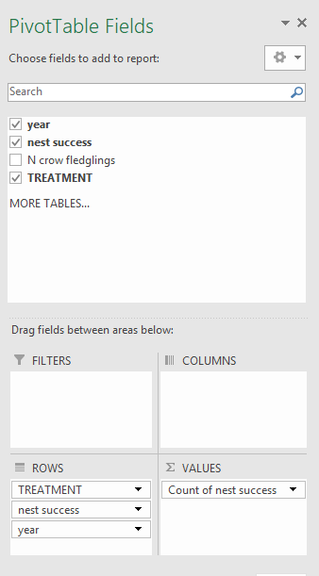
 | Fig. 7. PivotTable fields (above) and the PivotTable it generates (left) for number of successful and failed nests in relation to presence/absence of a cuckoo.

Section 2
Table 3 shows what should be included in the table. You have to make an extra column for your own calculation to show the standard error, using the data from the PivotTable, as PivotTables don’t calculate these. Students find this table difficult to work out as they often don’t realise that you need to include the data on whether the nest was successful overall or not. If the students try the calculation with and without nest success included, they will see that the values are different, but why? Without using the nest success as a separate variable, the PivotTable counts all of the nests with crow fledglings, regardless of whether all the fledglings were, for example, eaten the day before they fledged and regardless of the cause of the nest loss. However, we are only interested in the number of crow chicks that fledge.

Table 3. PivotTable showing total number, average, standard deviation and standard error of crow fledglings depending on whether or not a great spotted cuckoo chick was present in the nest.

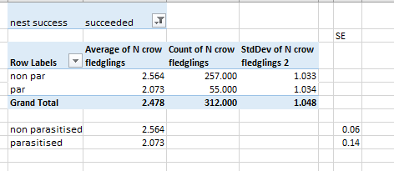

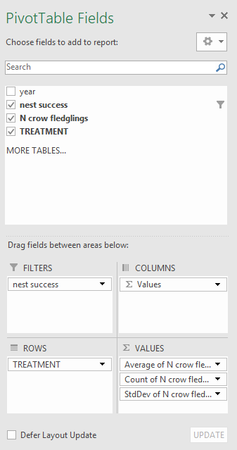 | 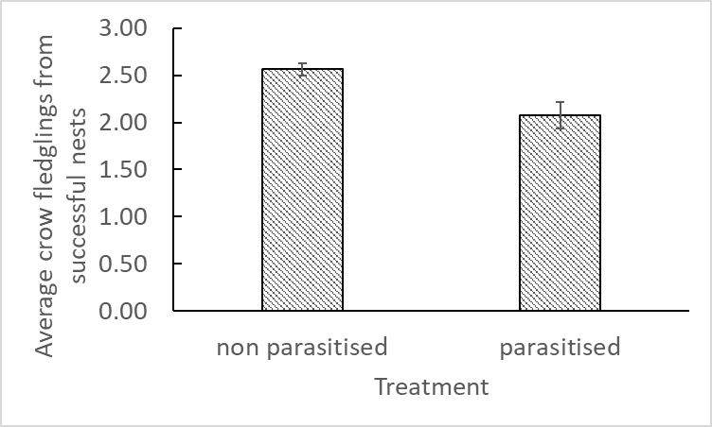  Figure 8. Average number of crow fledglings that leave the nest when great spotted cuckoos are present or not. Error bars show 1 SE of the mean.

This graph should have error bars as the bars show averages.
As the students probably expected, this graph suggests that there is a cost to raising a cuckoo chick, as the crows’ average fitness is reduced (fewer offspring fledge).

At this point, we anticipate that students hypothesise that reproductive fitness of crows is greater without cuckoo chicks (i.e. more crow chicks fledge without than with a cuckoo chick present). They have no information yet to suggest anything different from that and the results in section 2 should confirm their expectations about host birds raising cuckoos. If the students have written a different hypothesis at this point, they need to be asked to explain their reasoning.

Section 3
The table should look like this:

Table 4. Proportion of crows raising at least one fledgling in relation to the presence or absence of a cuckoo chick

Row Labels | Count of nest success
non par | 478
failed | 221
succeeded | 257
par | 72
failed | 17
succeeded | 55
Grand Total | 550

The number of successful nests needs to be expressed as a proportion of the total nests in each treatment:

Non parasitised: 257/478 = 0.538
Parasitised: 55/72 = 0.764

The PivotTable fields should look like this:

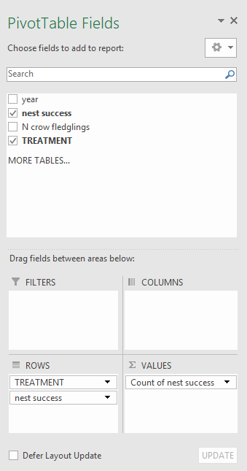 | 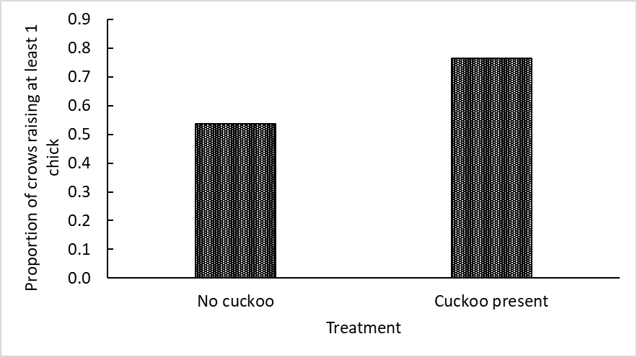  Fig. 9. Proportion of crow nests that were successful in the presence and absence of a cuckoo nestling.

There shouldn’t be error bars with this graph as these are not averages and there is no replication in the calculation. Students may be unclear on this (although asking them what data they would use to calculate the standard error might clarify the point).

Ecologically, the point the students need to pick up here is that a higher proportion of crows’ nests are successful when a cuckoo is present compared to nests without a cuckoo chick. This is a surprising result and the students should stop and consider whether they expected this and compare against the hypothesis they generated in paragraph 22.

In the Canestrari paper, these data are expressed as probabilities but my students found this terminology more confusing than being asked for proportions; they may still find this section difficult (it represents the main bottle neck in our classes) and they may need additional explanation, particularly of what the denominator should be in the proportion.
Section 4

The table should look like this. I’ve added an extra column to show the calculation of proportion.

Table 5. PivotTable showing numbers of successful nests in relation to adding a cuckoo chick to a nest (ADD); non-parasitised nests (NON PAR); nests with a cuckoo chick (PAR) and nests where a cuckoo chick was removed (REM).

Treatment | Sum clutch success | Count of clutch success2 | Proportion of successful nests
ADD | 10 | 14 | 10/14 = 0.714
NON PAR | 9 | 24 | 9/24 = 0.375
PAR | 17 | 28 | 17/28 = 0.607
REM | 5 | 16 | 5/16 = 0.313
Grand Total | 41 | 82

The proportions for each treatment need to be expressed as the number of successful nests out of the total nests for that treatment.

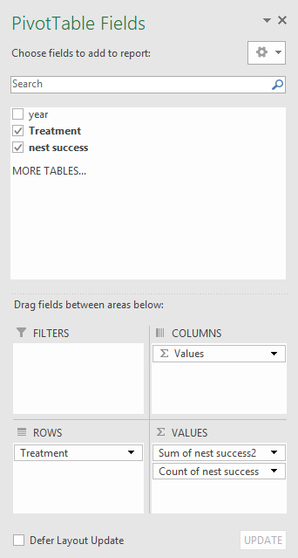 | 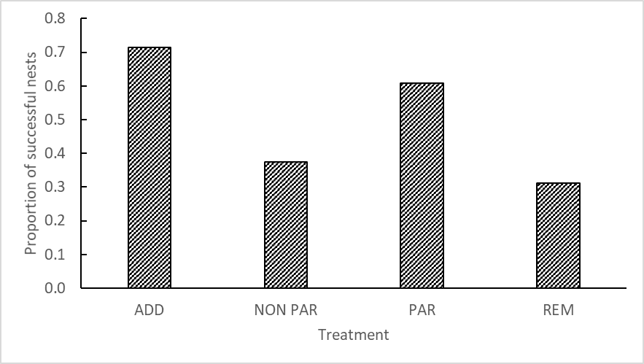Figure 10. Proportion of nests fledging at least one crow chick in relation to experimental treatments: adding a cuckoo chick to a nest (ADD); non-parasitised nests (NON PAR); nests with a cuckoo chick (PAR) and nests where a cuckoo chick was removed (REM).

Again, there are no error bars as these aren’t averages.

These results confirm the earlier findings that nests are more successful when a cuckoo is present, either naturally or added as part of the experiment. Students should also note that removing a cuckoo chick from a nest has the effect of making the nest less successful. Stronger students may see that this shows that there isn’t anything different about nests that cuckoos select, it’s simply due to the presence or absence of a cuckoo chick. Again, this emphasises the difference between absolute nest success (as shown here and in section 3) and degrees of success (numbers of chicks fledged, section 2). At this stage, students may need guidance in interpreting apparently contradictory results.

Most students will work out that there is an overall benefit to having a cuckoo in the nest despite the reduced numbers of offspring per nest. The discussion questions present information from other studies suggesting that shifting levels of predation on an annual basis can alter the cost/benefit ratio of brood parasitism, so students may be able to conclude that the interaction between crows and cuckoos can shift between parasitism and mutualism depending on the other aspects of the environment. If it were always advantageous to raise a cuckoo you might imagine crows would actually try and attract cuckoos to lay eggs in their nests. If it were always a disadvantage to have a cuckoo chick, crows might have more refined adaptations to detect cuckoos and evict them, in the way that magpies do.

The Canestrari et al. (2014) paper also includes a figure (Fig. 2) showing a chromatogram of the volatile chemicals in the cuckoo chick’s secretion. You could ask students to investigate online the properties of the most abundant chemicals: acetic acid, p-cresol, indole and butyric acid. All are volatile, acidic, nasty smelling and presumably unpleasant to have squirted over you. The paper also includes some data on meat treated with these secretions that were fed to feral cats.

Section 5
- Write a short overview of each of your findings for sections 2, 3 and 4 – see answers above.

- Do the results of each dataset provide support for the hypothesis that cuckoos are detrimental to the reproductive success of crows? Do the results of the different data sets seem contradictory? Explain your reasoning.

Here, the students need to make the distinction between a small cost at the level of raising slightly fewer chicks to the fledgling stage compared to the cost of losing the whole nest to predation.

- The main predators of crows’ nests in northern Spain are red foxes (Vulpes vulpes), feral domestic cats (Felis catus), common genets (Genetta genetta) and stone martens (Martes foina). Canestrari et al. (2014) report that nestling cuckoos produce a ‘malodourous, cloacal secretion’ when grabbed by a predator. How might this observation allow you to develop your interpretation of the findings? What ecological interaction might be occurring between crows and cuckoos in this experiment?

The cuckoo nestling confers protection on its nest-mates as predators experiencing a face full of acidic, smelly secretion presumably flee. There are no data to show whether the cuckoo will do this when faced with the approach of a predator or only when physically attacked. Many predators will remove one chick at a time so if the predator takes a crow chick first it is likely to return. As long as the cuckoo isn’t the last chick remaining in such a scenario, it will still confer a benefit to remaining crow chicks, assuming the predator doesn’t return for another experience of cuckoo cloacal secretion.

- Another research team (Soler et al. 2017) carried out a similar experiment to that of Canestrari et al. (2014) in southern Spain. The area they worked in had very low predation levels (only 7 nests depredated during the nestling phase out of 66 nests studied over 4 years). Thinking back to your findings in this exercise (that crow nests with cuckoo chicks were more likely to be successful in producing at least one fledgling than crow nests without cuckoo chicks), what results do you think Soler et al. (2017) found? Explain your rationale. Sketch a bar chart of your predicted outcome for the translocation experiment carried out by Soler et al. (2017). Use the same format that you had for the bar chart in section 3.

Soler et al. were unable to replicate the findings of Canestrari et al.: there was no advantage to magpies or crows in having a cuckoo chick in their nest. They plot different graphs from Canestrari et al., focusing on probability of predation rather than graphs directly comparable to Canestrari et al. In the exchange between the authors, Canestrari et al. (2017) suggest that the different findings may be because predation rates were so much lower at this study site in southern Spain. Fig. 11 shows a bar chart of the predicted findings of Soler et al. (2017). If cuckoo chicks don’t result in increased survival of crow nests, you would expect the bars to be the same height. There is no suggestion that a cuckoo chick decreases the proportion of successful crow nests so the bar wouldn’t be smaller than for nests without a cuckoo.

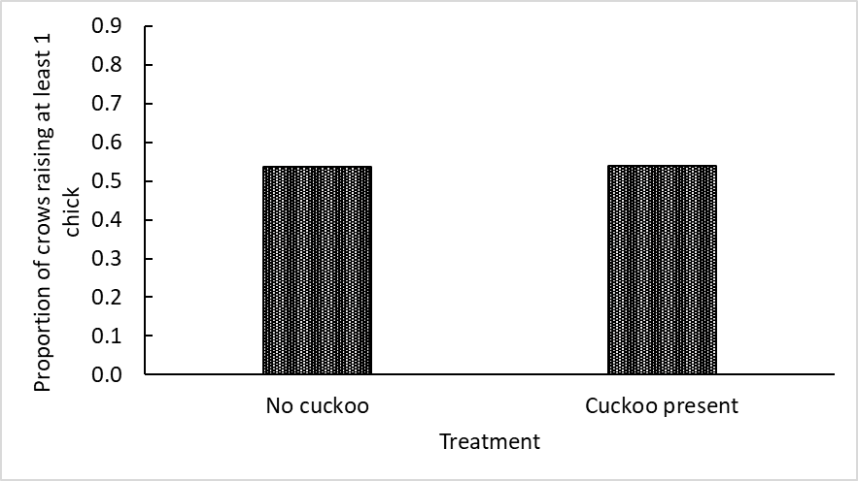
Fig. 11. Bar chart to illustrate predicted findings of Soler et al. (2017).

- Brood parasites and their hosts are presumed to be engaged in a long-running evolutionary arms race where hosts should become better at spotting parasite eggs (and either remove them or abandon the whole nest) at the same time that brood parasites become better at deceiving their hosts. Explain how your findings may affect the nature of this evolutionary arms race. Compare the interactions of cuckoos and crows with the interactions between magpies and great spotted cuckoos described in the Introduction.

Natural selection would be unable to act in favour of individuals that became better at detecting great spotted cuckoo eggs in their nests and evicting them, if there is a high predation risk; such individuals would be at a disadvantage compared with their less observant con-specifics. Where predation varies year to year, an evicting crow would sometimes be at an advantage and sometimes not. In areas where predation is lower on a long-term basis, you might expect to see natural selection favour individuals that did throw out brood parasite eggs.

- Soler et al. (2017) were unable to replicate the findings of Canestrari et al. (2014) in cuckoos, crows and magpies in southern Spain. They discuss various reasons for this difference. One suggestion is that cuckoo chicks do better in the absence of any crow nest mates (crow chicks are considerably larger than cuckoo nestlings) and therefore there would be no benefit to a cuckoo nestling in protecting a whole nest of competitors from predators. Brood parasites that evict all their nest mates (and potential nest mates in the form of eggs) are described as ‘virulent’ (i.e. they exert a high impact on the host species). What might limit great spotted cuckoos from being more ‘virulent’?

Crow eggs and chicks are larger than cuckoos and there is a physical cost to a newly hatched cuckoo chick in trying to remove eggs from a nest. If cuckoos hatch after the crows, they would be unlikely to remove them from the nest. Host parents may not respond as strongly to begging behaviour by chicks if only one (the cuckoo) remains. It may also explain why crows are a secondary host and magpies are the preferred host in this area of northern Spain.

COPYRIGHT STATEMENT
The Ecological Society of America (ESA) holds the copyright for TIEE Volume 13, and the authors retain the copyright for the content of individual contributions (although some text, figures, and data sets may bear further copyright notice). No part of this publication may be reproduced, stored in a retrieval system, or transmitted, in any form or by any means, electronic, mechanical, photocopying, recording, or otherwise, without the prior written permission of the copyright owner. Use solely at one's own institution with no intent for profit is excluded from the preceding copyright restriction, unless otherwise noted. Proper credit to this publication must be included in your lecture or laboratory course materials (print, electronic, or other means of reproduction) for each use.
To reiterate, you are welcome to download some or all of the material posted at this site for your use in your course(s), which does not include commercial uses for profit. Also, please be aware of the legal restrictions on copyright use for published materials posted at this site. We have obtained permission to use all copyrighted materials, data, figures, tables, images, etc. posted at this site solely for the uses described at TIEE site.

GENERIC DISCLAIMER
Adult supervision is recommended when performing this lab activity. We also recommend that common sense and proper safety precautions be followed by all participants. No responsibility is implied or taken by the contributing author, the editors of this Volume, nor anyone associated with maintaining the TIEE web site, nor by their academic employers, nor by the Ecological Society of America for anyone who sustains injuries as a result of using the materials or ideas, or performing the procedures put forth at the TIEE web site, or in any printed materials that derive therefrom.

